Fill in the blanks with the correct adverbs.
1 | 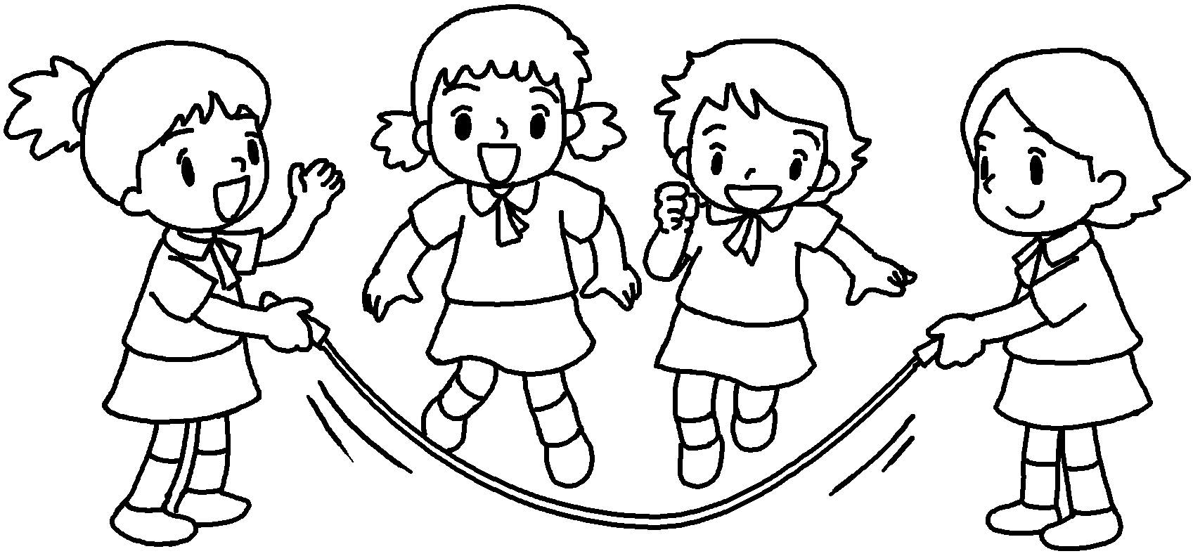 | The girls are skipping h in the playground.
2 | 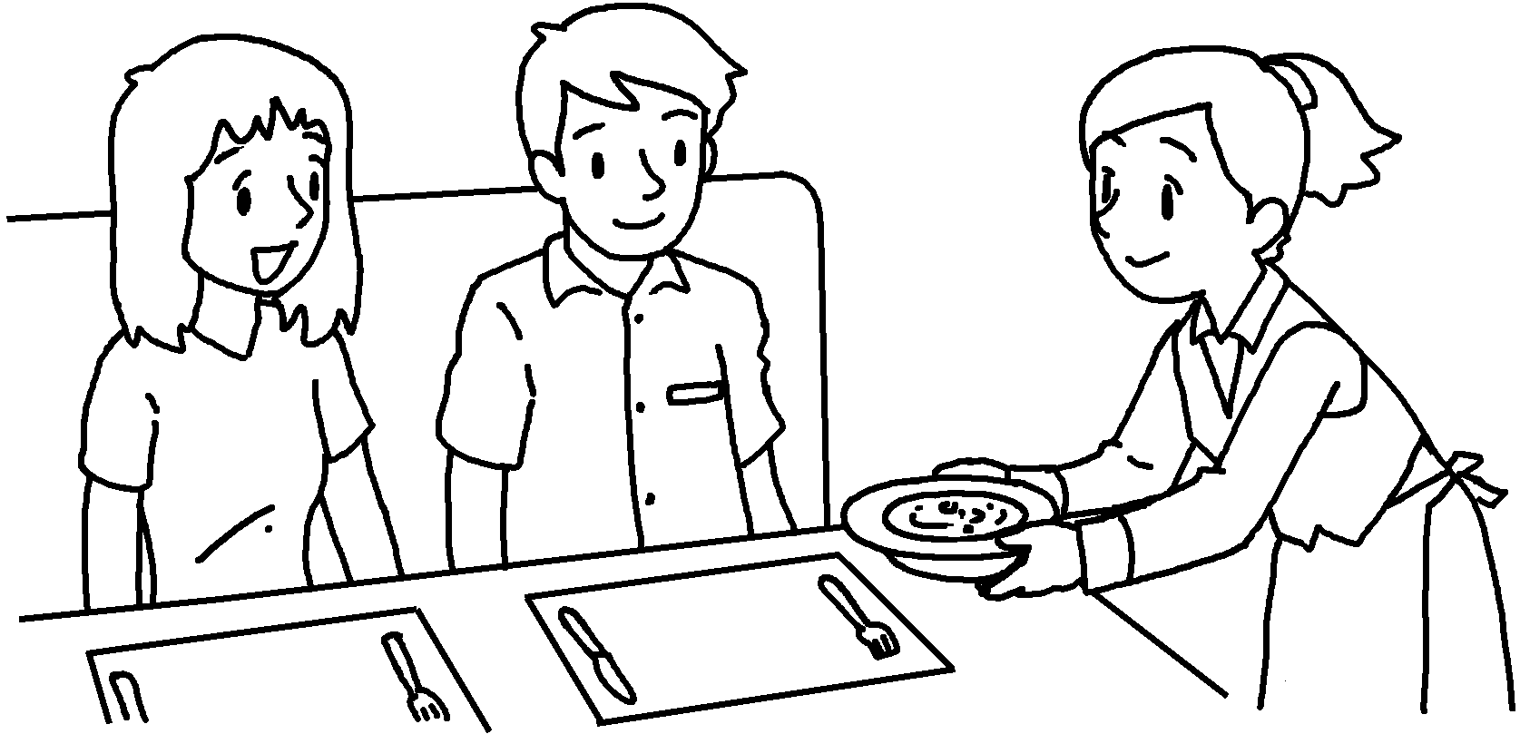 | The waitress served food to us  c .
3 | 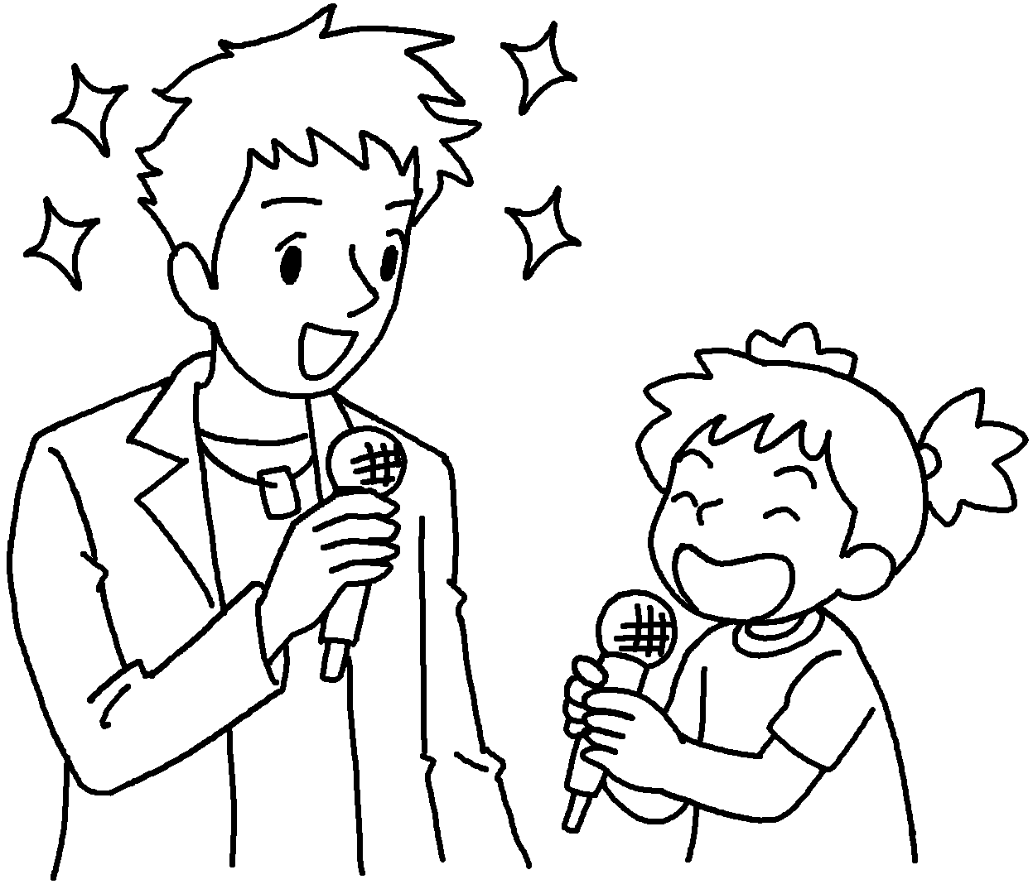 | Sarah sang with her favourite singer  e .
4  Exam week  Mimi | 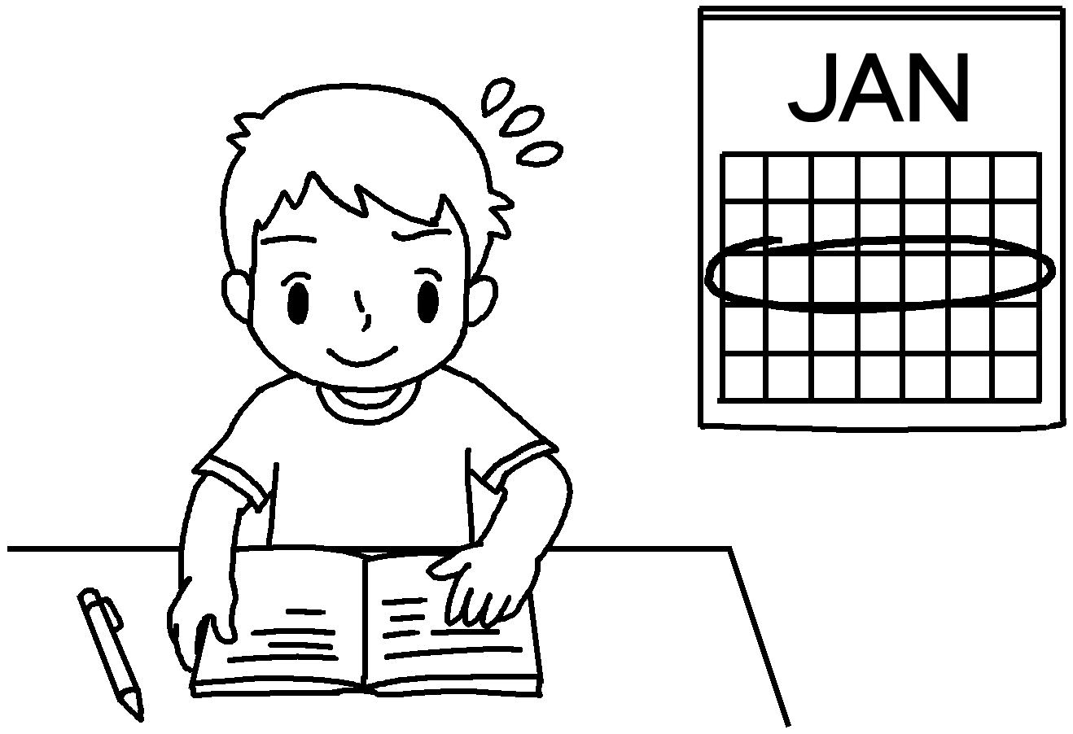 | Tommy is a diligent student.  He always works h for the exams.
5 | 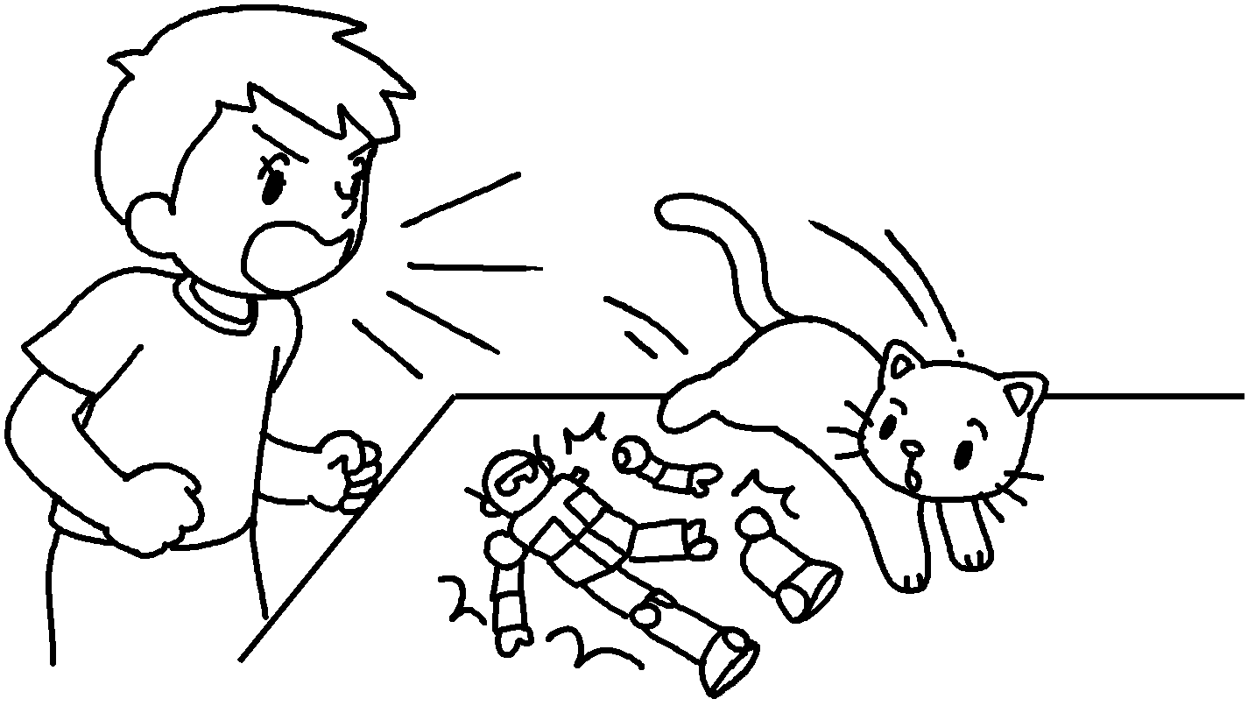 | Mimi broke Ben’s model.  Ben shouted at her a .
6 | 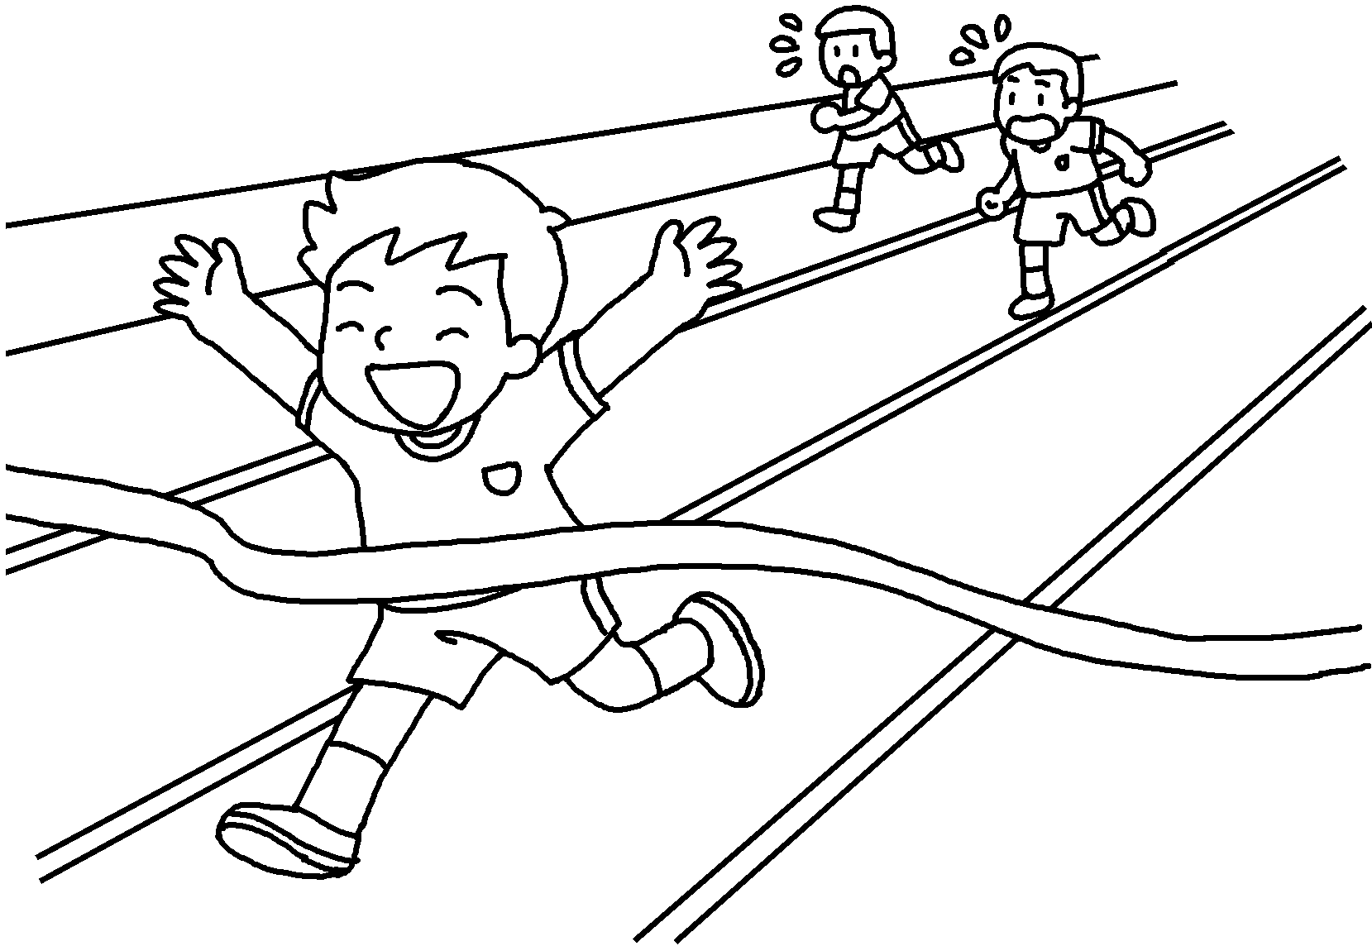 | John is good at sports.  He runs f .  He won first prize on Sports Day.


Book 6B Chapter 5 Graded Worksheets
Worksheet 3⬇⬇⬇
- happily
- carefully
- excitedly
- hard
- angrily
- fast

