- Friendship
Do you have a best friend? What do you do together? Read and find out about Clare’s best friend.



My best friend
By Clare Wong
My mum and dad separated when I was six. Dad went to live in Shanghai. I cried when Dad’s plane left. It was very difficult. But Ted has always been there for me. He is the most loyal friend ever.
Ted and I spend a lot of time together. When I am feeling sad or lonely, Ted pushes his cold wet nose into my hand. He always understands how I feel. We never quarrel.

When we go to the park, other kids want to play with him. He always looks at me eagerly, as if to ask ‘Is it OK?’ before he runs off. When it is time to go home, he always comes when I whistle.

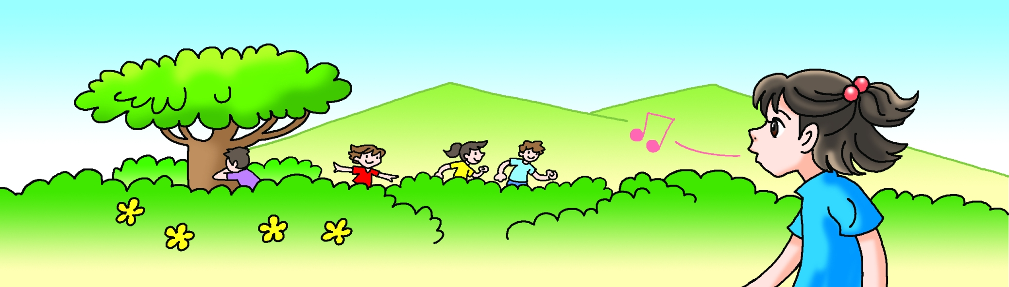

When I first met Ted, he was shy. Now he is very confident – he walks around our flat like he owns it! He doesn’t move as quickly as before. He sleeps more too, curled up with his nose on his paws. But every day he still waits at the door when I come home from school, until today …

Now I am at the clinic because Ted was sick and needed an operation. My heart is breaking as I wait outside the vet’s room. If the operation goes well, Ted will be full of life again, like a puppy. If the operation goes badly …

Here is the vet now. She smiles warmly and gives me the thumbs up. The nurse is carrying Ted. His golden tail hangs down towards the floor. Ted lifts his head and barks weakly. Everything is going to be OK!

