Back covers
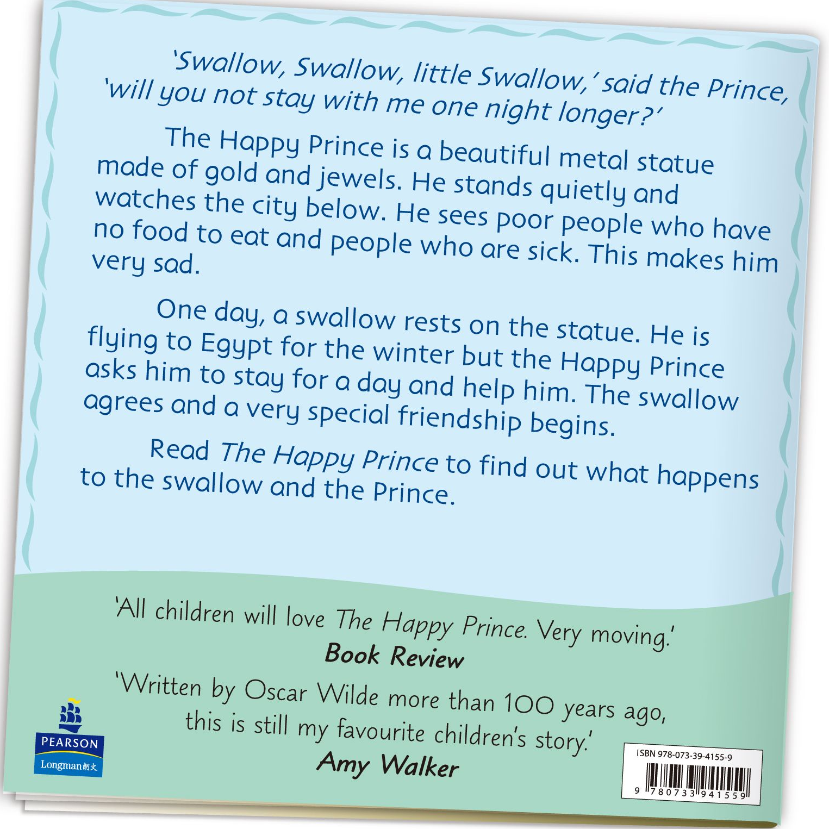
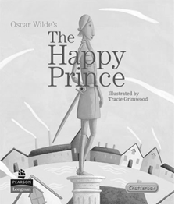

Write the answers and blacken  the circles.

1 Who wrote The Happy Prince?

2 Which word tells you that a swallow is a kind of bird?

3 The Happy Prince is not a real prince. Which sentence tells you this?

- Why is the Happy Prince unhappy?

5 Which of the following about The Happy Prince is NOT true?
 A. The Happy Prince can talk.
 B. The Happy Prince and the swallow become friends.
 C. The swallow meets the Happy Prince in Egypt.
 D. The Happy Prince wants the swallow to help him.

6 Which of the following CAN’T you read about on the back cover?
 A. people’s opinions of the book
 B. the ending of the story
 C. a sentence from the book
 D. what the story is about
Answers: (Accept any reasonable answers.)
1 Oscar Wilde. 2 Flying.
3 The Happy Prince is a beautiful metal statue made of gold and jewels.
4 Because he sees poor people who have no food to eat and people who are sick.
5 C 6 B

