Choose and write.
meaningful terrible

1 | 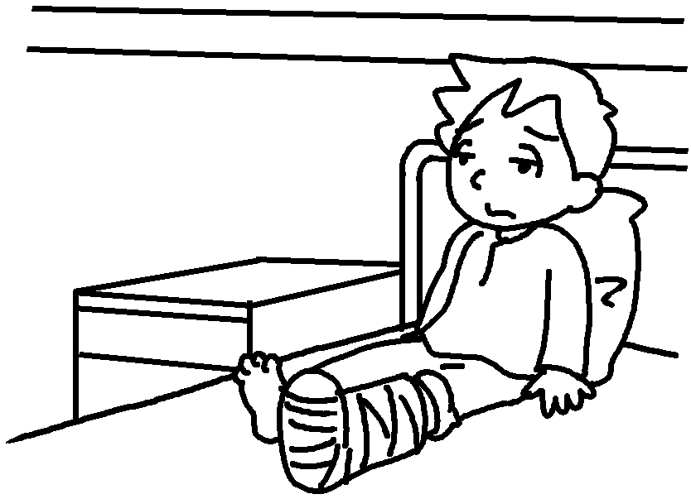 | 2 | 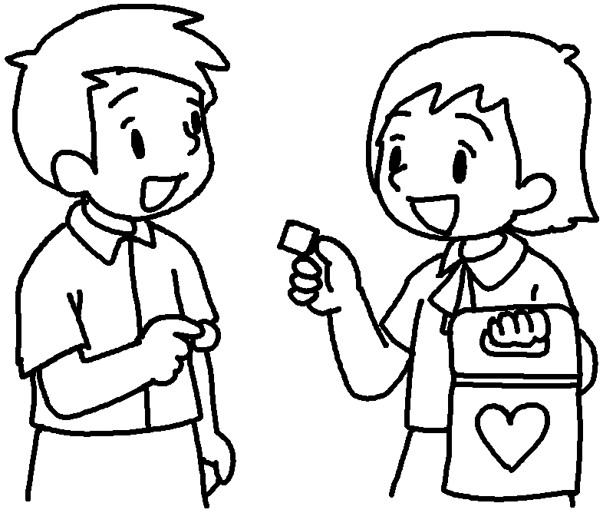 | 1  2
joyful painful

3 | 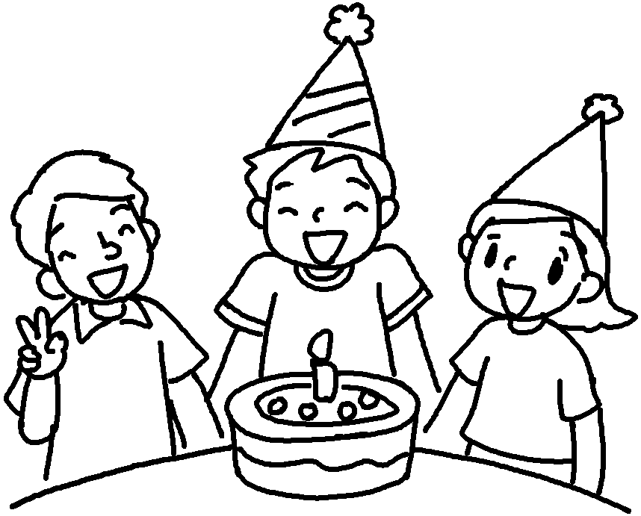 | 4 | 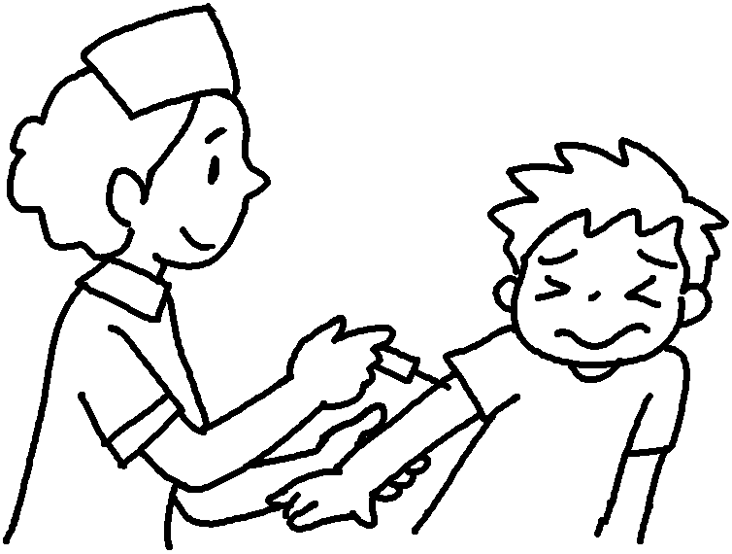 | 3  4
enjoyable awful
proud excited disappointed

5 | 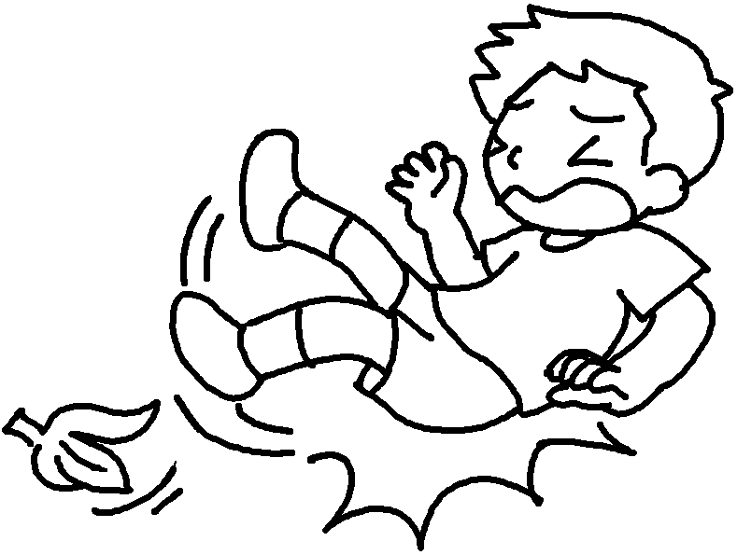 | 6 | 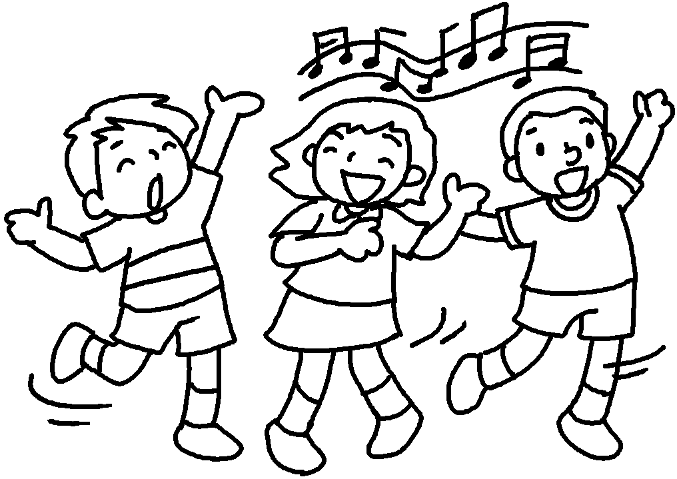 | 5  6

7 | 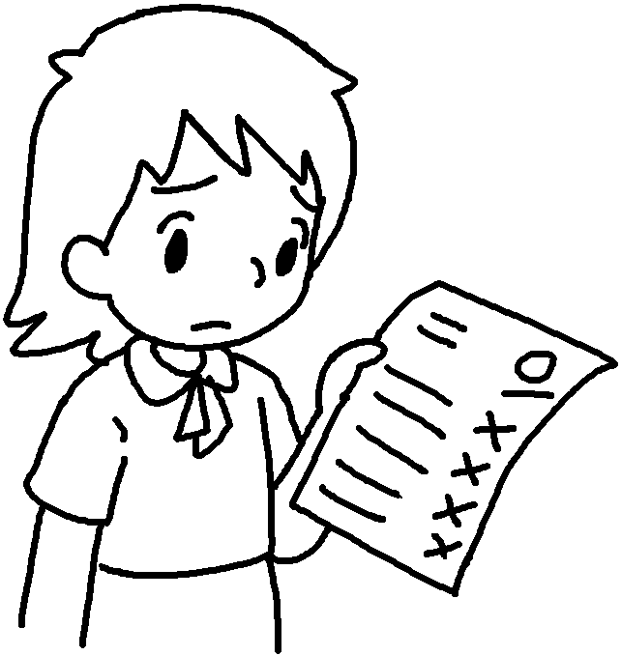 | 8 | 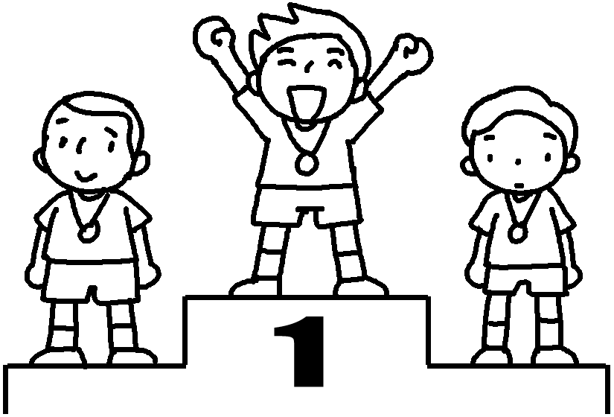 | 7  8  9 | with  of  about
9 | 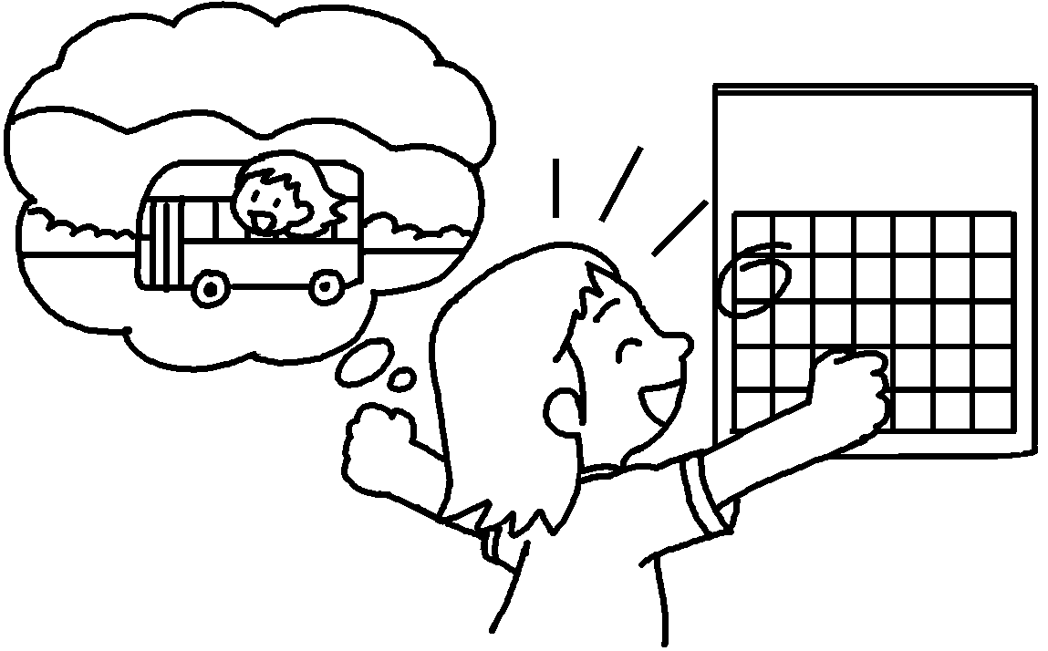 |  | school  picnic | 7  8  9 | with  of  about
ashamedpleasedupset

10 |  | 11 | 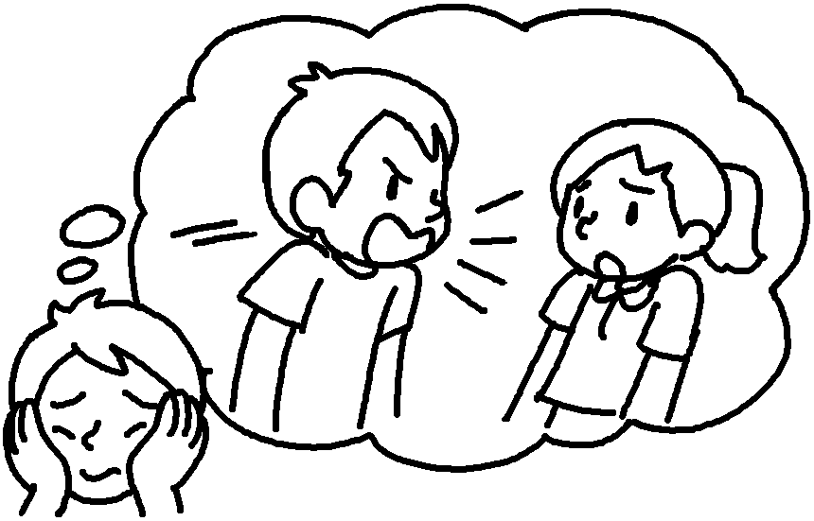 | 10  11  12 | with  of  about
12 | 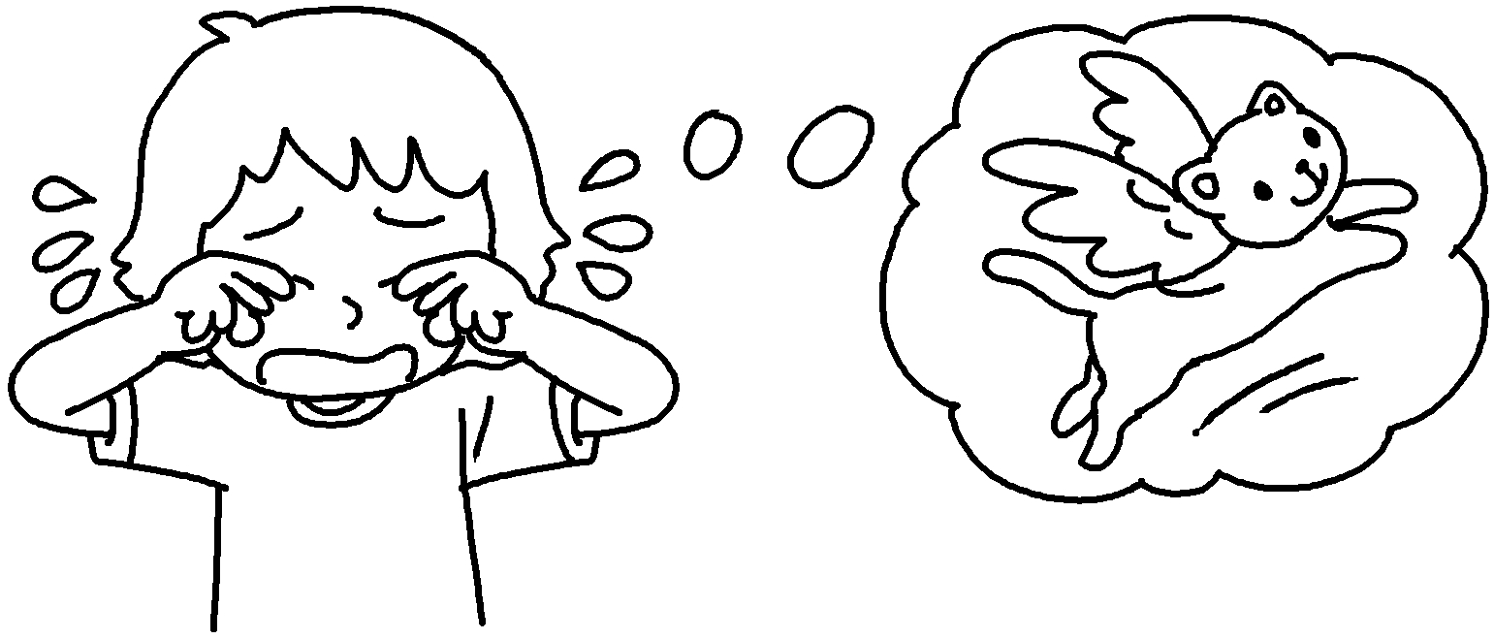 |  |  | 10  11  12 | with  of  about


Book 6B Chapter 6 Graded Worksheets
Worksheet 1⬇
- terrible
- meaningful
- joyful
- painful
- awful
- enjoyable
- disappointed
- proud
- excited
- pleased
- ashamed
- upset

