Choose and write.
meaningful terrible

1 | 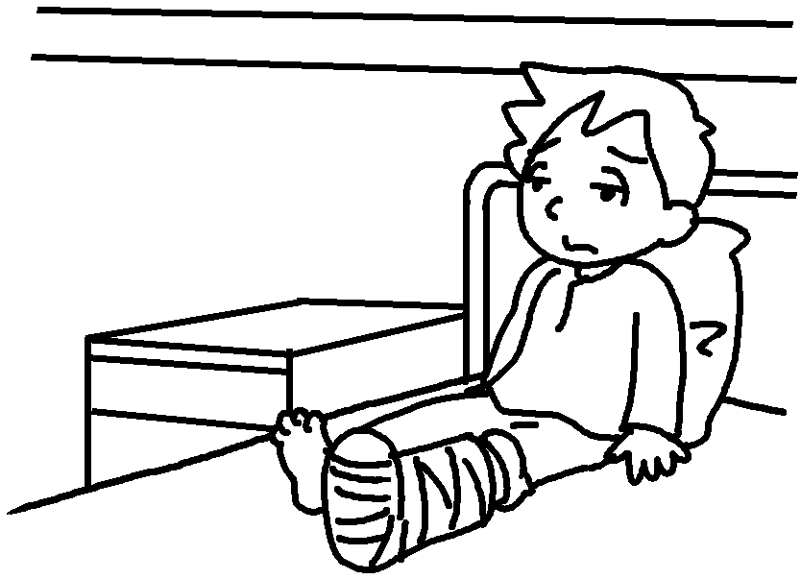 | 2 | 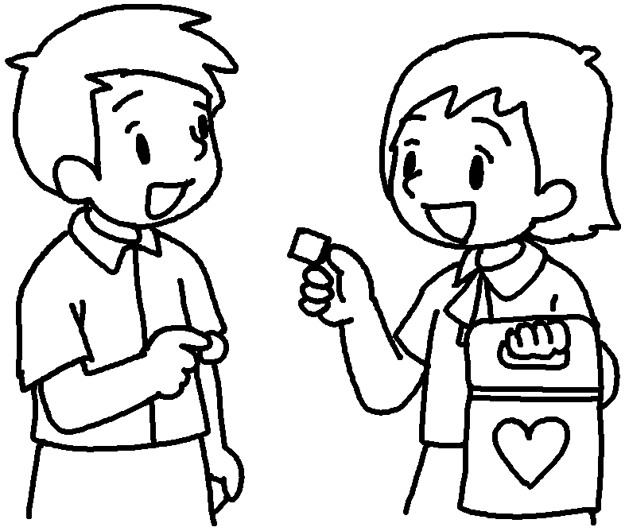 | 1  2
joyful painful

3 | 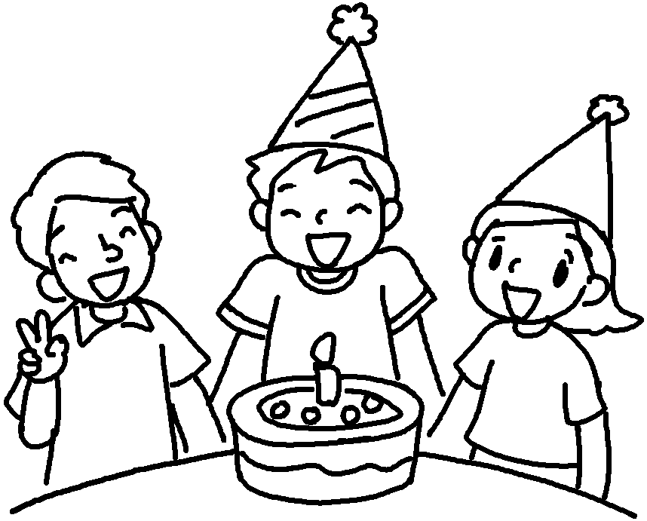 | 4 | 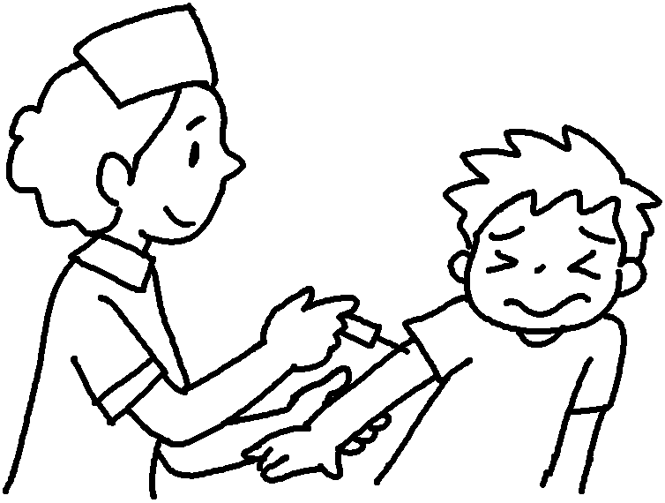 | 3  4
enjoyable awful
proud excited disappointed

5 | 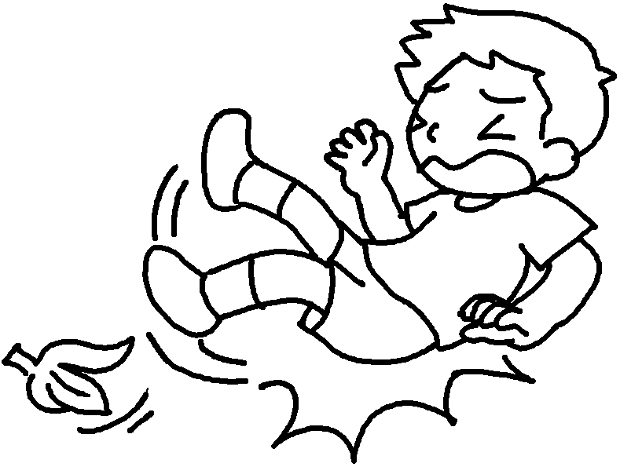 | 6 | 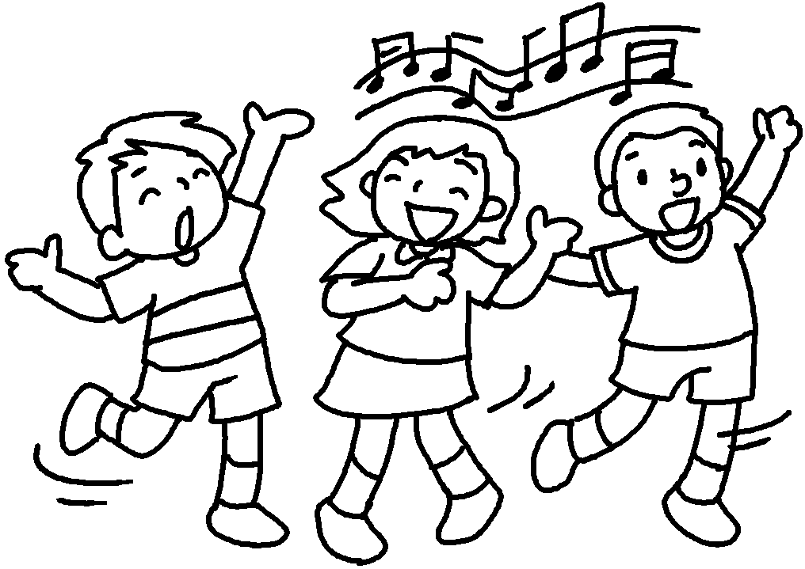 | 5  6

7 | 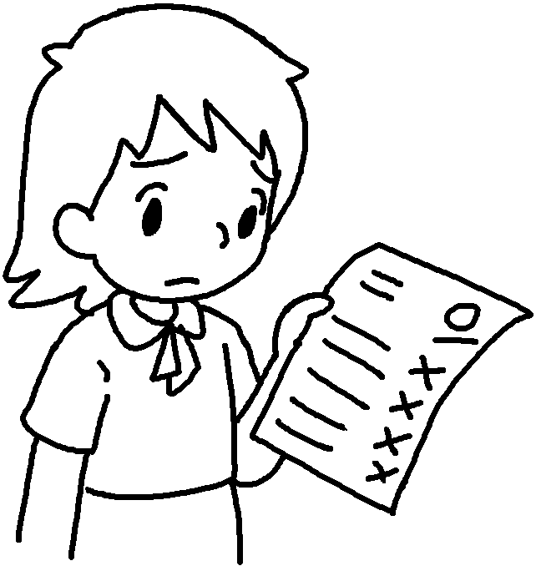 | 8 | 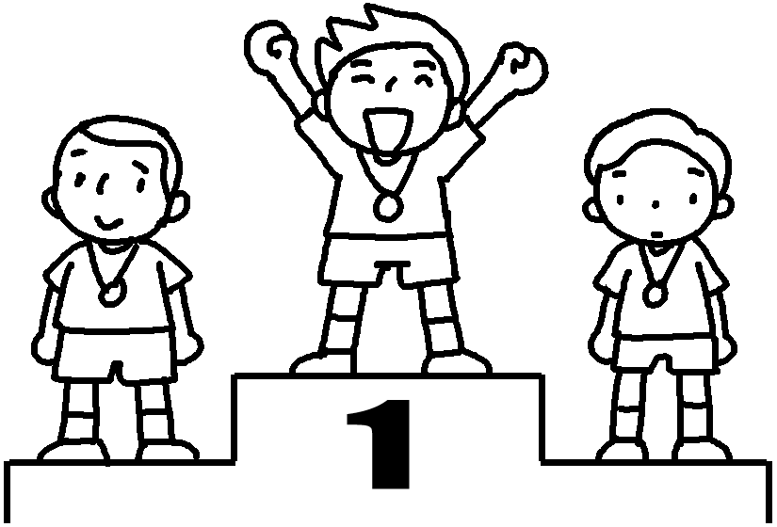 | 7  8  9 | with  of  about
9 | 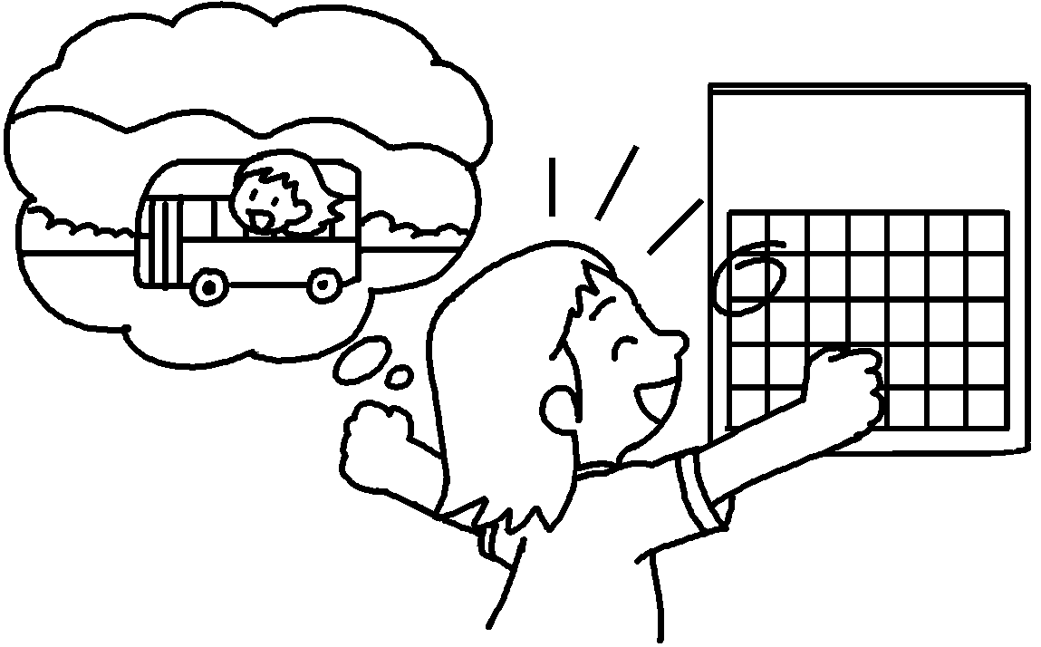 |  | school  picnic | 7  8  9 | with  of  about
ashamedpleasedupset

10 |  | 11 | 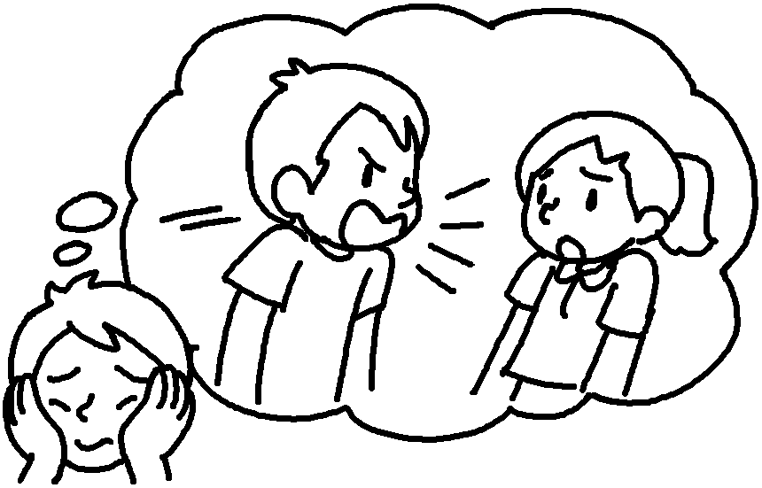 | 10  11  12 | with  of  about
12 | 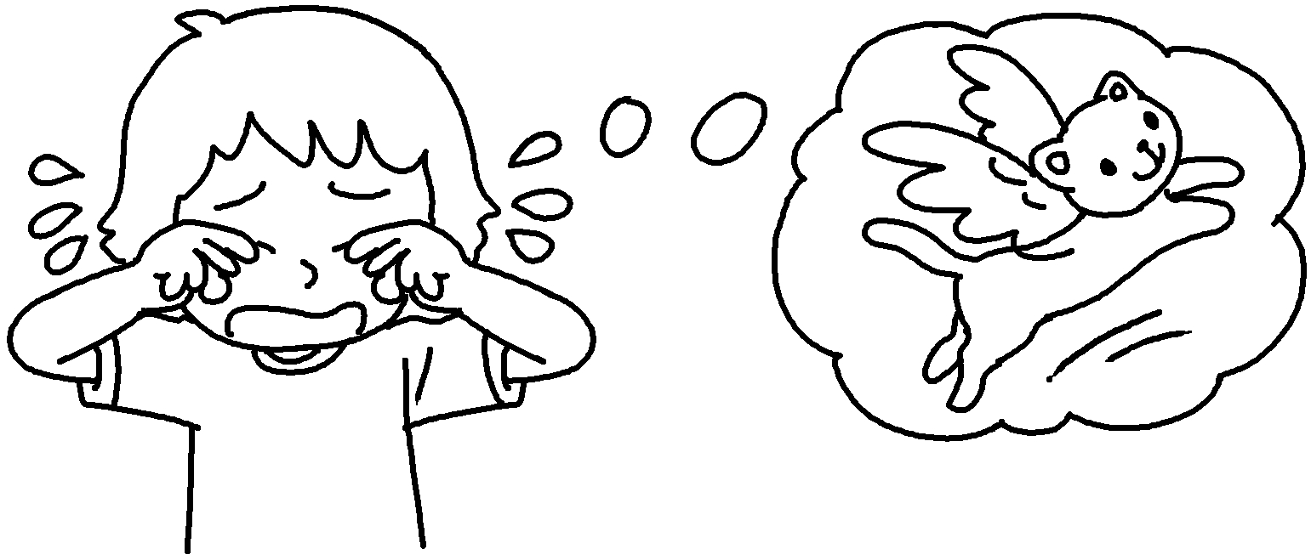 |  |  | 10  11  12 | with  of  about


Book 6B Chapter 6 Graded Worksheets
Worksheet 1⬇⬇
- t e r r i b l e
- m e a n i n g f u l
- j o y f u l
- p a i n f u l
- a w f u l
- e n j o y a b l e
- d i s a p p o i n t e d
- p r o u d
- e x c i t e d
- p l e a s e d
- a s h a m e d
12 u p s e t

