Look at the pictures and write the correct adjectives.

1 | 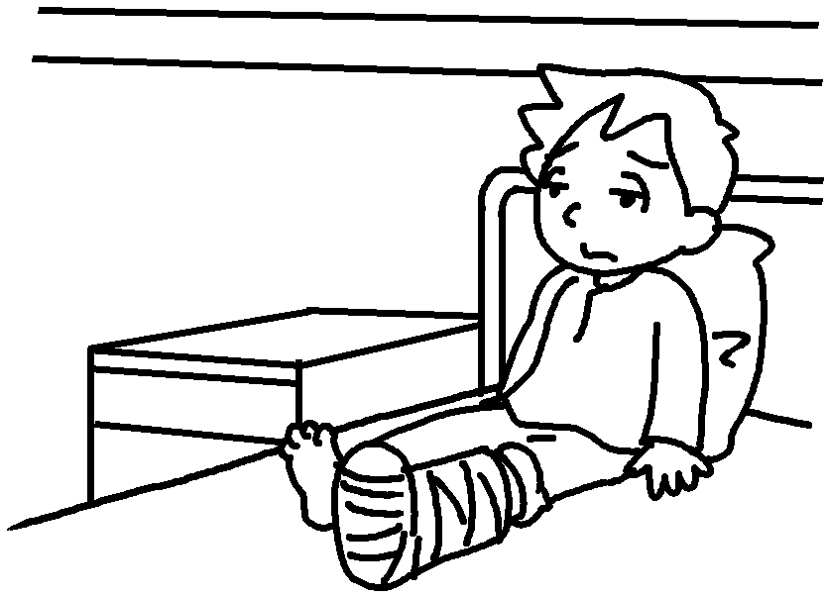 | 2 | 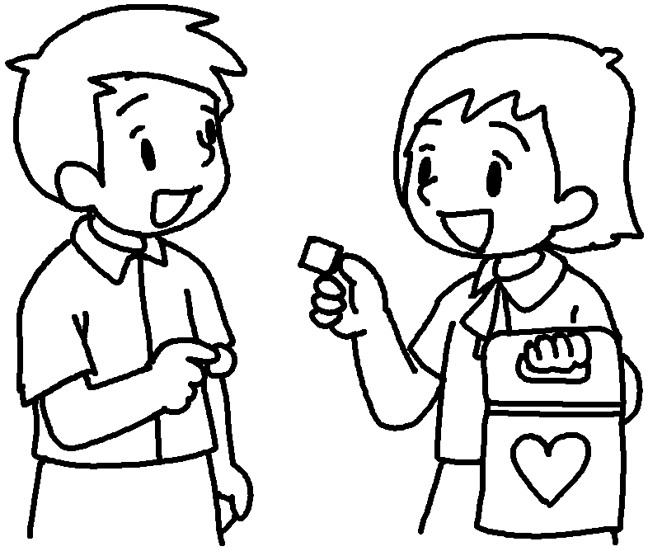 | 1  2 | t  m

3 | 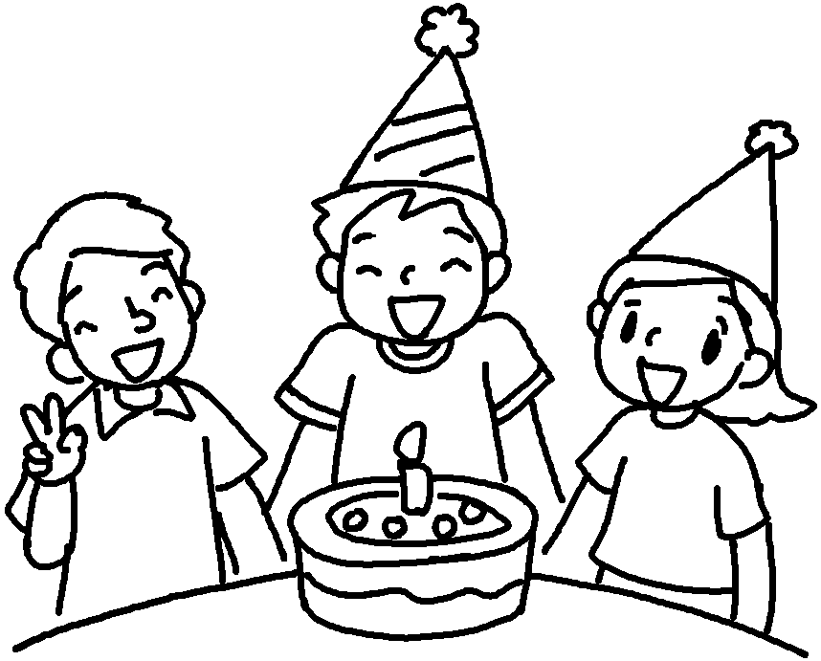 | 4 | 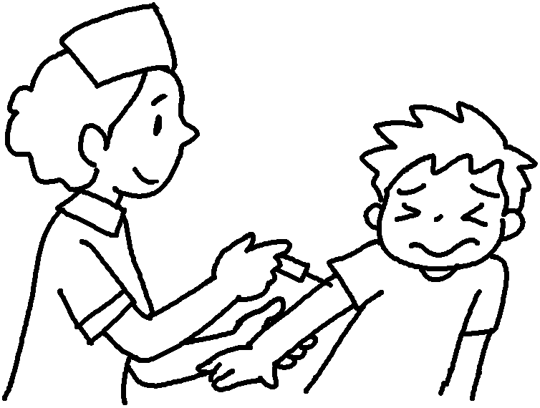 | 3  4 | j  p

5 | 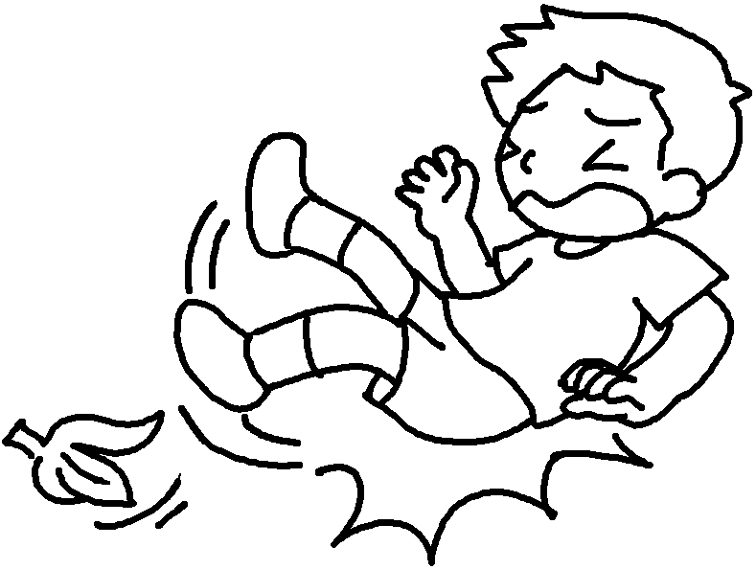 | 6 | 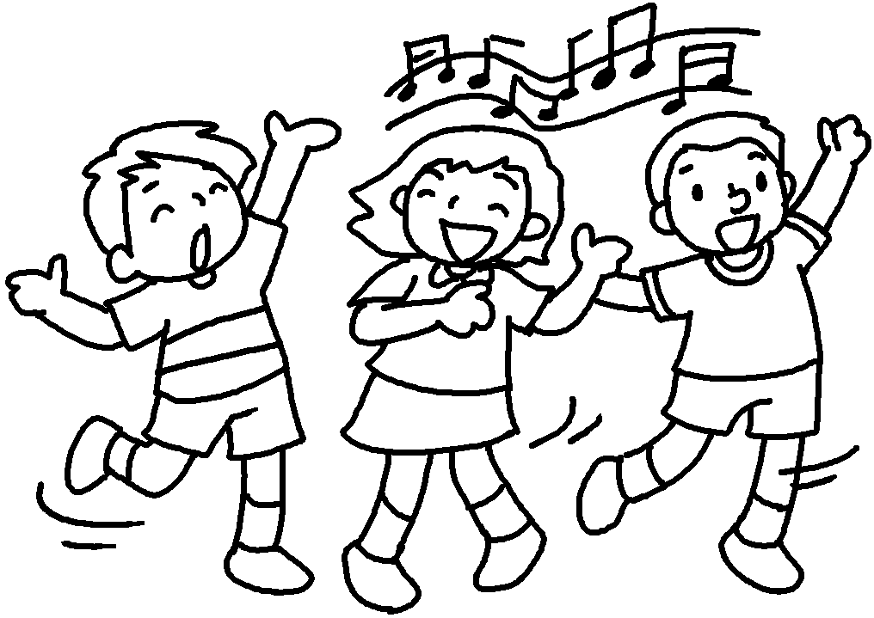 | 5  6 | a  e

7 | 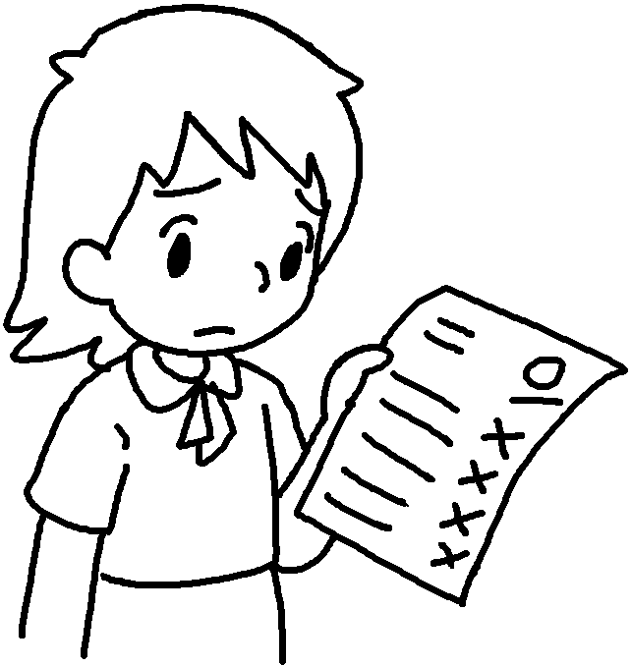 | 8 | 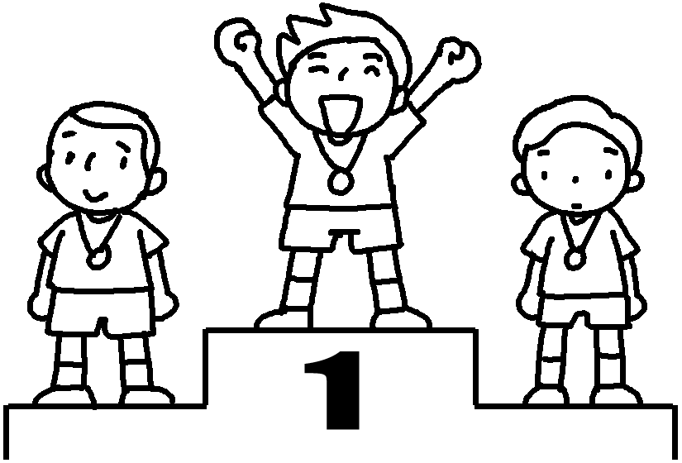 | 7  8  9 | d with  p of  e about
9 | 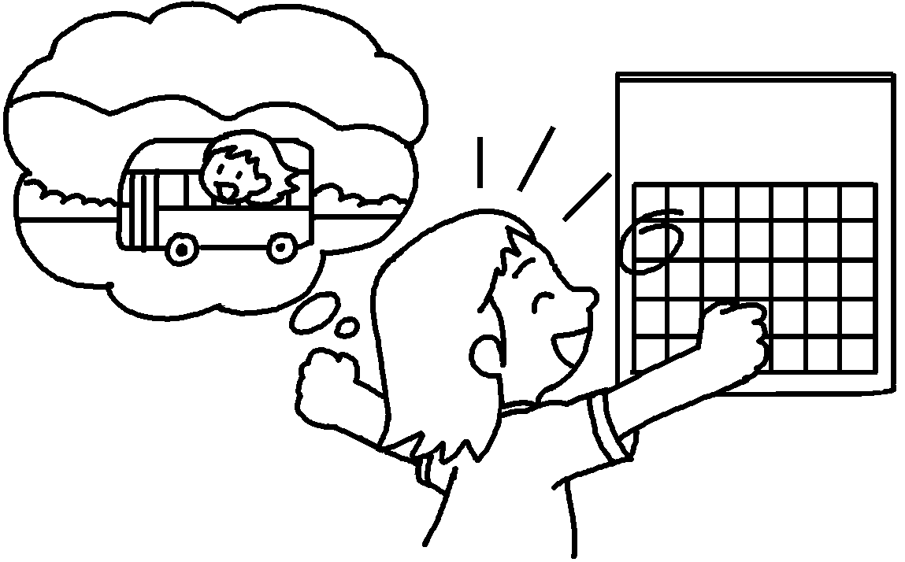 |  | school  picnic | 7  8  9 | d with  p of  e about

10 | 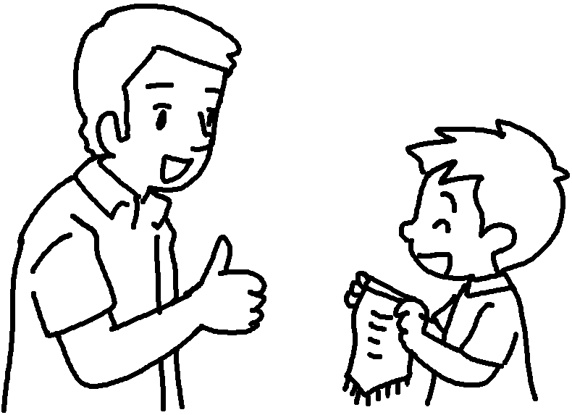 | 11 | 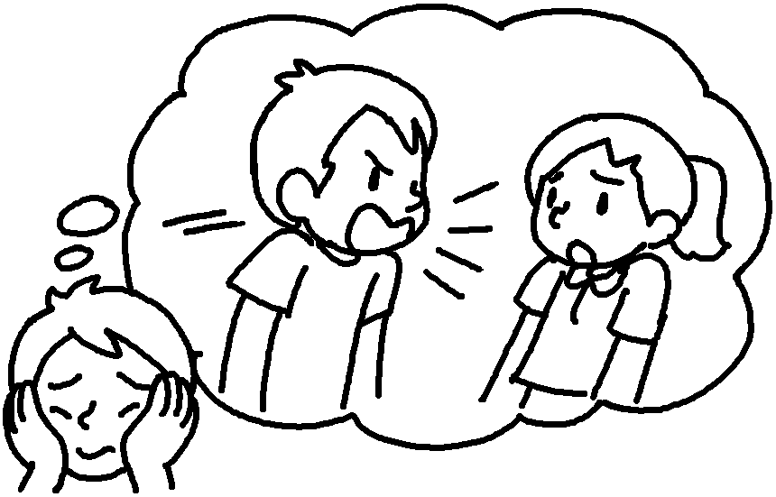 | 10  11  12 | p with  a of  u about
12 | 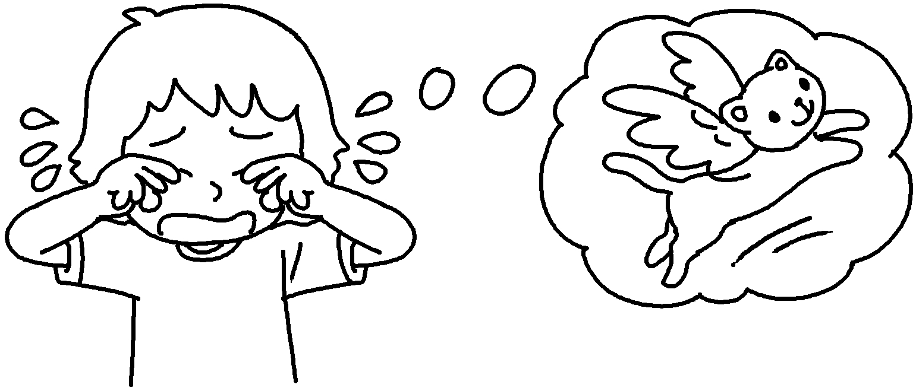 |  |  | 10  11  12 | p with  a of  u about

Book 6B Chapter 6 Graded Worksheets
Worksheet 1⬇⬇⬇
- terrible
- meaningful
- joyful
- painful
- awful
- enjoyable
- disappointed
- proud
- excited
- pleased
- ashamed
- upset

