Choose and write.
angry with excited about ashamed of
scared of pleased withworried about

1 | 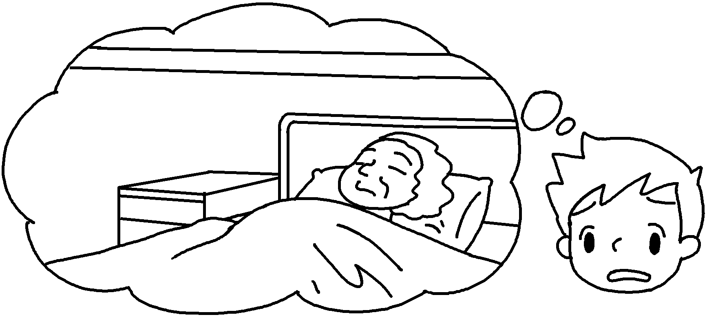 | My grandma was sick. I was  her.
2 | 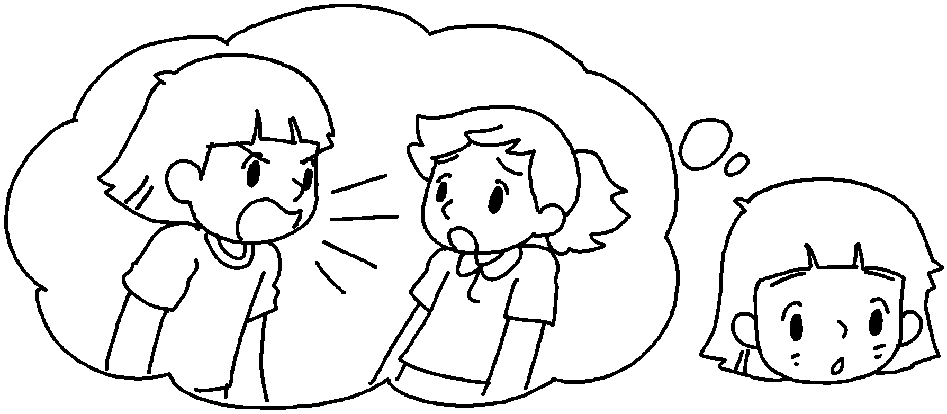 | I shouted at my best friend Betty. I was myself.
3 | 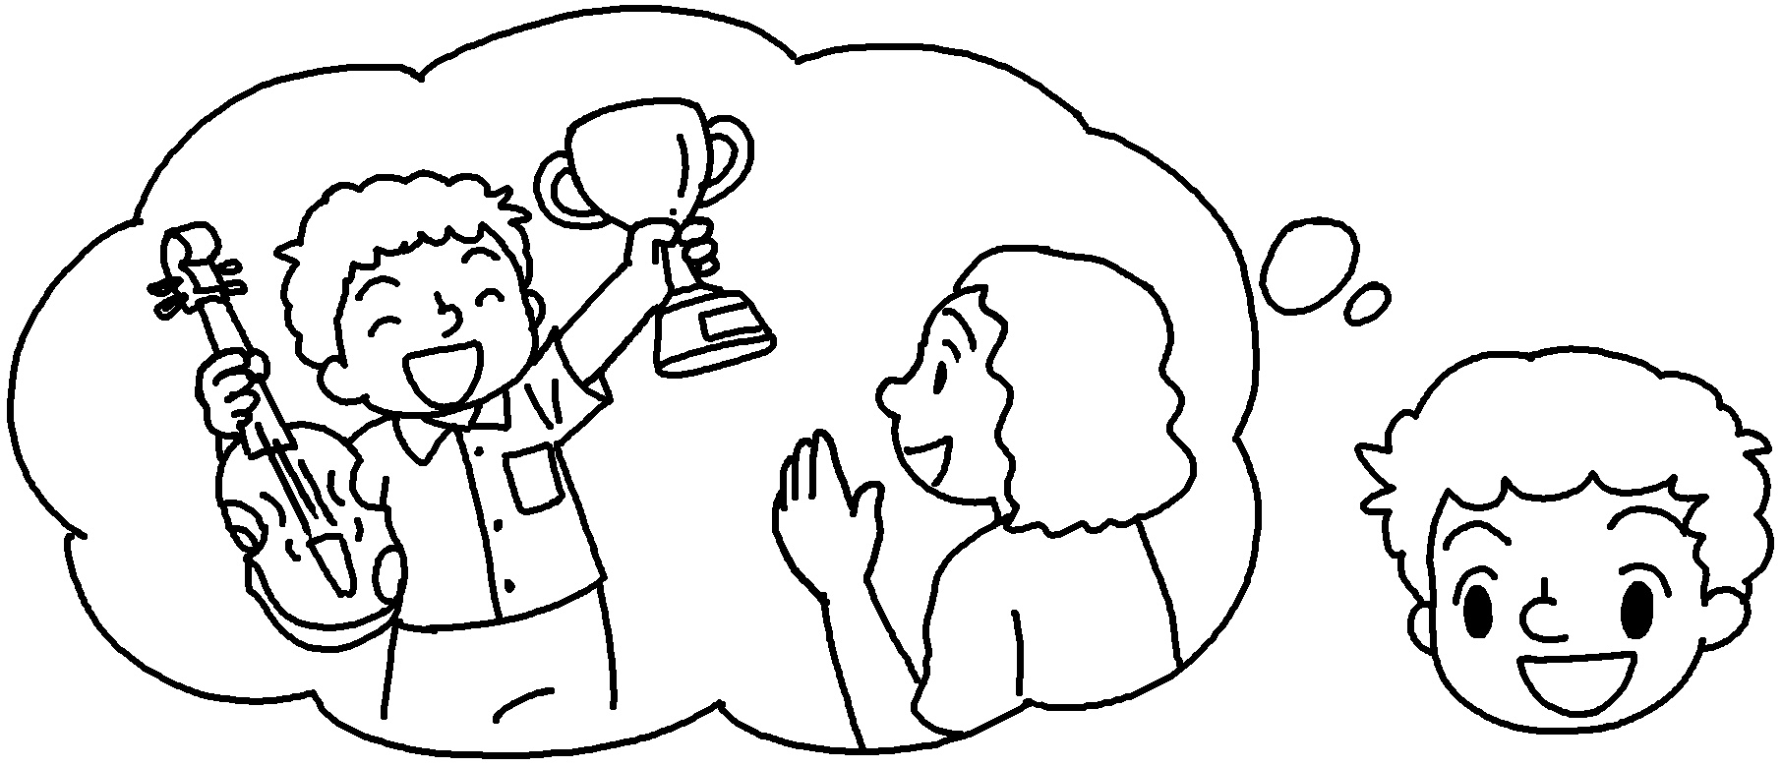 | I won the violin competition. My mum was me.
4 | 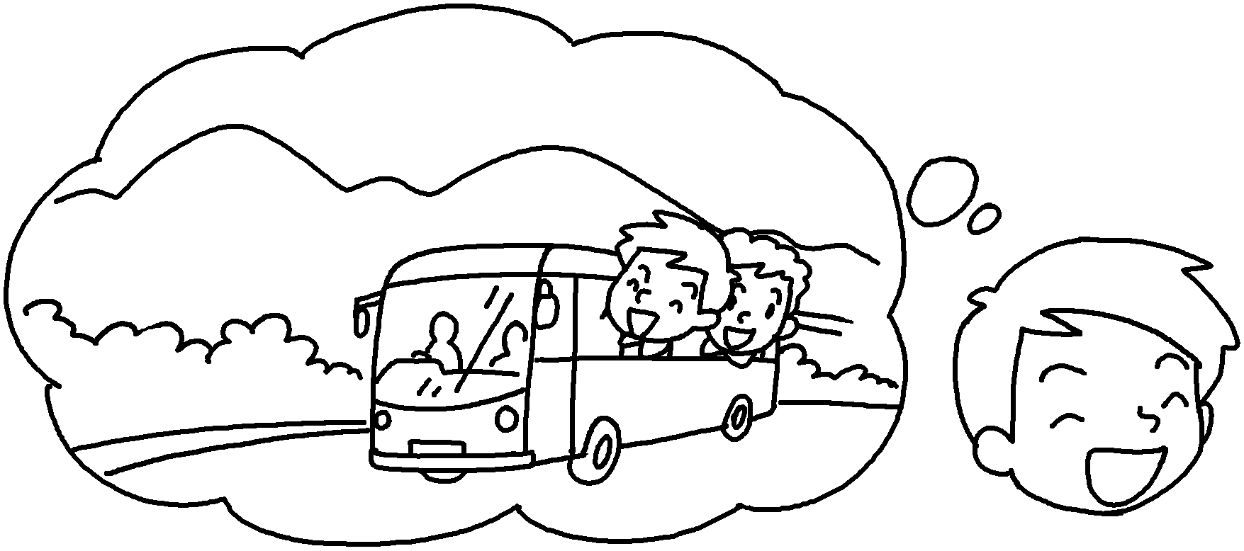 | Tomorrow is the school picnic. I’m  it.
5 | 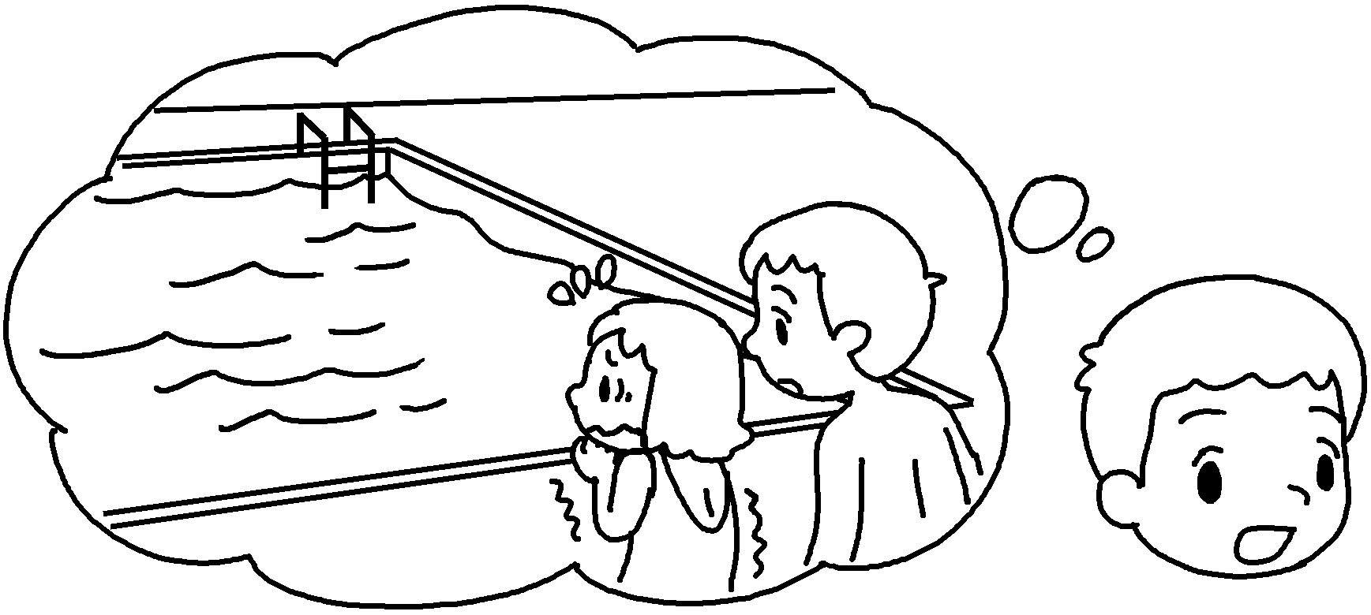 | My sister can’t swim. She’s  water.
6 | 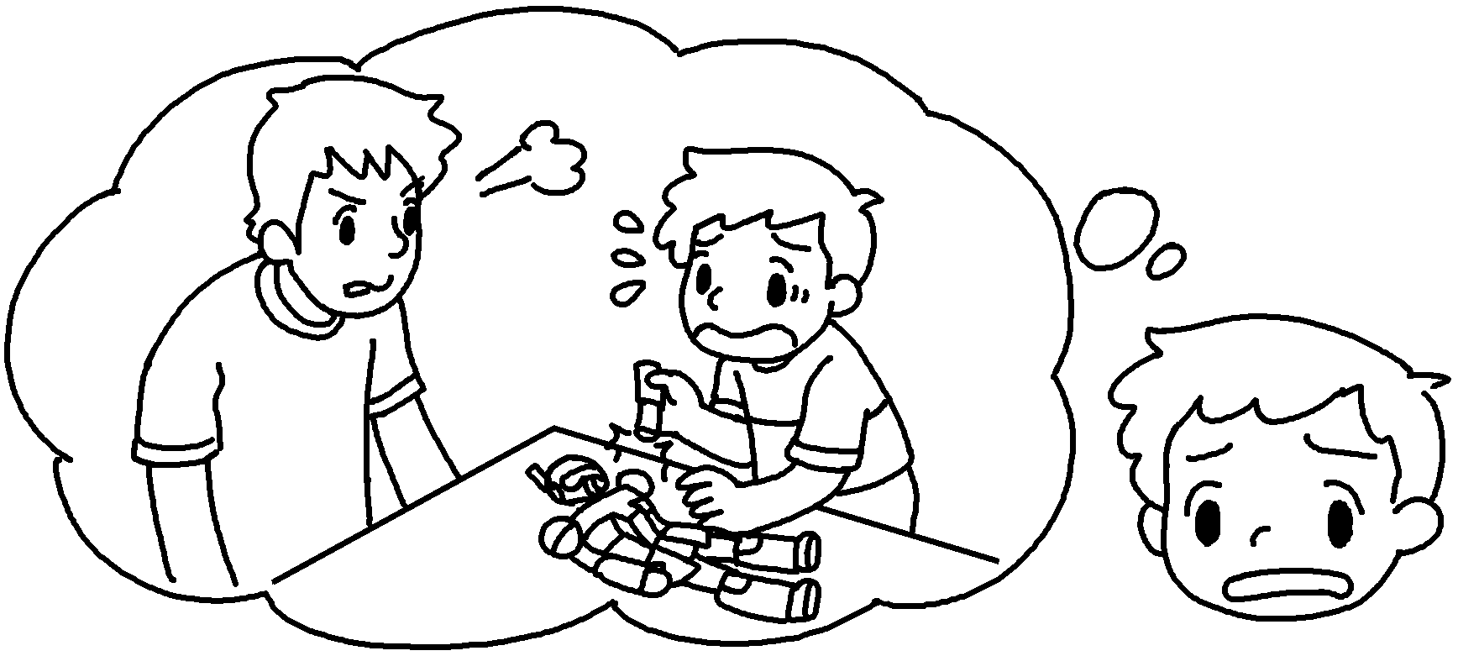 | I broke my brother’s robot. He was  me.


Book 6B Chapter 6 Graded Worksheets
Worksheet 2⬇
- worried about
- ashamed of
- pleased with
- excited about
- scared of
- angry with

