Finish the sentences. Use each adjective once only.
…ing
was
joyful
painful
meaningful
enjoyable

1 | ( fall ) over was a terrible experience. | 
2 | ( sleep ) in a tent was  an awful experience. | 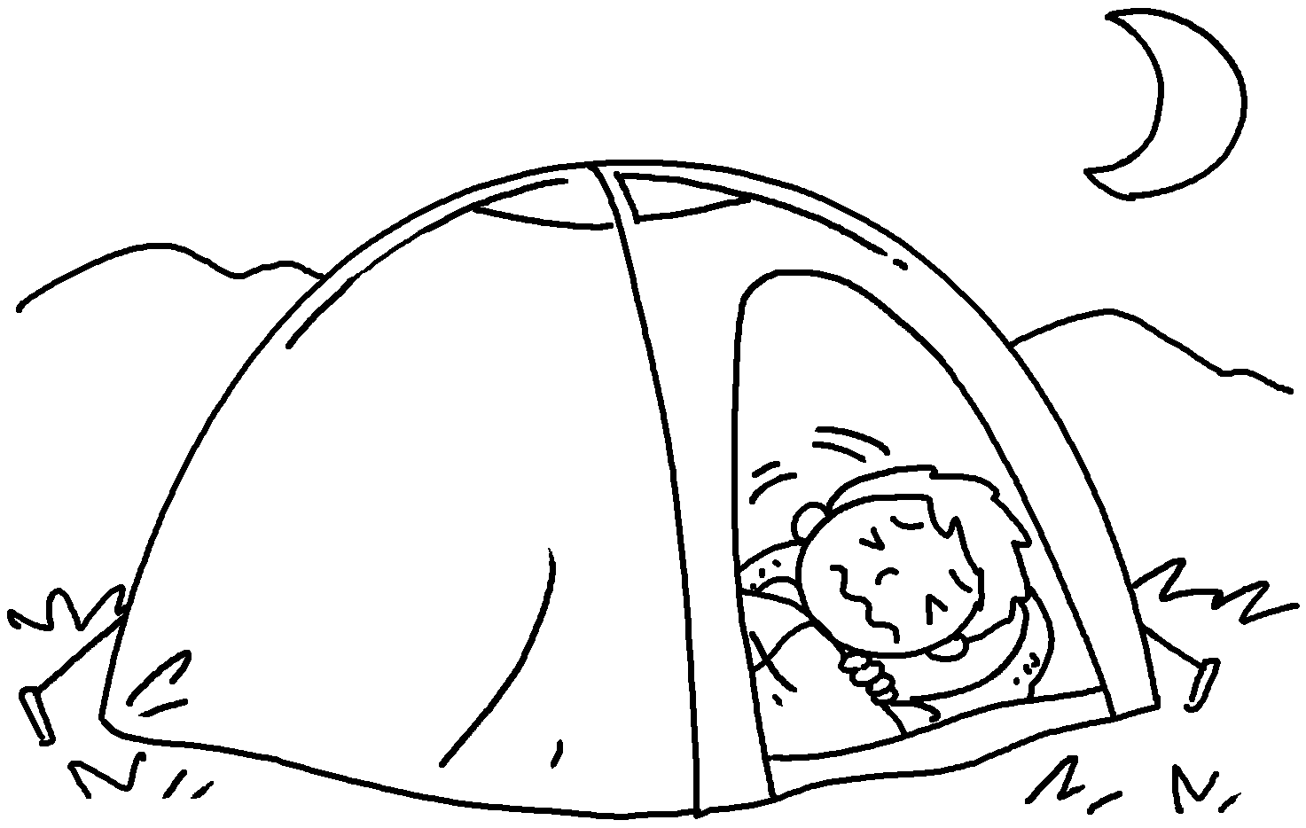
3 | ( dance ) on stage was  a experience. | 
4 | ( visit ) an old people’s home a experience. | 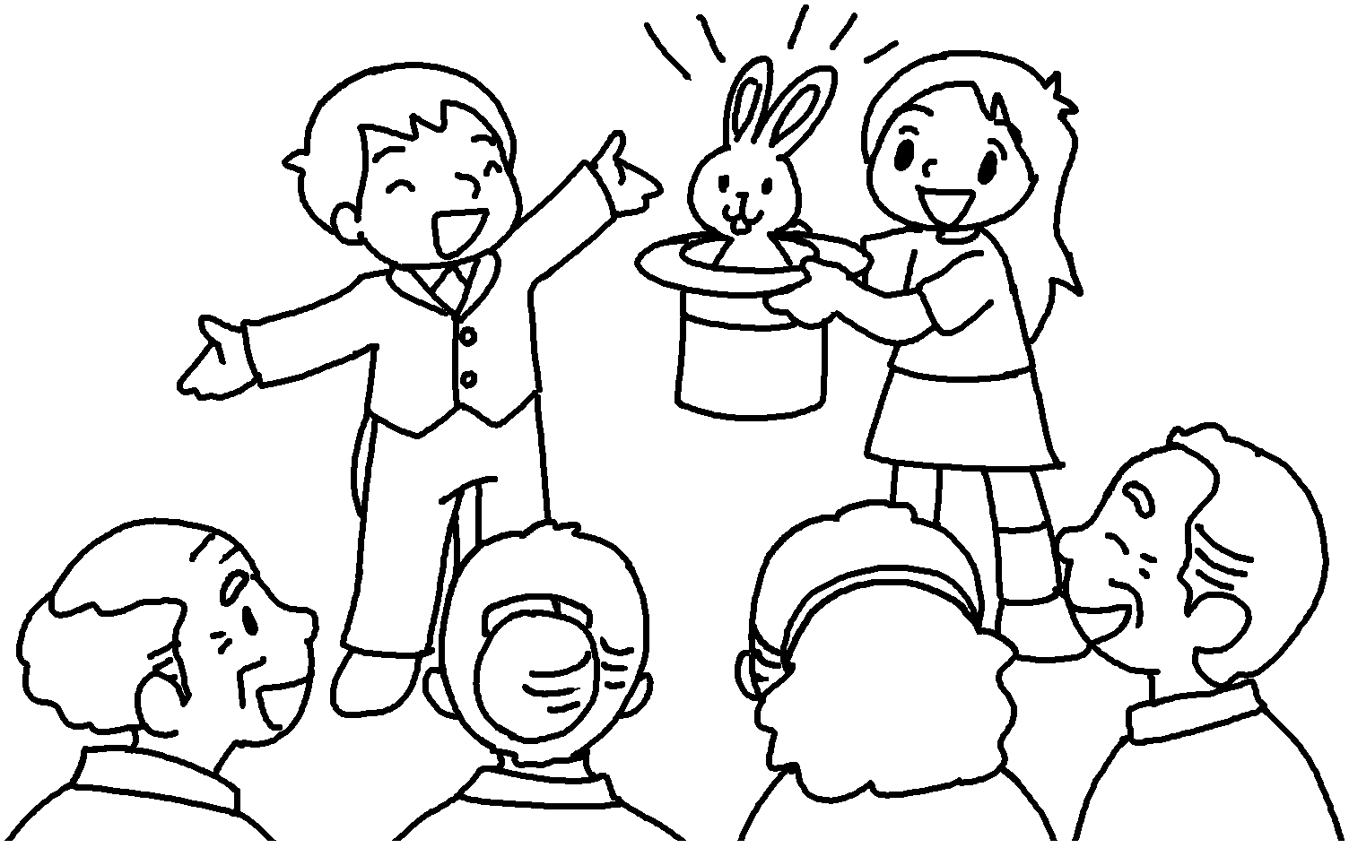
5 | ( break ) my leg  a experience. | 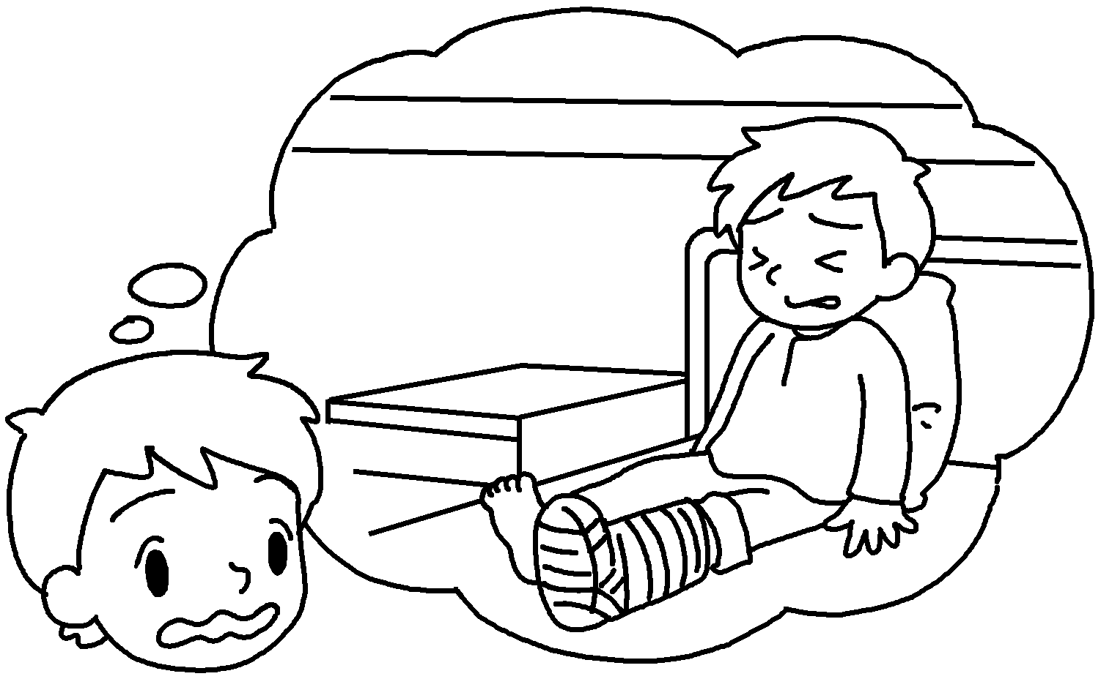
6 | ( meet ) my pen friend from England an  experience. | 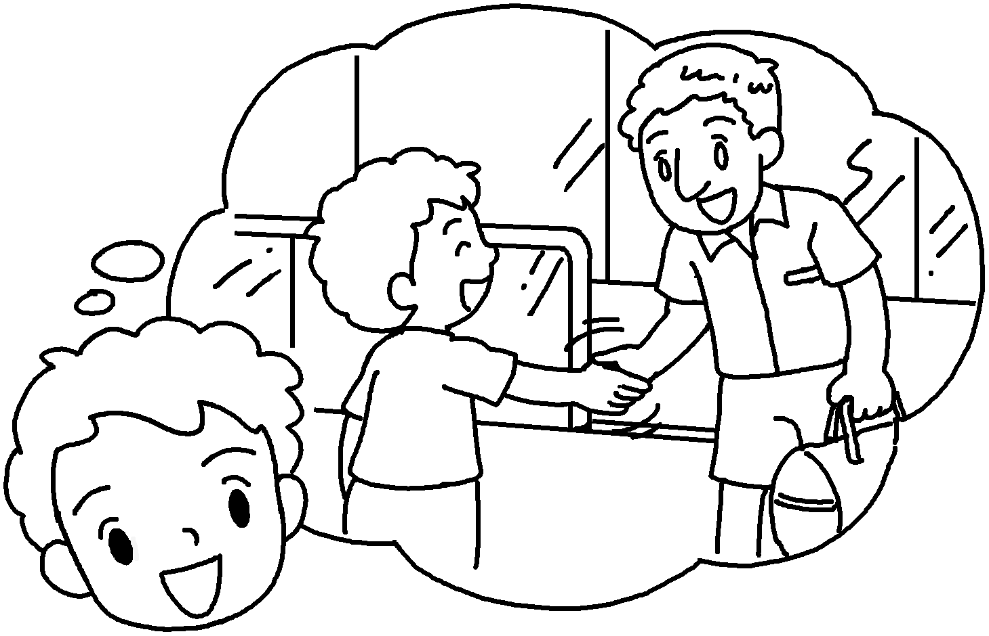


Book 6B Chapter 6 Graded Worksheets
Worksheet 3⬇
- Falling
- Sleeping
- Dancing joyful
- Visiting was meaningful
- Breaking was painful
- Meeting was enjoyable

