Finish the sentences using the correct form of the verbs and the adjectives. Use each word once only.

be dance break meet sleep visit

meaningful painful joyful awful terrible enjoyable

1 | over was a experience.  Falling | 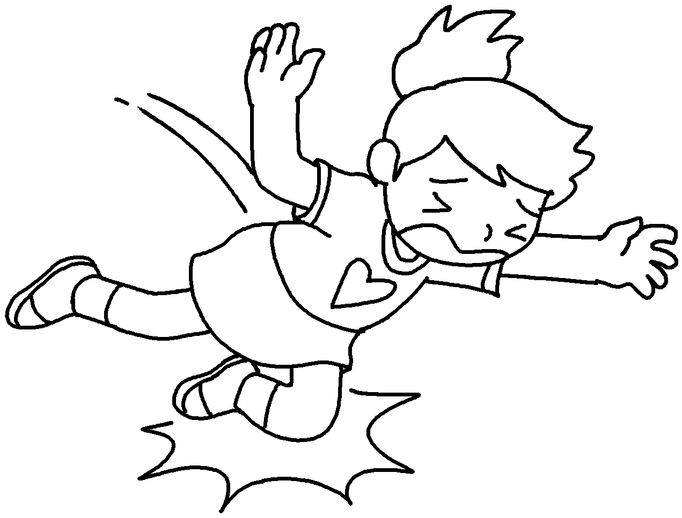
2 | in a tent was an  experience. | 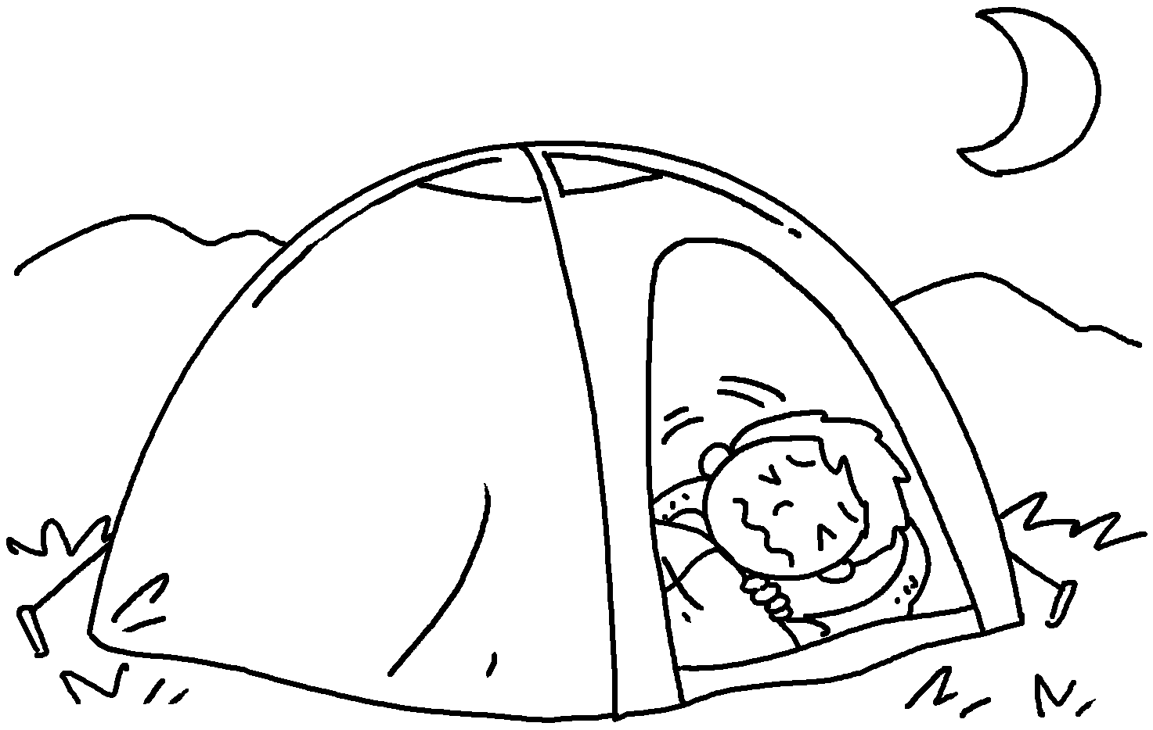
3 | on stage was a  experience. | 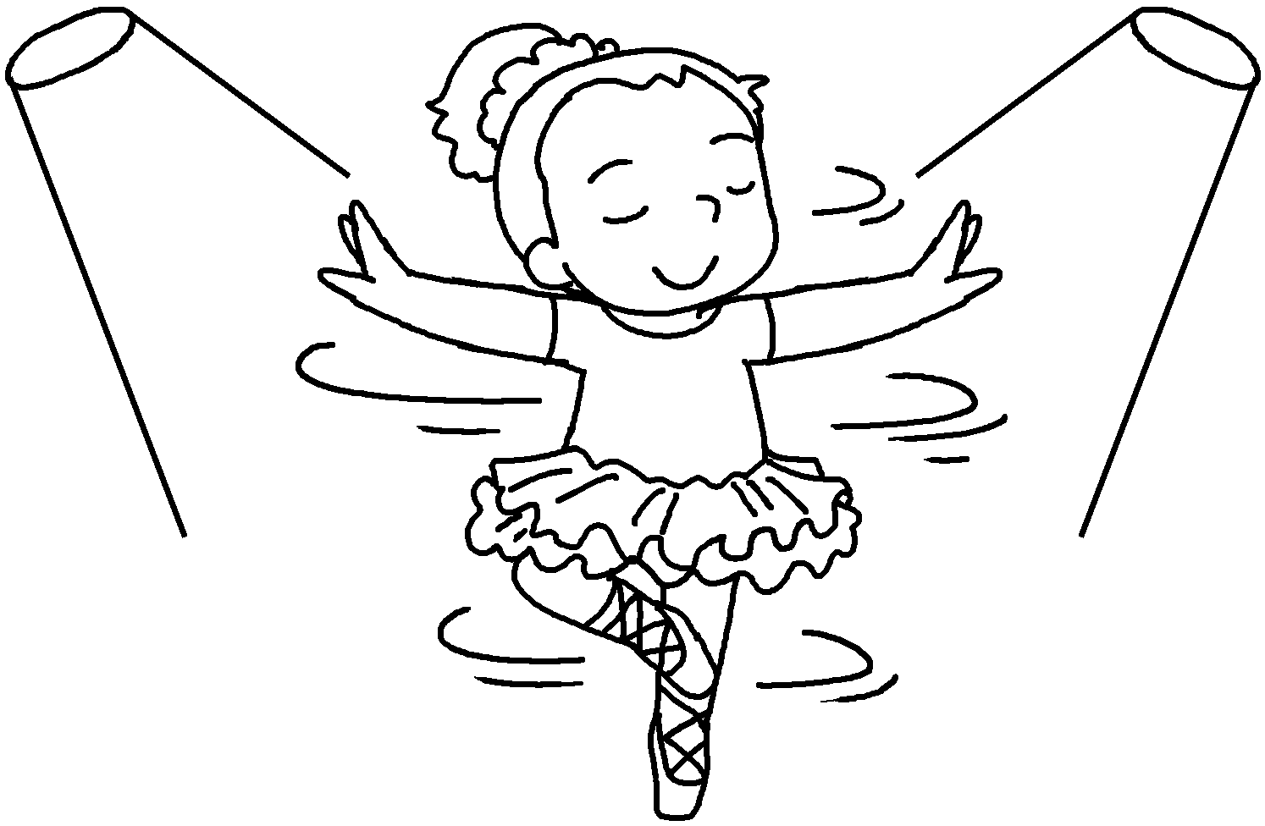
4 | an old people’s home  a experience. | 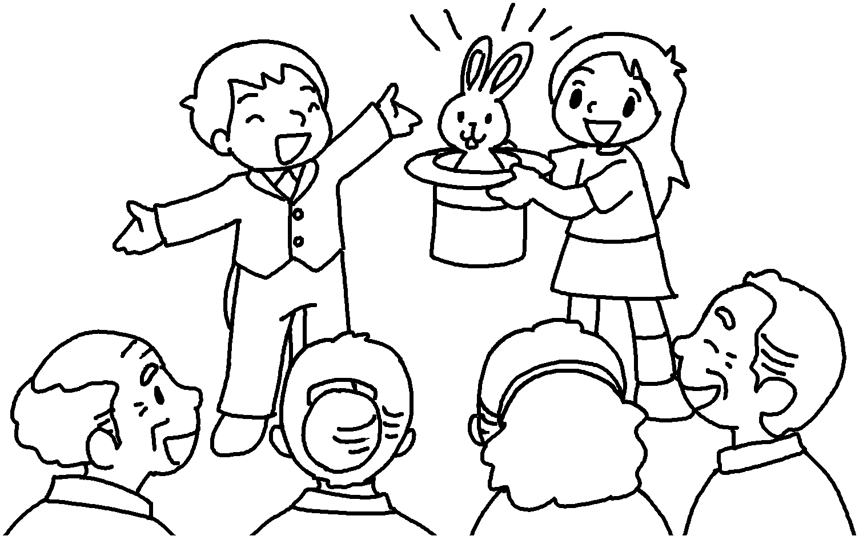
5 | my leg  a experience. | 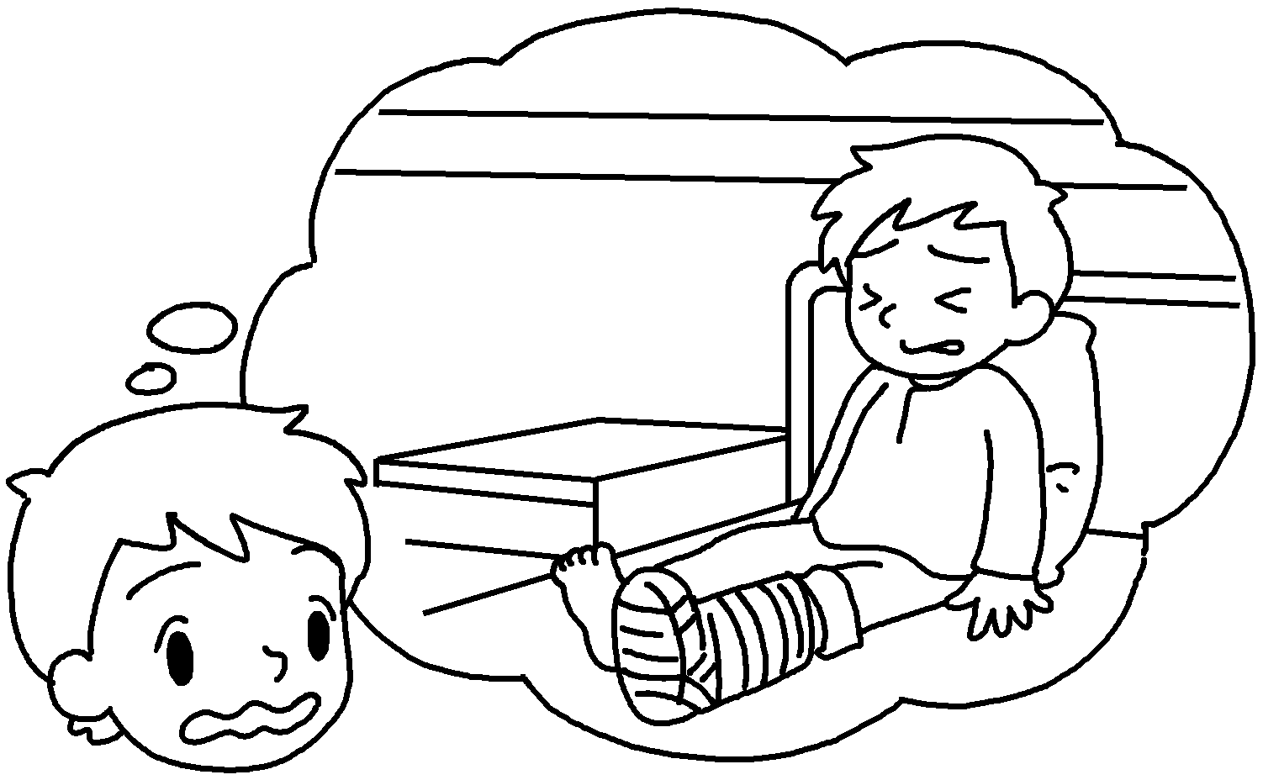
6 | my pen friend from England  an experience. | 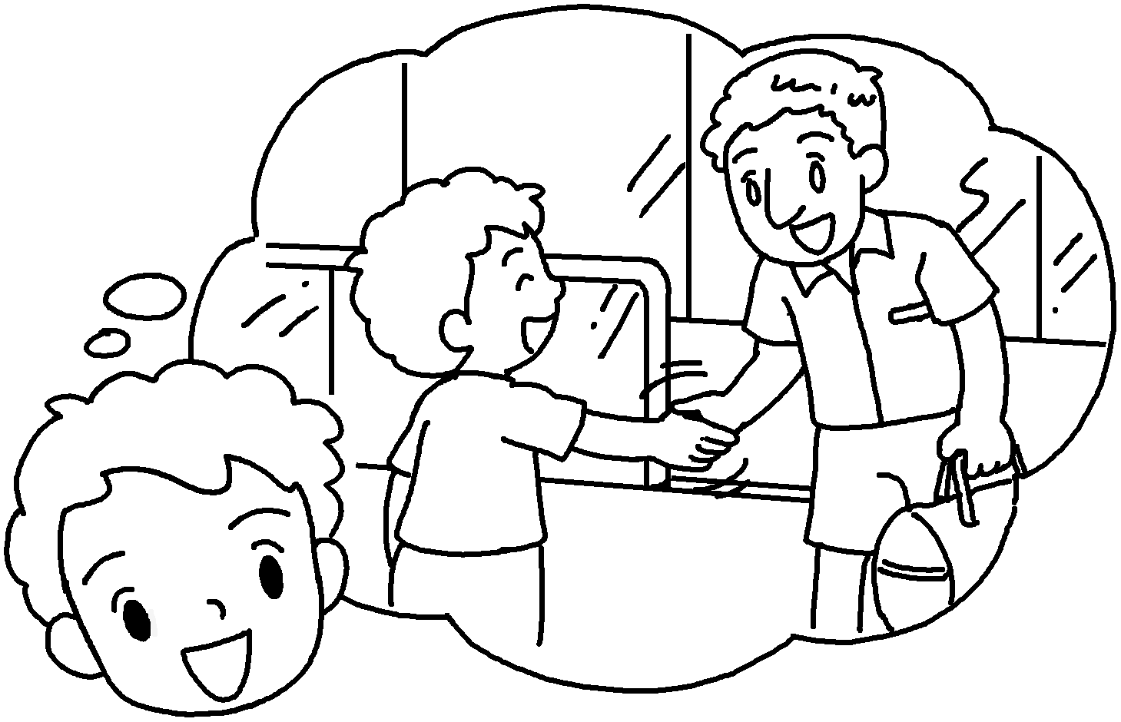


Book 6B Chapter 6 Graded Worksheets
Worksheet 3⬇⬇
- terrible
- Sleeping awful
- Dancing joyful
- Visiting was meaningful
- Breaking was painful
- Meeting was enjoyable

