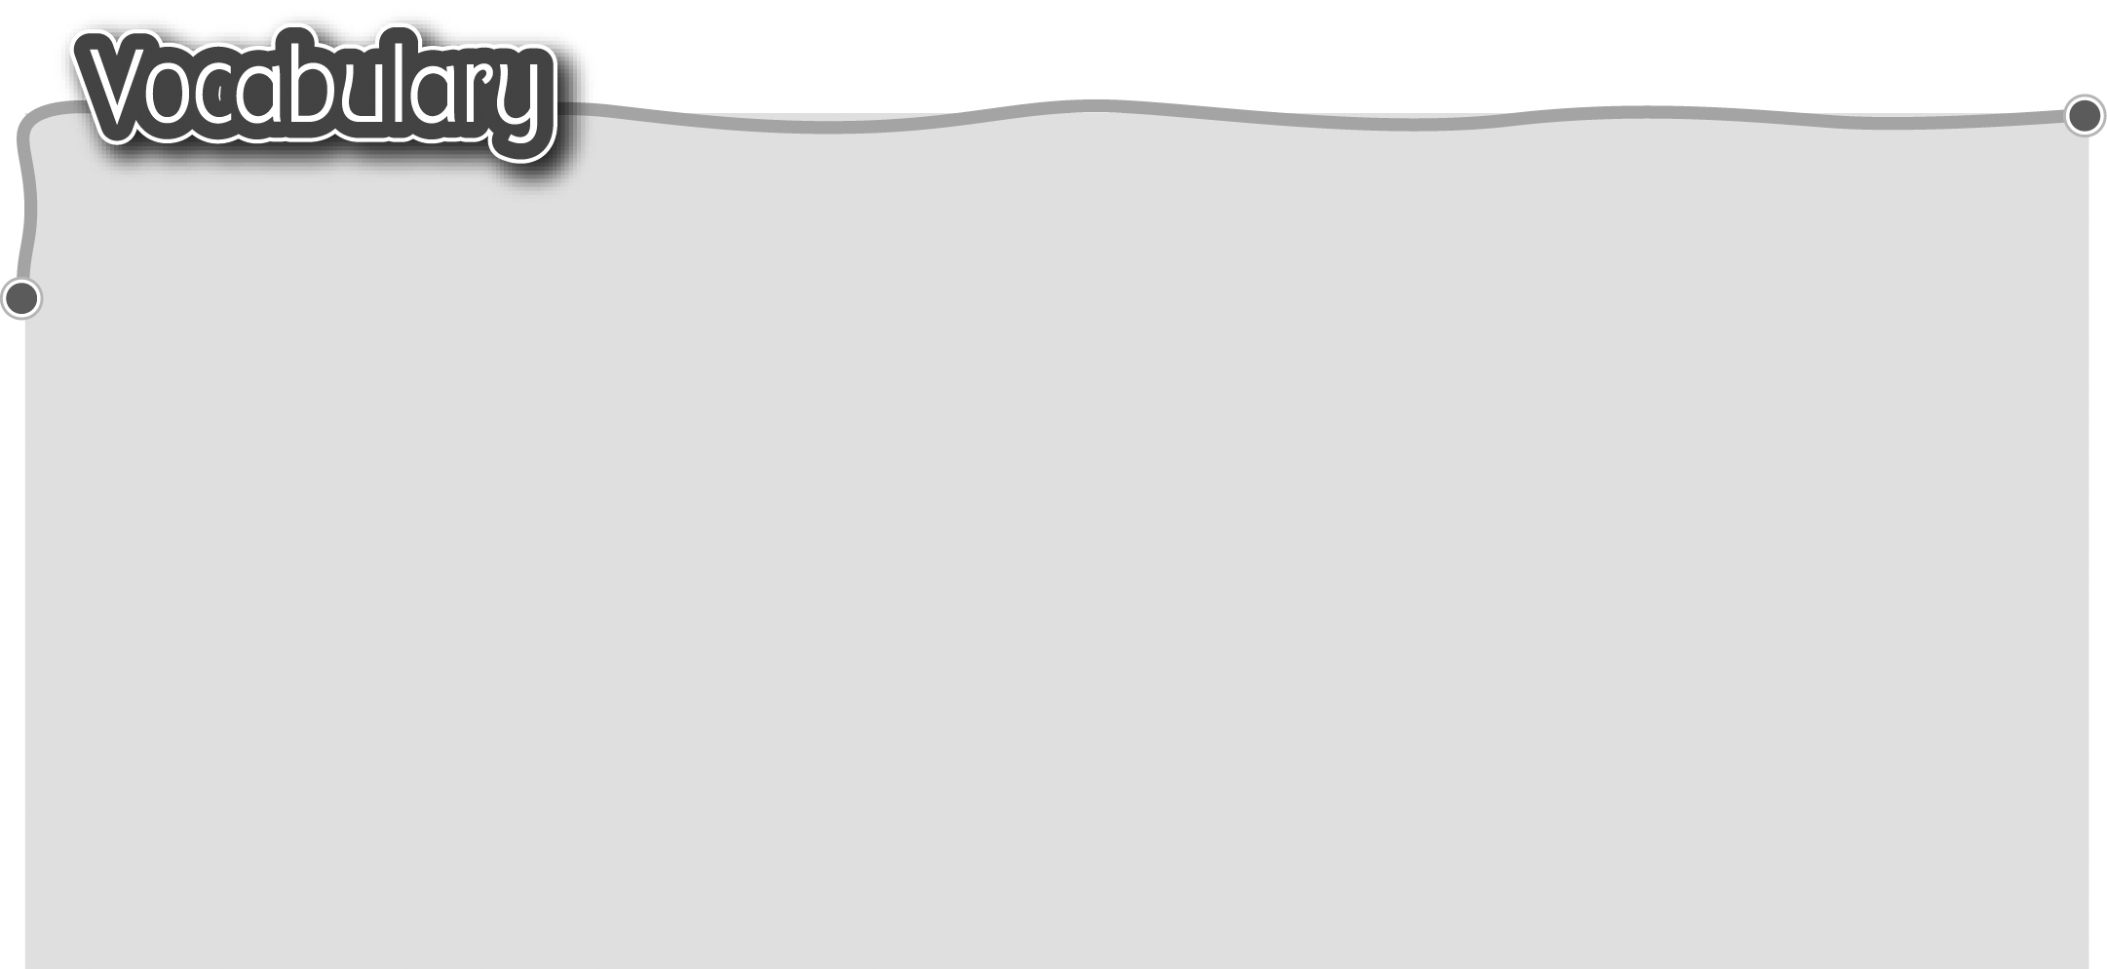
1 meaningful 有意義 8 ashamed of 因……感到羞恥
2 joyful 歡樂 9 disappointed with 對……失望
3 painful 痛苦 10 pleased with 對……感到滿意
4 awful / terrible 糟糕/可怕 11 angry with 因……生氣
5 enjoyable 愉快 12 excited about 因……興奮
6 scared of 害怕 13 worried about 擔心
7 proud of 因……感到自豪 14 upset about 因……不開心
The words marked with * have different meanings in other
contexts. You can look up those meanings in a dictionary.
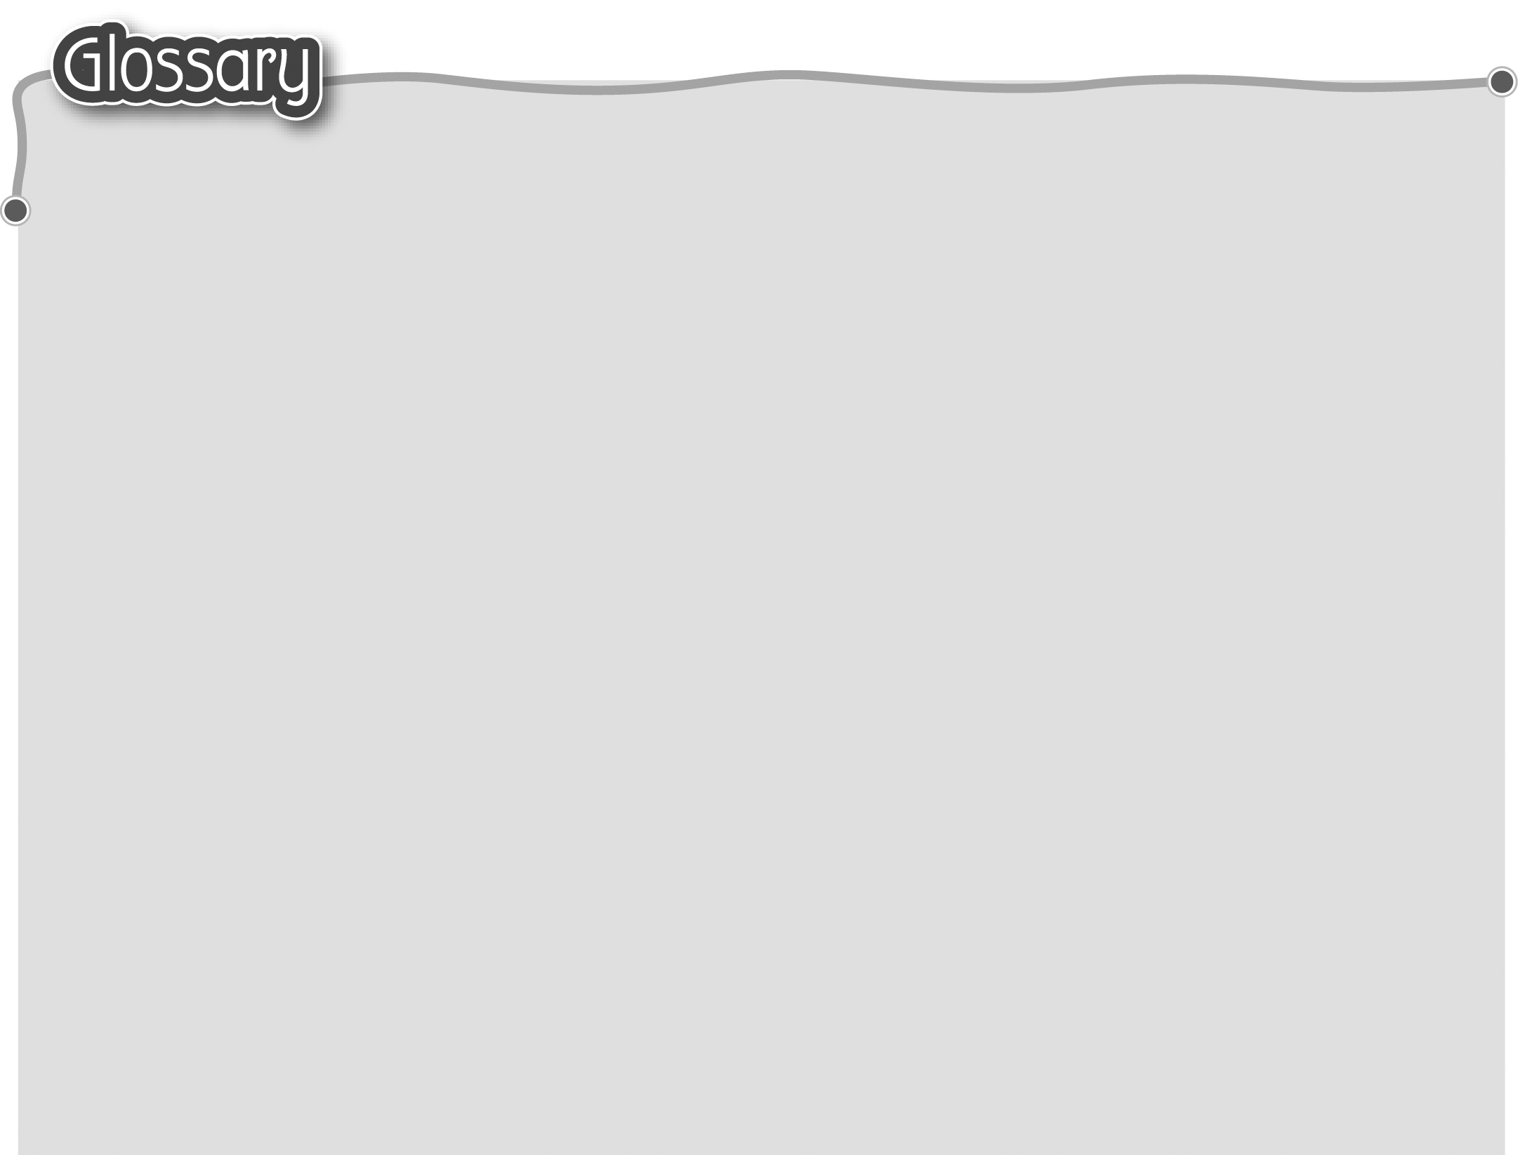
1 memorable (p.46) 難忘 14 hug (p.47, p.51) 擁抱（名詞/動詞）
2 experience* (p.46) 經驗（名詞） 15 cuddling (cuddle) (p.47)
3 smelly (p.46) 有臭味 擁抱（動詞）
4 strange* (p.46) 陌生 16 past* (p.47) 過去（形容詞）
5 horrible (p.46) 恐怖 17 behaviour (p.47) 行為舉止
6 wrinkled (p.46) 有皺紋 18 tightly (p.47) 緊緊地
7 plum (p.46) 梅子 19 result* (p.49) 結果/成績（名詞）
8 held (hold)* (p.47) 抱住/握住 20 lost (lose)* (p.50) 遺失
9 pull a silly face (p.47) 扮鬼臉 21 trip (p.51) 旅程
10 toe (p.47) 腳趾 22 abroad (p.51) 到國外
11 peep* (p.47) 偷看（動詞） 23 went (go) camping (p.51) 露營
12 toothless (p.47) 沒有牙 24 insect (p.51) 昆蟲
13 grin (p.47) 露齒的笑

