- Memorable experiences
Danny wrote about his most memorable experience for an essay competition. What do you think he wrote about? Read and find out.



My most memorable experience
By Danny Ho
When I was seven, Mum and Dad said they had something to tell me. ‘Am I getting a new electronic game?’
‘No,’ Mum smiled. ‘It’s better than an electronic game.’
‘A computer?’ I asked.
‘No,’ said Dad. ‘You’re going to have a baby brother.’
I was so disappointed. I didn’t want a boring, smelly baby. It was awful news.
The night before my brother was born, I stayed at Grandma’s house. Sleeping in a strange bed was horrible and I was scared of Grandma’s old cat. I was worried about meeting the baby. Most of all, I didn’t want to share my mum and dad.

The next day Grandma took me to the hospital. Dad was very proud of Mum – and of Ken, my brother. He was red and wrinkled like a dried plum.

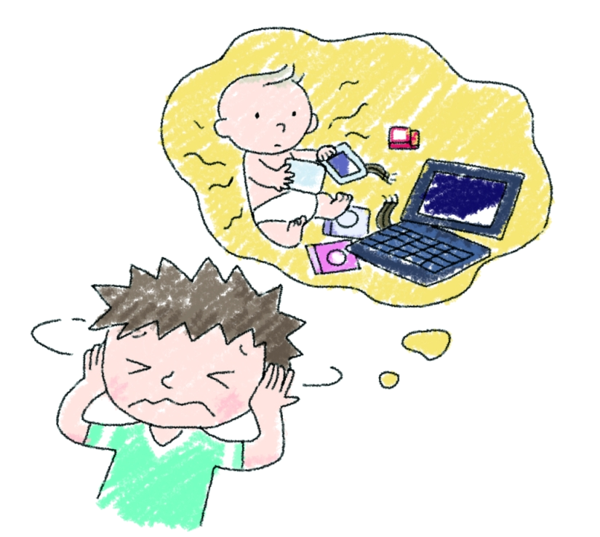
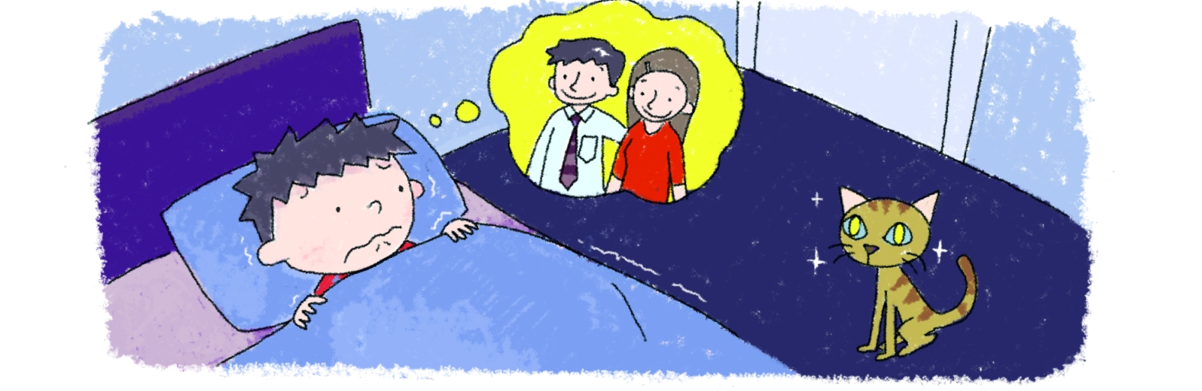
For the next few weeks Ken cried and cried! Mum didn’t have time to do the housework. Once I even had to wear a dirty uniform to school. I was really upset about that. I pretended that Ken wasn’t there. I never held him or played with him.
One day, Mum and Dad were trying to make Ken smile. I was reading a book. I peeped out at them and hid again quickly. Ken smiled. I looked out again. Ken smiled a big, joyful grin. I felt warm inside and smiled back.

‘He likes you. Give him a hug,’ said Mum. Cuddling my baby brother was a wonderful experience. I was ashamed of my past behaviour. Ken held my finger tightly and smiled. It was an amazing feeling.
Now my brother is four years old. He smiles all the time but I’ll never forget his first smile. It was better than an electronic game and a computer!


