RP no: Century Gothic 15pt
(所有圈號用15pt)
Choose and write.
care for others | enjoy teamwork
improve my basketball skills | improve my English
know right from wrong | make my own choices
respect others | solve problems

1 | 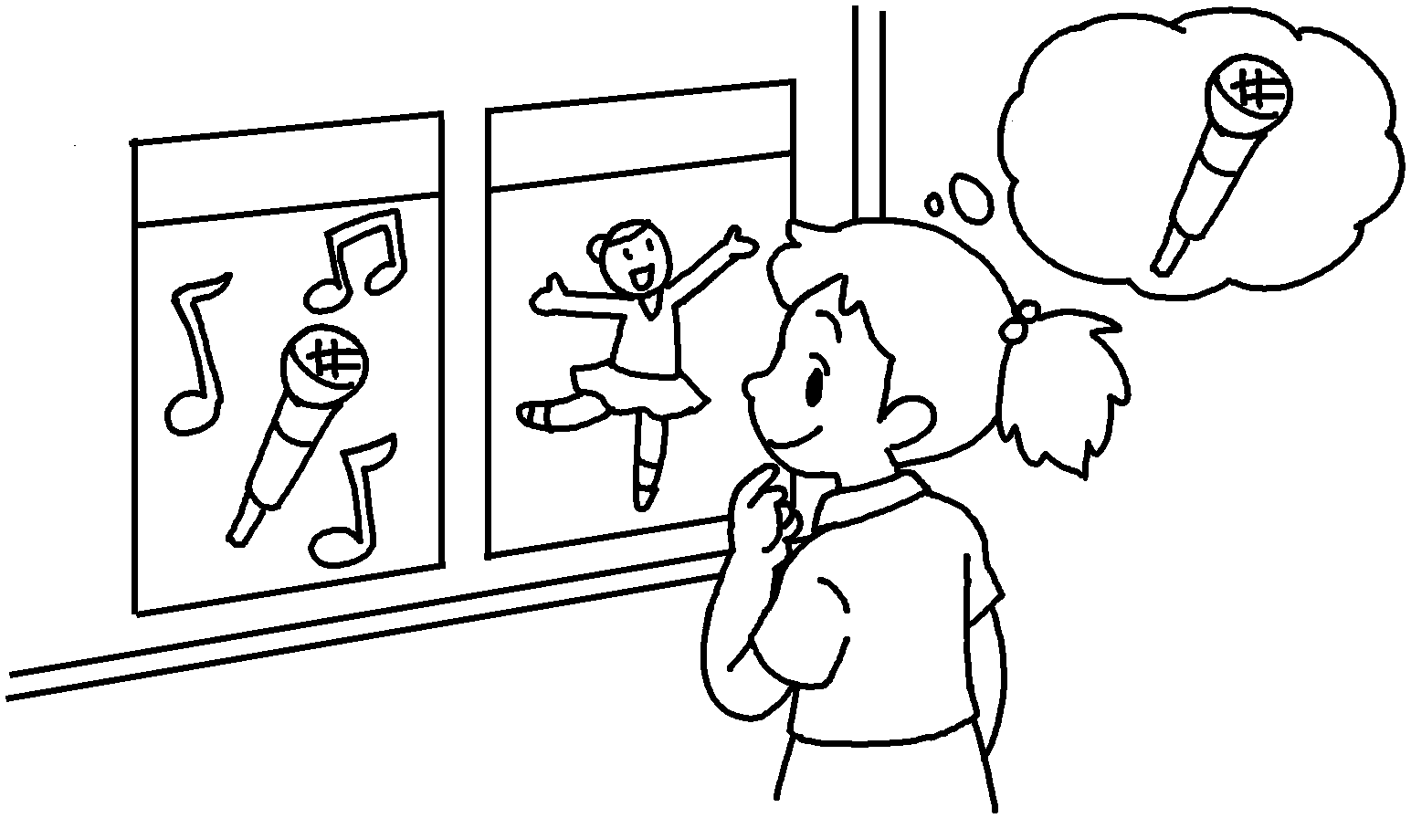 |  |  | 5  2 | 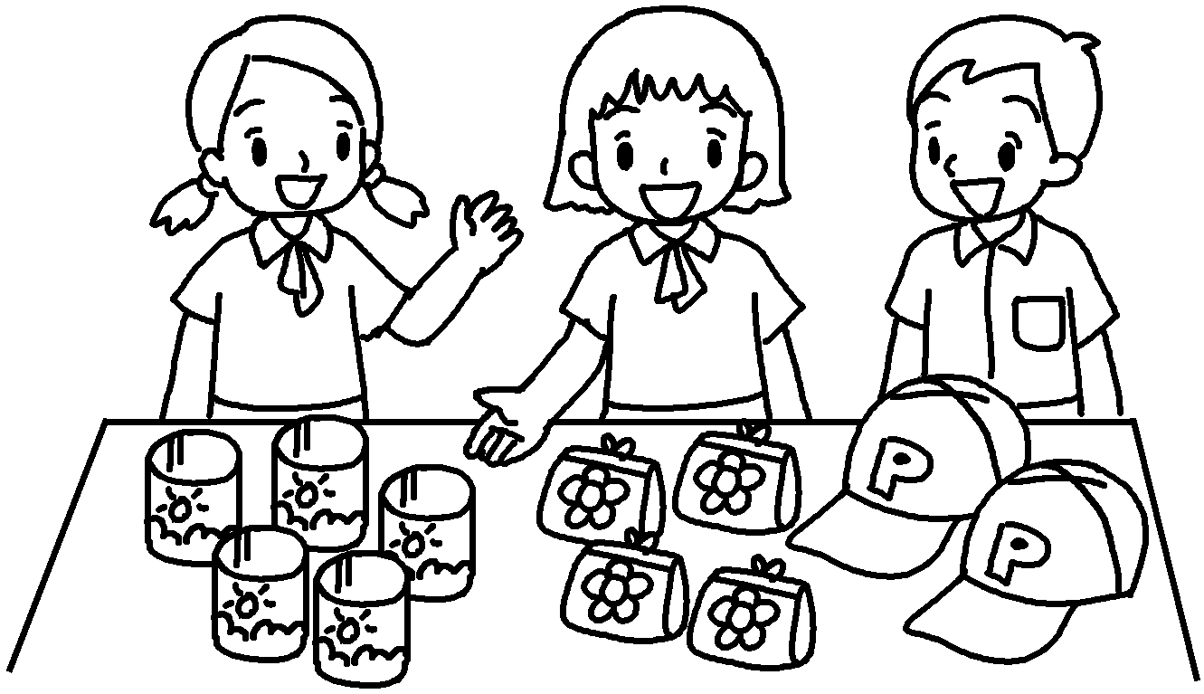 |  |  | 6  3 | 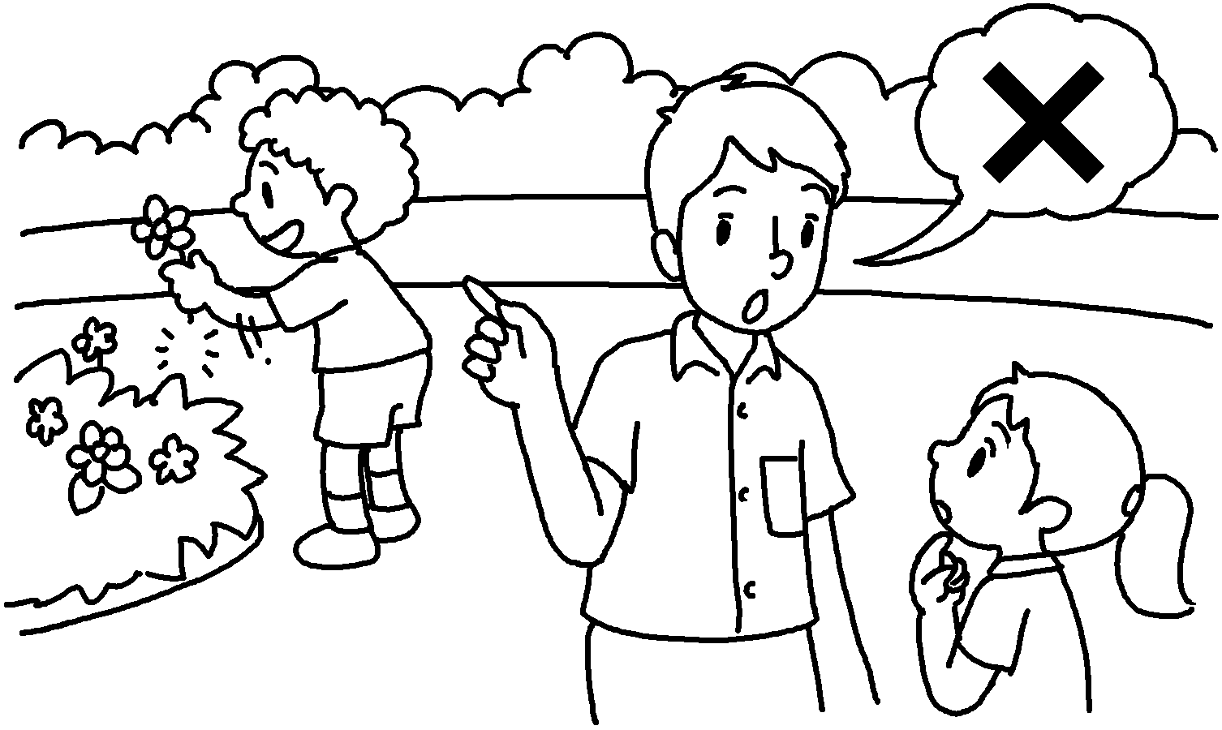
4 | 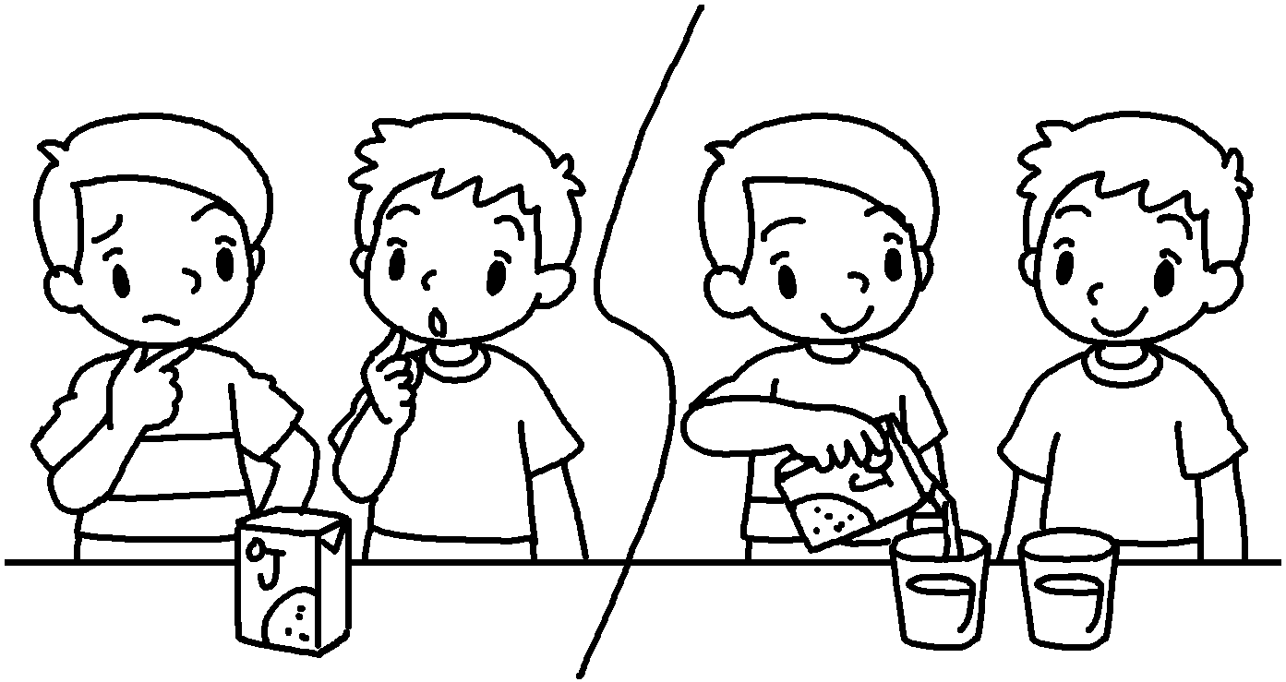  7 |  |  |  | 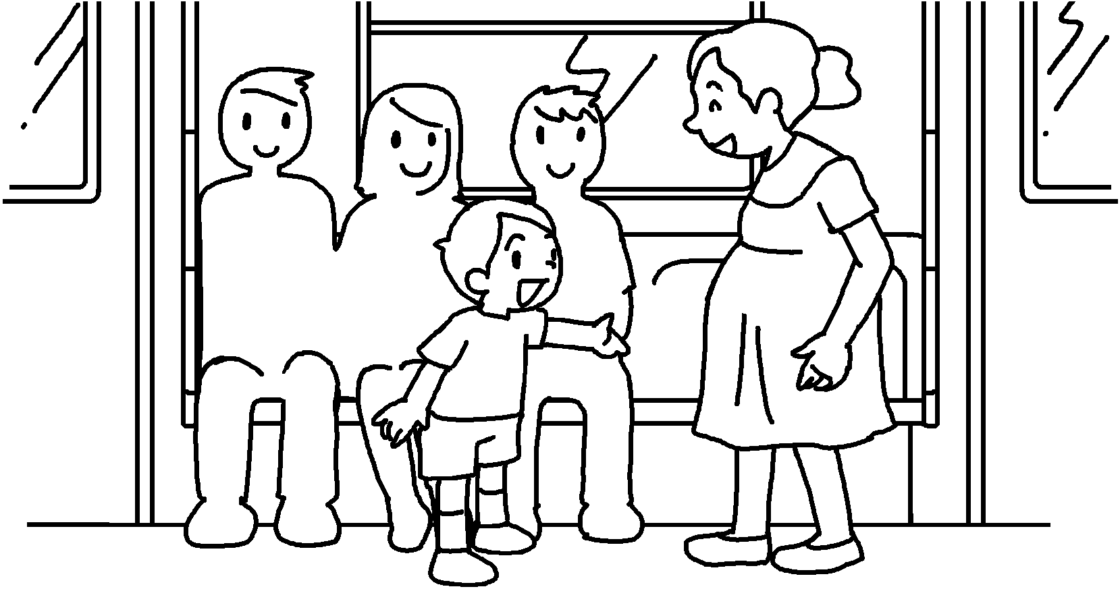  8 |  |  | Goodbye,  teachers. | 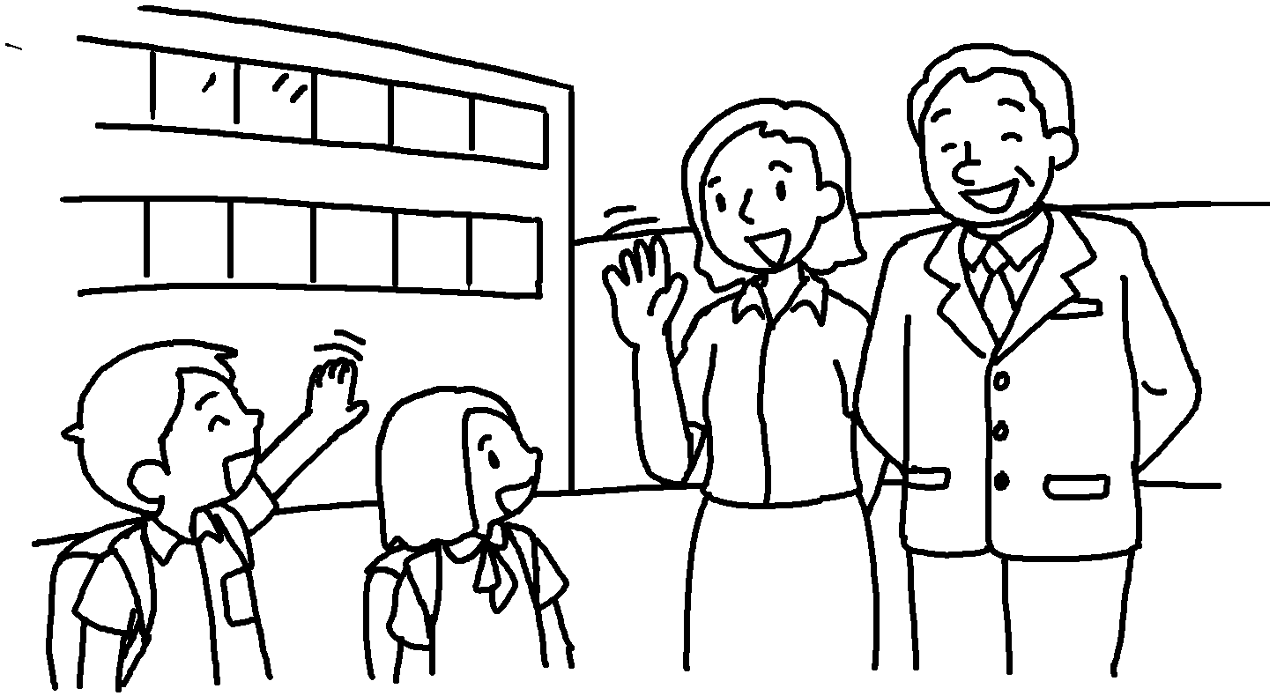
 |  |  | 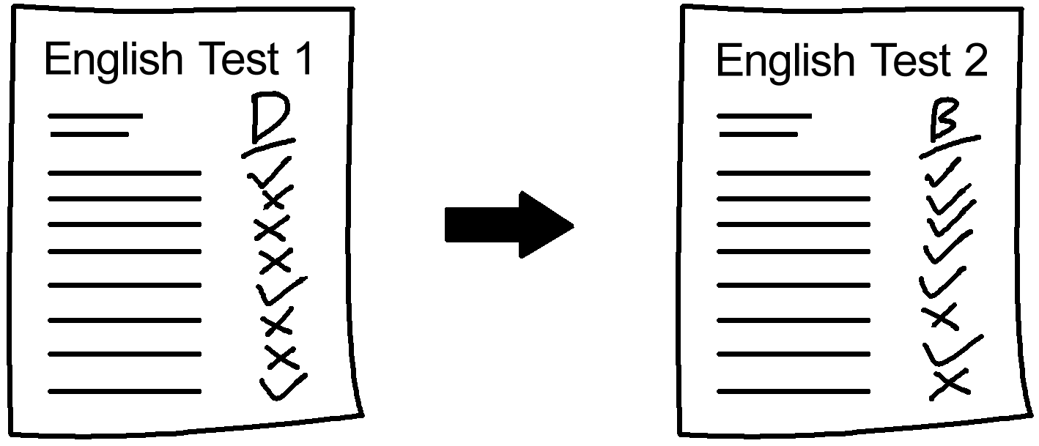 |  |  |  | 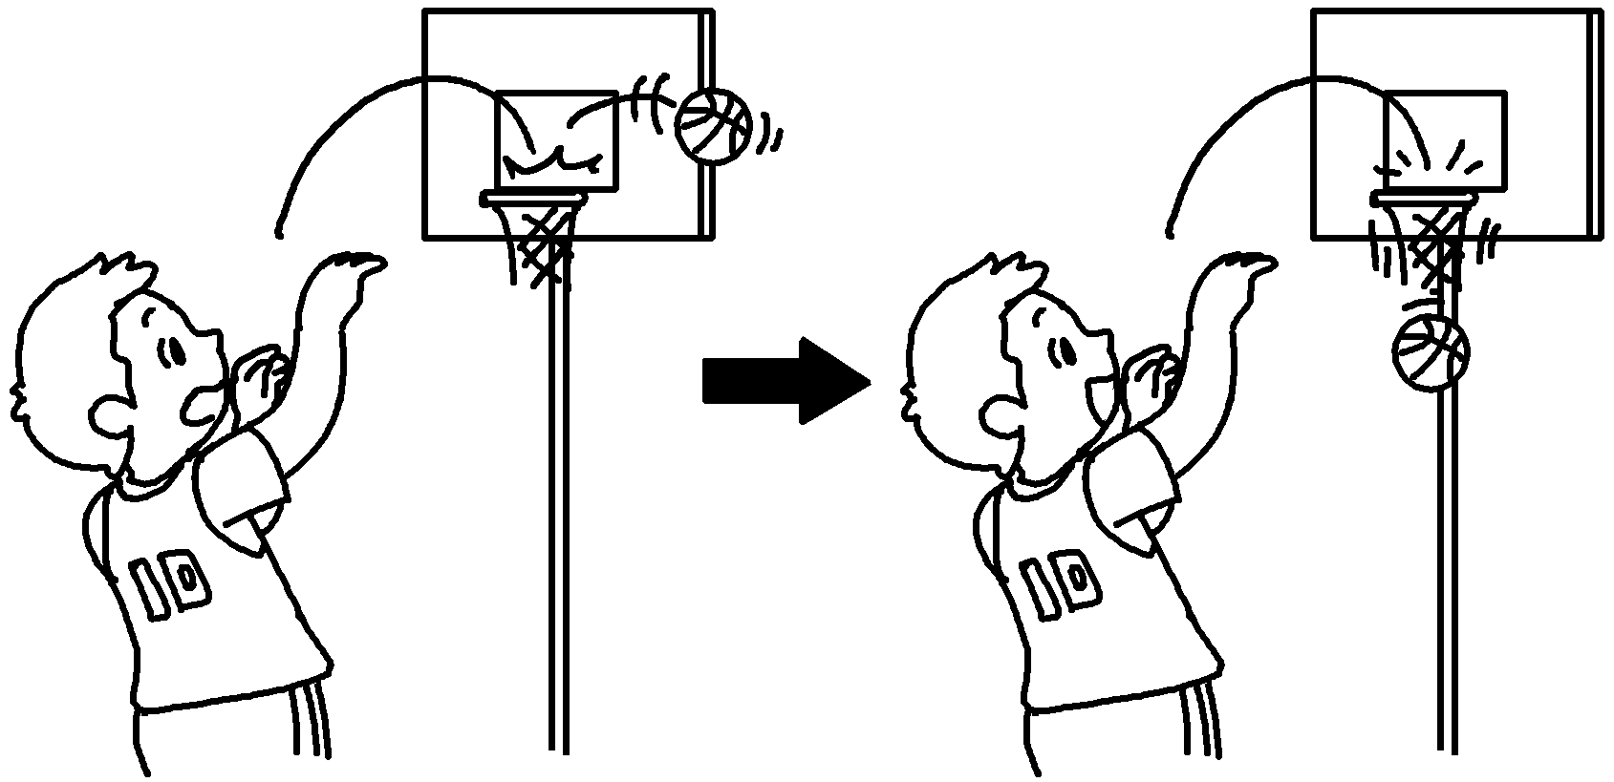

1
2
3
4
5
6
7
8

RP no: Century Gothic 15pt
(所有圈號用15pt)


Book 6B Chapter 7 Graded Worksheets
Worksheet 1⬇
- make my own choices
- enjoy teamwork
- know right from wrong
- solve problems
- care for others
- respect others
- improve my English
- improve my basketball skills

