RP no: Century Gothic 15pt
(所有圈號用15pt)
Look at the pictures and write.

1 | 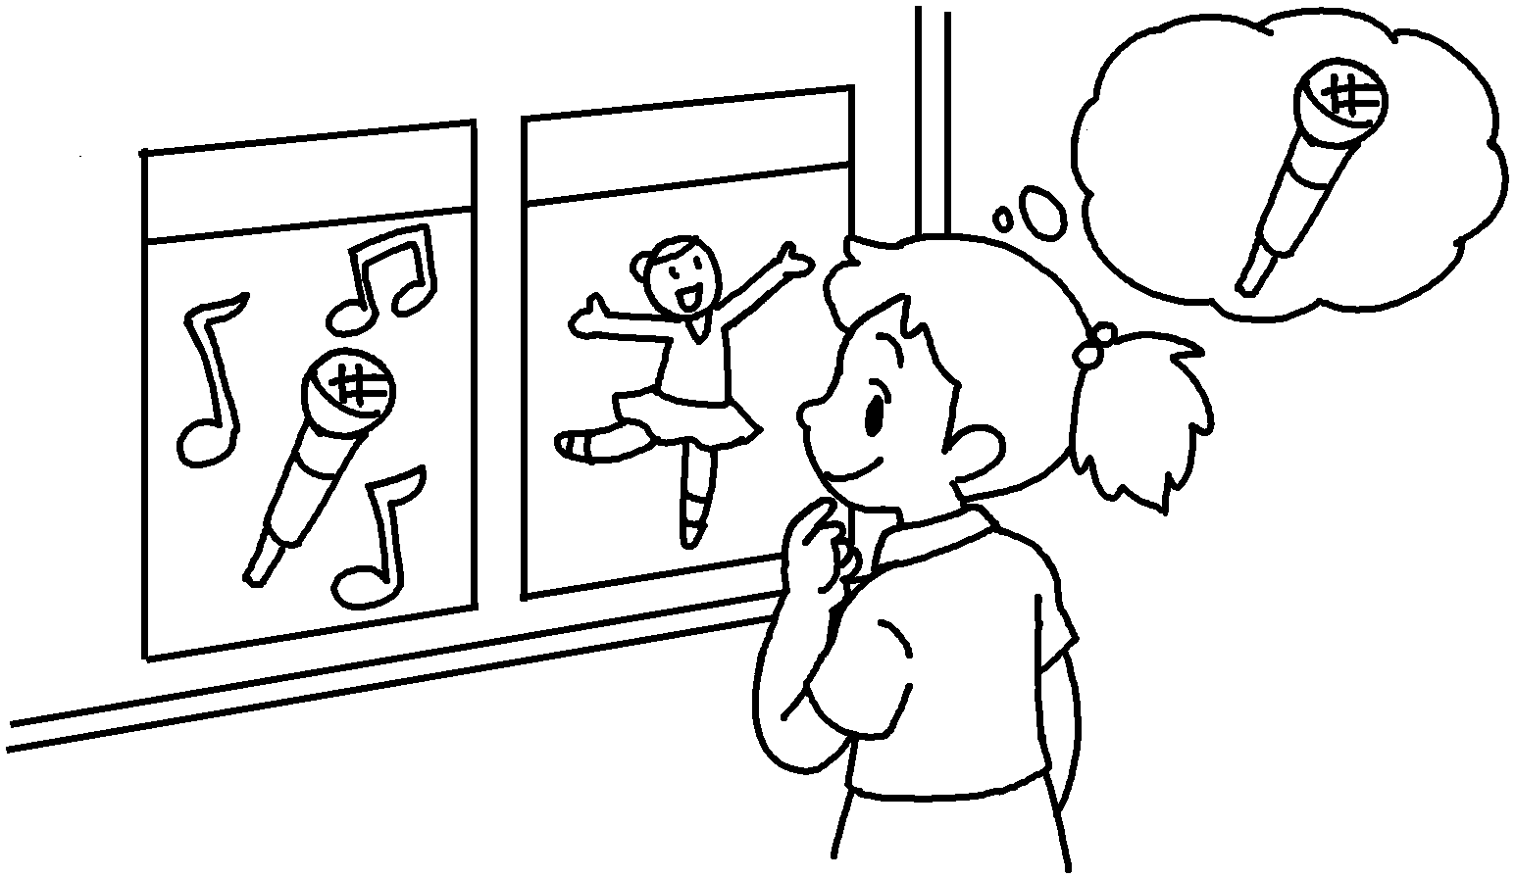 | 2 | 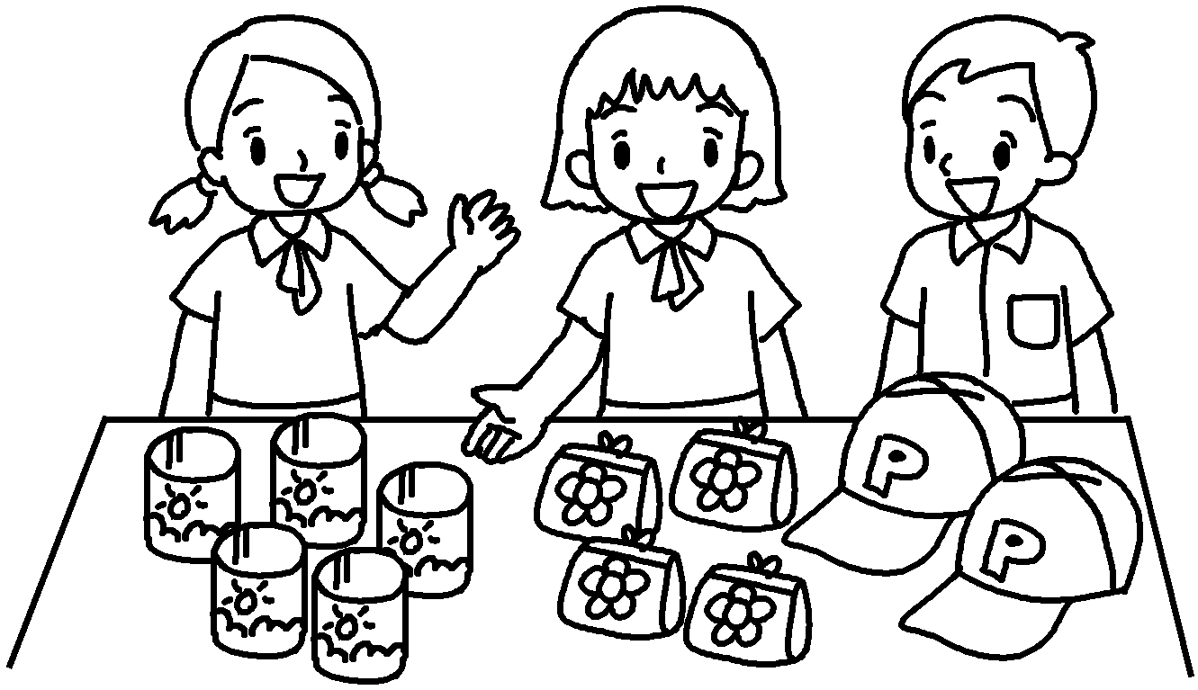 | 3 | 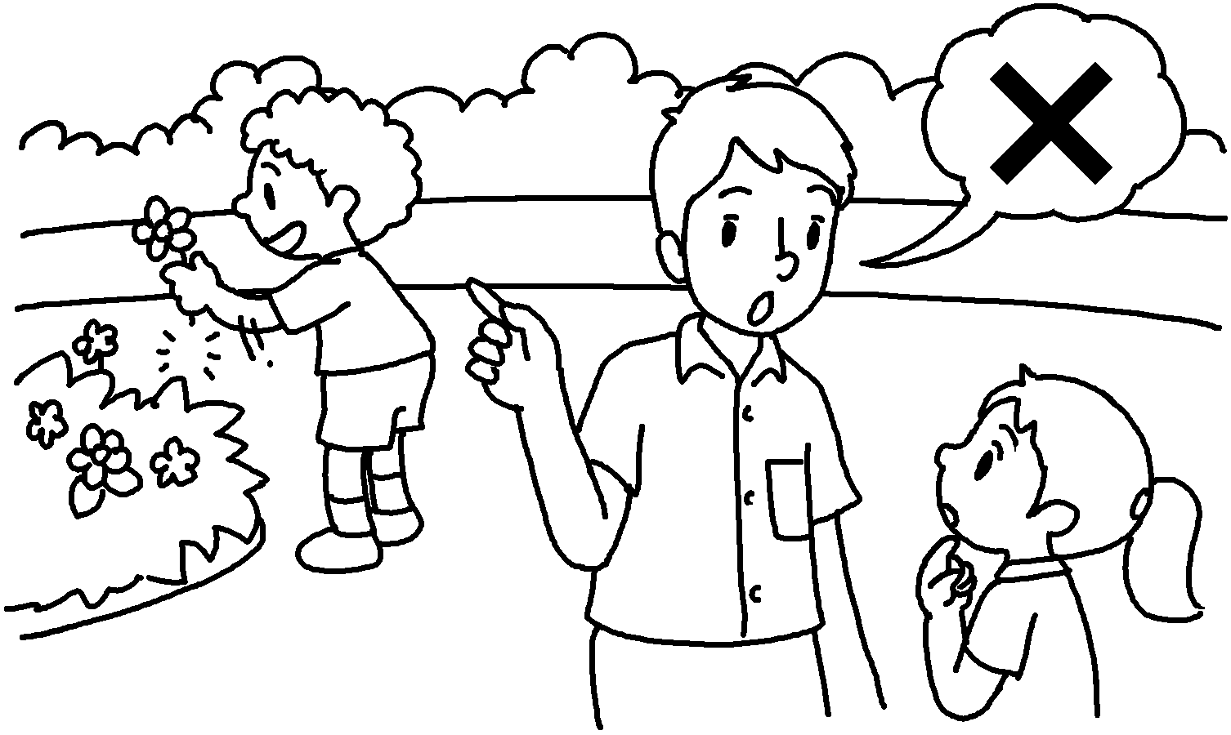

4 | 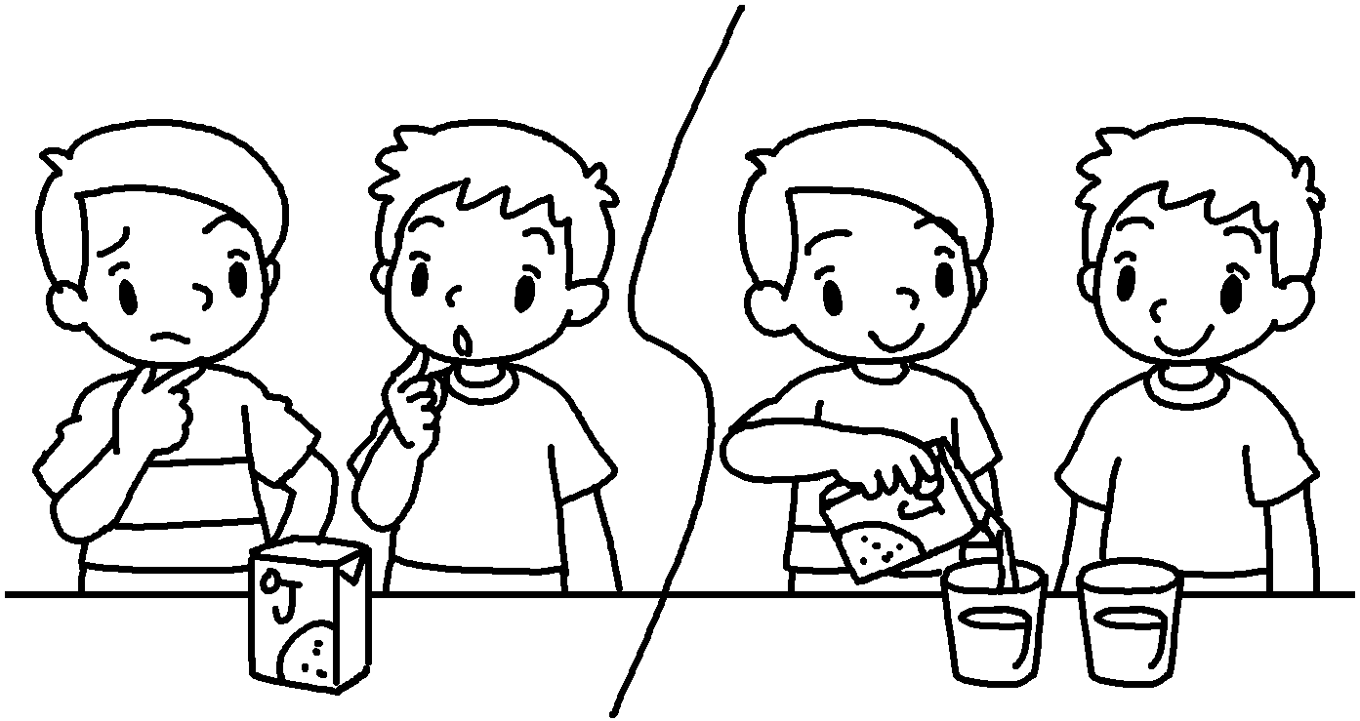 | 5 | 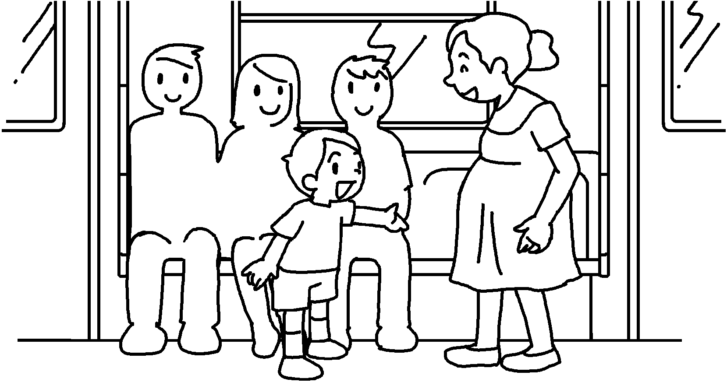 | 6  Goodbye,  teachers. | 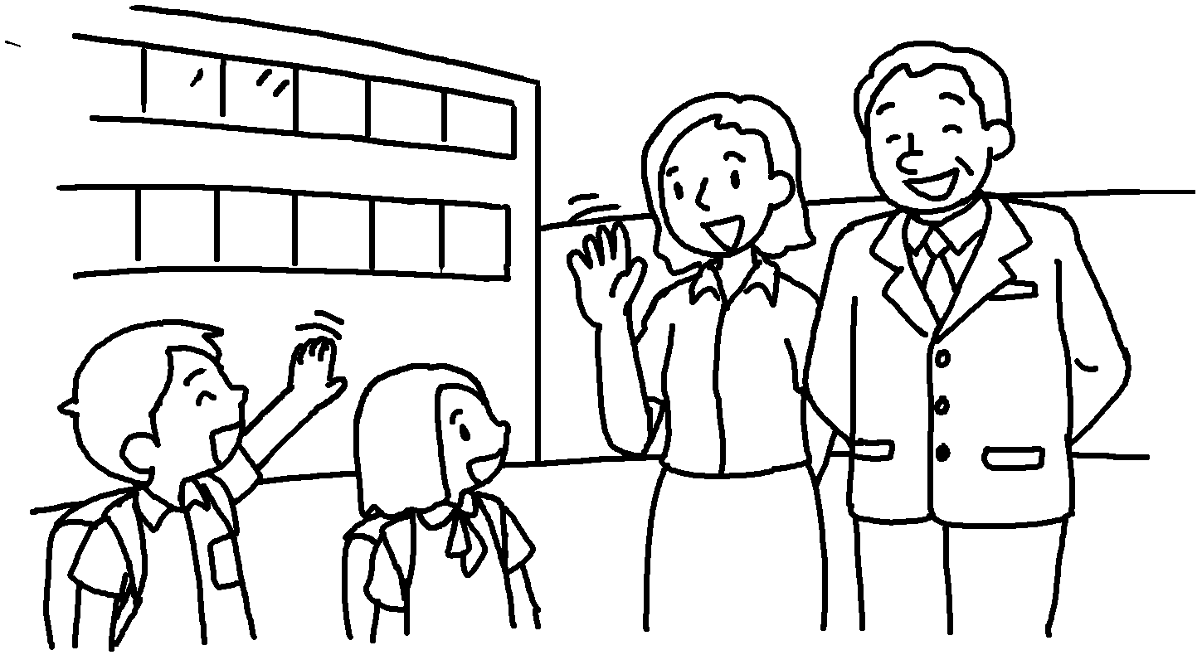

 |  | 7 | 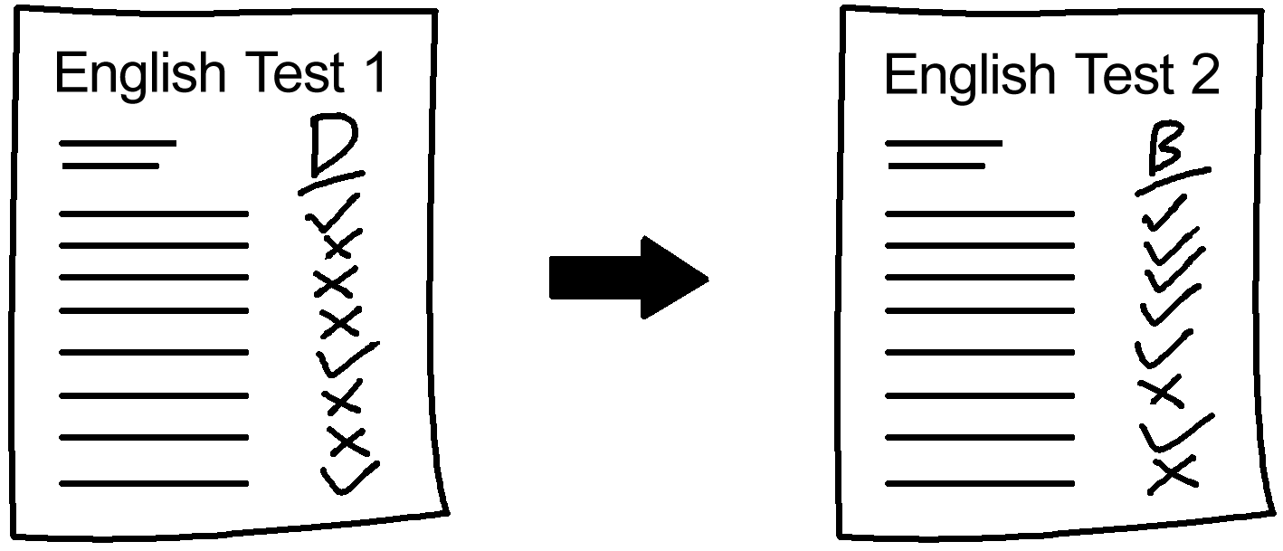 | 8 | 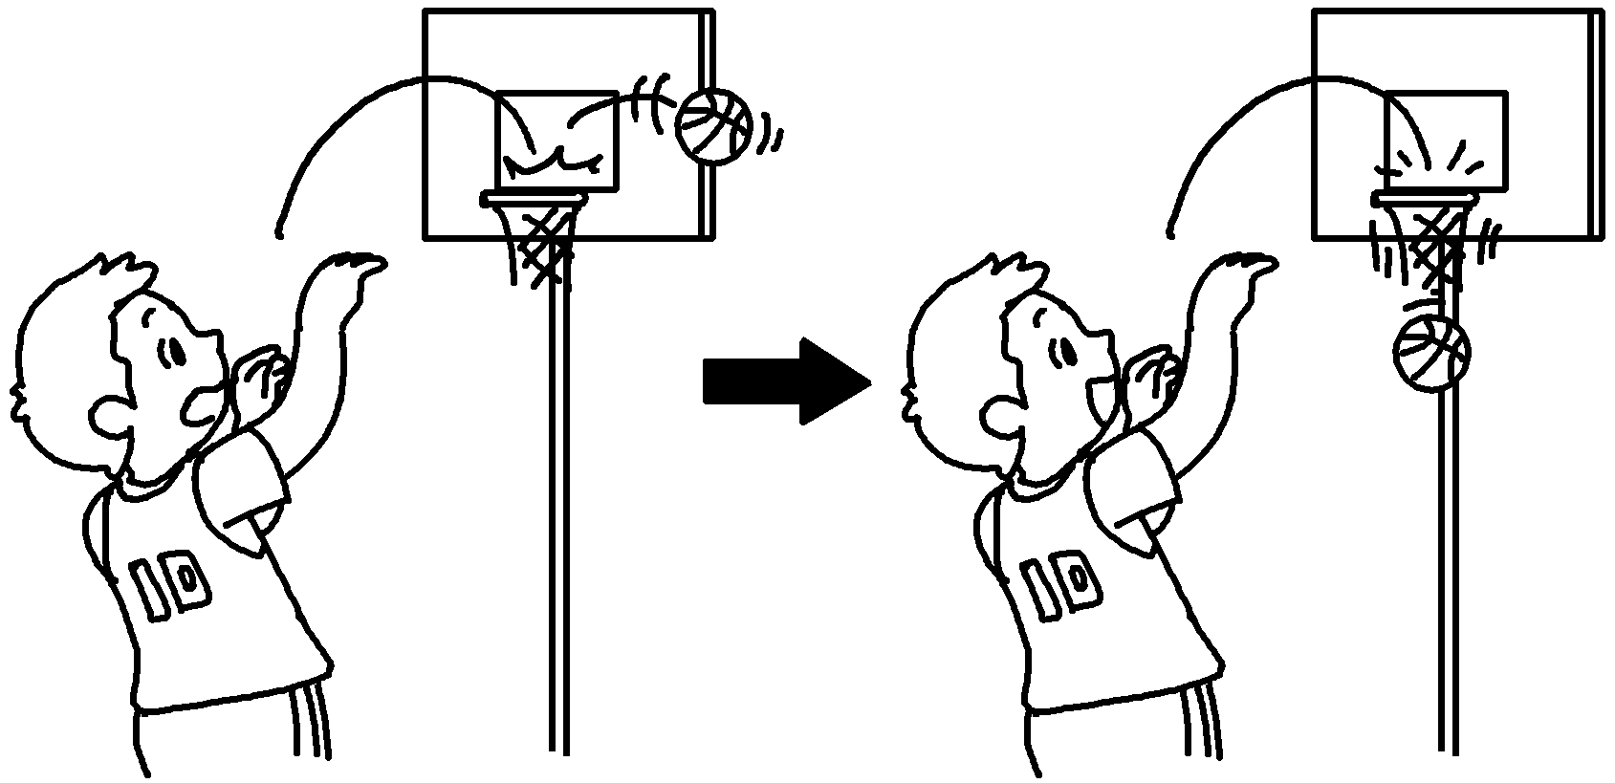

1 | make my own c
2 | enjoy t
3 | k right
4 | s p
5 | c others
6 | r others
7 | i my
8 | my


Book 6B Chapter 7 Graded Worksheets
Worksheet 1⬇⬇⬇
- choices
- teamwork
- know from wrong
- solve problems
- care for
- respect
- improve English
- improve basketball skills

