Finish the sentences.
taught
me
to

 |  | Do you have time to practise?
1 | Mrs Poon me improve my English. | 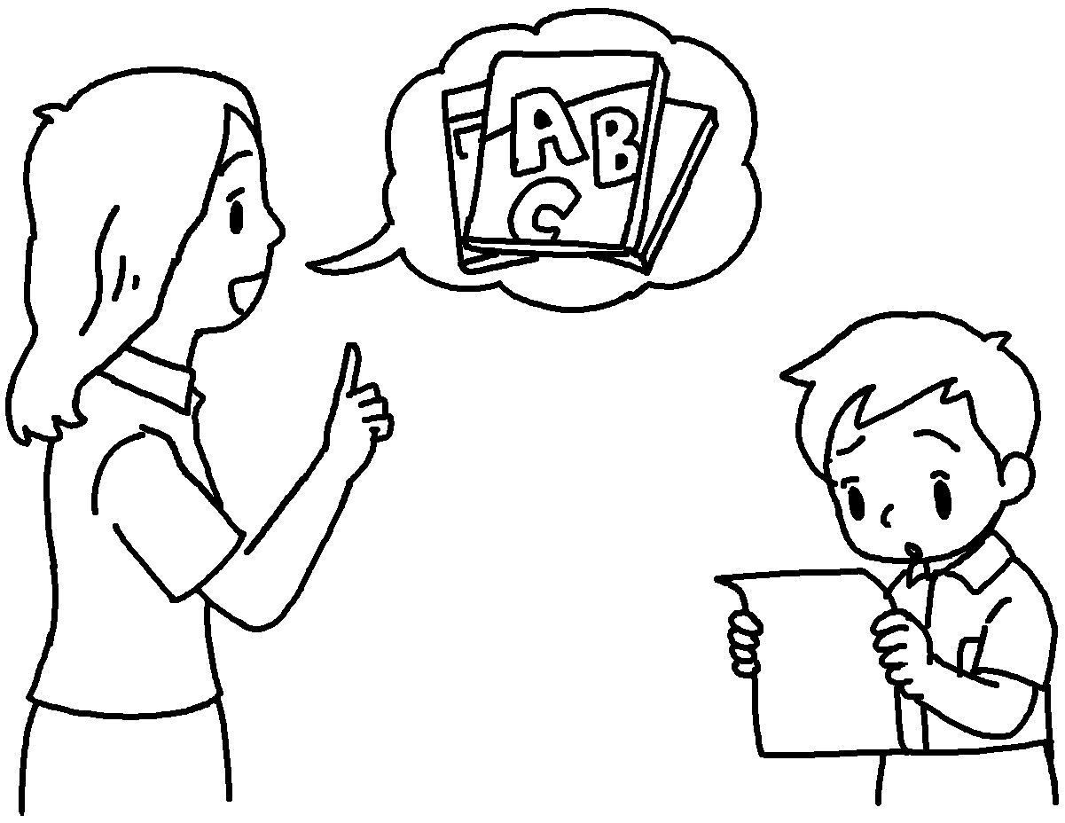
2 | Mr Lai  improve my basketball skills. | 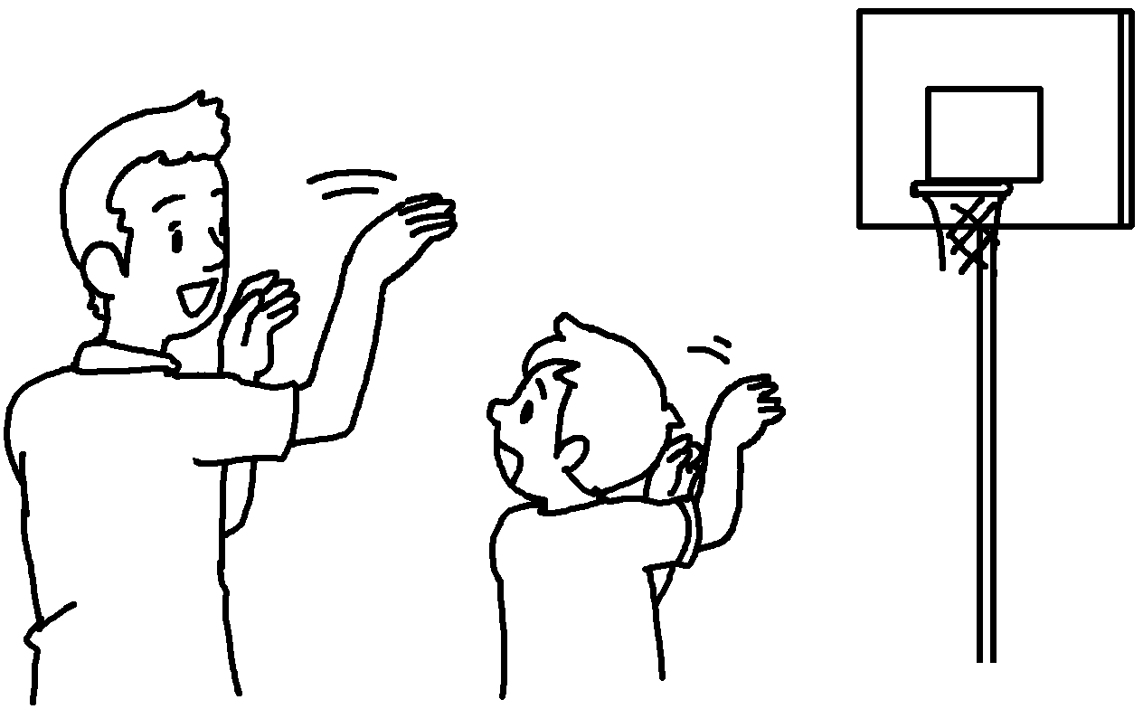
3 | Miss Lau me  ( care ) for others. | 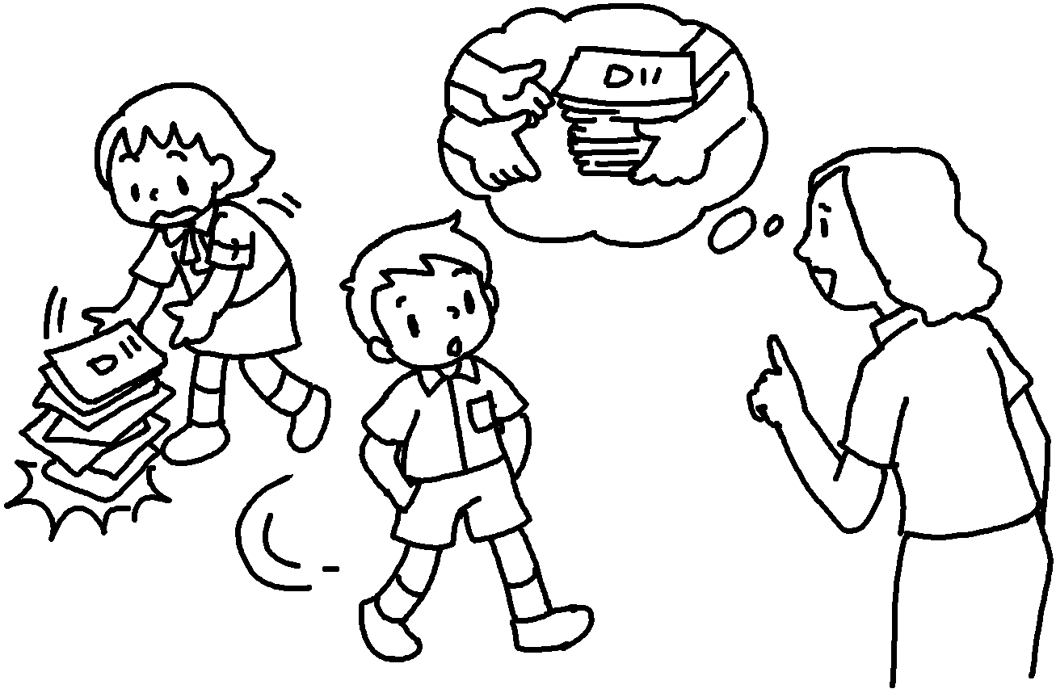
4 | Mr Kwan  ( know )  right from wrong. | 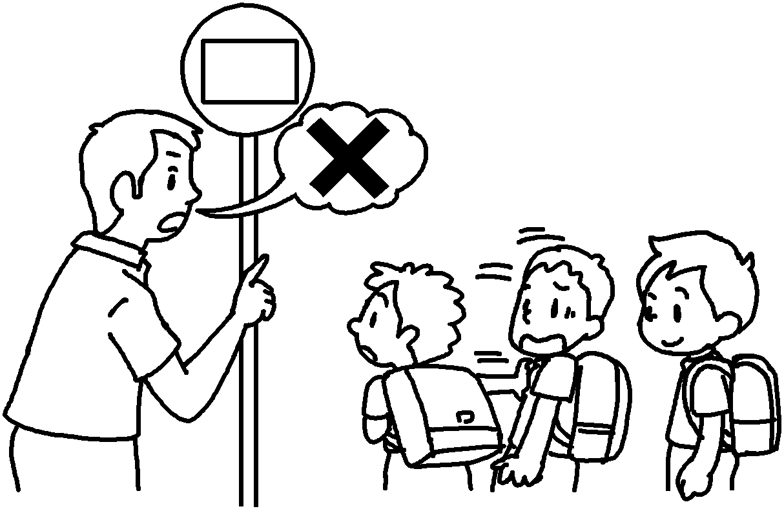
5 | Miss Chow  ( make ) my own choices. | 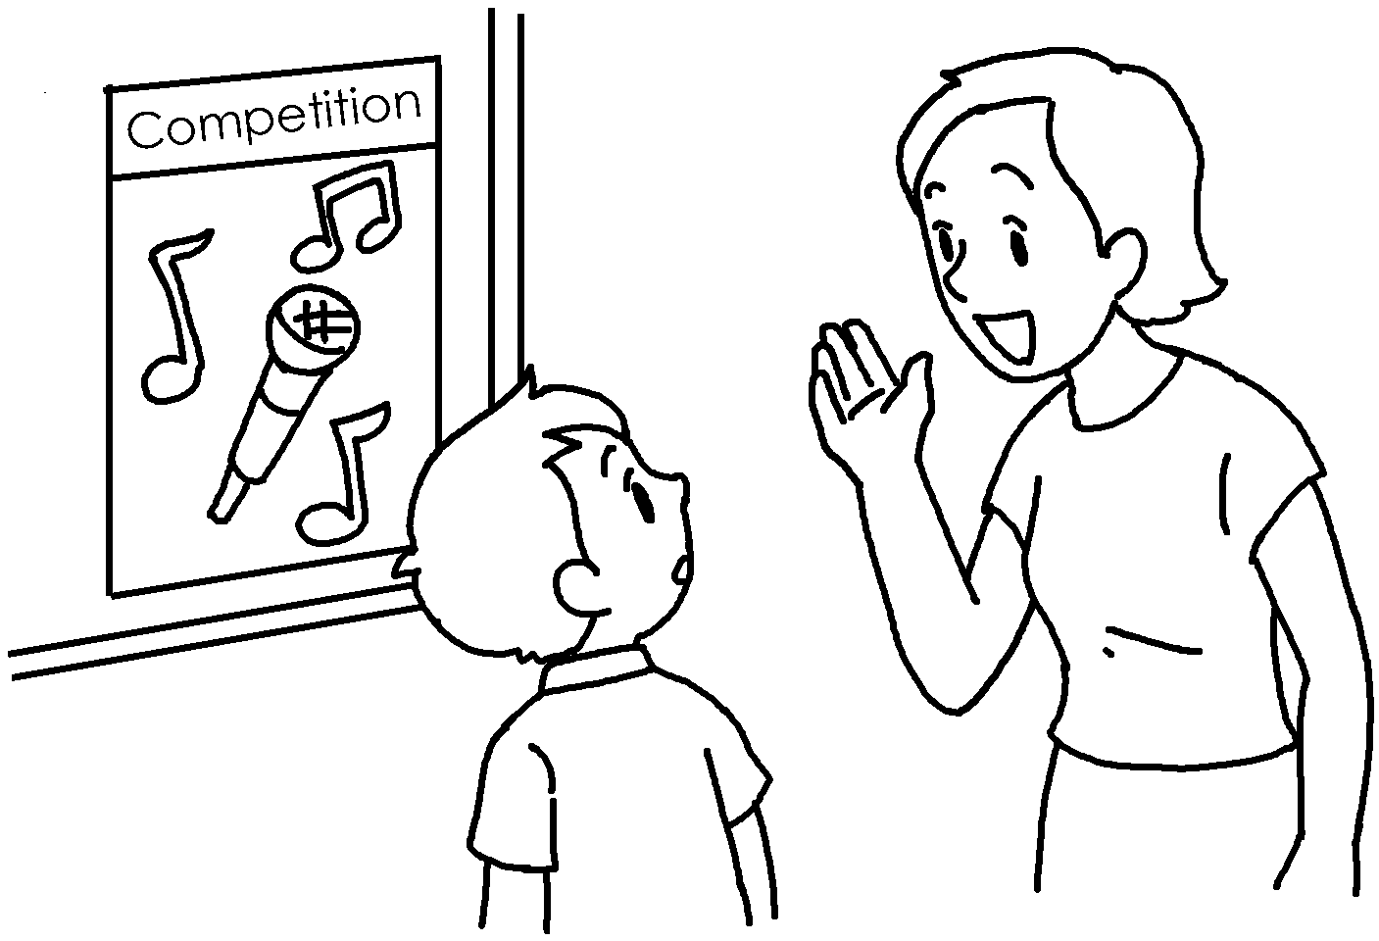


Book 6B Chapter 7 Graded Worksheets
Worksheet 2⬇
1 taught to
2 taught me to
3 taught to care
4 taught me to know
5 taught me to make

