What did the teachers teach Alan? Finish the sentences.

make … choices improve … basketball skills improve … English
know right from wrong care for others

 |   Alan | Do you have time to practise?
1 | Mrs Poon taught me to  my . | 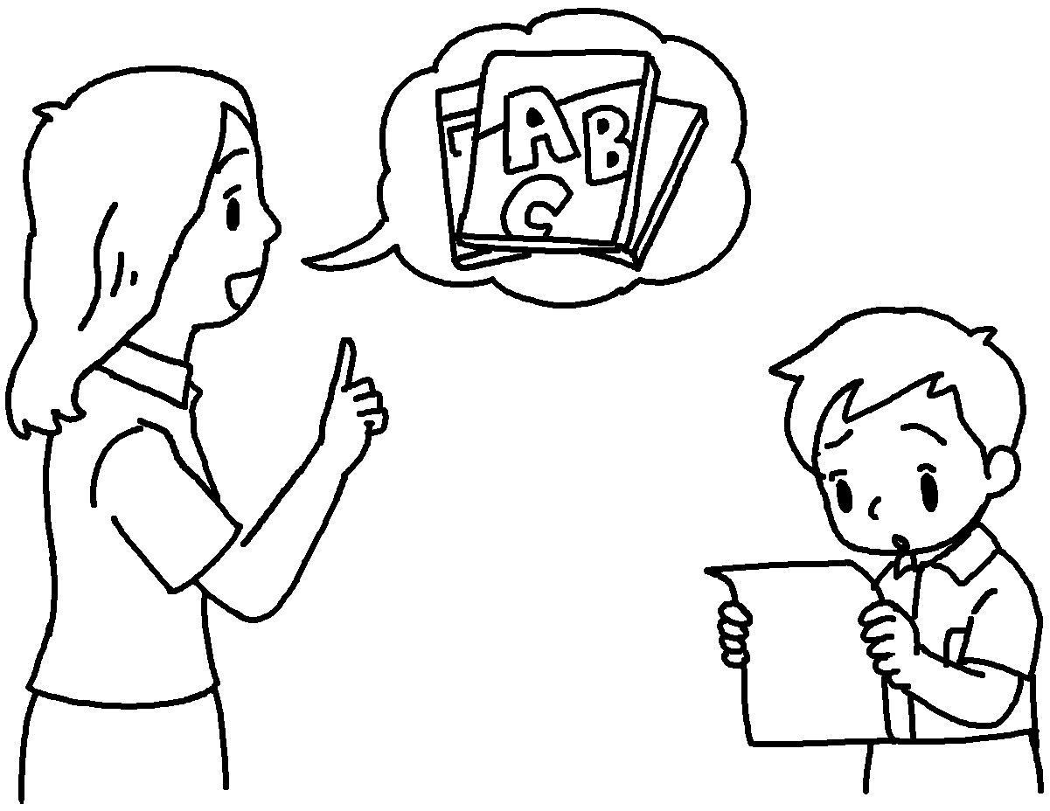
2 | Mr Lai taught me  . | 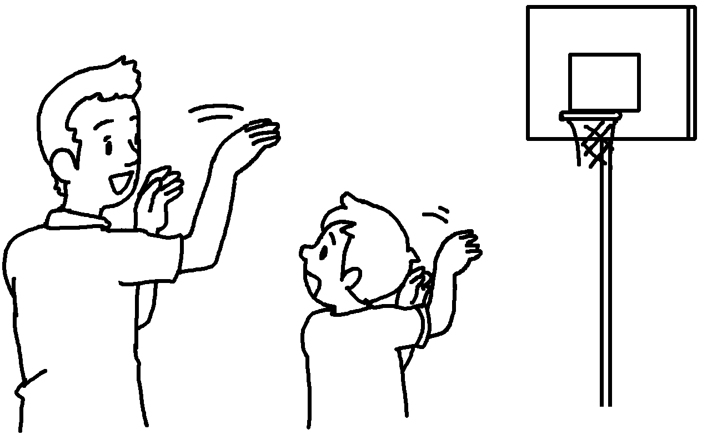
3 | Miss Lau  . | 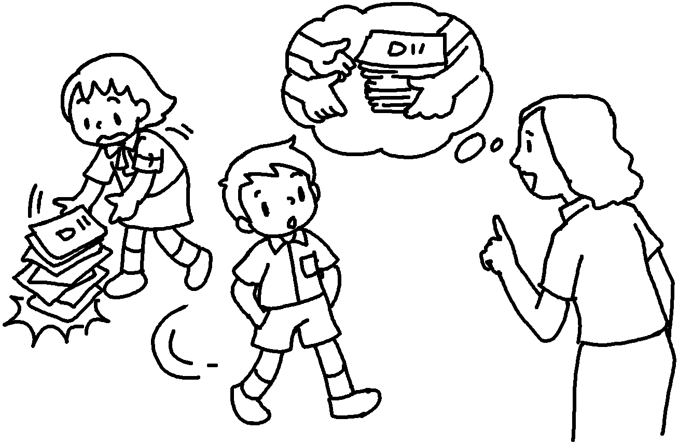
4 | Mr Kwan  . | 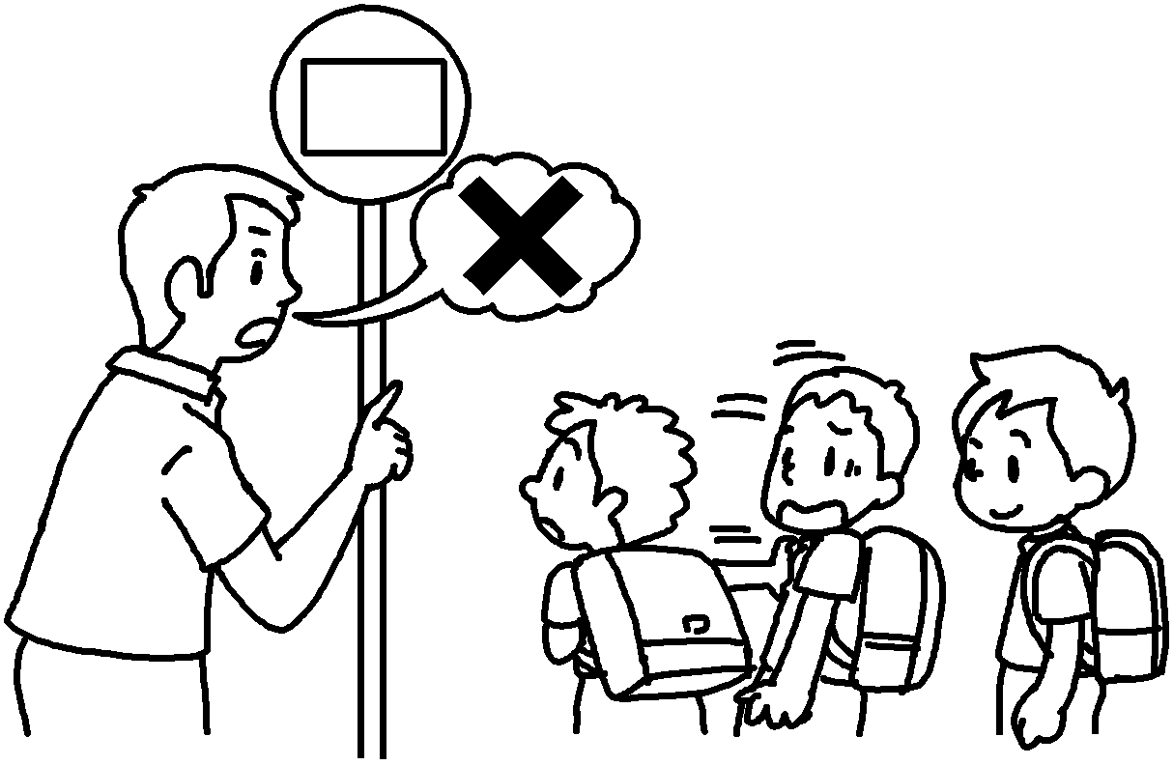
5 | Miss Chow  . | 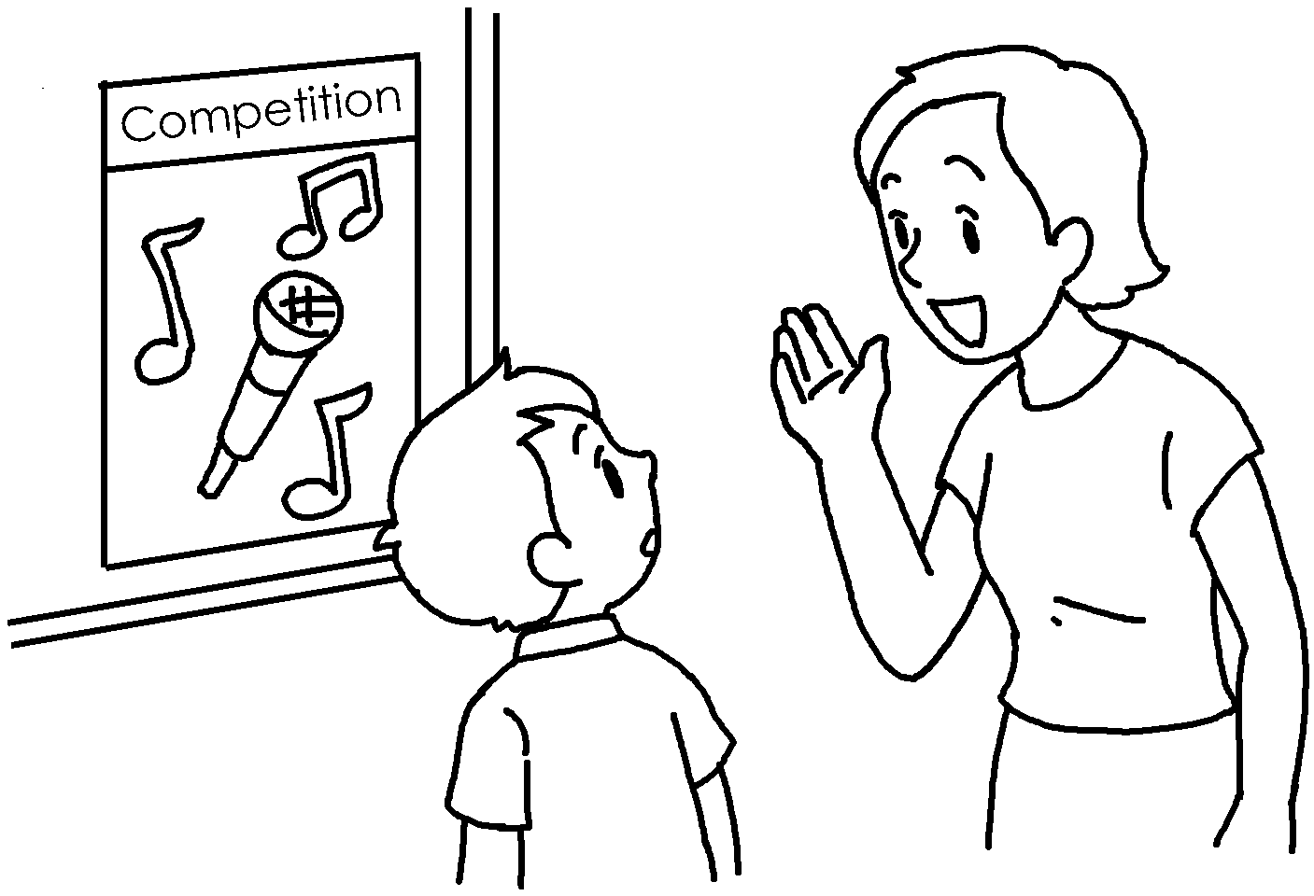


Book 6B Chapter 7 Graded Worksheets
Worksheet 2⬇⬇
1 improve English
2 to improve my basketball skills
3 taught me to care for others
4 taught me to know right from wrong
5 taught me to make my own choices

