What did the teachers teach Alan? Finish the sentences.

make improve know care for

 |   Alan | Do you have time to practise?
1 | Mrs Poon taught me to  my English. | 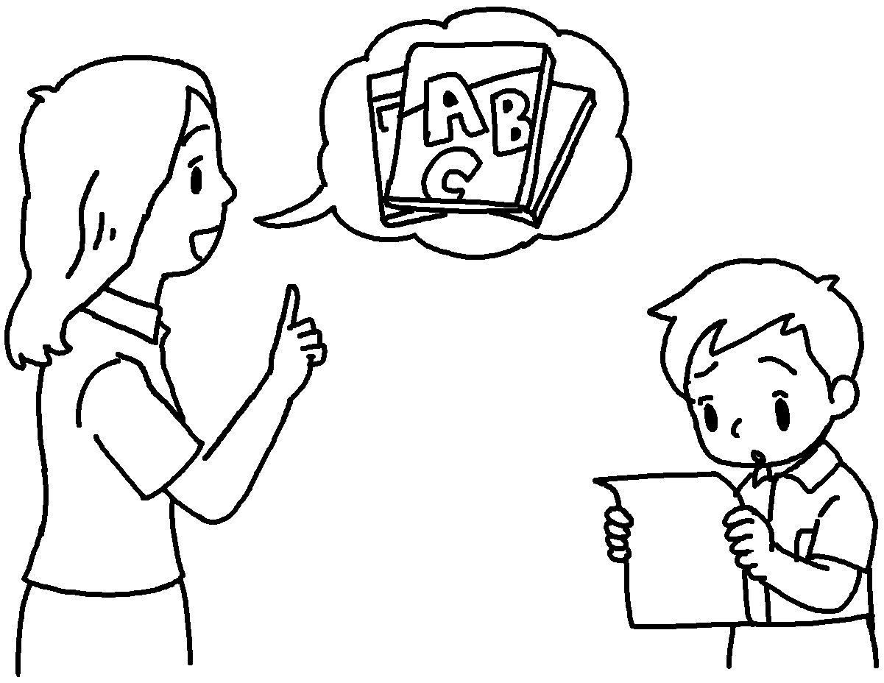
2 | Mr Lai taught me  . | 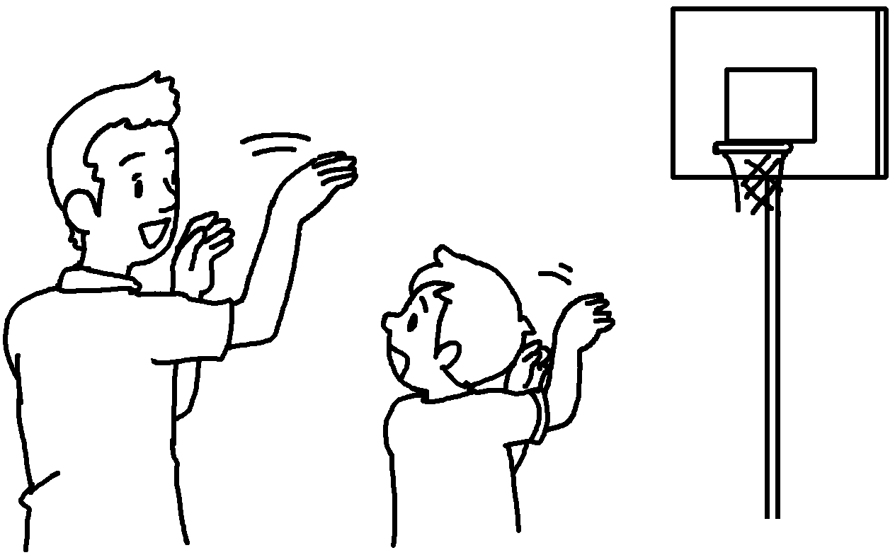
3 | Miss Lau  . | 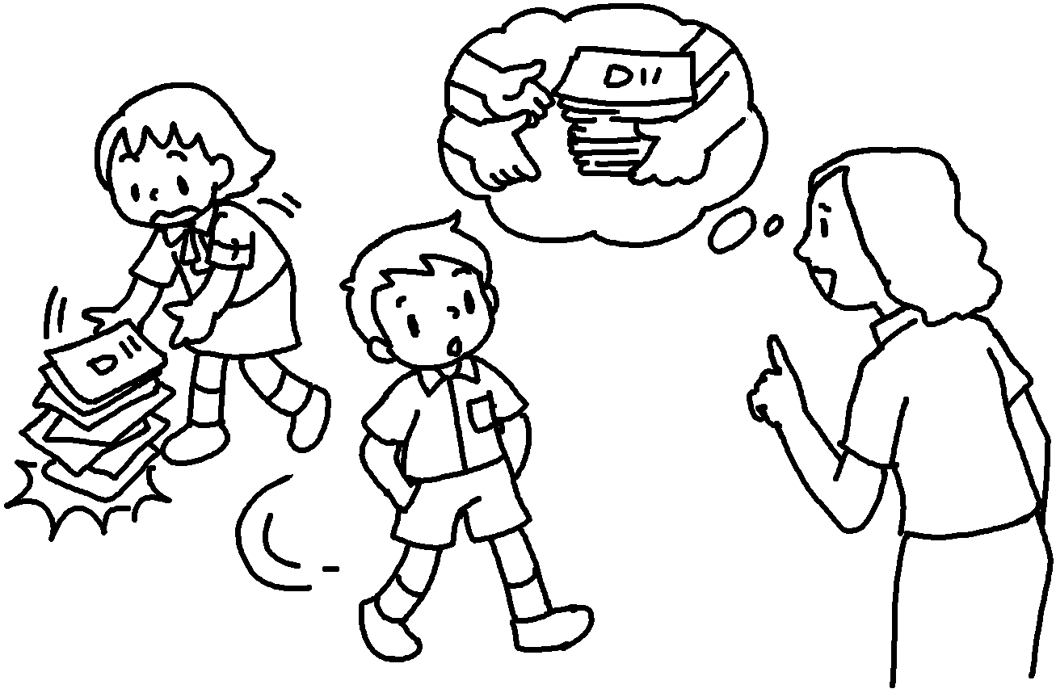
4 | Mr Kwan  wrong. | 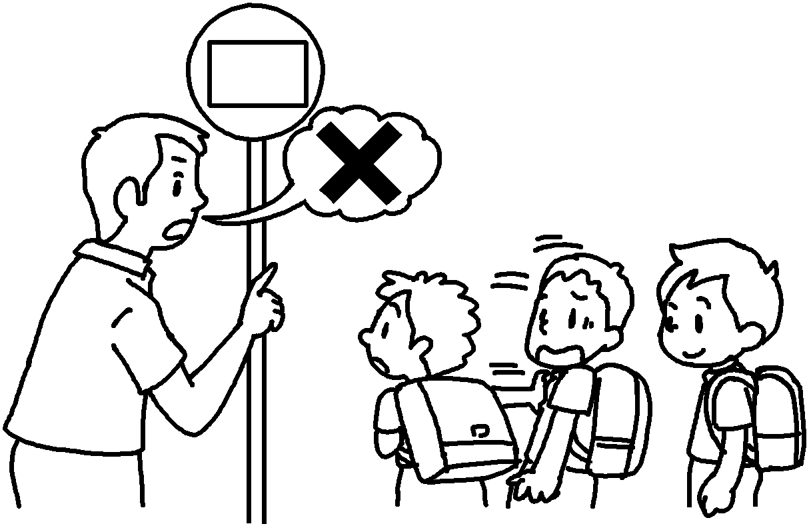
5 | Miss Chow  . | 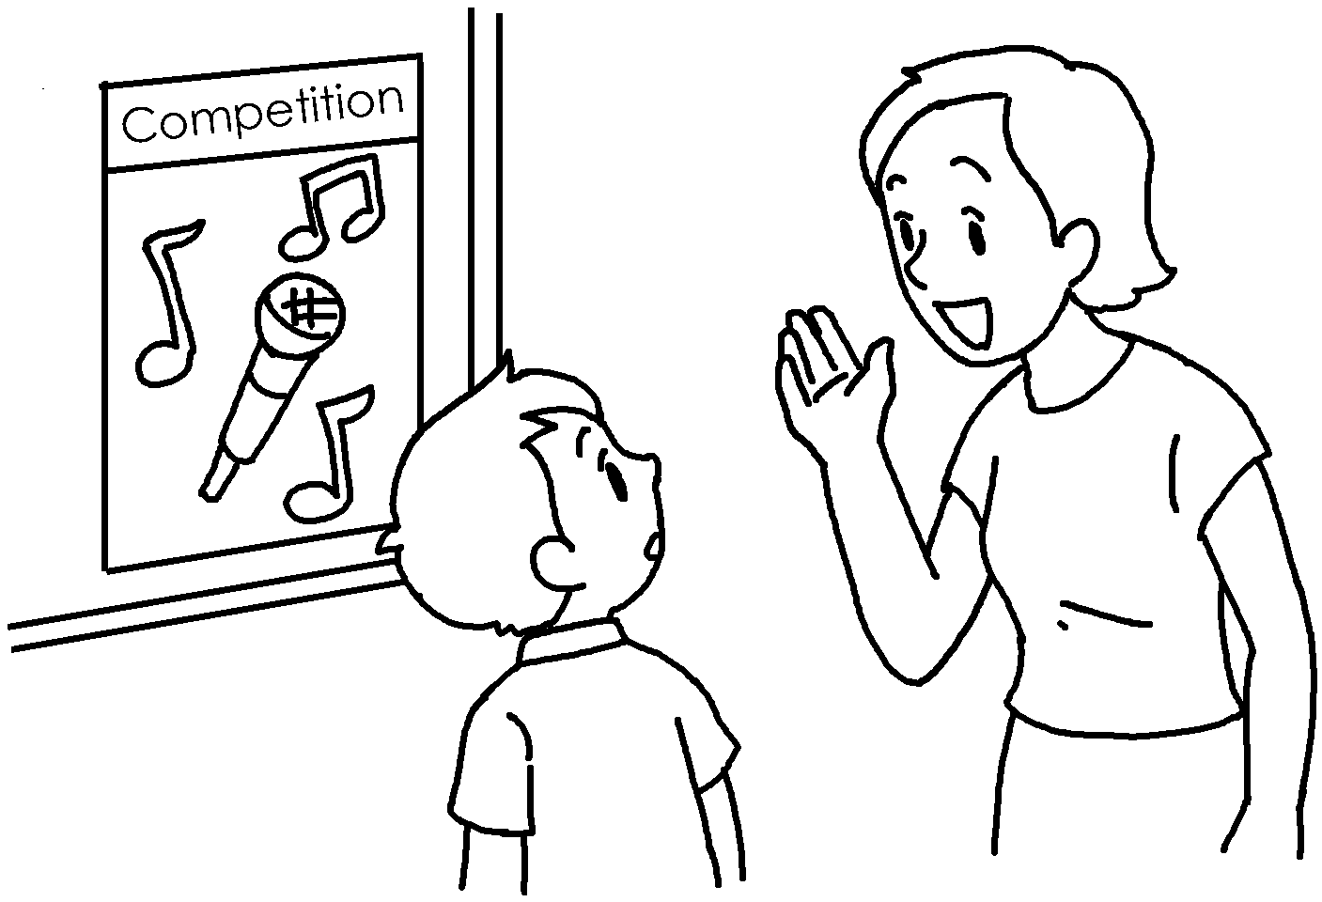


Book 6B Chapter 7 Graded Worksheets
Worksheet 2⬇⬇⬇
1 improve
2 to improve my basketball skills
3 taught me to care for others
4 taught me to know right from
5 taught me to make my own choices
(Accept any reasonable answers.)

