Finish the sentences.
thank you
sorry
for
…ing

1 | Mr Lam, thank you  ( teach ) us to enjoy teamwork. | 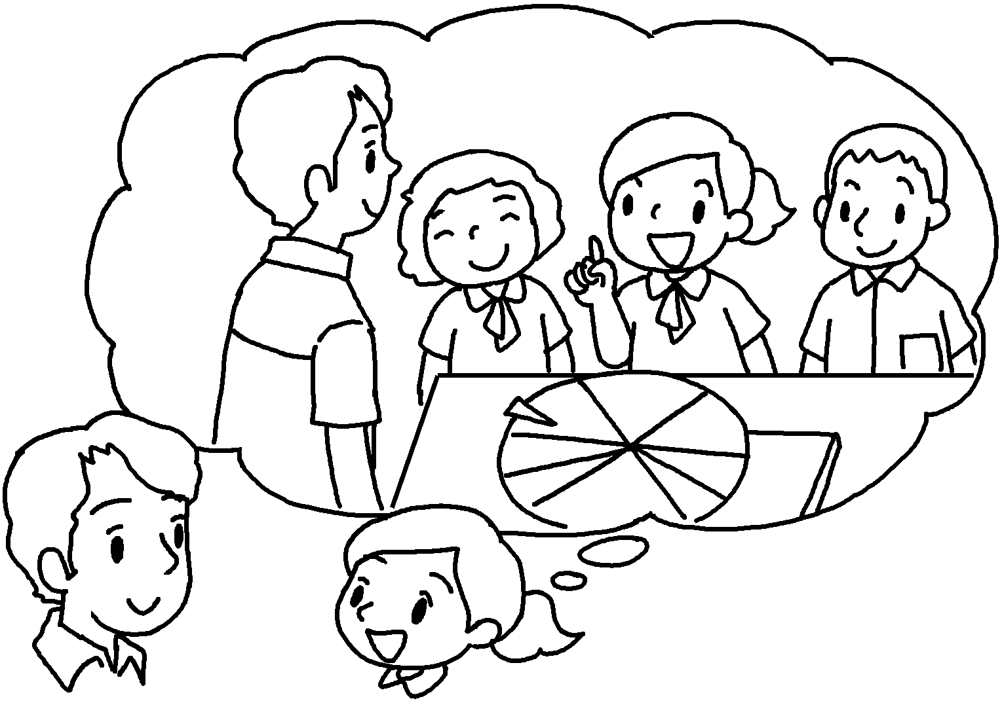
2 | I am sorry  ( play ) tricks on you. | 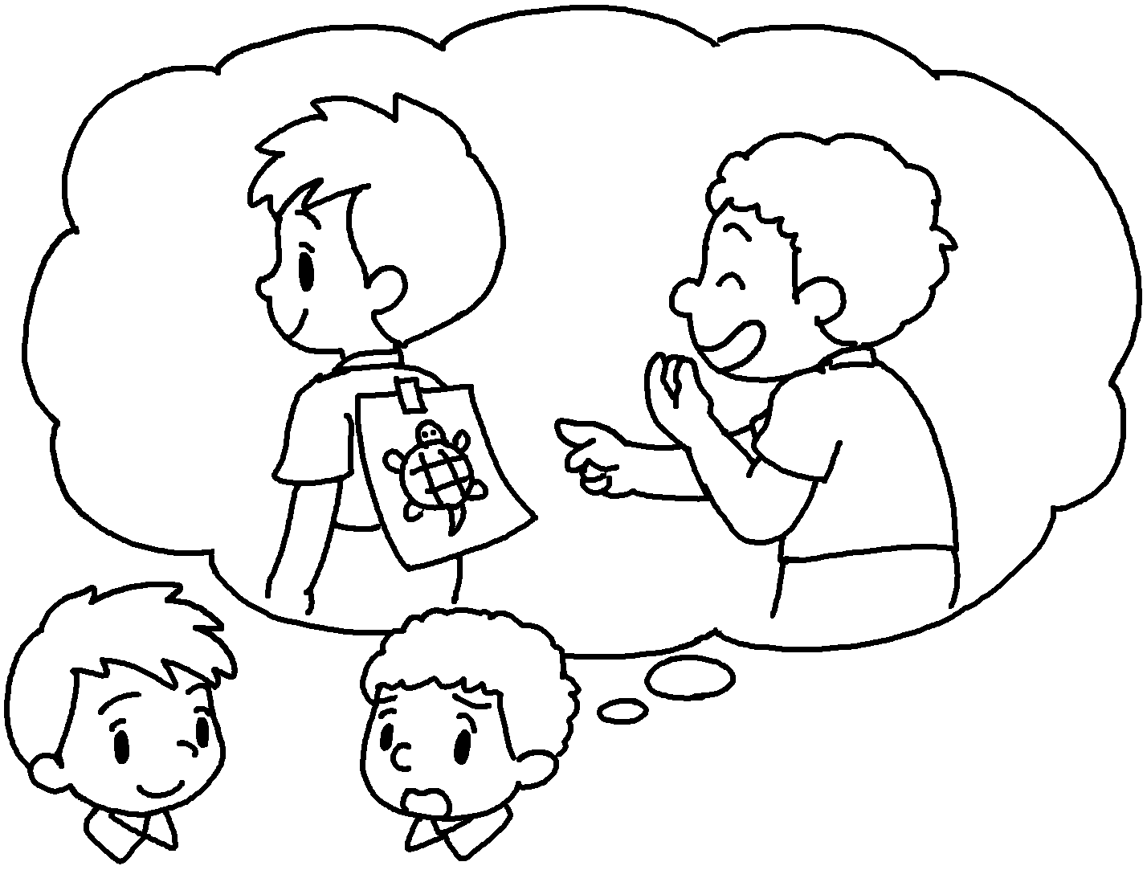
3 | I am  ( hand ) in my homework  late. | 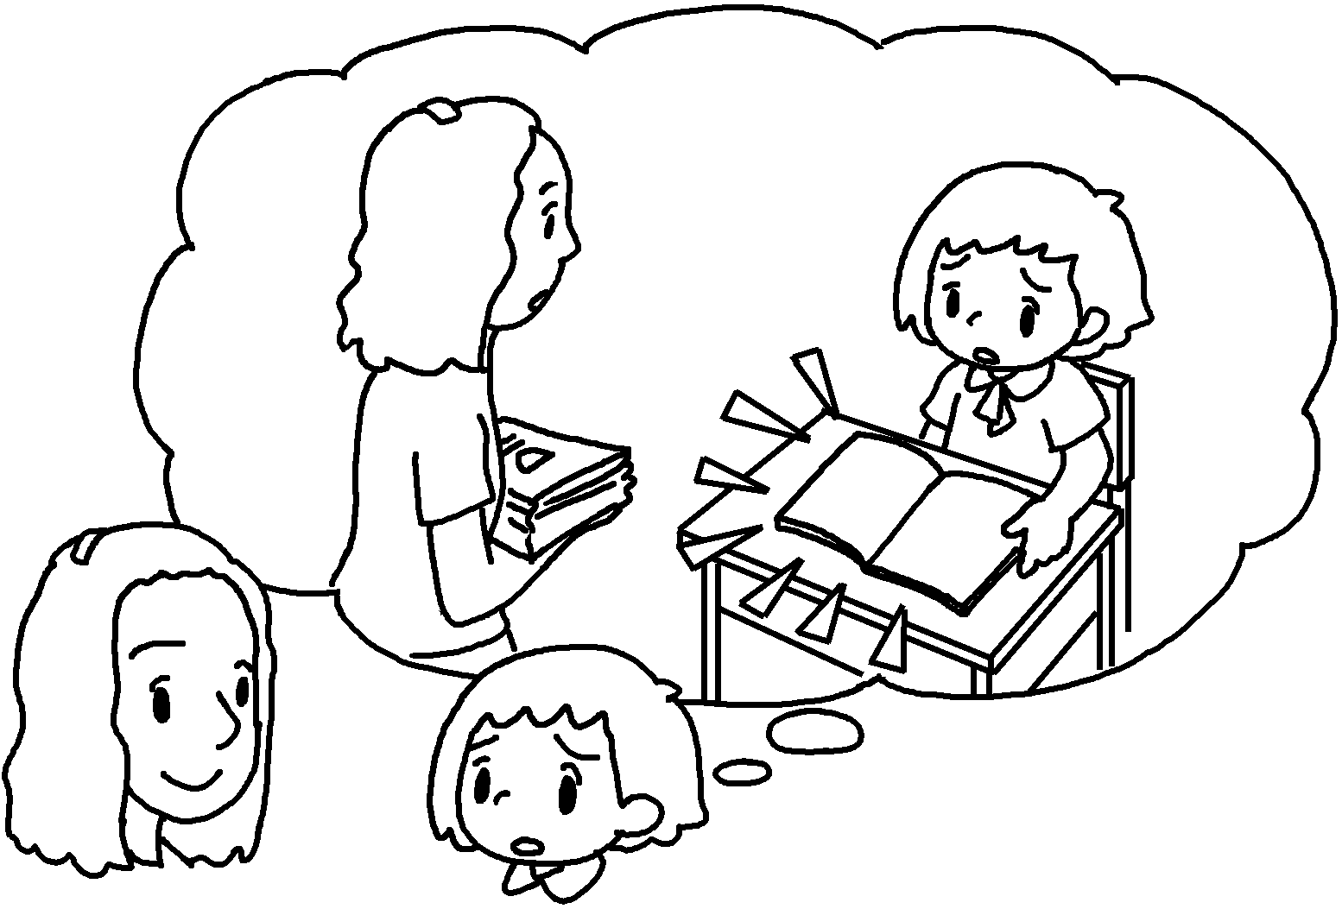
4 | Miss Wu,  ( teach ) me to improve my football skills. | 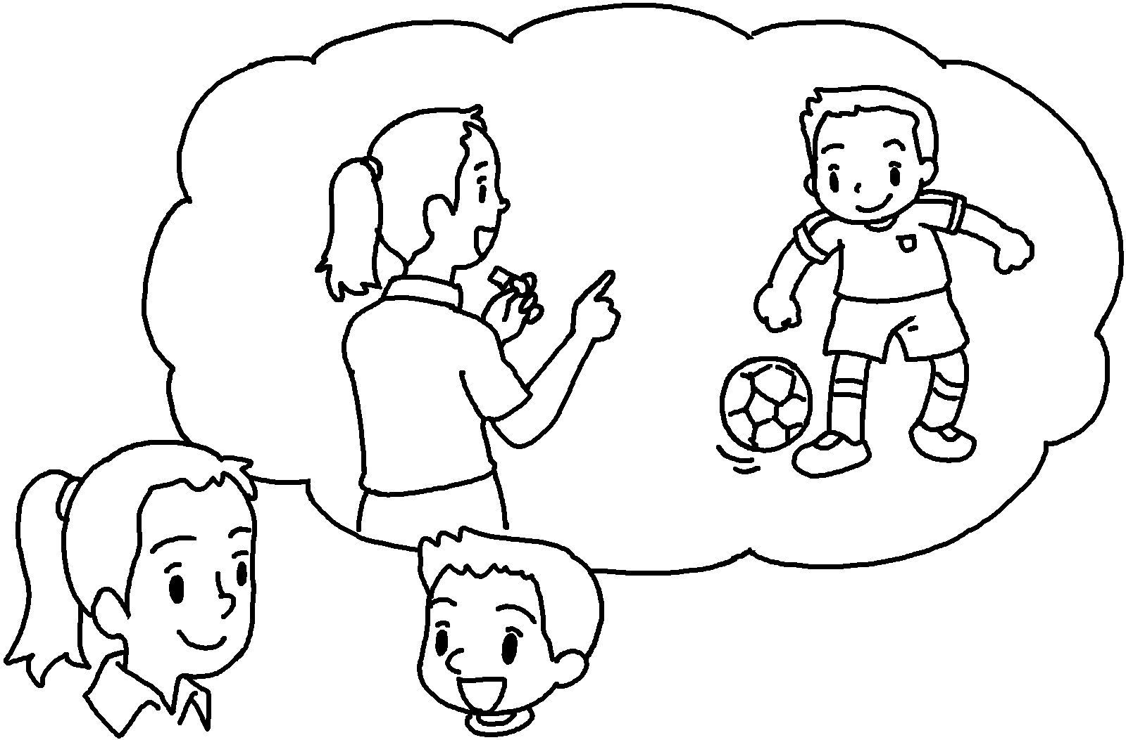
5 | I am  ( talk ) in class. | 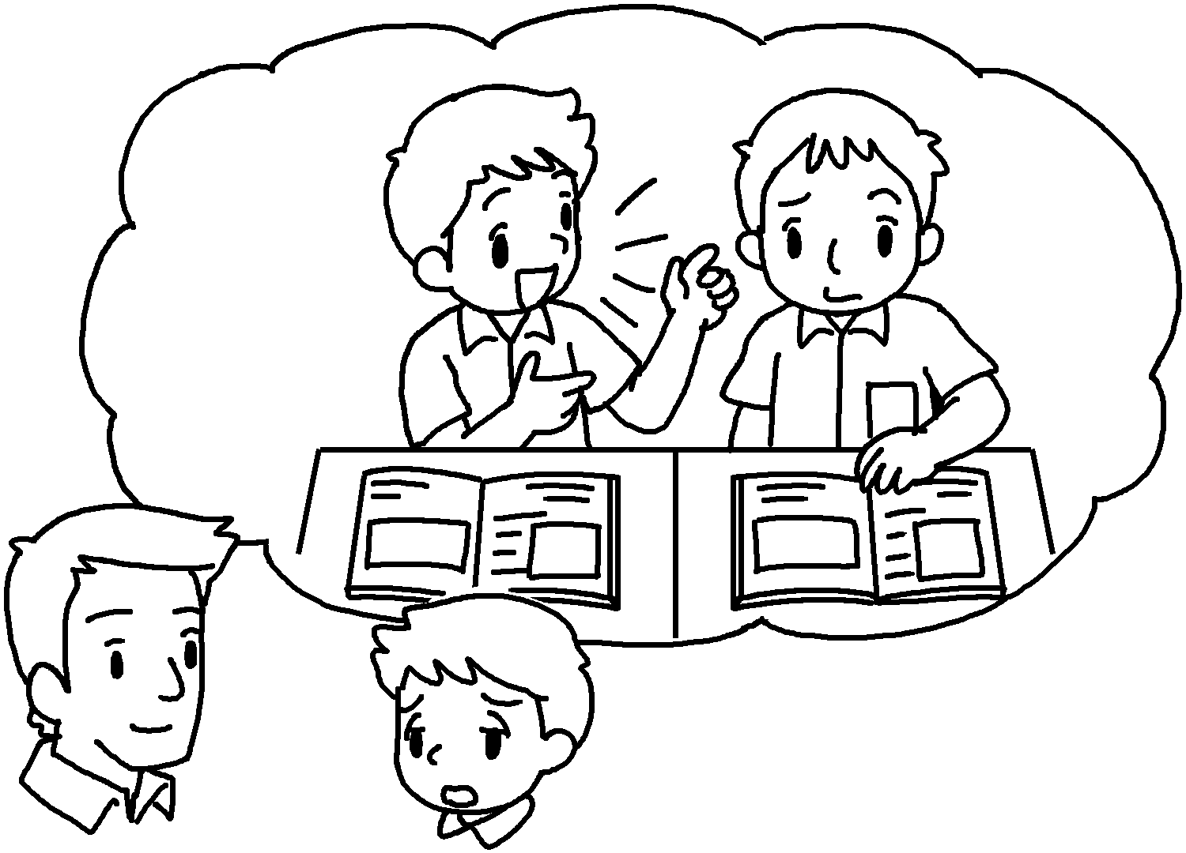


Book 6bBChapter 7 Graded Worksheets
Worksheet 3⬇
- for teaching
- for playing
- sorry for handing
- thank you for teaching
- sorry for talking

