Finish the sentences using the correct form of the words.
thank you for
sorry for

play teach hand talk

1 | Mr Lam, thank you  us to enjoy teamwork. | 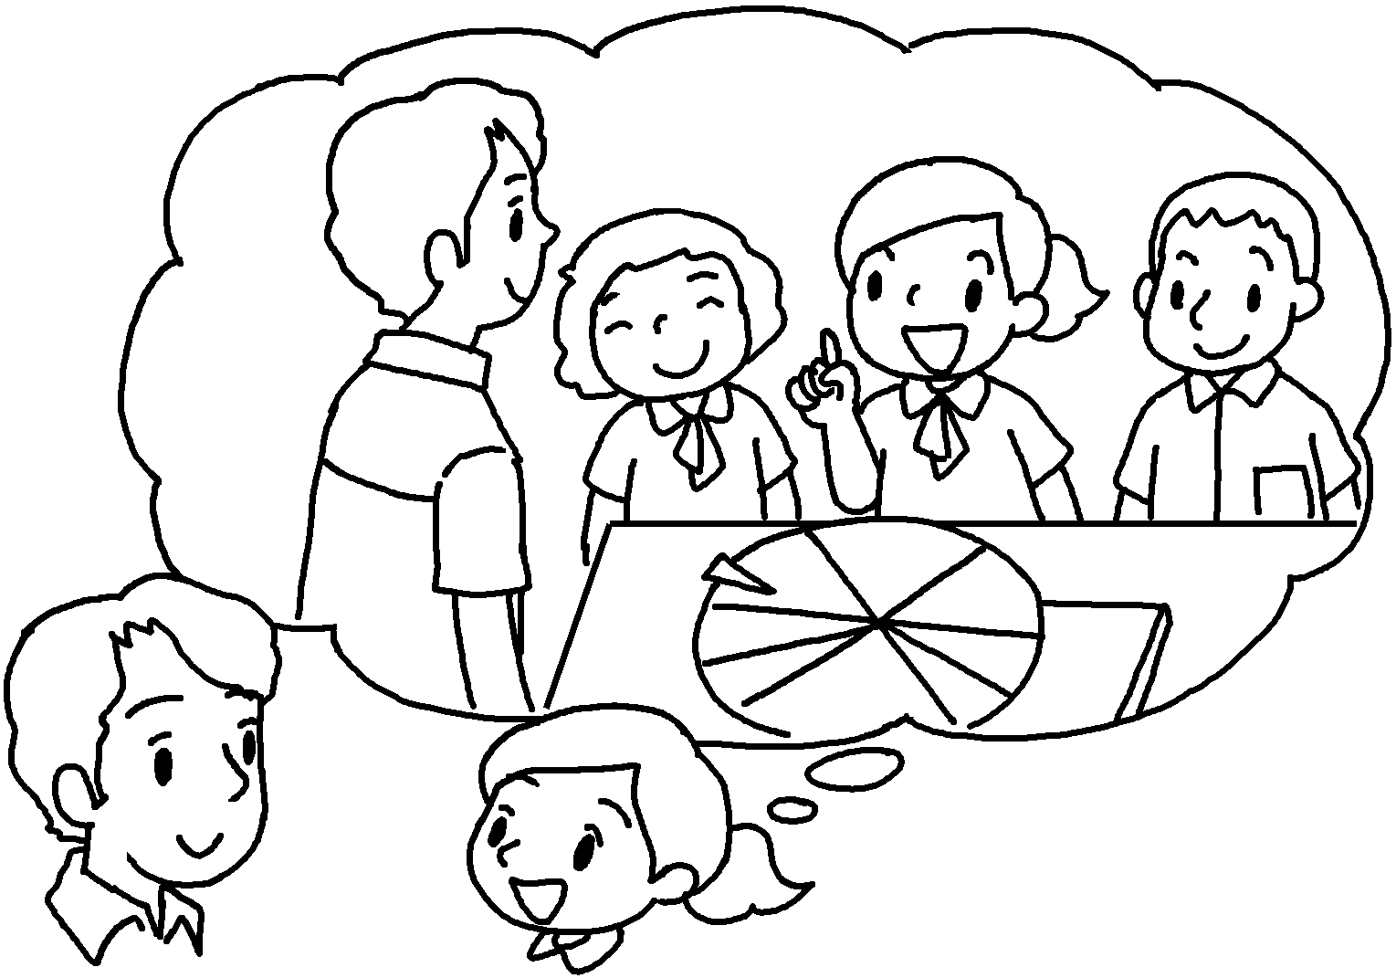
2 | I am sorry  tricks on you. | 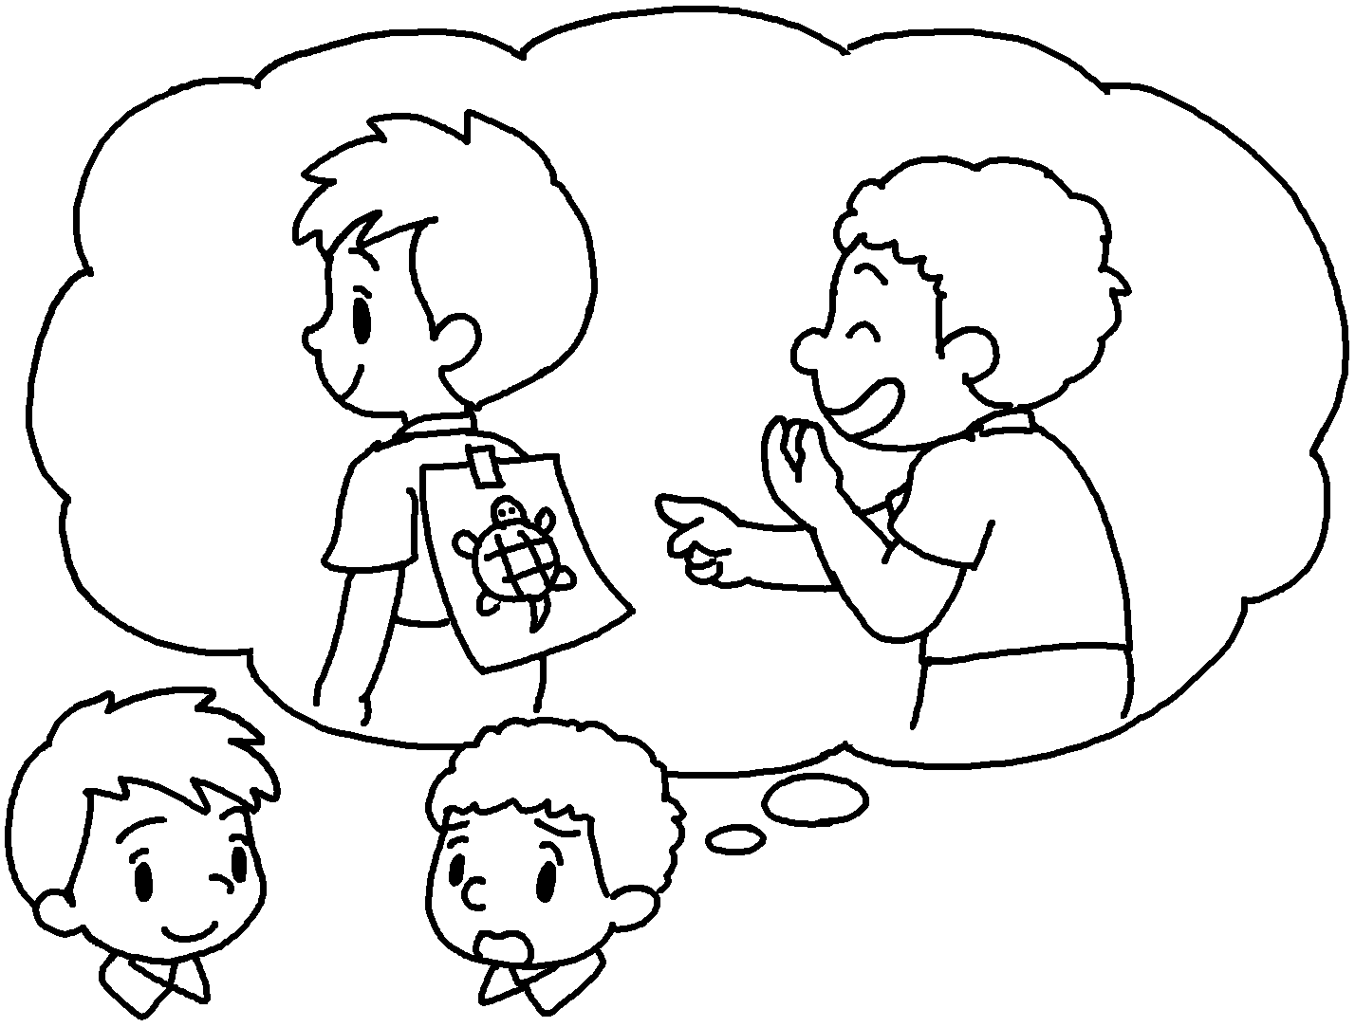
3 | I am  in my homework late. | 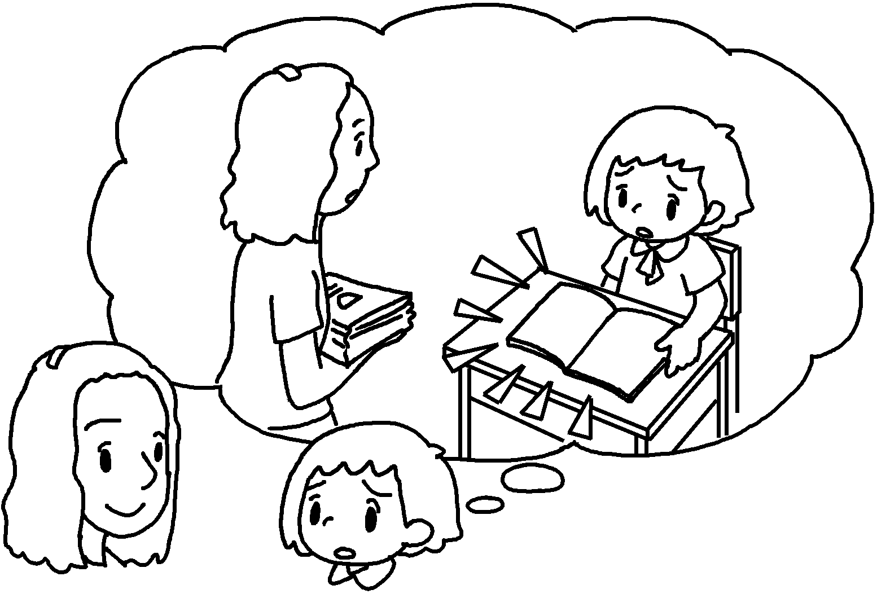
4 | Miss Wu,  me to improve my football skills. | 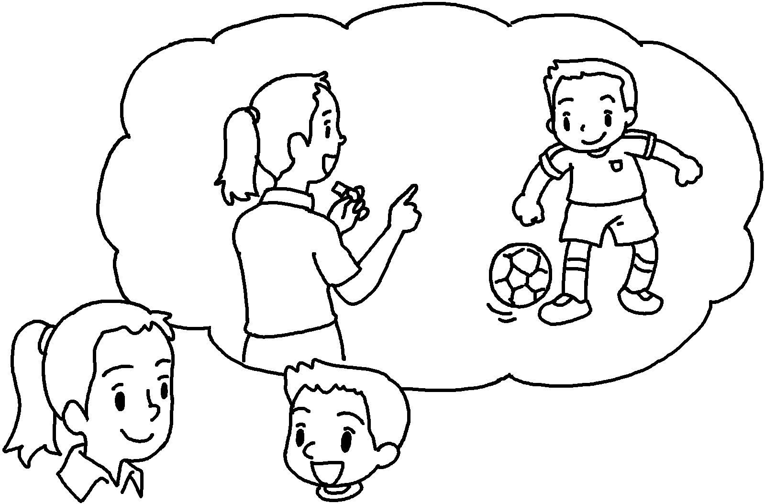
5 | I am  in class. | 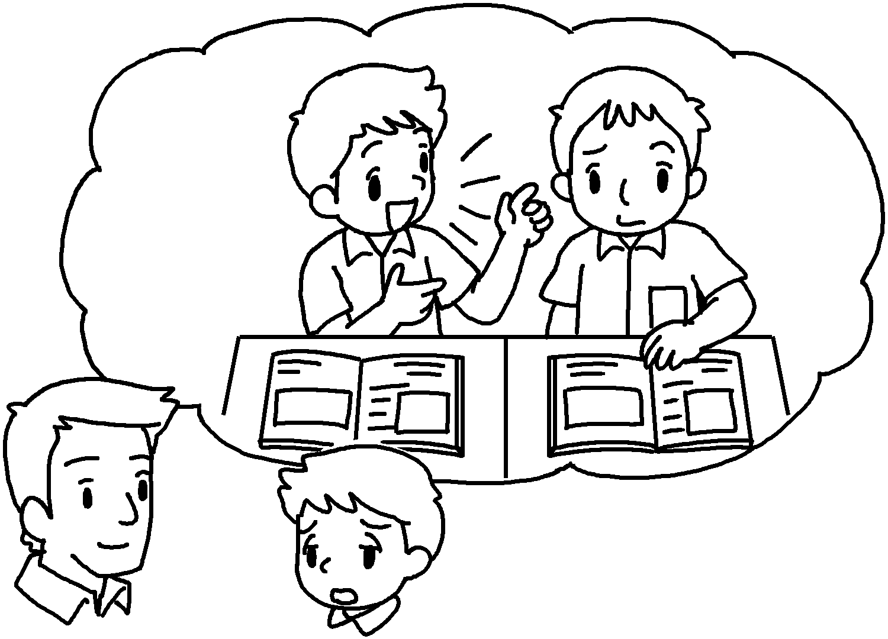


Book 6bBChapter 7 Graded Worksheets
Worksheet 3⬇⬇
- for teaching
- for playing
- sorry for handing
- thank you for teaching
- sorry for talking

