Finish the sentences.
thank you for
sorry for

1  1 | Mr Lam, thank you  us to enjoy teamwork. | 
2 | I am sorry  tricks on you. | 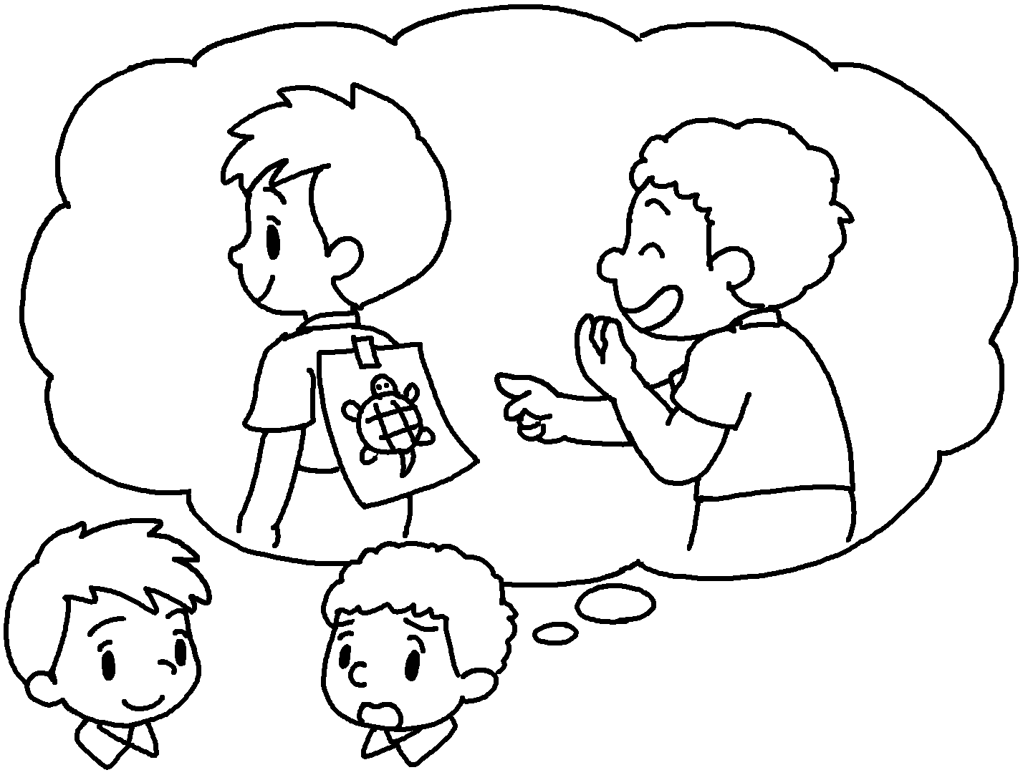
3 | I am  in my homework late. | 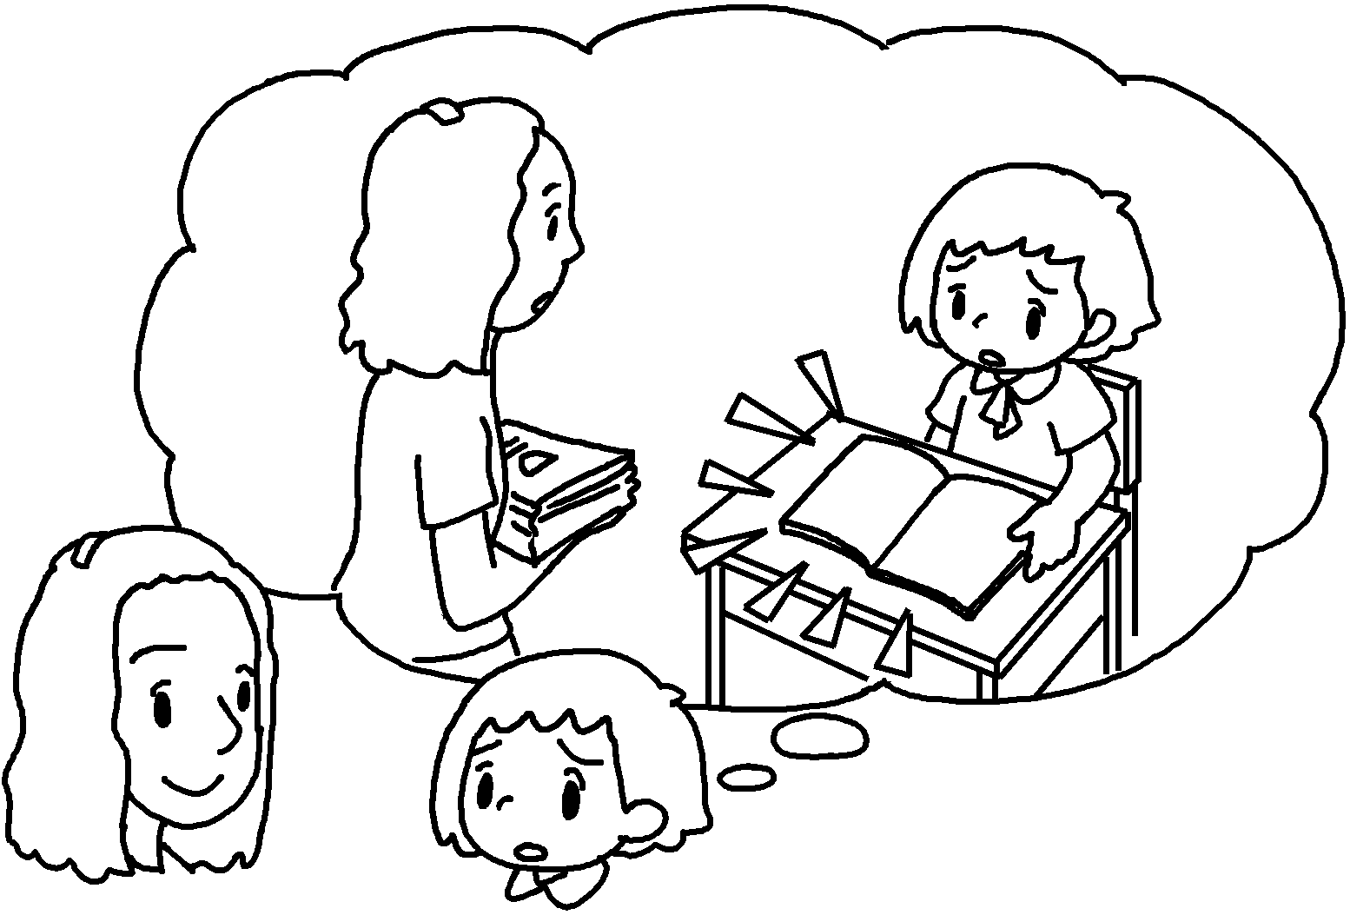
4 | Miss Wu,  me to improve my  skills. | 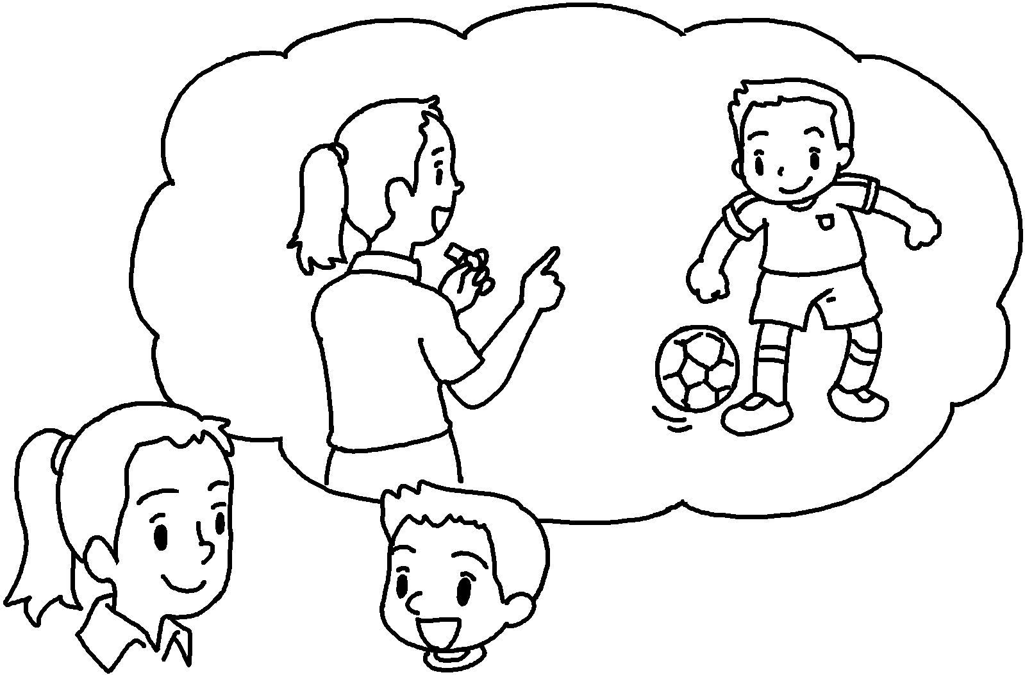
5 | I am  in . | 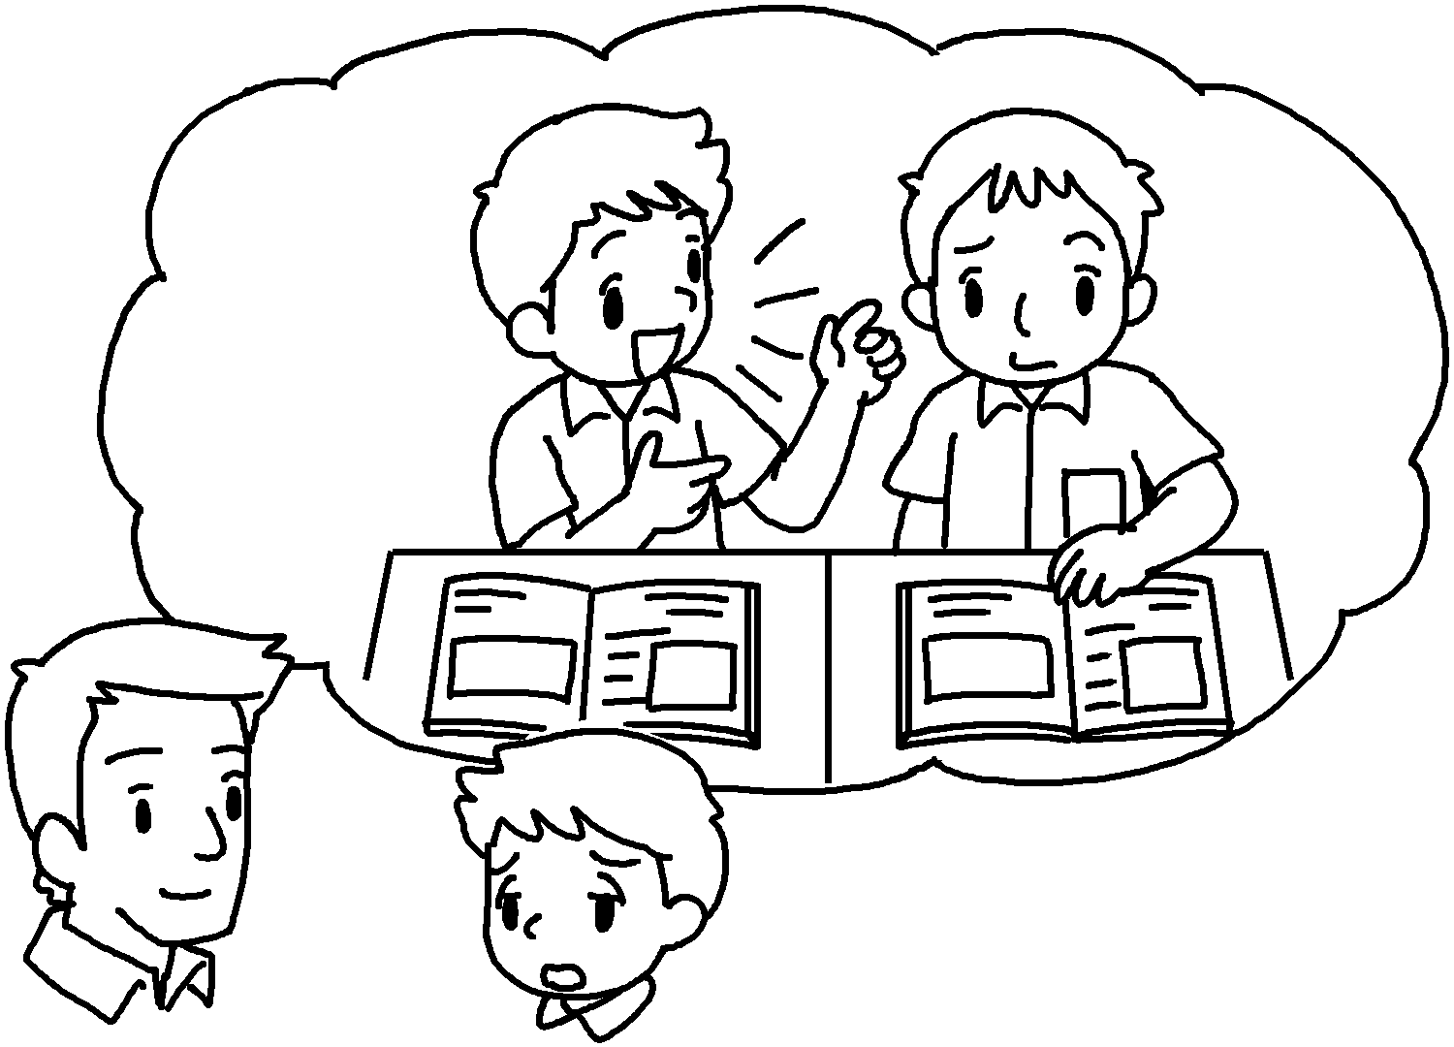


Book 6bBChapter 7 Graded Worksheets
Worksheet 3⬇⬇⬇
- for teaching
- for playing
- sorry for handing
- thank you for teaching football
- sorry for talking class
(Accept any reasonable answers.)

