Choose and write.
ball | car | doll | gun
plane | robot | teddy bear | train

1 | 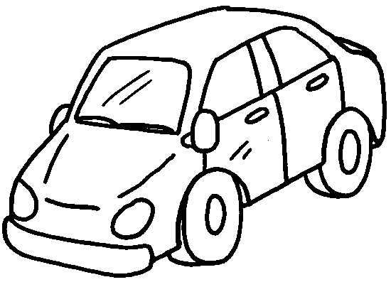 | 2 | 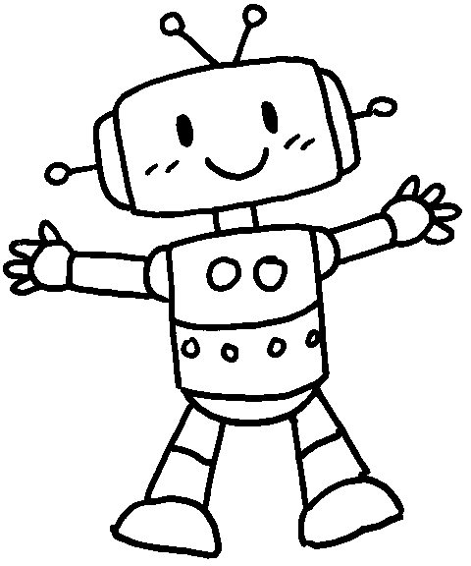
 | a |  | a
3 | 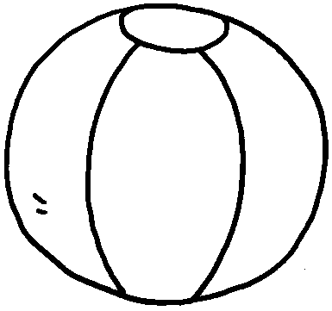 | 4 | 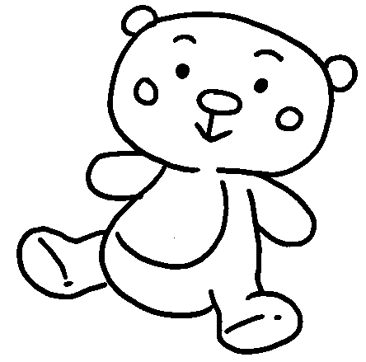
 | a |  | a
5 | 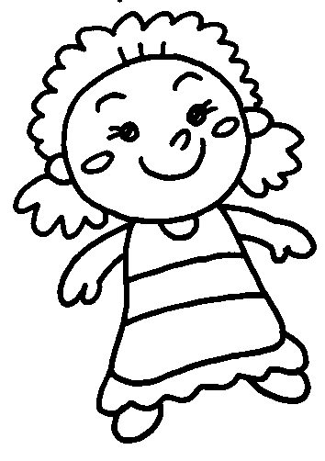 | 6 | 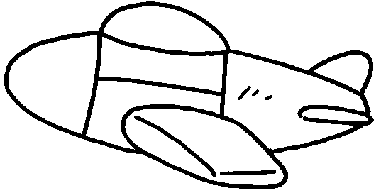
 | a |  | a
7 | 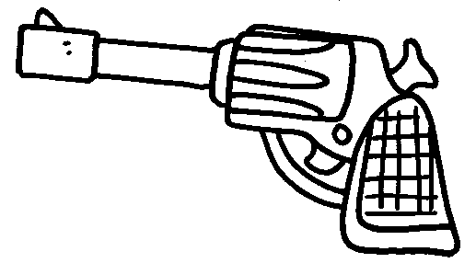 | 8 | 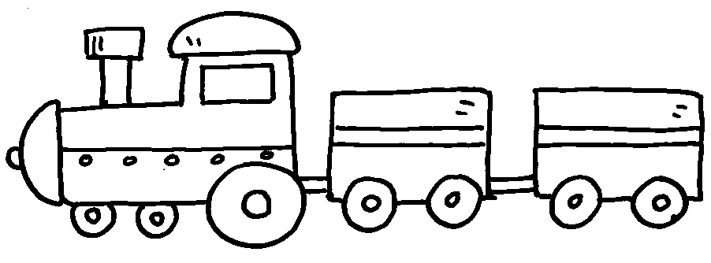
 | a |  | a


Book 1B Chapter 1 Graded Worksheets
Worksheet 1⬇
- car 2 robot
3 ball 4 teddy bear
5 doll 6 plane
7 gun 8 train

