Fill in the missing letters.

1 | 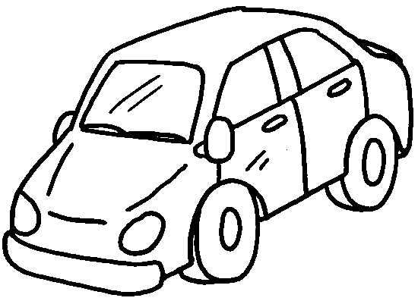 | 2 | 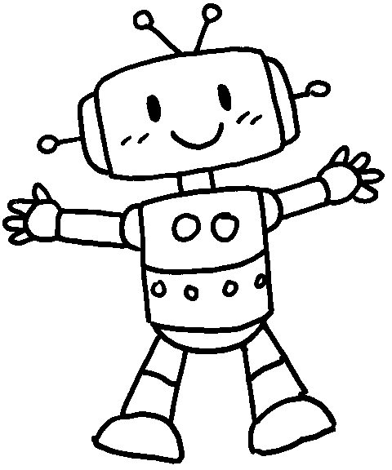
 | a c __ __ |  | a r __ __ __ __
3 | 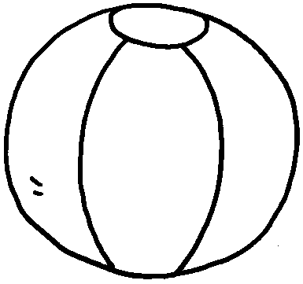 | 4 | 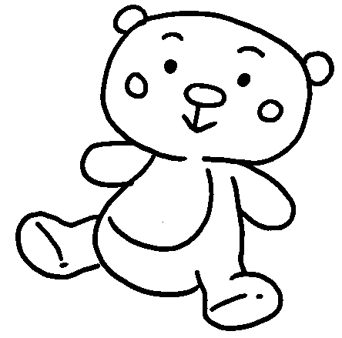
 | a b __ __ __ |  | a t __ __ __ __ b __ __ __
5 | 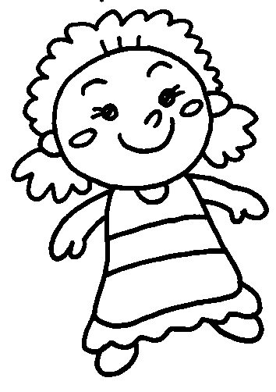 | 6 | 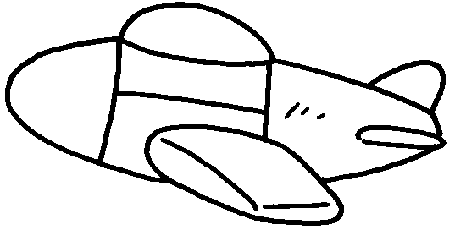
 | a d __ __ __ |  | a p __ __ __ __
7 | 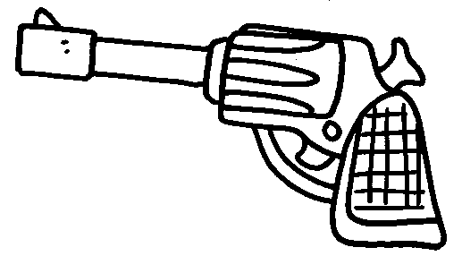 | 8 | 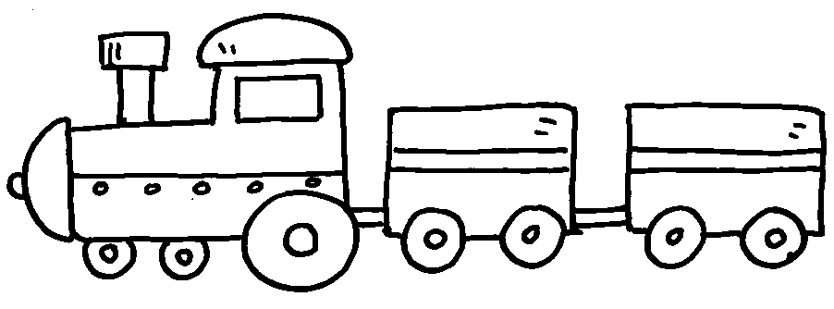
 | a g __ __ |  | a t __ __ __ __


Book 1B Chapter 1 Graded Worksheets
Worksheet 1⬇⬇
- c a r 2 r o b o t
3 b a l l 4 t e d d y b e a r
5 d o l l 6 p l a n e
7 g u n 8 t r a i n

