What are they? Write.

1 | 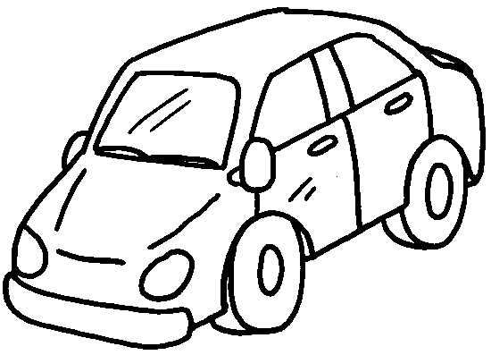 | 2 | 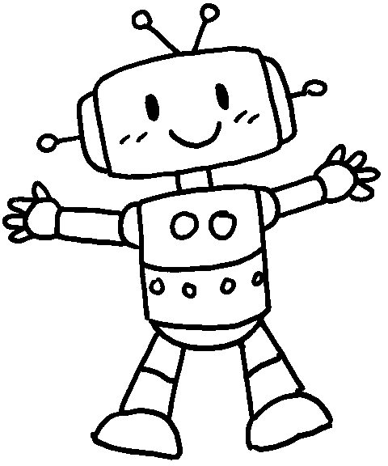
 | a c |  | a r
3 | 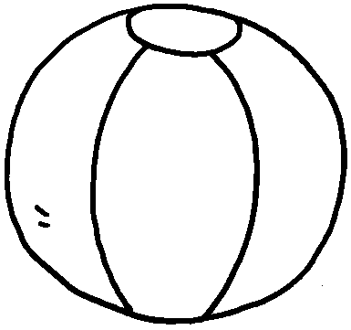 | 4 | 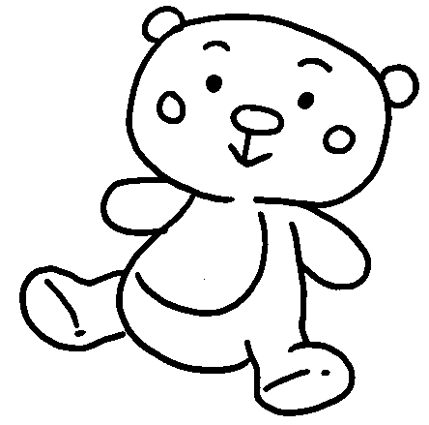
 | ___ |  | ___
5 |  | 6 | 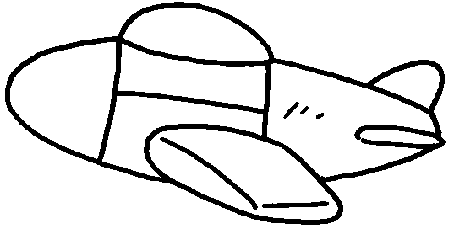
 | ___ |  | ___
7 | 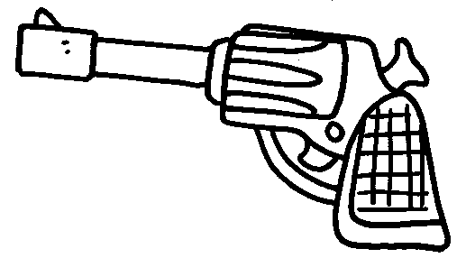 | 8 | 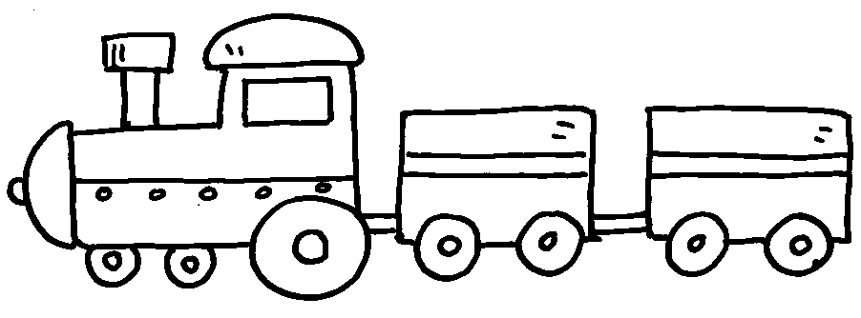
 | ___ |  | ___


Book 1B Chapter 1 Graded Worksheets
Worksheet 1⬇⬇⬇
- car 2 robot
3 a ball 4 a teddy bear
5 a doll 6 a plane
7 a gun 8 a train

