Circle the correct answers.
Good morning, Kate.
Good morning, Tom.
Good afternoon, Tom.
Goodbye, Tom.
Good morning, Jack.
Good afternoon, Jack.
Goodbye, Jack.
Goodbye, Andy.

1  A  B |  | A : I have a gun.  B : What colour is it?  A : ( It is / They are ) black.
2  A  B  A  B | 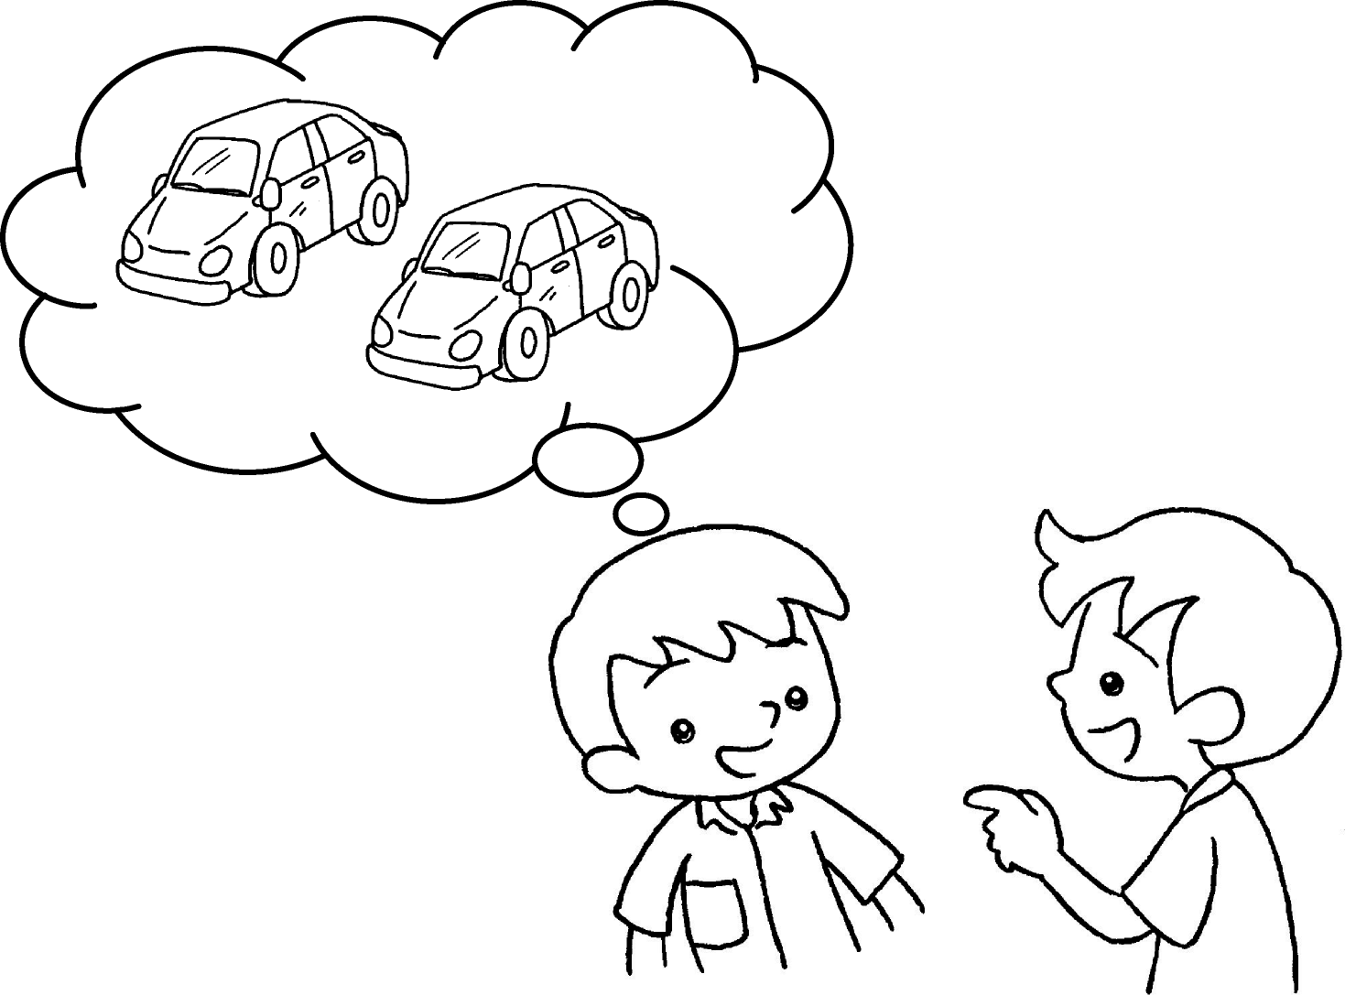 | A : I have two cars.  B : What colour ( is it / are they )?  A : They are pink.
3 | 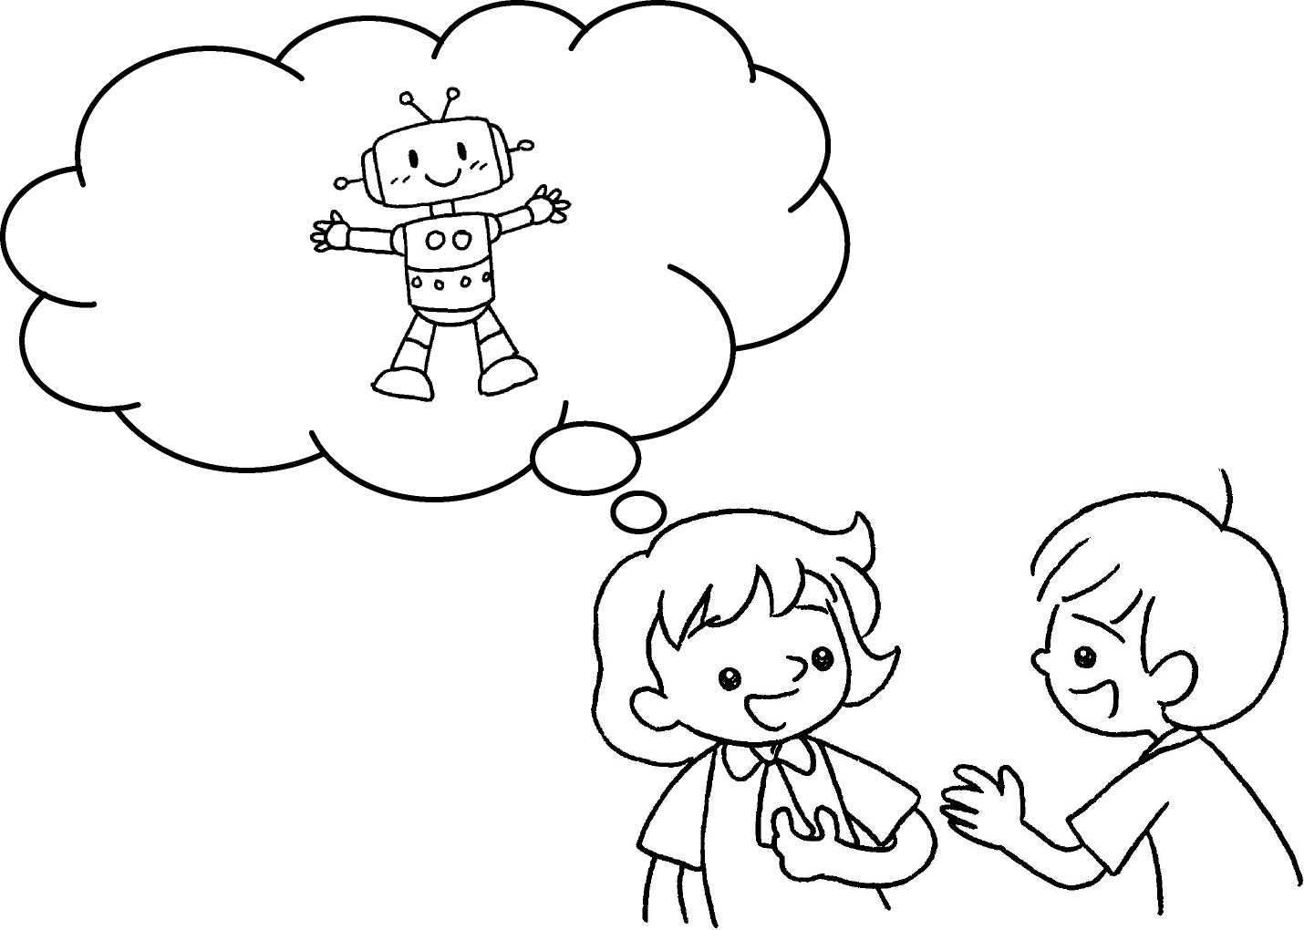 | A : I have a robot.  B : What colour ( is it / are they )?  A : ( It is / They are ) yellow.
4  A  B | 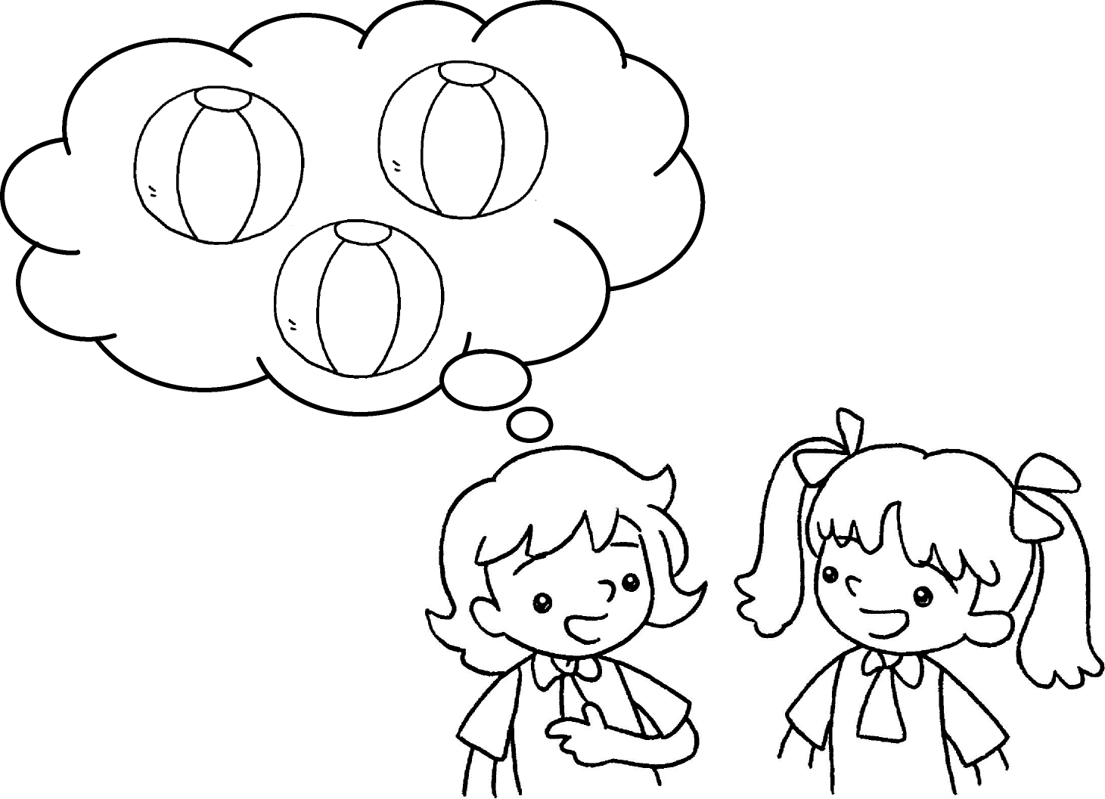 | A : I have three balls.  B : What colour ( is it / are they )?  A : ( It is / They are ) blue.
Good morning, Kate.
Good morning, Tom.
Good afternoon, Tom.
Goodbye, Tom.
Good morning, Jack.
Good afternoon, Jack.
Goodbye, Jack.
Goodbye, Andy.


Book 1B Chapter 1 Graded Worksheets
Worksheet 2⬇
- ( It is / They are )
- ( is it / are they )
- ( is it / are they )
( It is / They are )
- ( is it / are they )
( It is / They are )

