Finish the conversations.
Good morning, Kate.
Good morning, Tom.
Good afternoon, Tom.
Goodbye, Tom.
Good morning, Jack.
Good afternoon, Jack.
Goodbye, Jack.
Goodbye, Andy.

is / are it / they

1  A  B |  | A : I have a gun.  B : What colour is it?  A : It black.
2  A  B  A  B | 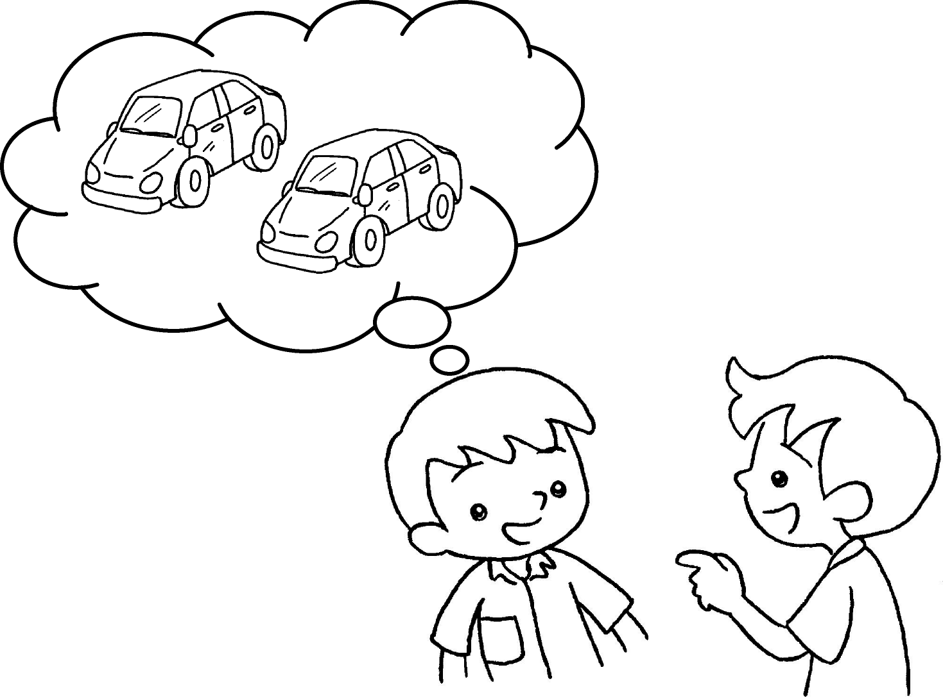 | A : I have two cars.  B : What colour are _______ ?  A : pink.
3 | 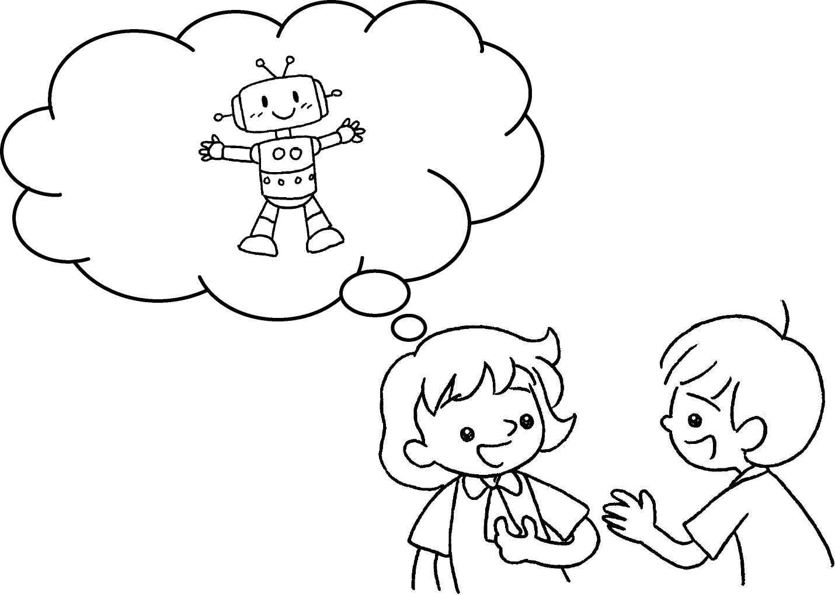 | A : I have a robot.  B : What colour ?  A : _________________ yellow.
4  A  B | 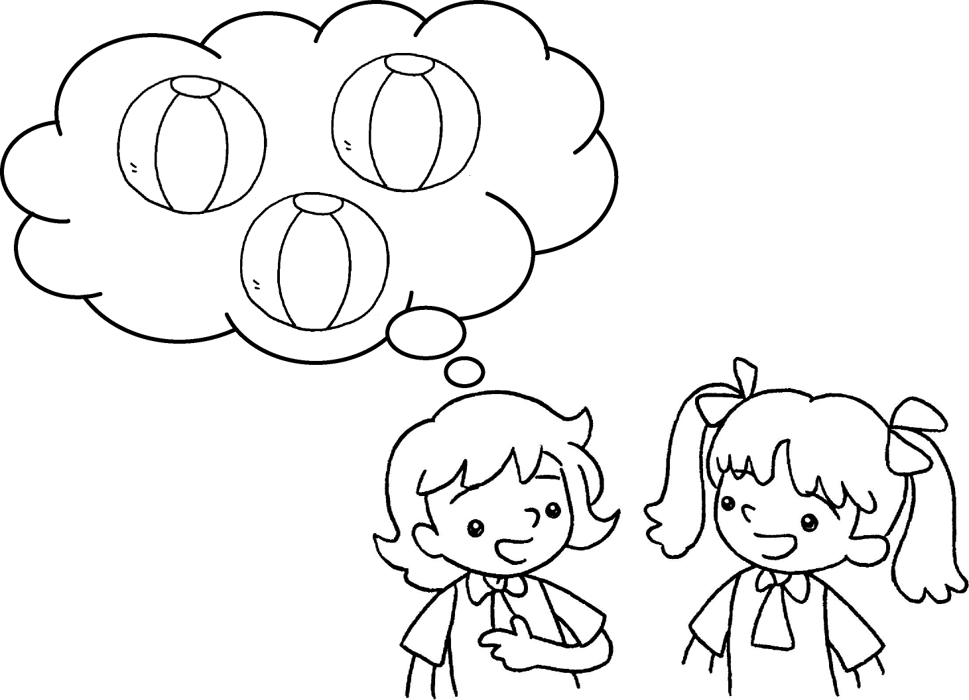 | A : I have three balls.  B : What colour ?  A : blue.


Book 1B Chapter 1 Graded Worksheets
Worksheet 2⬇⬇⬇
- is
- they
They are
- is it
It is
- are they
They are

