Finish the conversations.

1 | 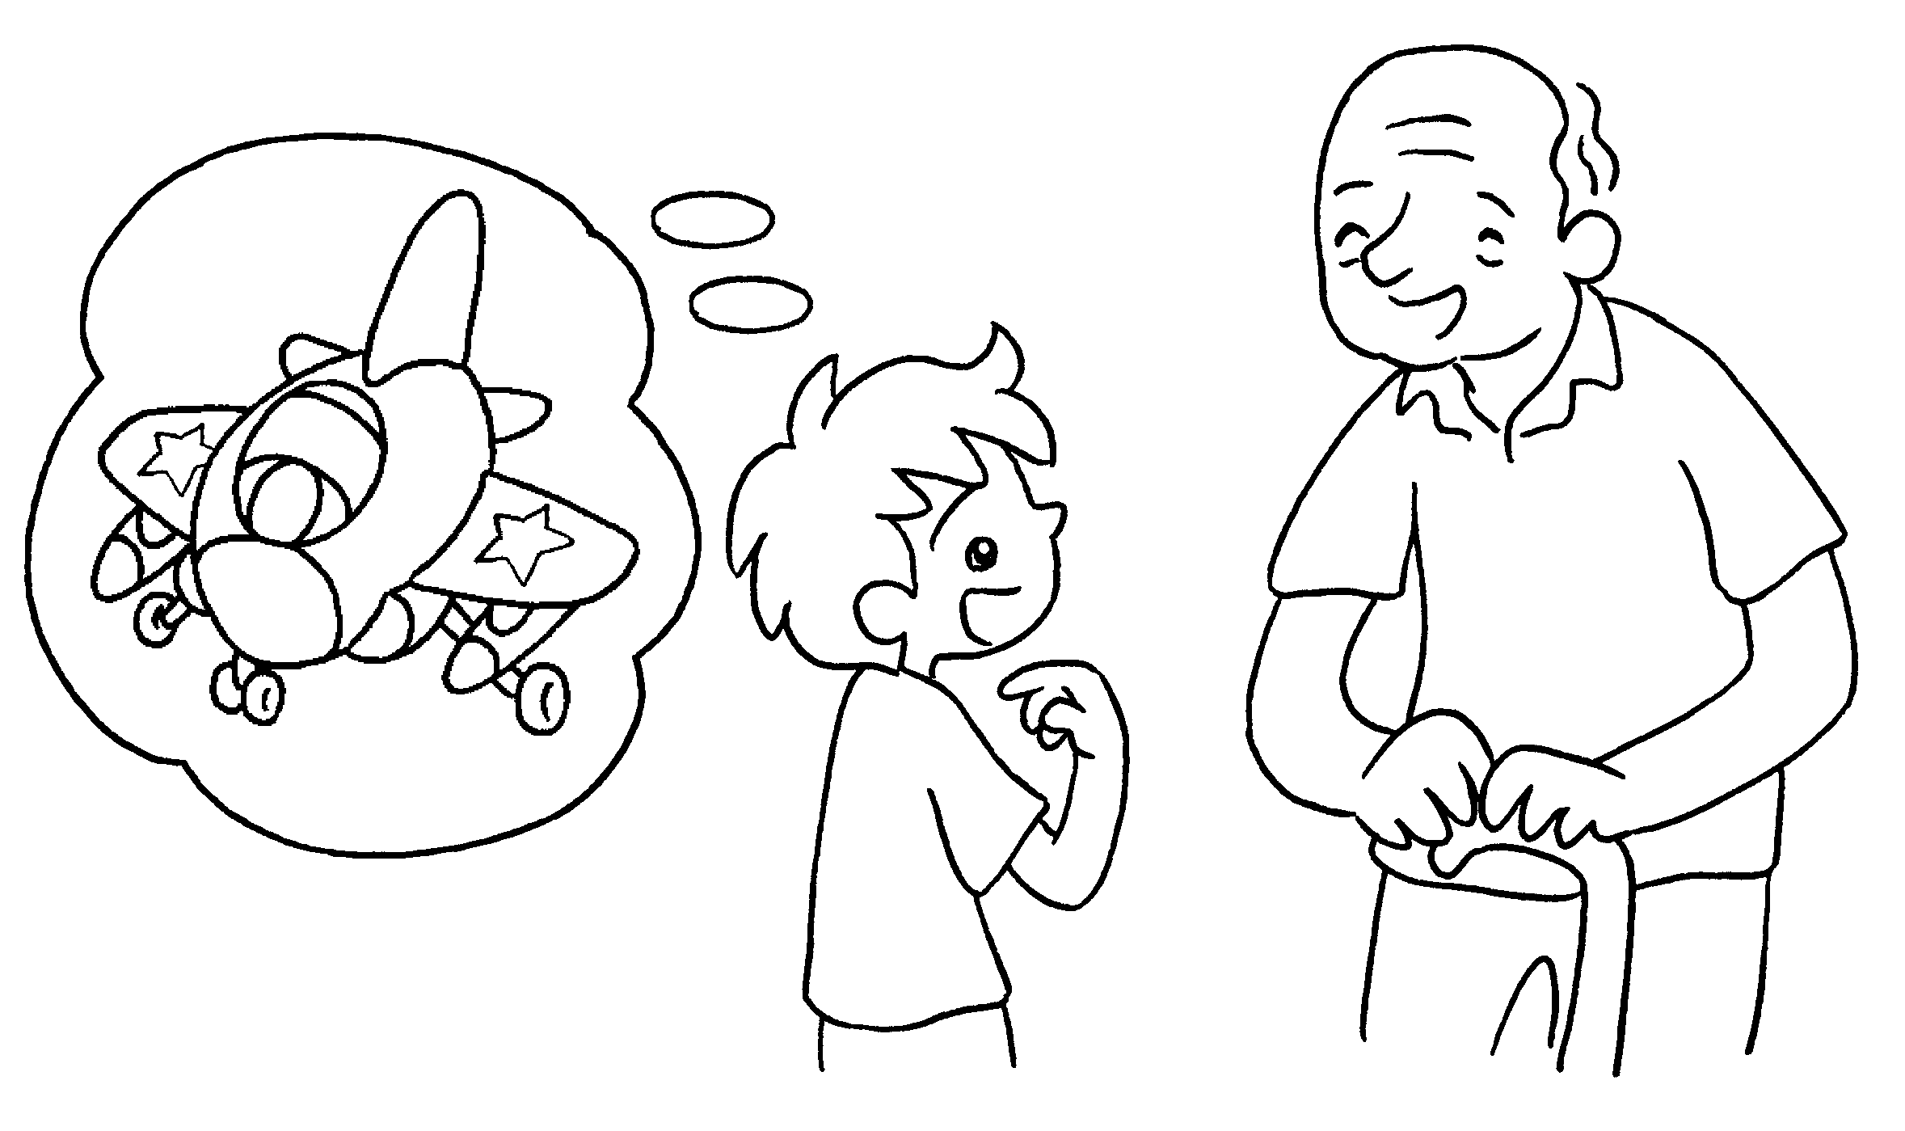  B  A  B  A | A : I have a plane.  B : What colour is it?  A : It is blue and pink.
2 | 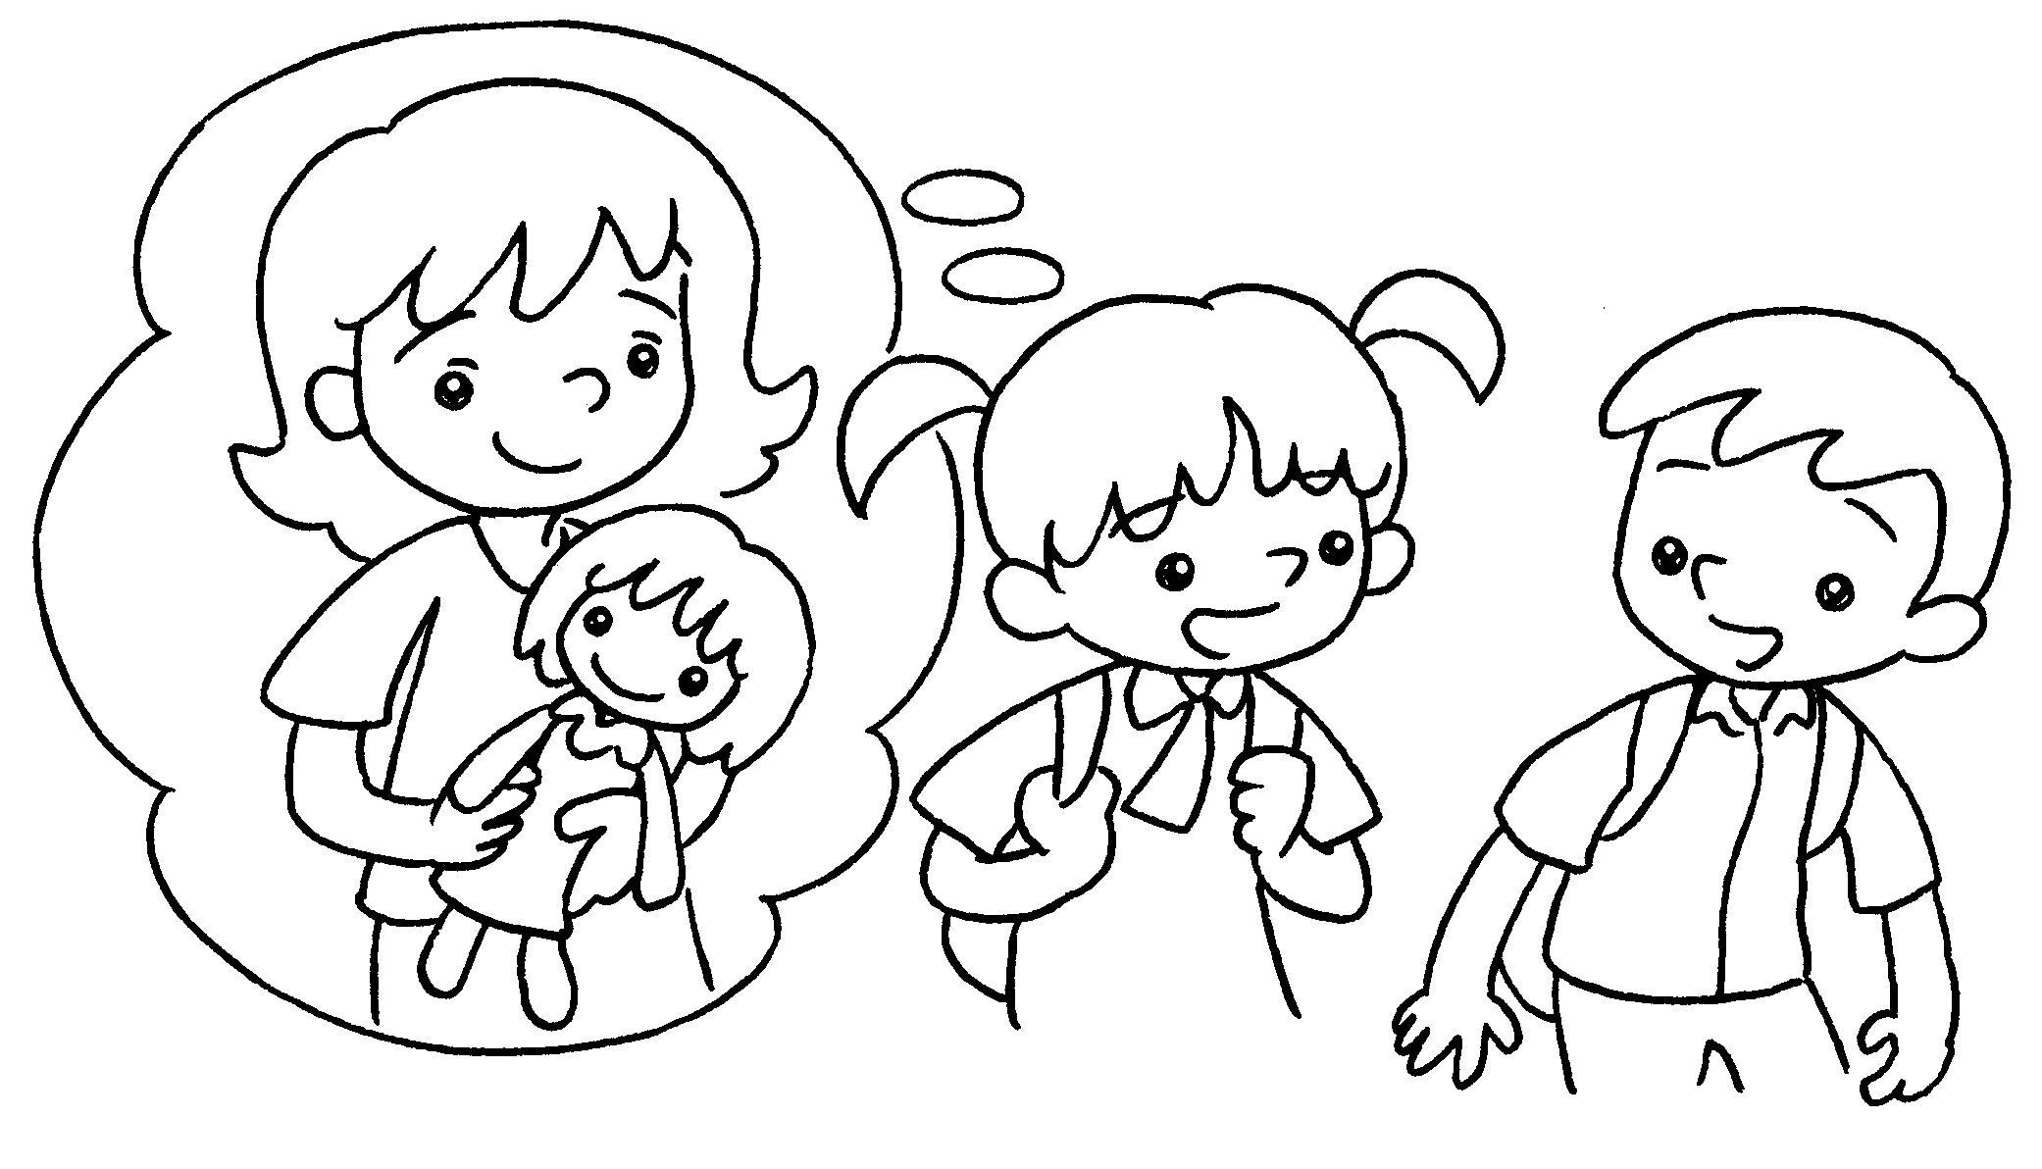 | A : Emma has a doll.  B : is it?  A : It is black _________ white.
3 | 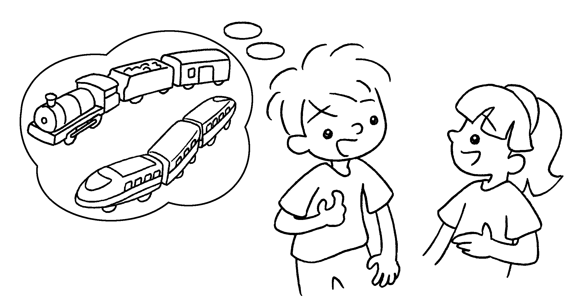  B  A | A : I have two trains.  B : ________ _________ are they?  A : They are yellow  green.
4 | 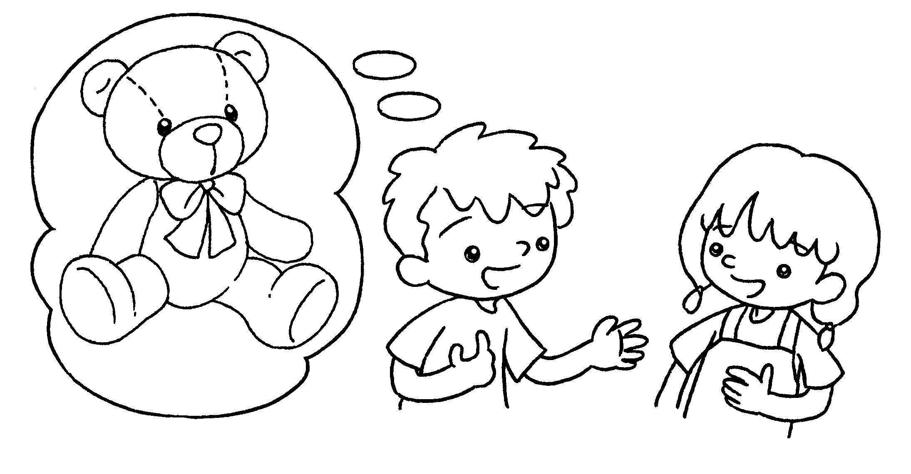  B  A | A : I have a teddy bear.  B : ?  A : It is pink white.


Book 1B Chapter 1 Graded Worksheets
Worksheet 3⬇⬇
- What colour
and
- What colour
and
- What colour is it
and

