Choose and write.
blouse | jacket | shirt | T-shirt

1 | 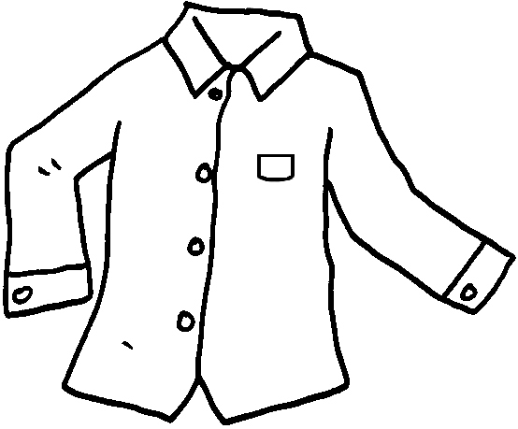 | 2 | 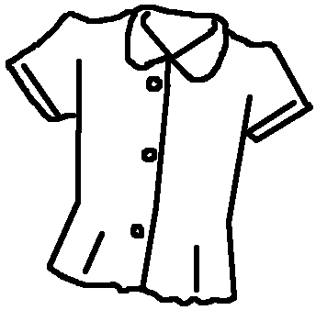
 | a |  | a
3 | 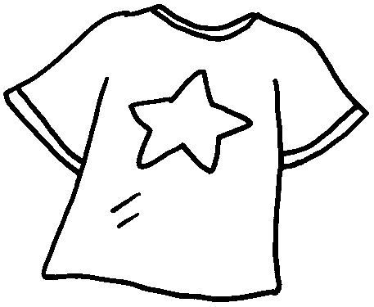 | 4 | 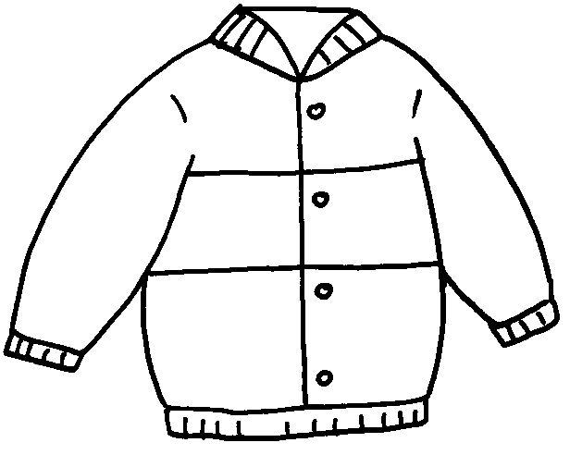
 | a |  | a

dress | skirt | shorts | trousers

5 | 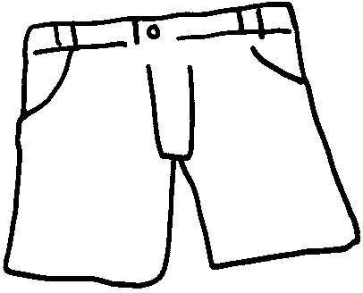 | 6 | 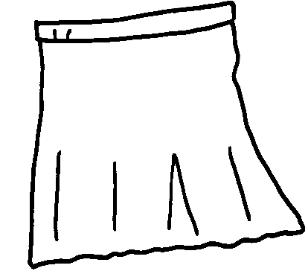
 |  |  | a
7 | 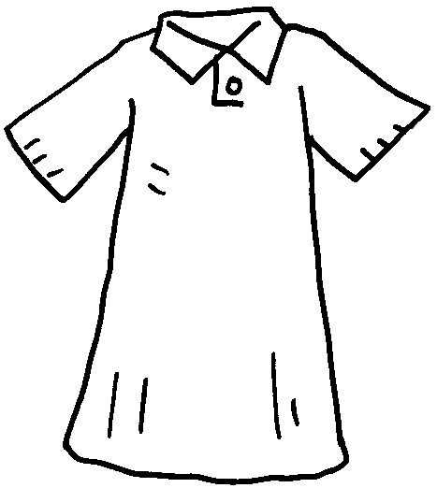 | 8 | 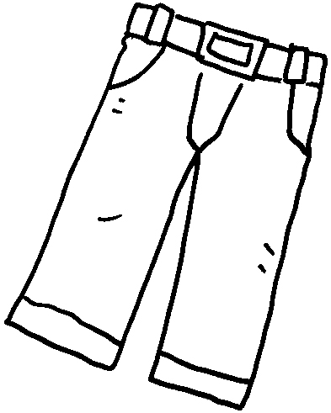
 | a

hat | shoes | socks

9 | 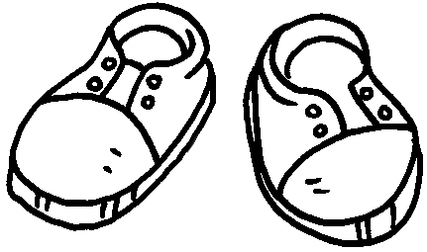 | 10 | 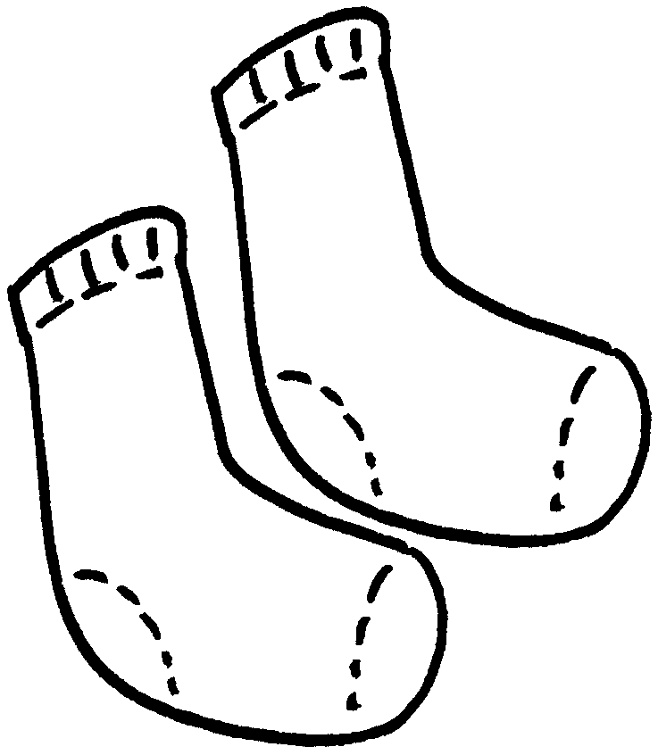 | 11 | 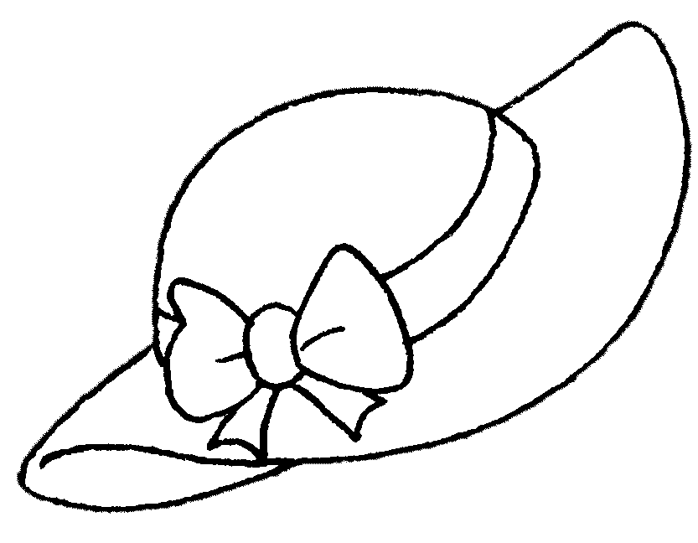
 |  |  |  |  | a


Book 1B Chapter 2 Graded Worksheets
Worksheet 1⬇
- shirt 2 blouse
3 T-shirt 4 jacket
5 shorts 6 skirt
7 dress 8 trousers
9 shoes 10 socks 11 hat

