Put the letters in the correct order to form words.

1 | 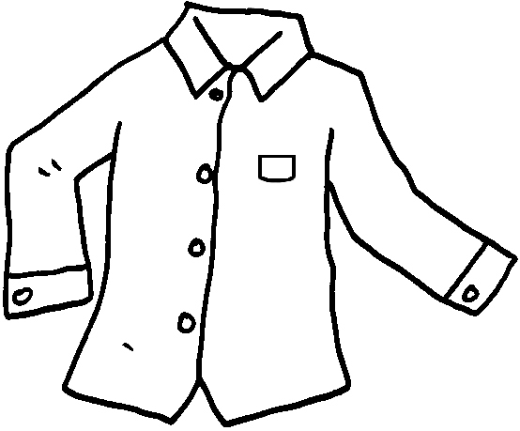 | sirth  a shirt |  |  | 2 | 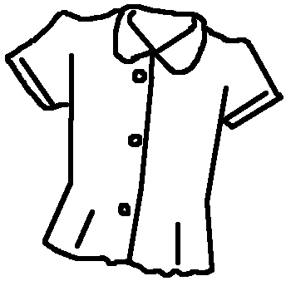 | soblue  a ____________
3 | 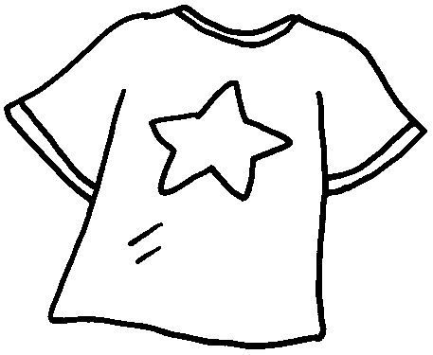 | T-tirhs  a ___________ |  |  | 4 | 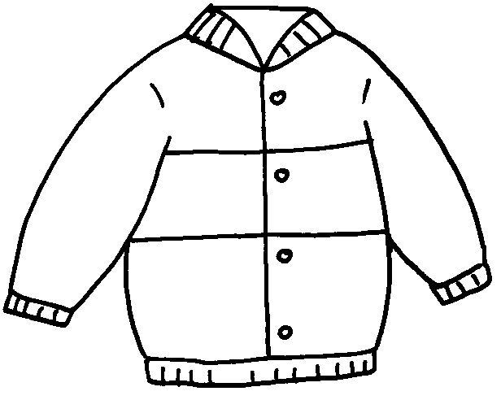 | cajekt  a _____________
5 | 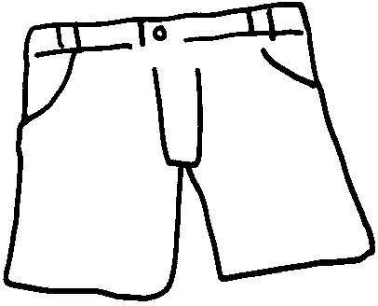 | thsros  _____________ |  |  | 6 | 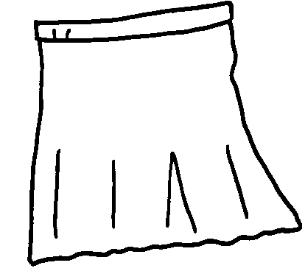 | stirk  a _____________
7 | 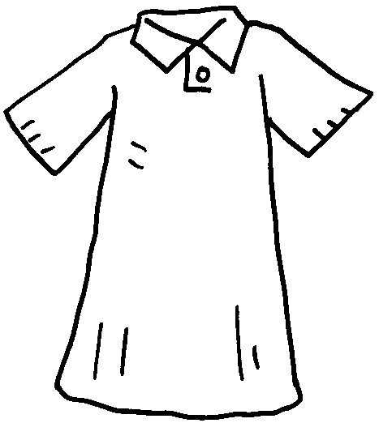 | srsed  a ___________ |  |  | 8 | 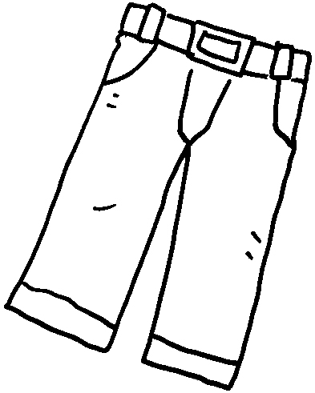 | oursters  _______________
9 | 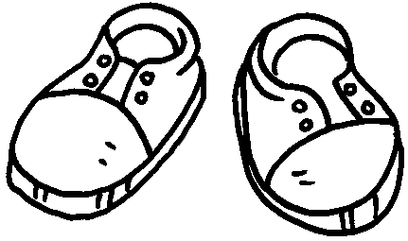 | heoss  _____________ |  | 10 |  | 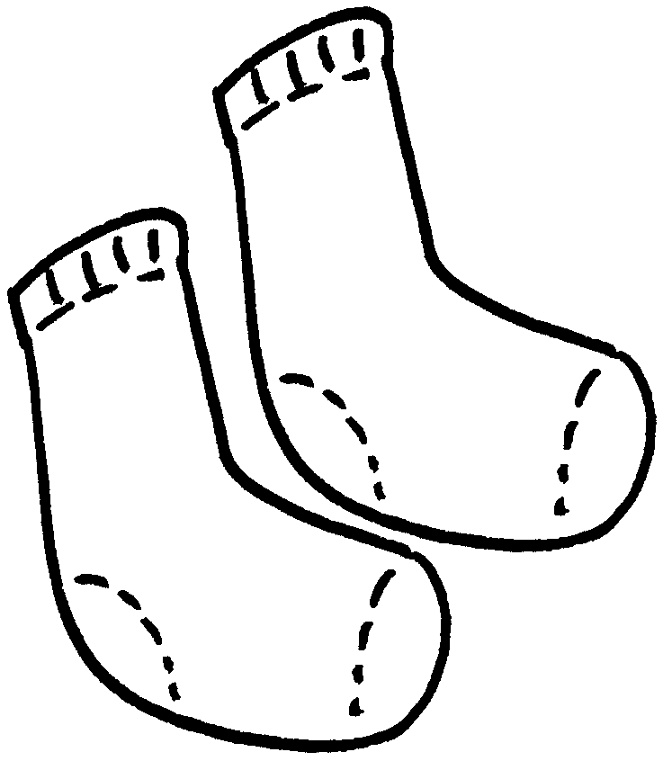 | cosks  _______________
11 |  |  | 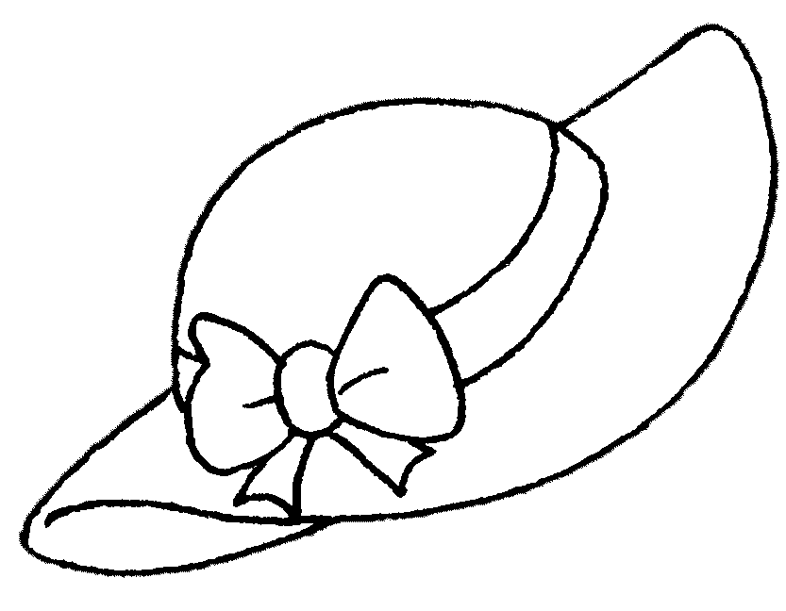 | tha  a ______________


Book 1B Chapter 2 Graded Worksheets
Worksheet 1⬇⬇
- blouse
- T-shirt 4 jacket
5 shorts 6 skirt
7 dress 8 trousers
9 shoes 10 socks 11 hat

