What are they? Write.

1 | 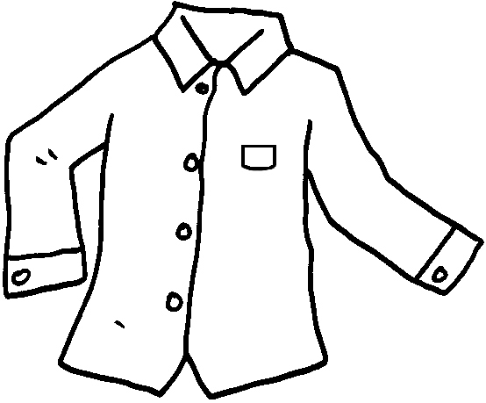 |  |  | 2 | 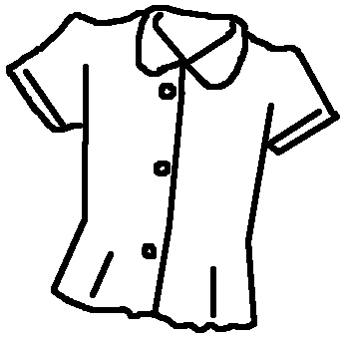
 | a s |  |  |  | a b
3 | 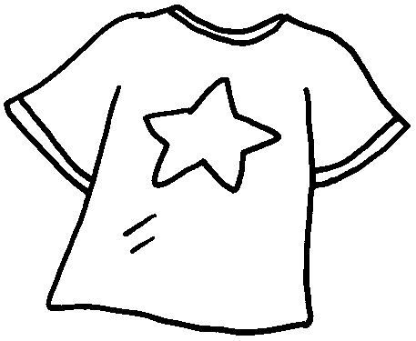 |  |  | 4 | 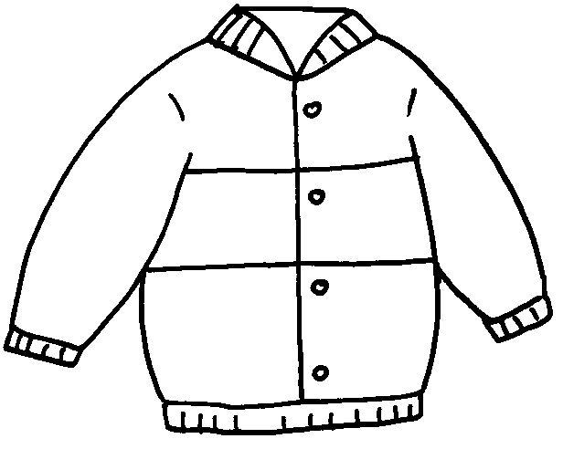
 | a |  |  |  | a
5 | 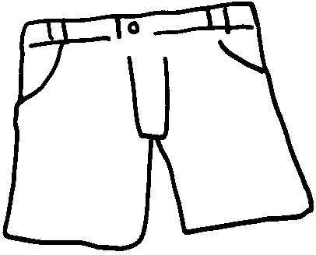 |  |  | 6 | 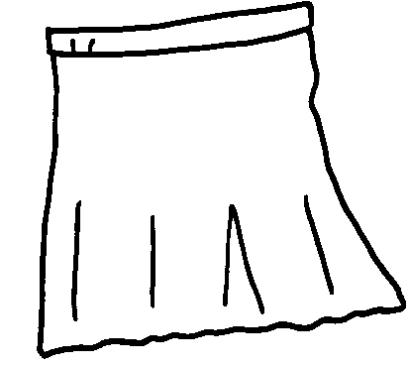
 |  |  |  |  | ____
7 | 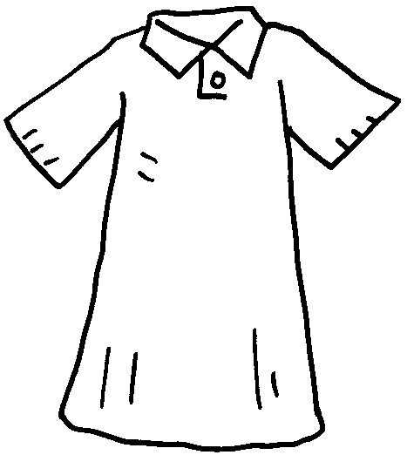 |  |  | 8 | 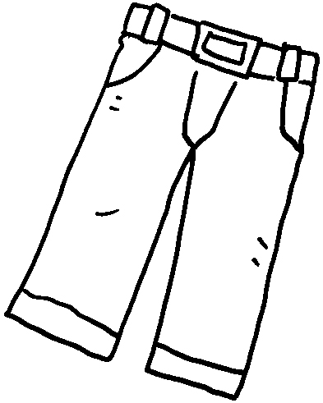
 | ____
9 | 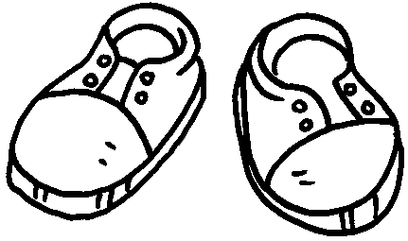 | 10 | 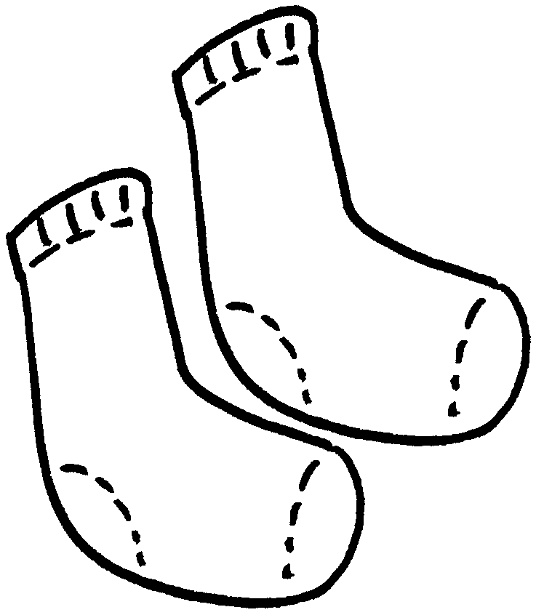 |  |  | 11 | 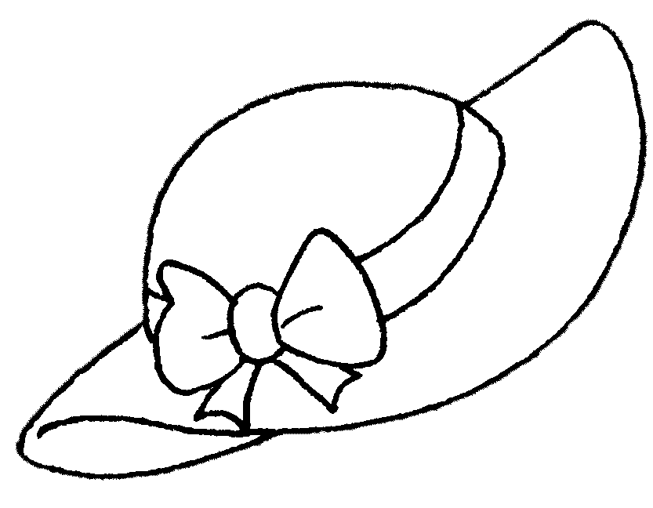
 |  |  |  |  |  |  | ___


Book 1B Chapter 2 Graded Worksheets
Worksheet 1⬇⬇⬇
1 shirt 2 blouse
3 T-shirt 4 jacket
5 shorts 6 a skirt
7 a dress 8 trousers
9 shoes 10 socks 11 a hat

