Choose and write.
His | Her

1 | 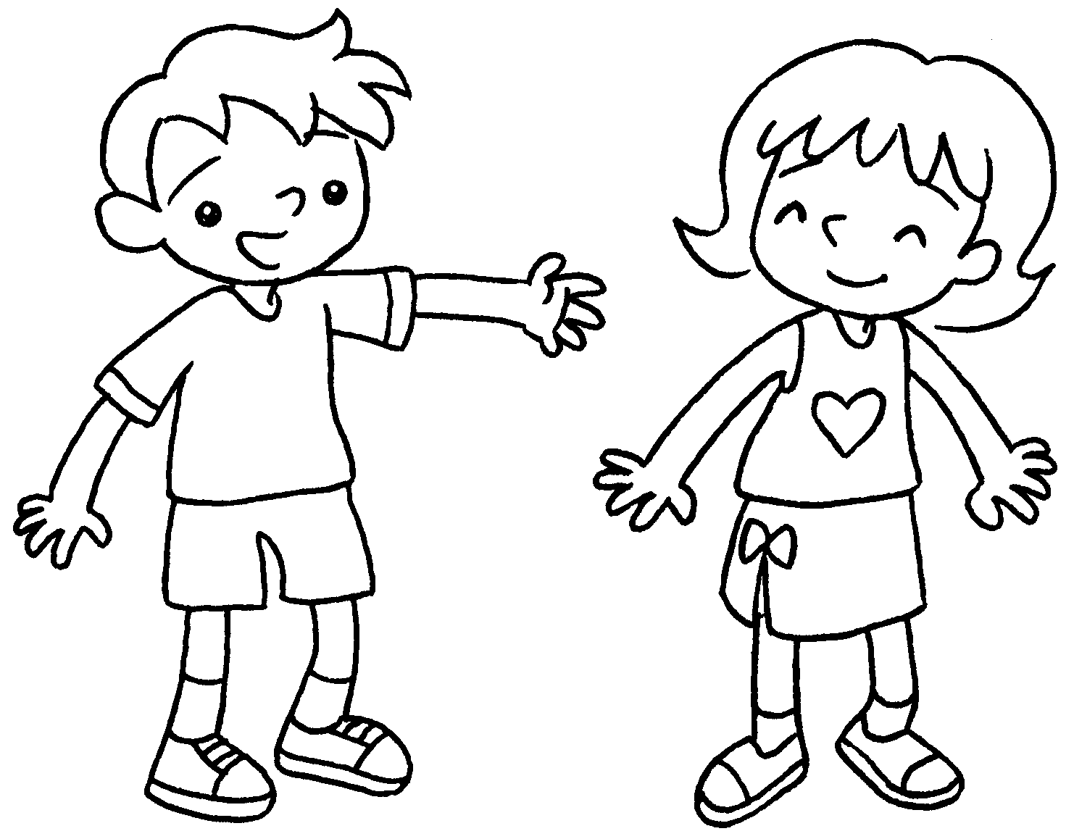  … | This is Tina.  skirt is white.
2 | 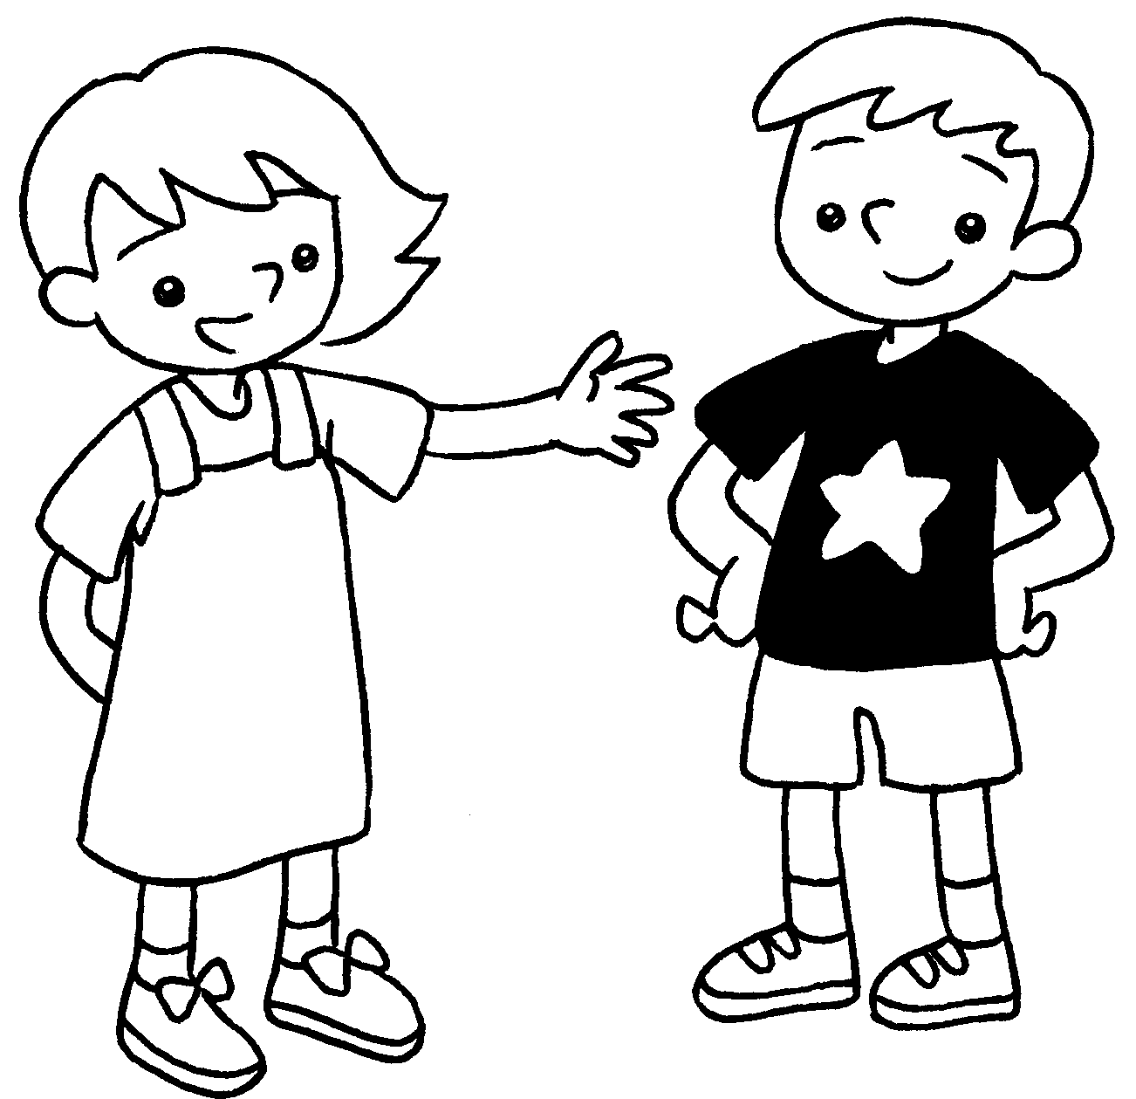  … | This is Ken.  T-shirt is black and white.
3 | 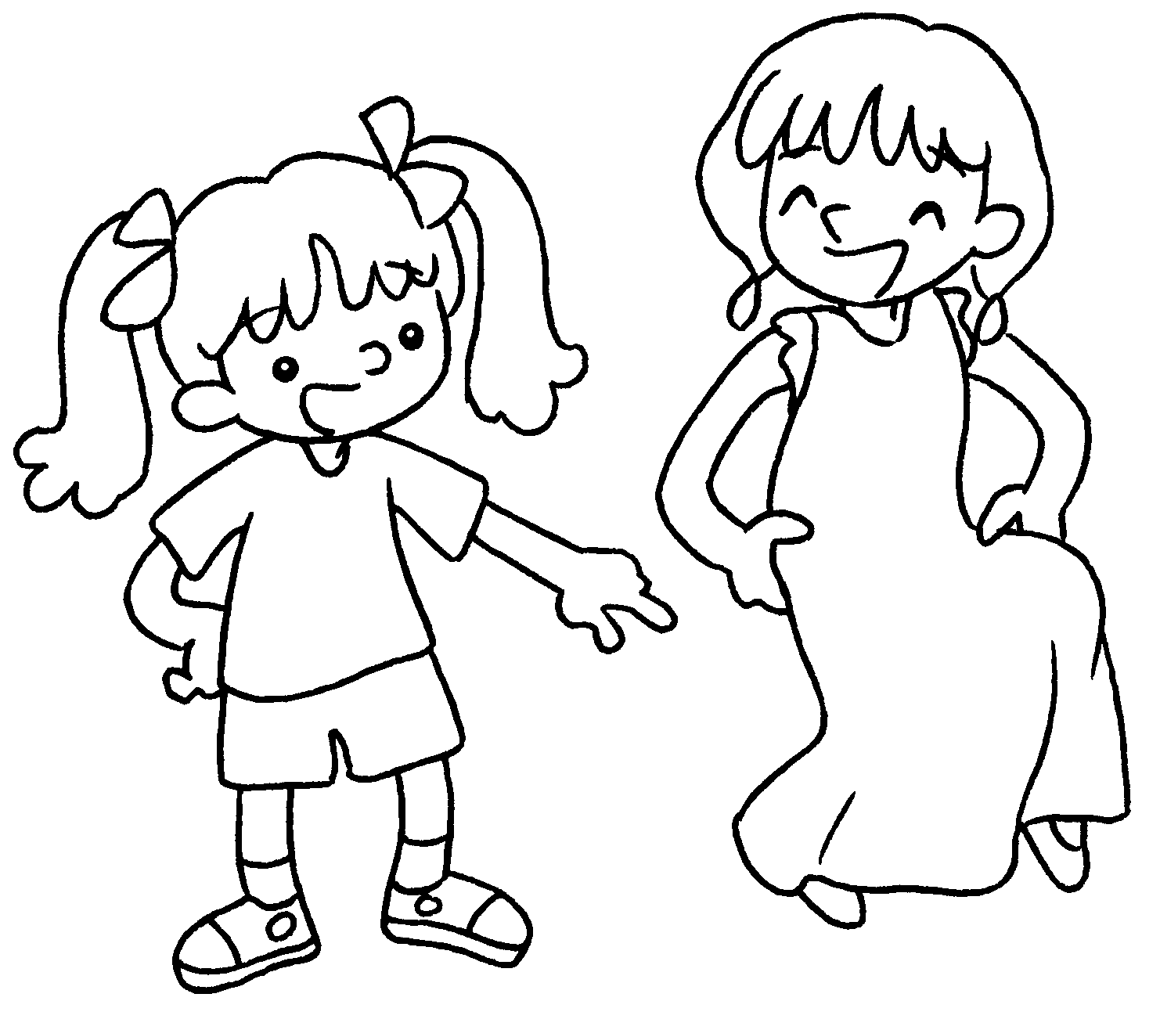  … | Look at Kitty.  dress is long.
4 | 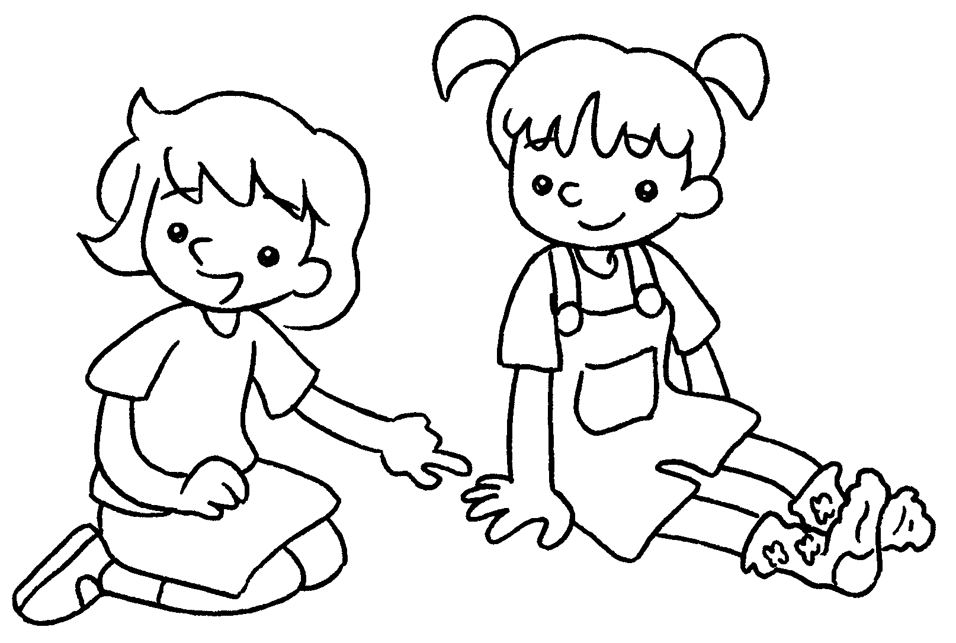  … | Look at Mary.  socks are purple and blue.
5 | 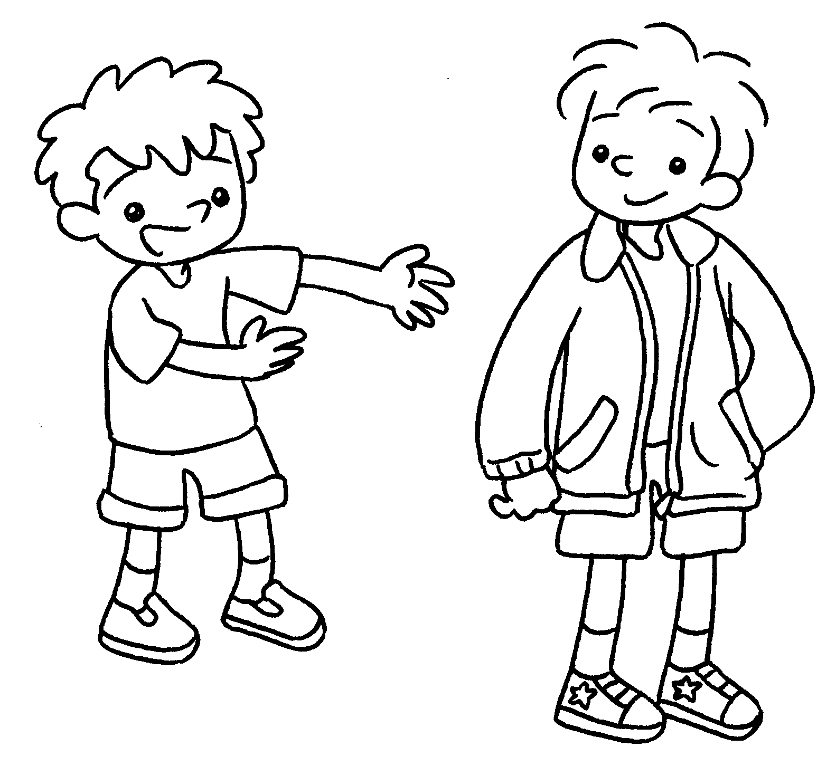  … | This is John.  jacket is red and green.


Book 1B Chapter 2 Graded Worksheets
Worksheet 2⬇
- Her
- His
- Her
- Her
- His

