What are the children saying? Tick ( ✓ ) the correct boxes.

1 | 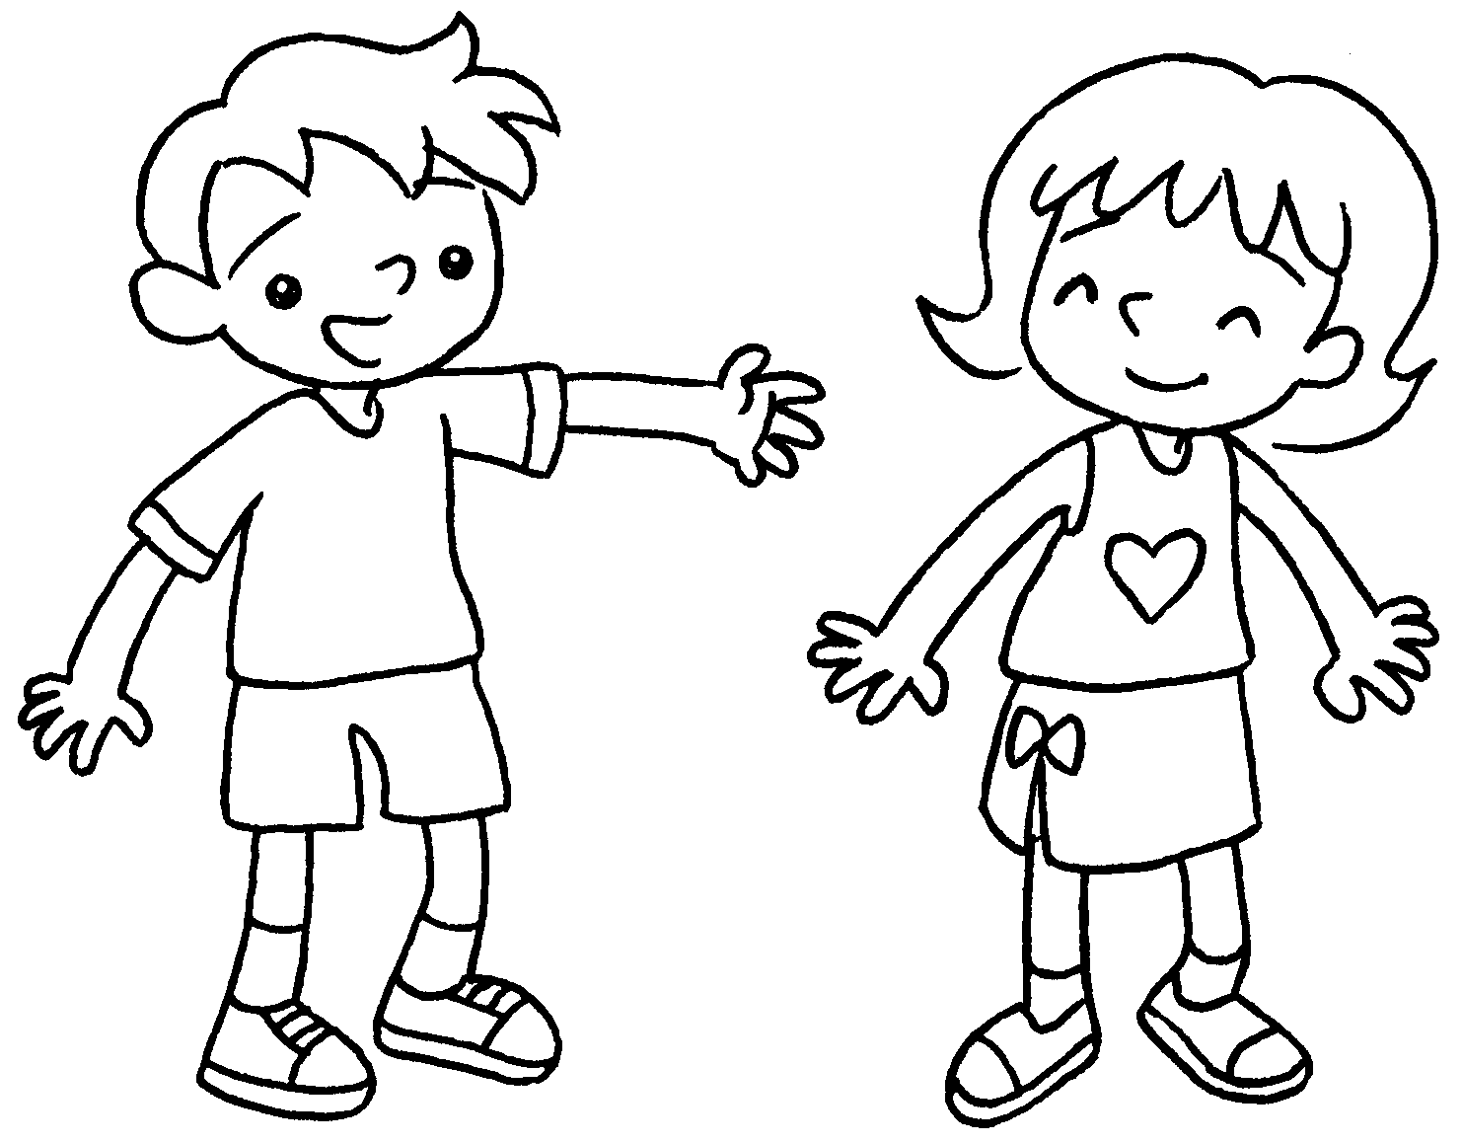  … | This is Tina.   His skirt is white.  Her skirt is white.
2 | 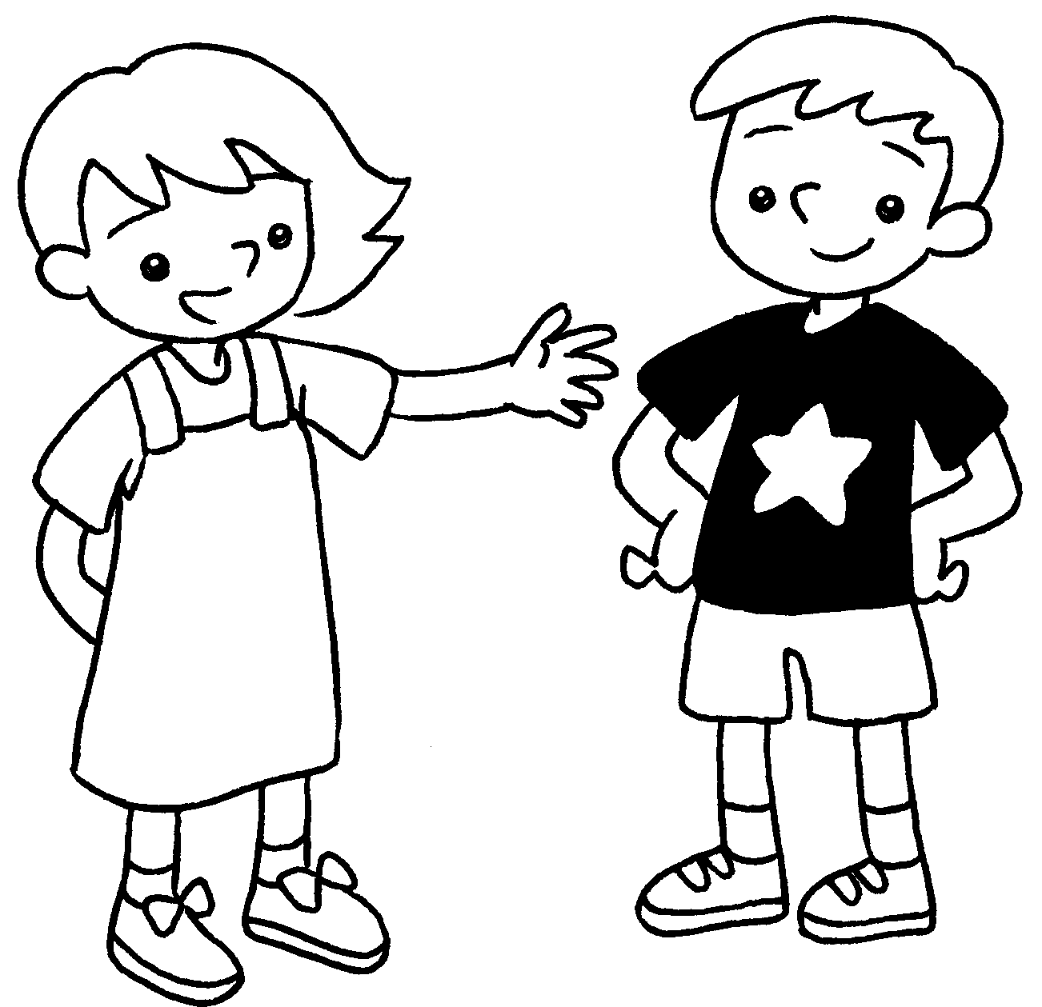  … | This is Ken.  His T-shirt is black and white.  Her T-shirt is black and white.
3 | 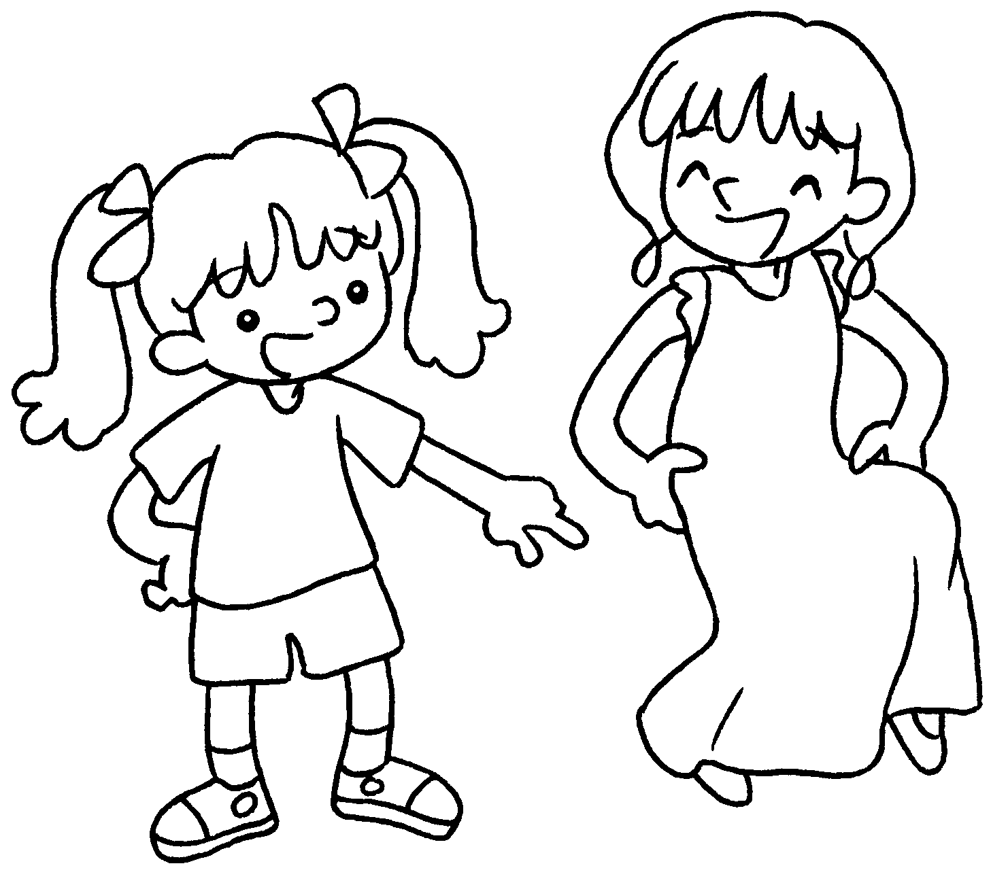  … | Look at Kitty.  His dress is long.  Her dress is long.
4 | 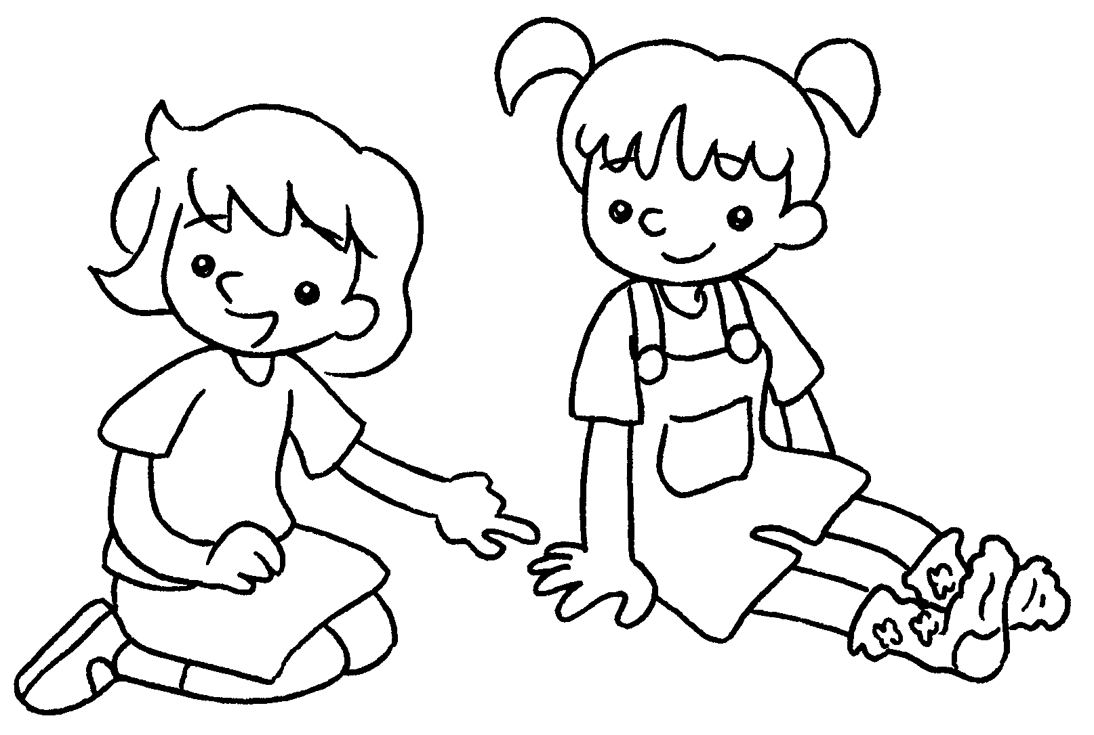  … | Look at Mary.  Her shoes are purple and blue.  His shoes are purple and blue.  Her socks are purple and blue.
5 | 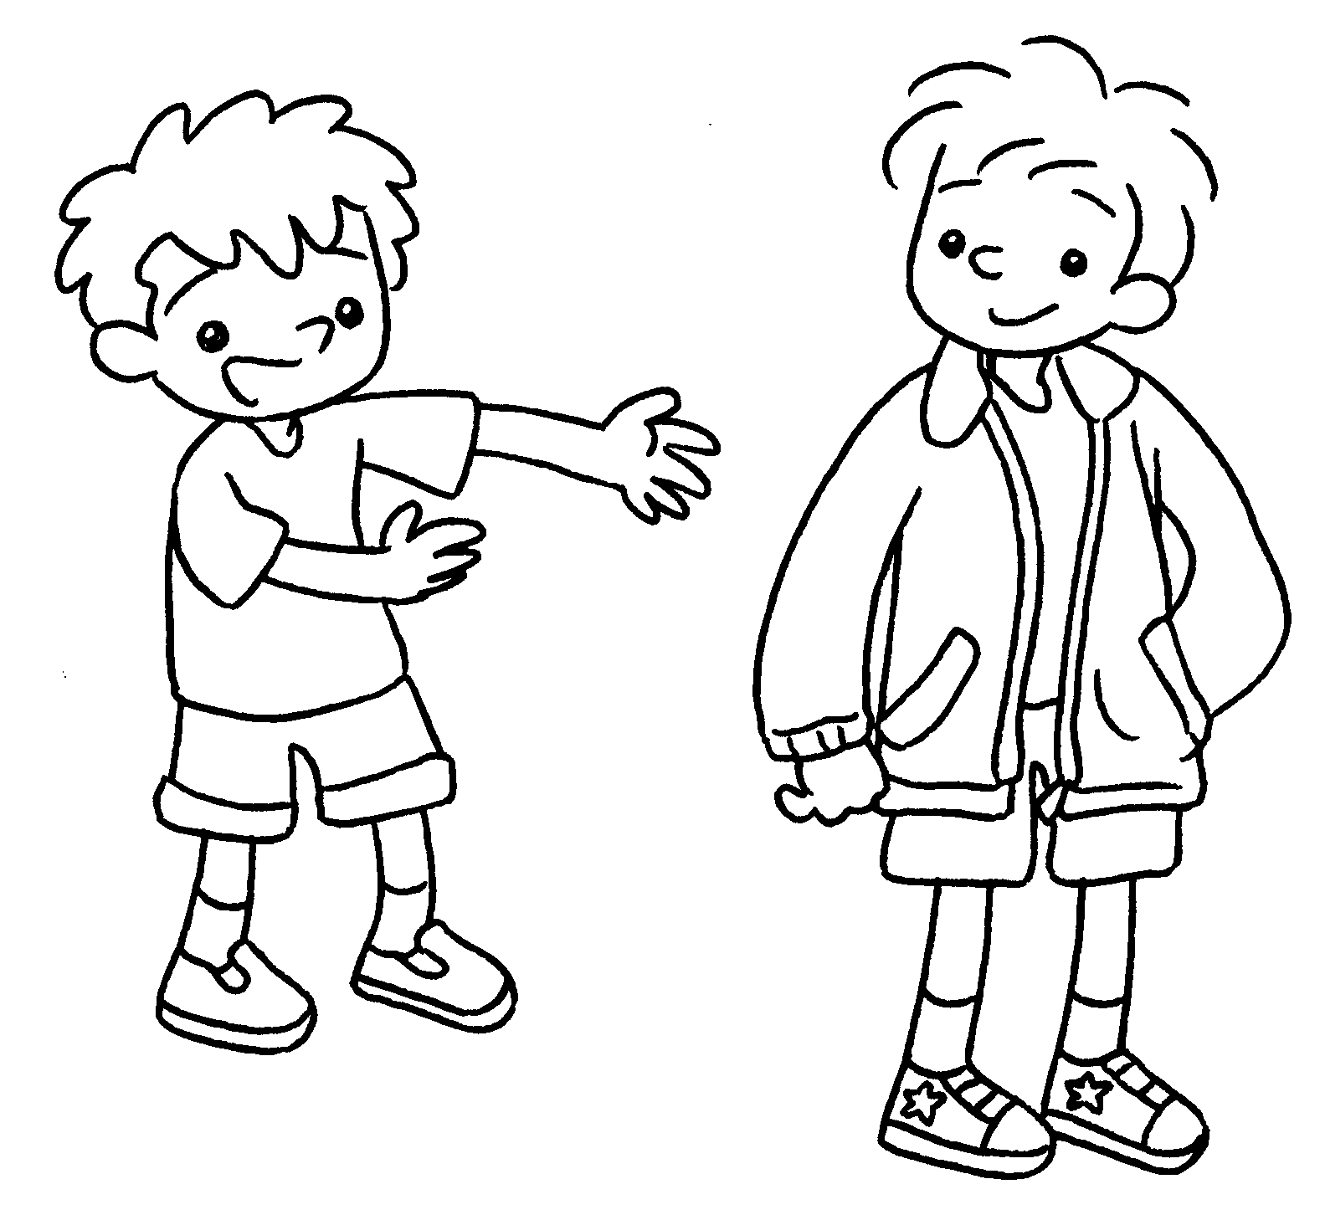  … | This is John.  His trousers are red and green.  Her jacket is red and green.  His jacket is red and green.


Book 1B Chapter 2 Graded Worksheets
Worksheet 2⬇⬇
1 His skirt is white.
 Her skirt is white.
2  His T-shirt is black and white.
Her T-shirt is black and white.
- His dress is long.
 Her dress is long.
- Her shoes are purple and blue.
His shoes are purple and blue.
 Her socks are purple and blue.
5 His trousers are red and green.
Her jacket is red and green.
- His jacket is red and green.

