Choose and write.
Our | Their

1  … | 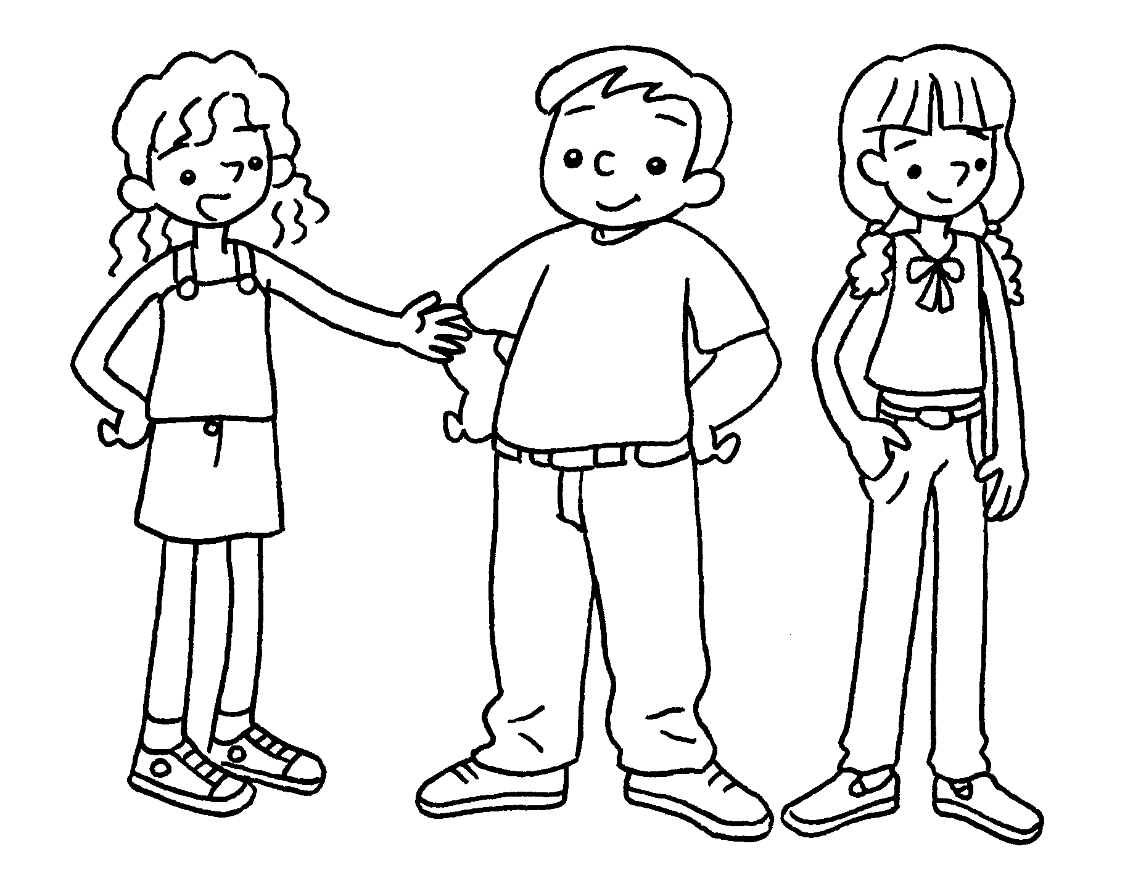 | They are Sam and Anna.  trousers are white.
2  … | 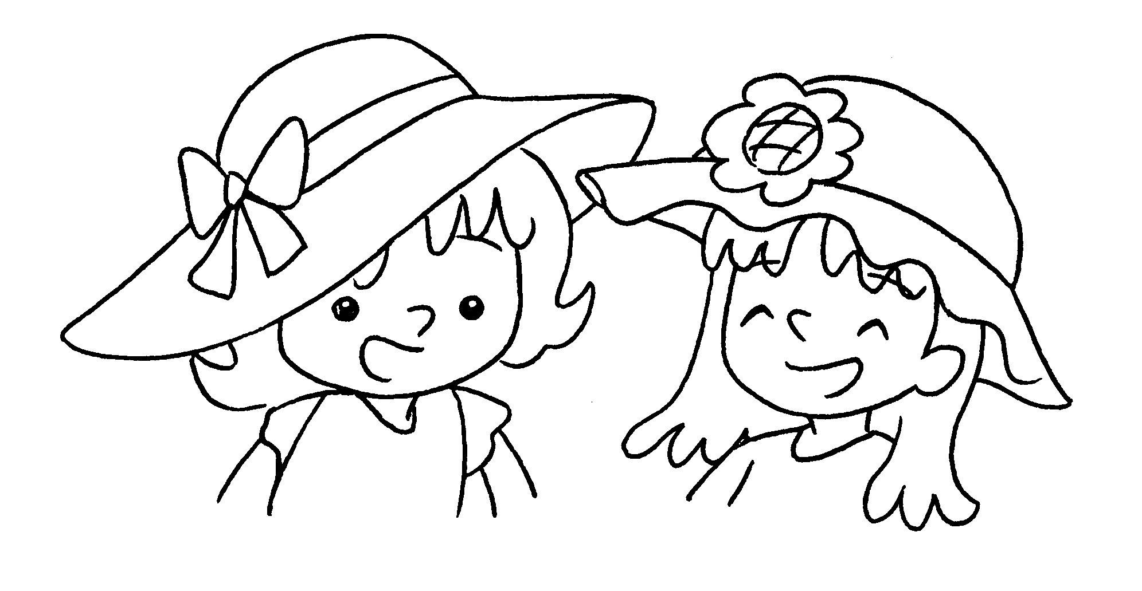 | We are Katie and Mabel.  hats are orange.
3  … | 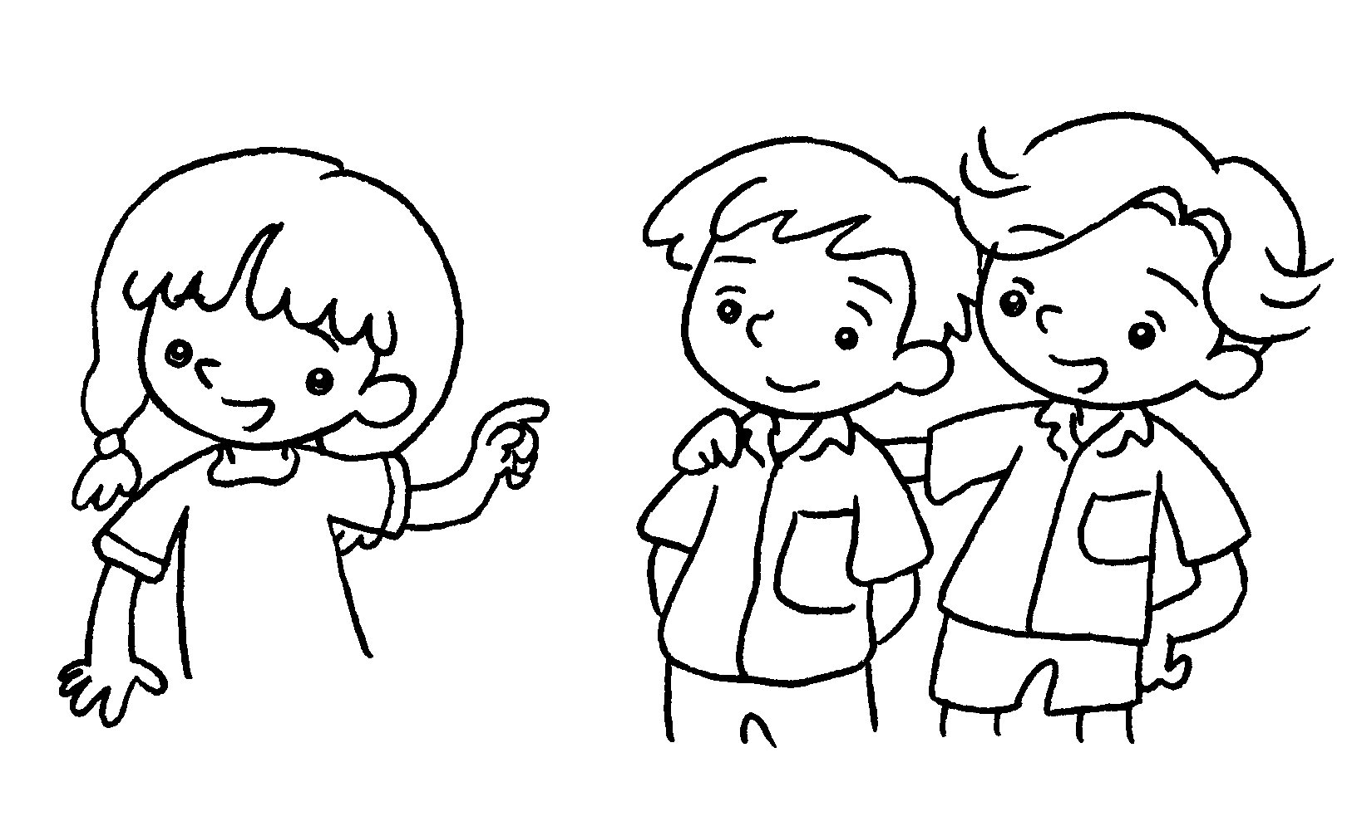 | Look at Billy and Tim.  shirts are white.
4  … | 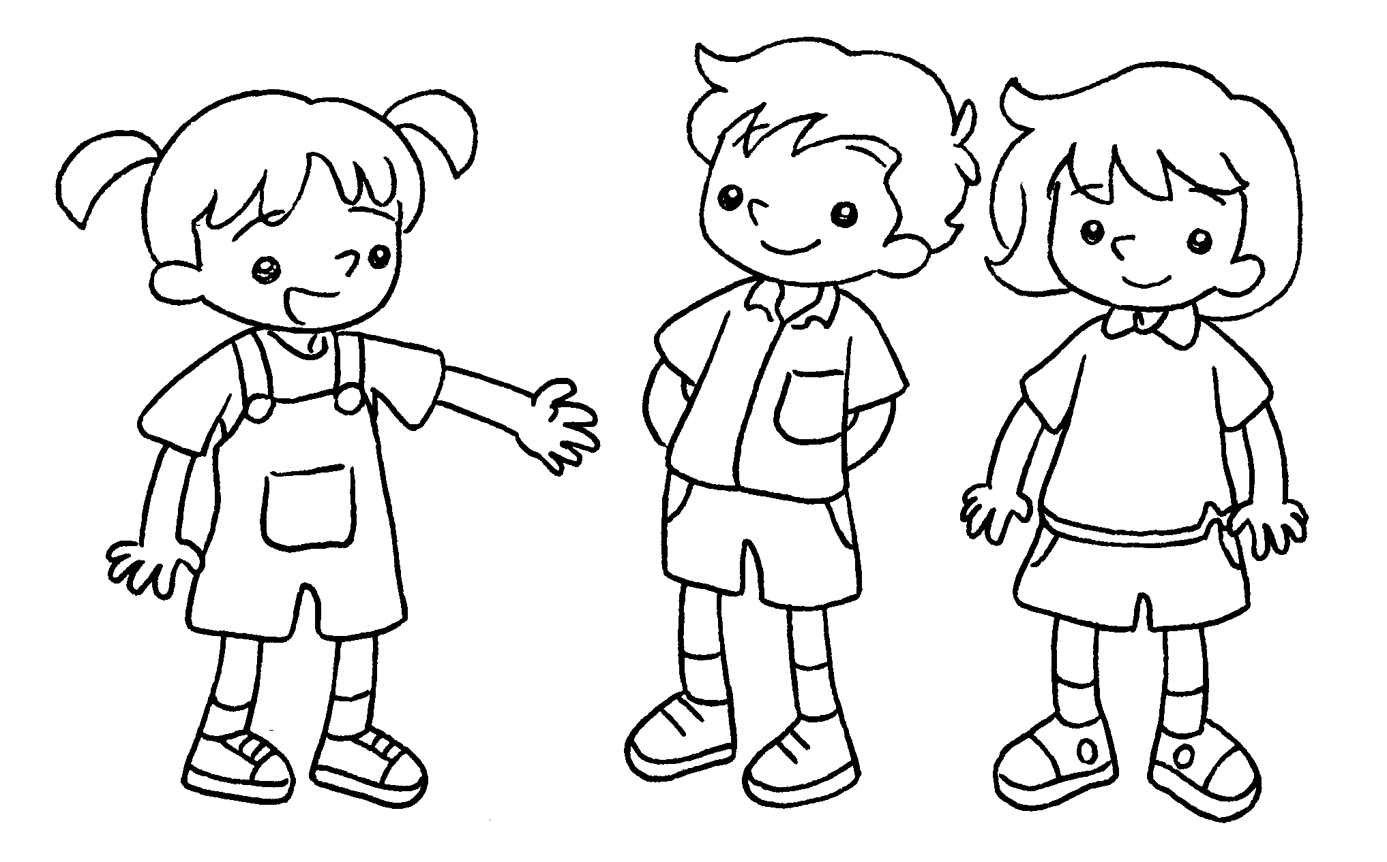 | They are Daniel and Cherry.  shorts are red and green.
5  … | 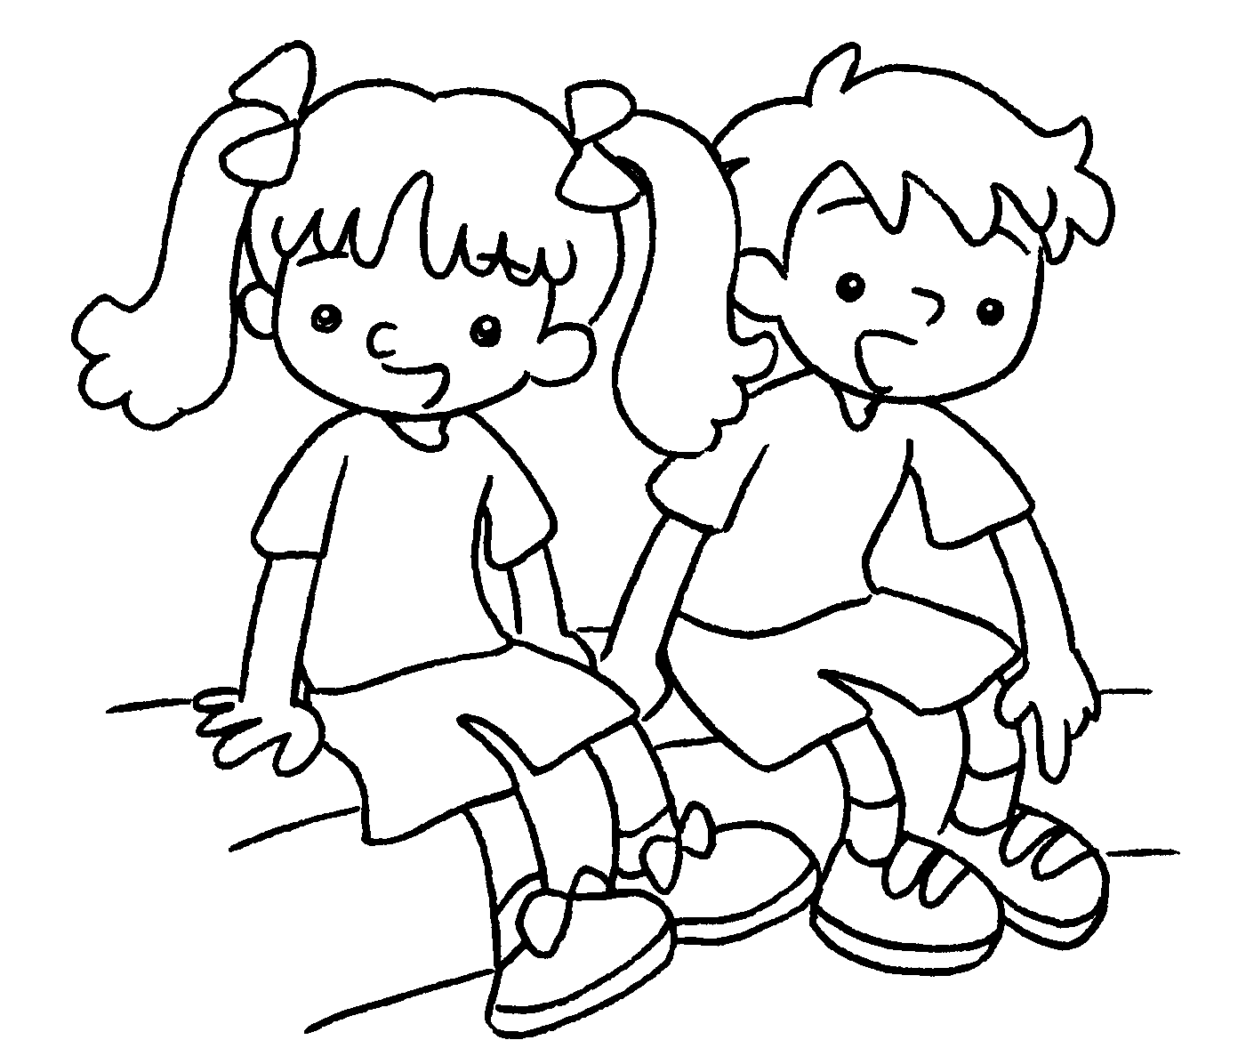 | We are Pam and Jerry.  shoes are pink and blue.



Book 1B Chapter 2 Graded Worksheets
Worksheet 3⬇
- Their
- Our
- Their
- Their
- Our

