What are the children saying? Tick ( ✓ ) the correct boxes.

1  … | 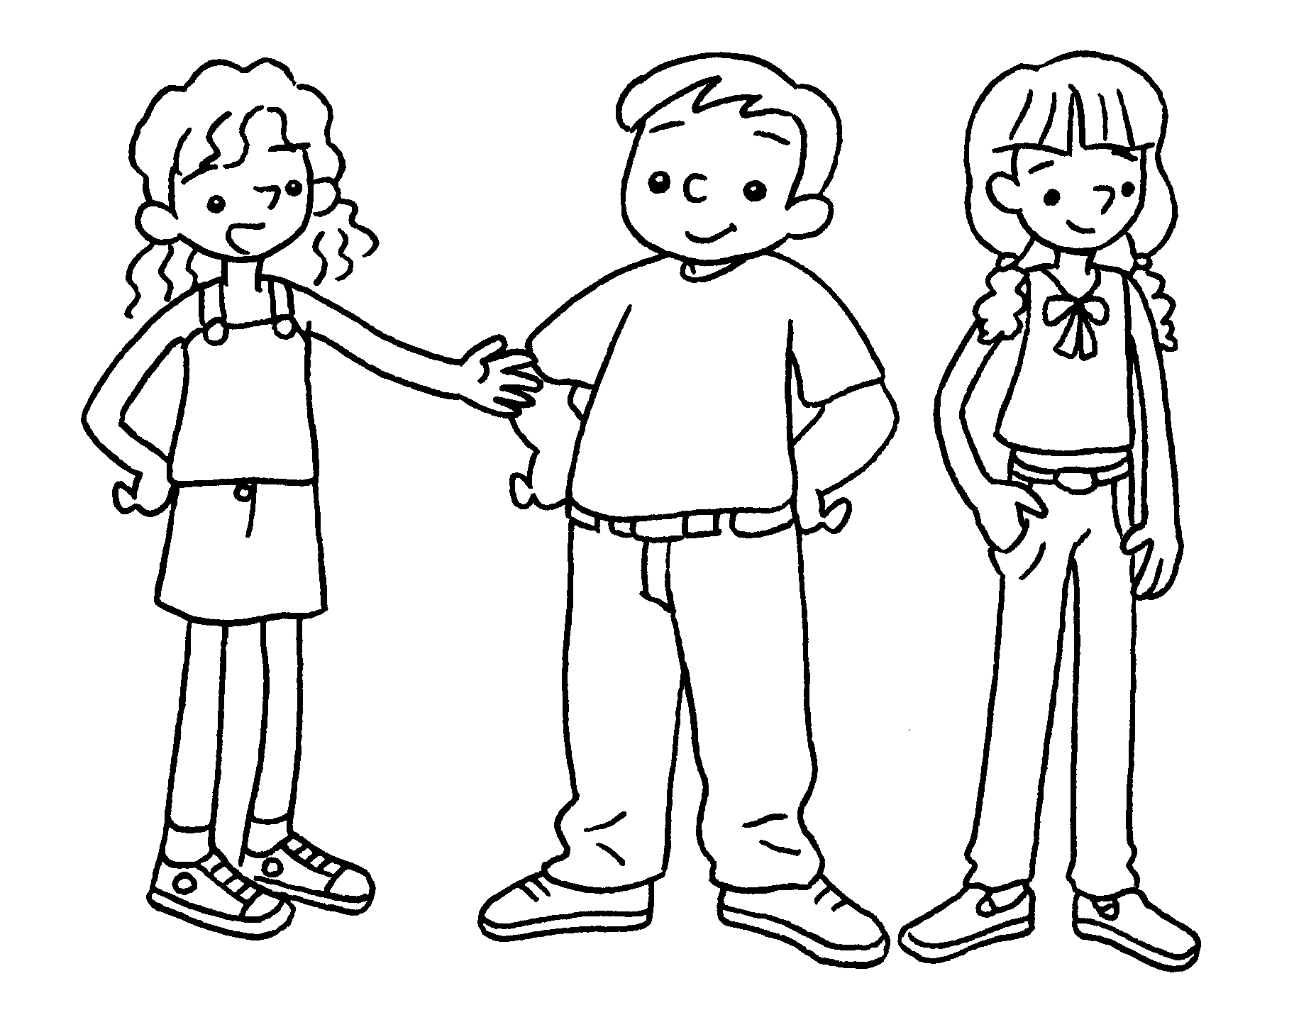 | They are Sam and Anna.   Our trousers are white.  Their trousers are white.
2  … | 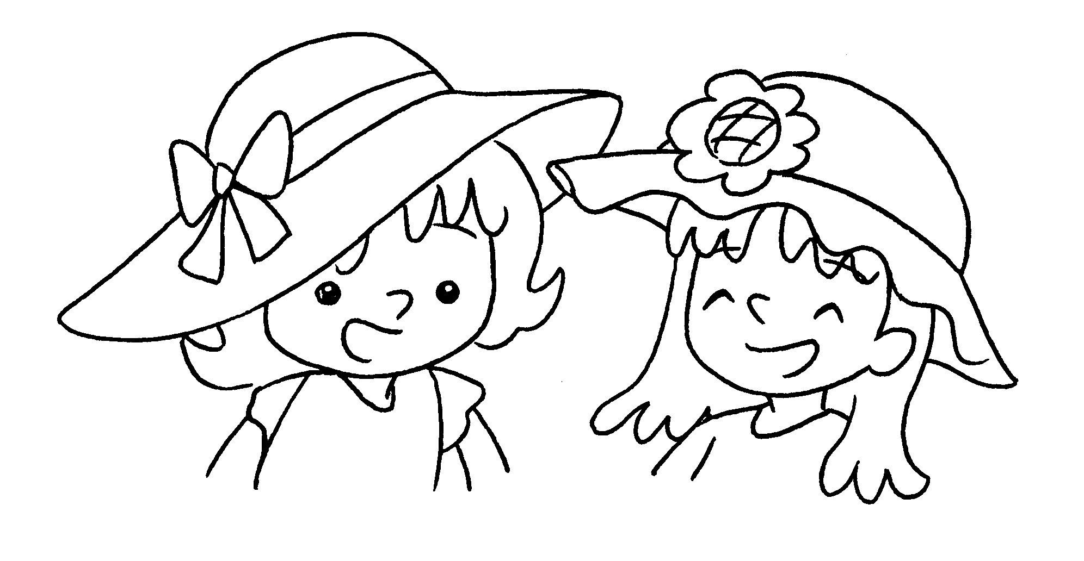 | We are Katie and Mabel.  Our hats are orange.  Their hats are orange.
3  … | 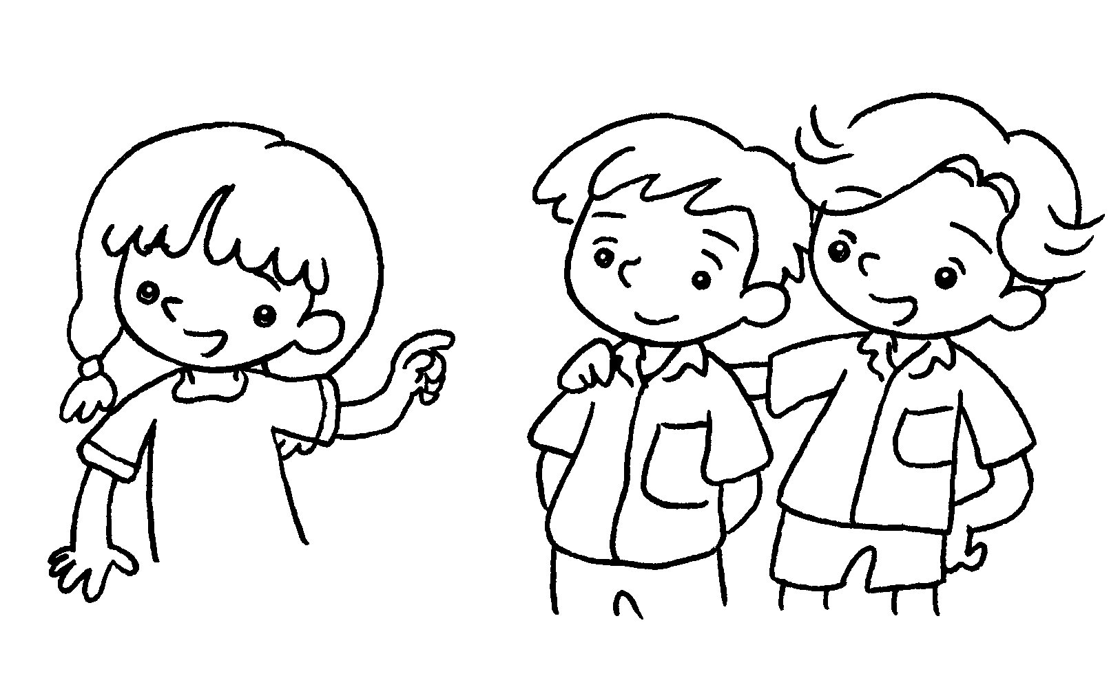 | Look at Billy and Tim.  Their shirts are white.  Their T-shirts are white.  Our T-shirts are white.
4  … | 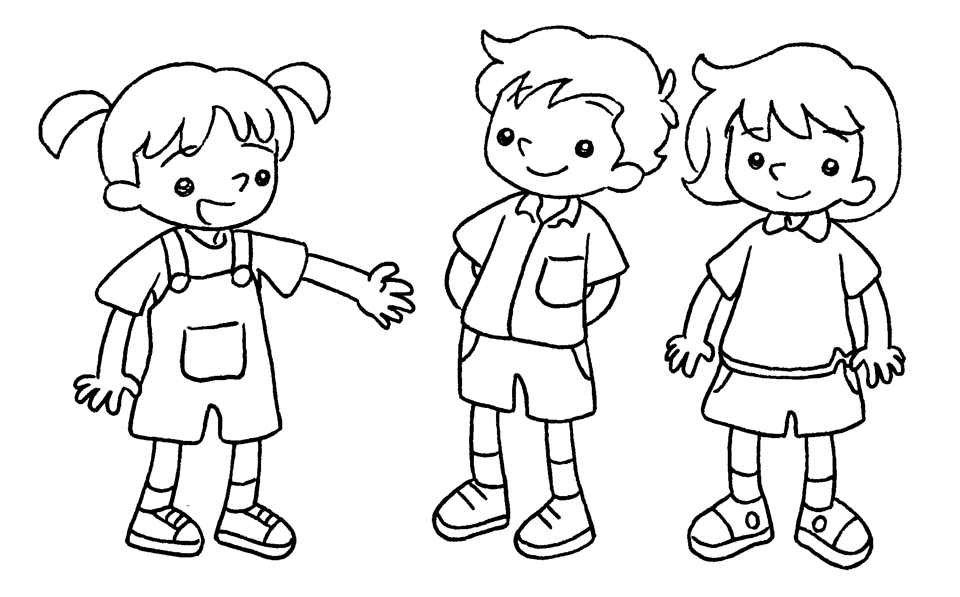 | They are Daniel and Cherry.  Our shirts are red.  Their trousers are red.  Their shorts are red.
5  … | 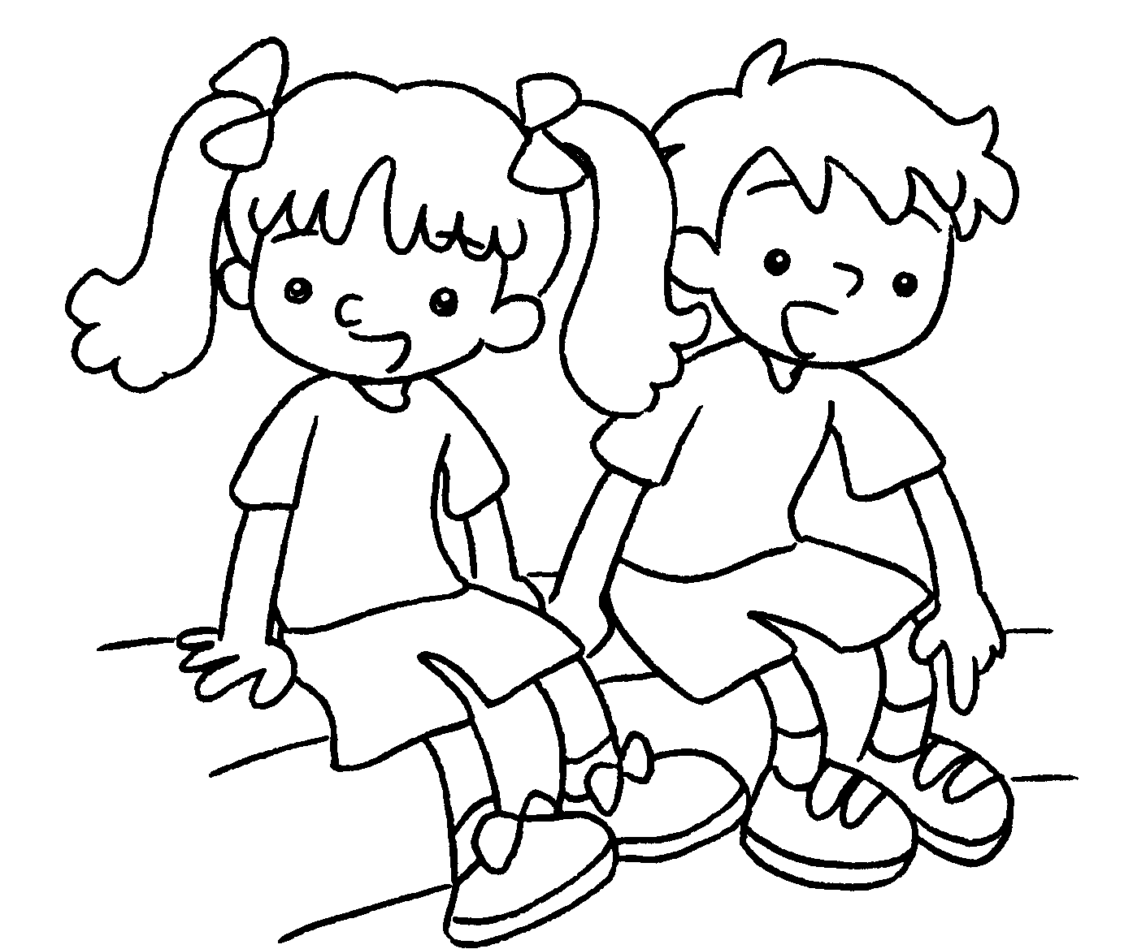 | We are Pam and Jerry.  Our shoes are blue.  Their shoes are blue.  Our jackets are blue.



Book 1B Chapter 2 Graded Worksheets
Worksheet 3⬇⬇
1 Our trousers are white.
 Their trousers are white.
-  Our hats are orange.
Their hats are orange.
-  Their shirts are white.
Their T-shirts are white.
Our T-shirts are white.
- Our shirts are red.
Their trousers are red.
 Their shorts are red.
5  Our shoes are blue.
Their shoes are blue.
Our jackets are blue.

