Choose and write.
Our | Their | His | Her

1  … | 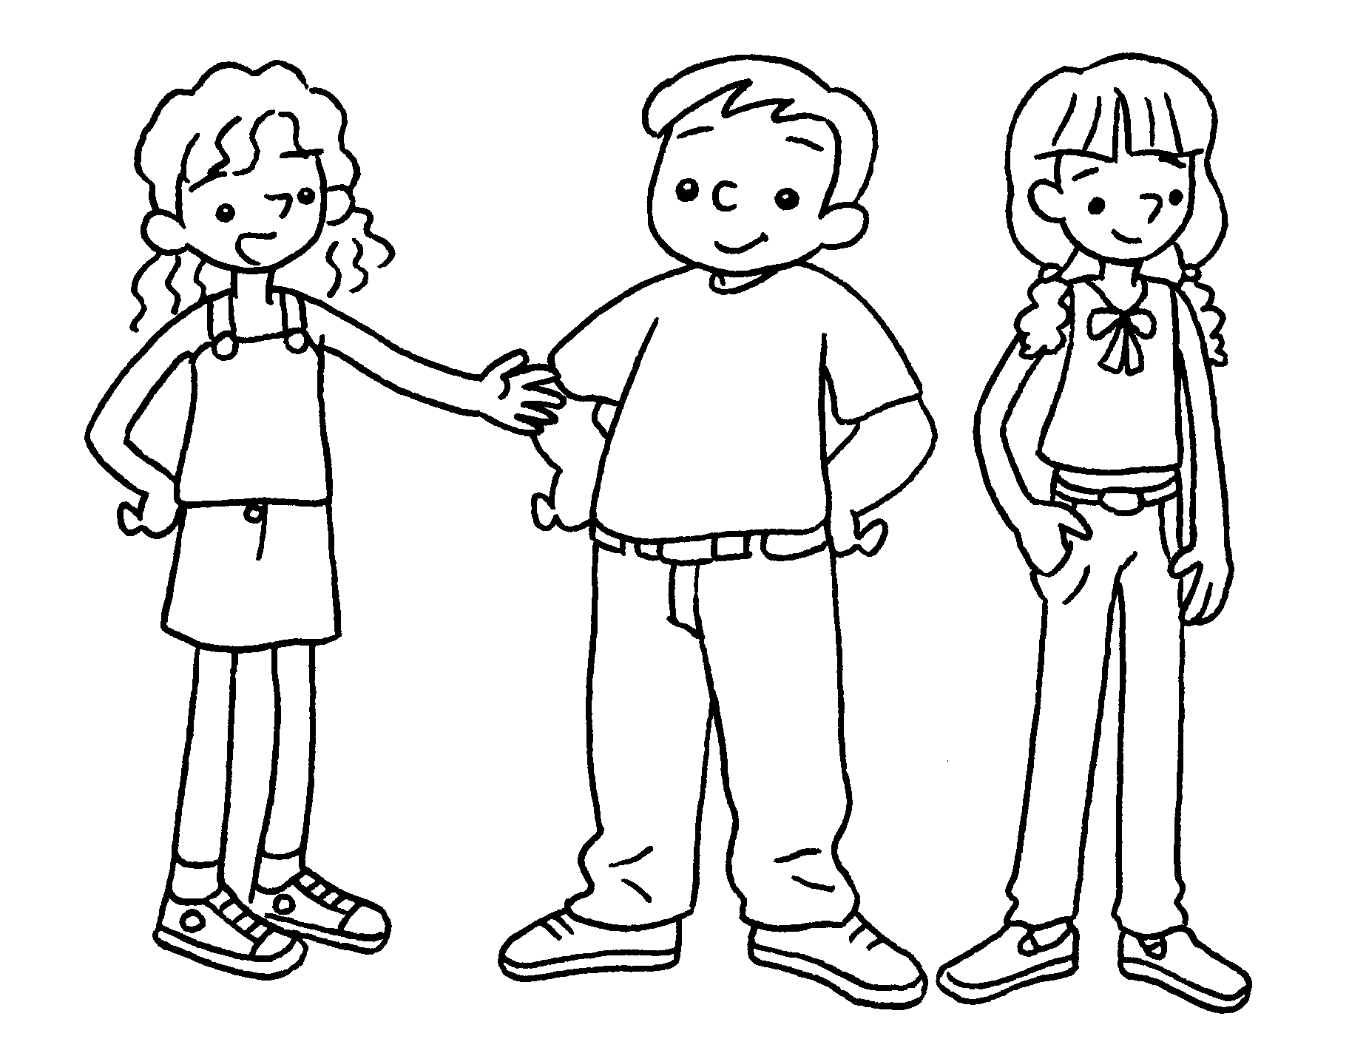 | They are Sam and Anna.  trousers are white.
2  … | 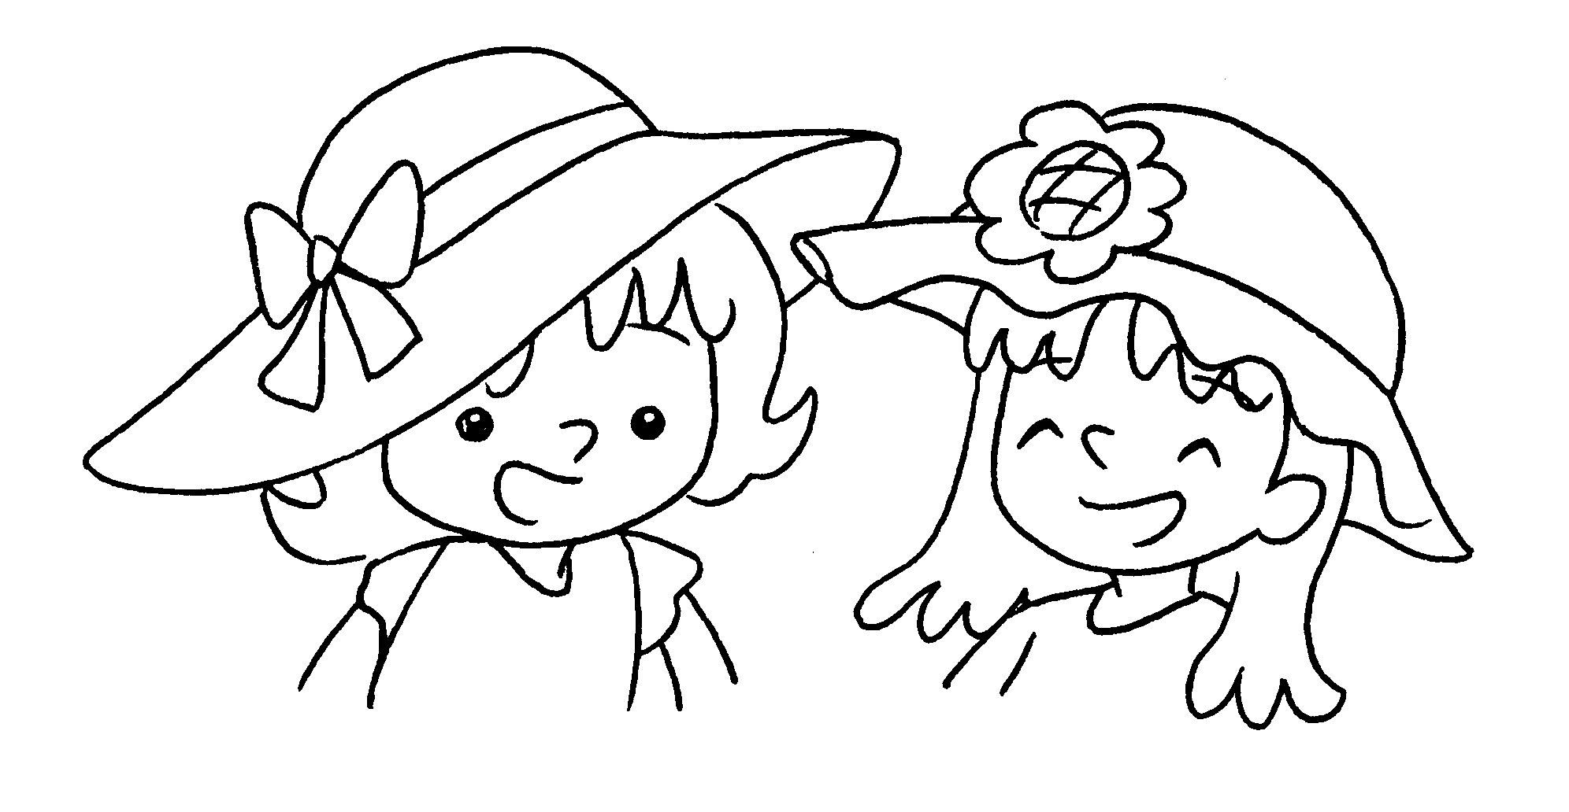 | We are Katie and Mabel.  hats are orange.
3  … | 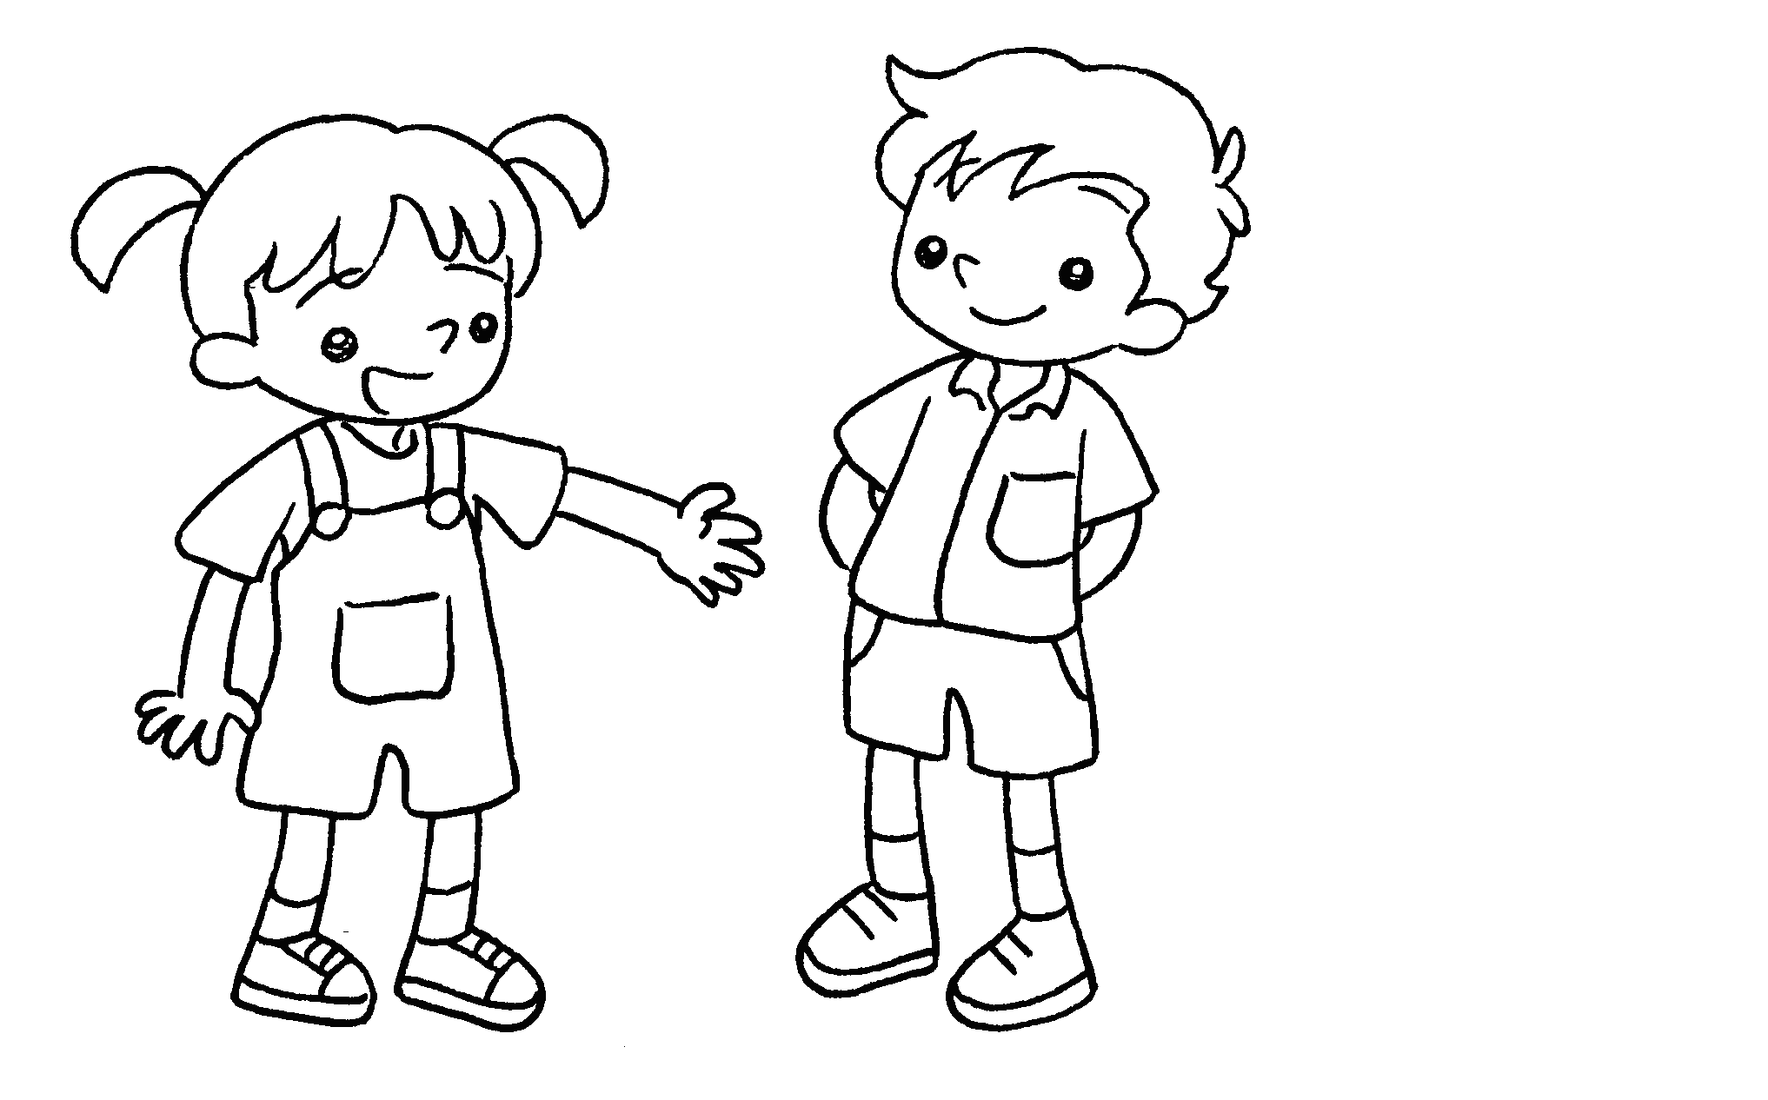 | This is Daniel.  T-shirt is green.
4  … | 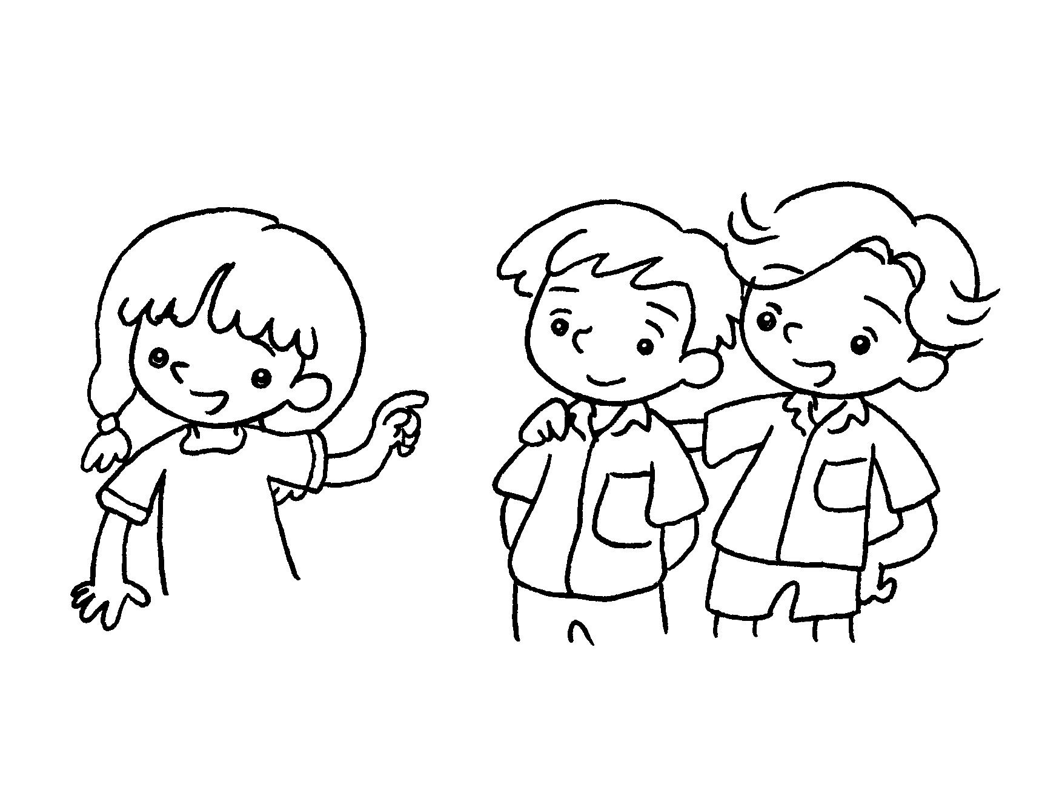 | Look at Billy and Tim.  shirts are white.
5  … | 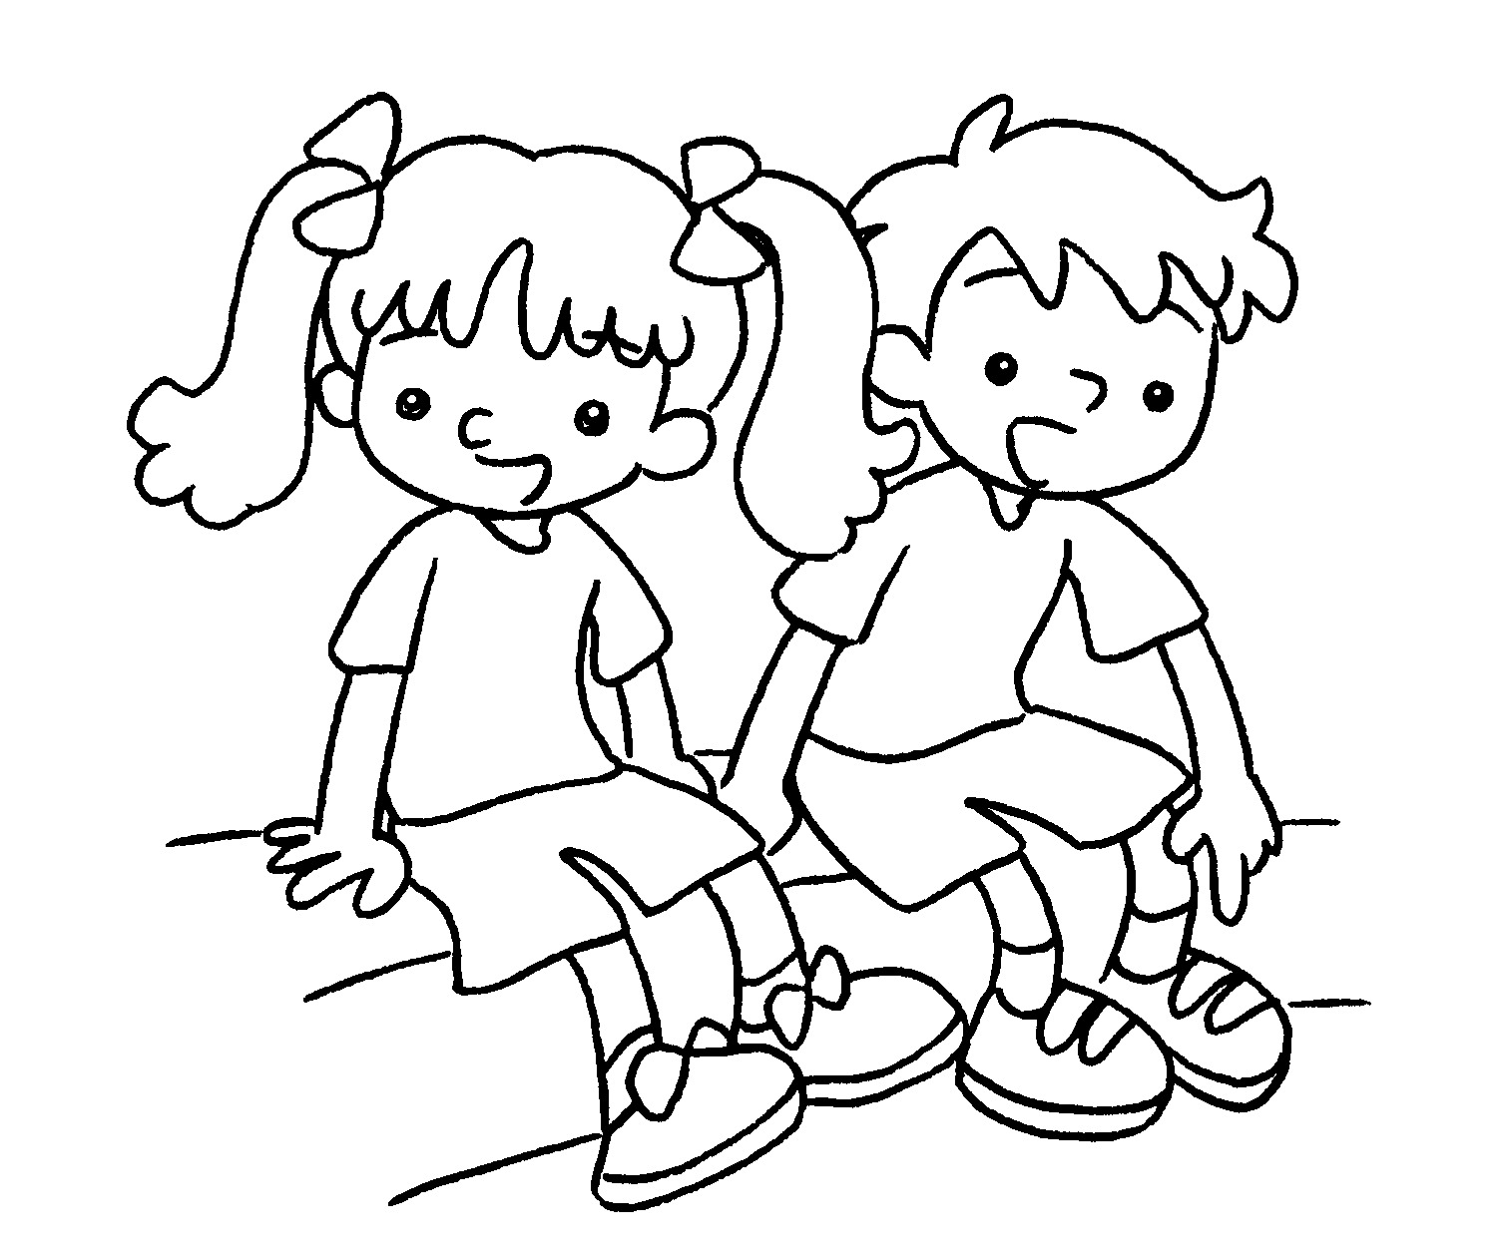 | We are Pam and Jerry.  shoes are blue.

6  … | 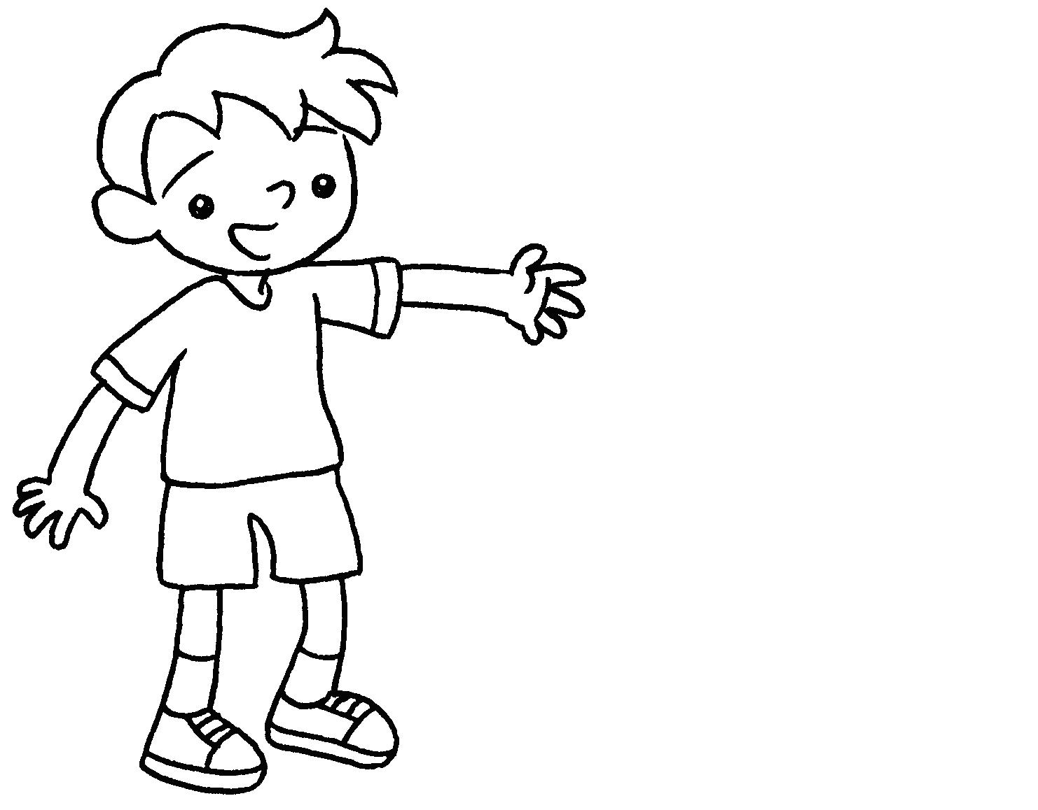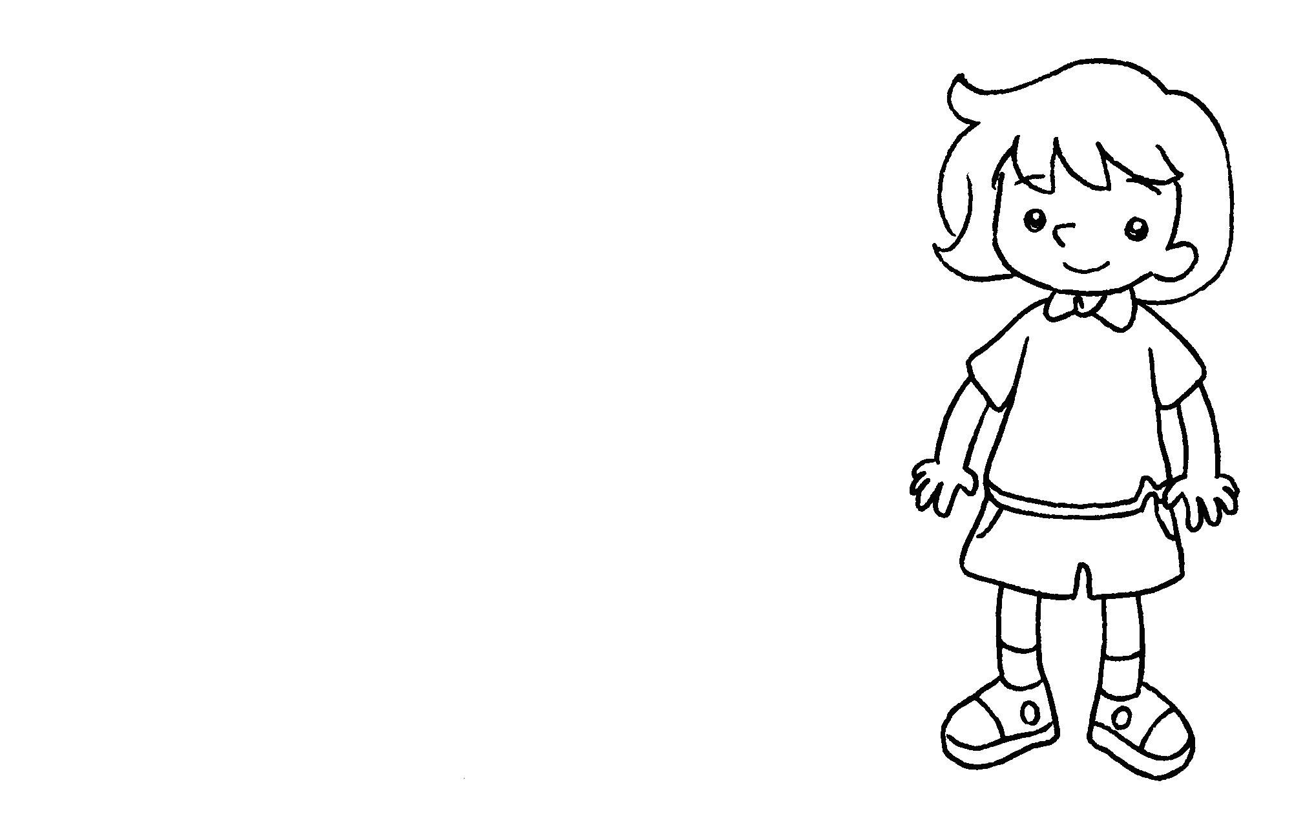 | This is Cherry.  shorts are pink.



Book 1B Chapter 2 Graded Worksheets
Worksheet 3⬇⬇⬇
1 Their
2 Our
3 His
4 Their
5 Our
6 Her

