Task — Writing a description of a puppet
1 Complete the description of Ken’s puppet.

This is Mark.
His T-shirt is green.
His shorts are blue.
His ________________________________ .
His ________________________________ .
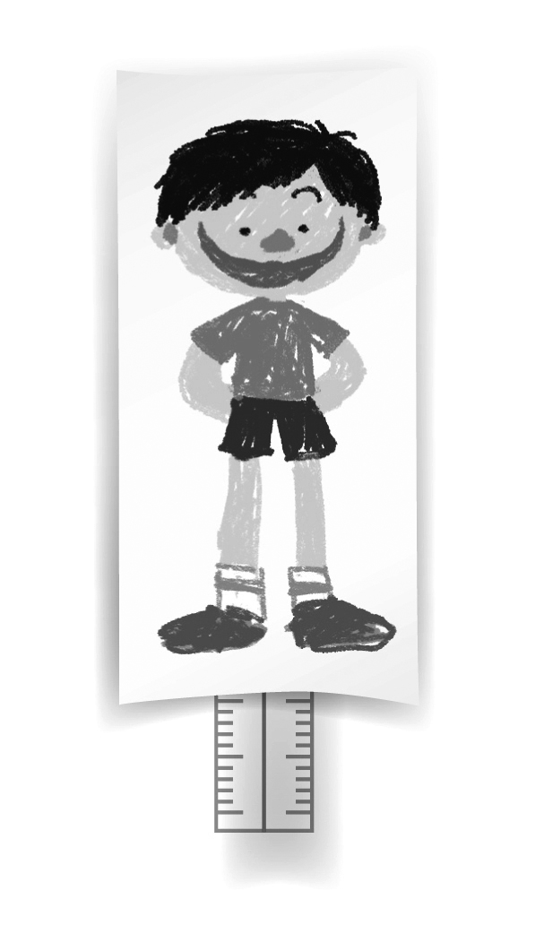

Here are some questions to help you add more sentences:
Eyes — big / small? Legs — long / short?
His eyes are … His legs are ...
Nose — big / small? Arms — long / short?
His nose is ... His arms are ...
Ears — big / small? Hair — long / short?
His ears are ... His hair is ...
Mouth — big / small?
His mouth is ...

My puppet

2 Complete the description of your puppet. Use the words in the boxes to help you.
Clothes
a T-shirt, a shirt, a blouse, a dress, a skirt, a jacket, a hat, trousers, shorts, socks, shoes

Colours
red, orange, yellow, green, blue, purple, pink, white, black
Body parts
eyes, nose, ears, mouth, legs, arms, hair

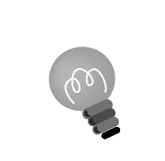
Hint: Is your puppet a boy or a girl? Remember to use His and He has for a boy and Her and She has for a girl.

This is ____________________ .
_________________________________________________
____________________________________________________________________________________________________________________________________________________

Write your puppet’s name here.

Write about your puppet’s clothes and body parts.

