Task — Writing a description of a puppet
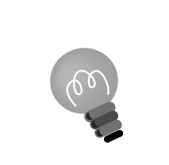
1 Complete the description of Ken’s puppet.
Hints: a) You can use He / She has or His / Her for body parts, e.g. He has long hair. / His hair is long.
b) Remember to use is and are correctly, e.g. His T-shirt is
green. / His shorts are blue.

This is Mark.
His T-shirt is green.
His shorts are blue.
___________________________________ .
___________________________________ .
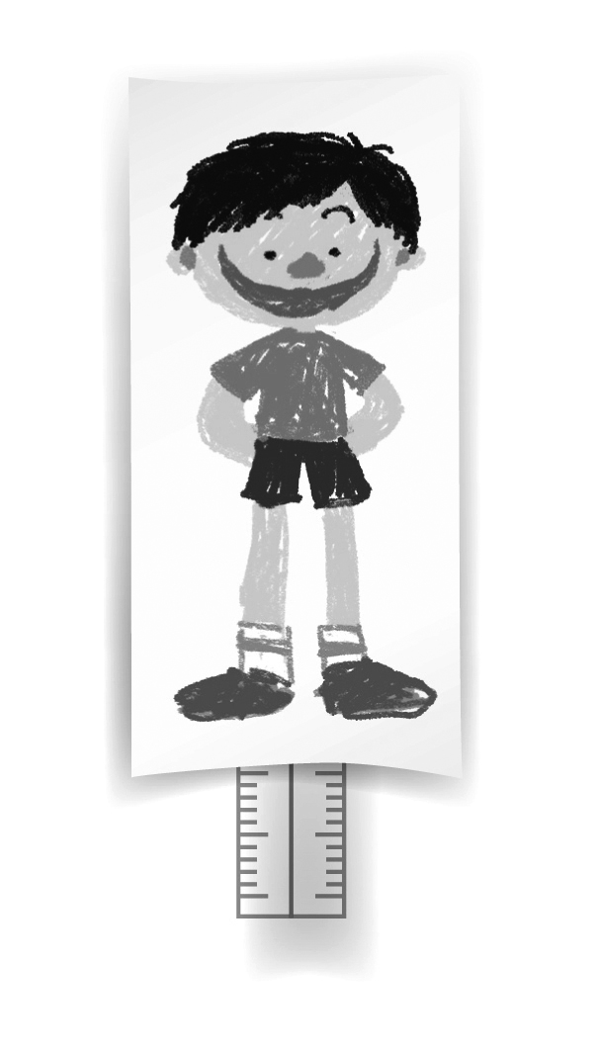

Here are some questions to help you add more sentences:
Eyes — big / small? Legs — long / short?

Nose — big / small? Arms — long / short?

Ears — big / small? Hair — long / short?

Mouth — big / small?

My puppet

2 Complete the description of your puppet. Use the words in the boxes to help you.

Colours
red, orange, yellow, green, blue, …
Clothes
a T-shirt, a shirt, a blouse,
a dress, …
Body parts
eyes, nose, ears, mouth, …

Hint: Is your puppet a boy or a girl? Remember to use His and He has for a boy and Her and She has for a girl.

__________________________
____________________________________________________________________________________________________________________________________________________________________________________________________
Write your puppet’s name here.

Write about your puppet’s clothes and body parts.

