Choose and write.
1

2

3

5

4

7

6

8

9

10

11

12

ant | bee | bird

 | 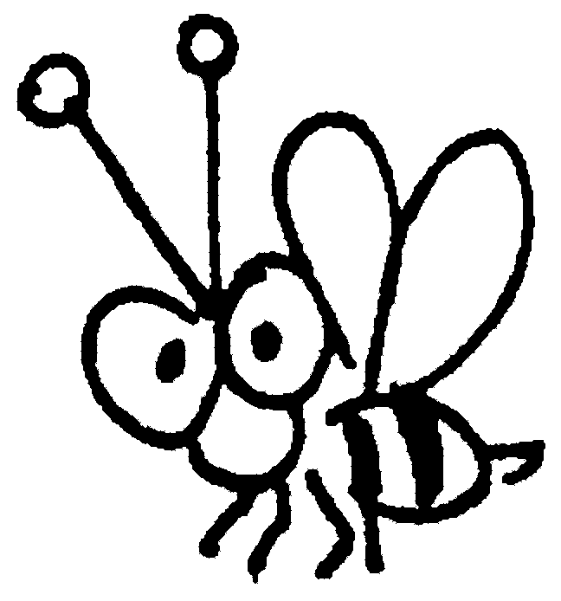 |  | 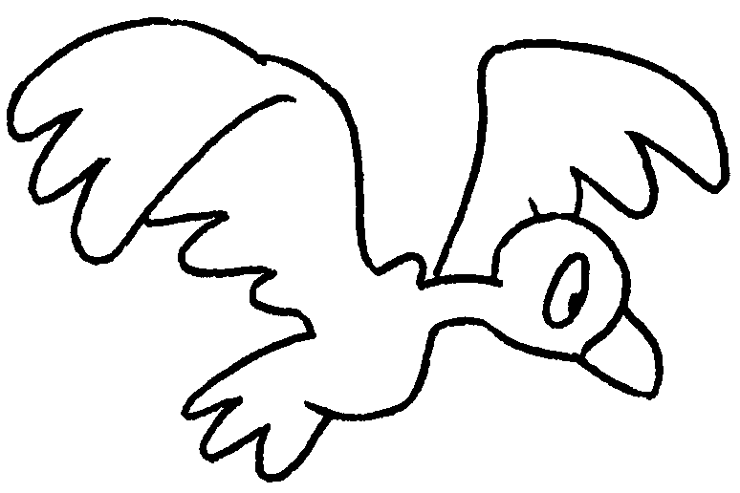 |  | 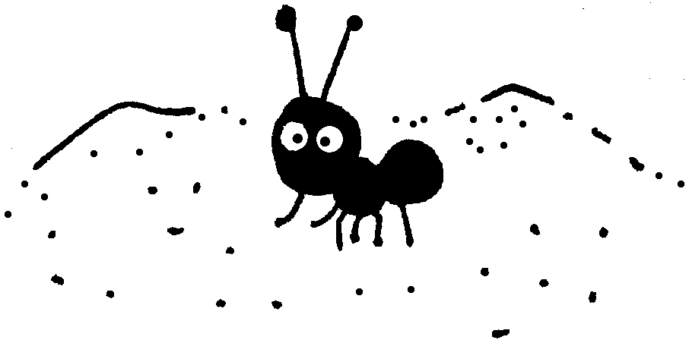
 | a |  | a |  | an

bench | see-saw | slide | swing

 | 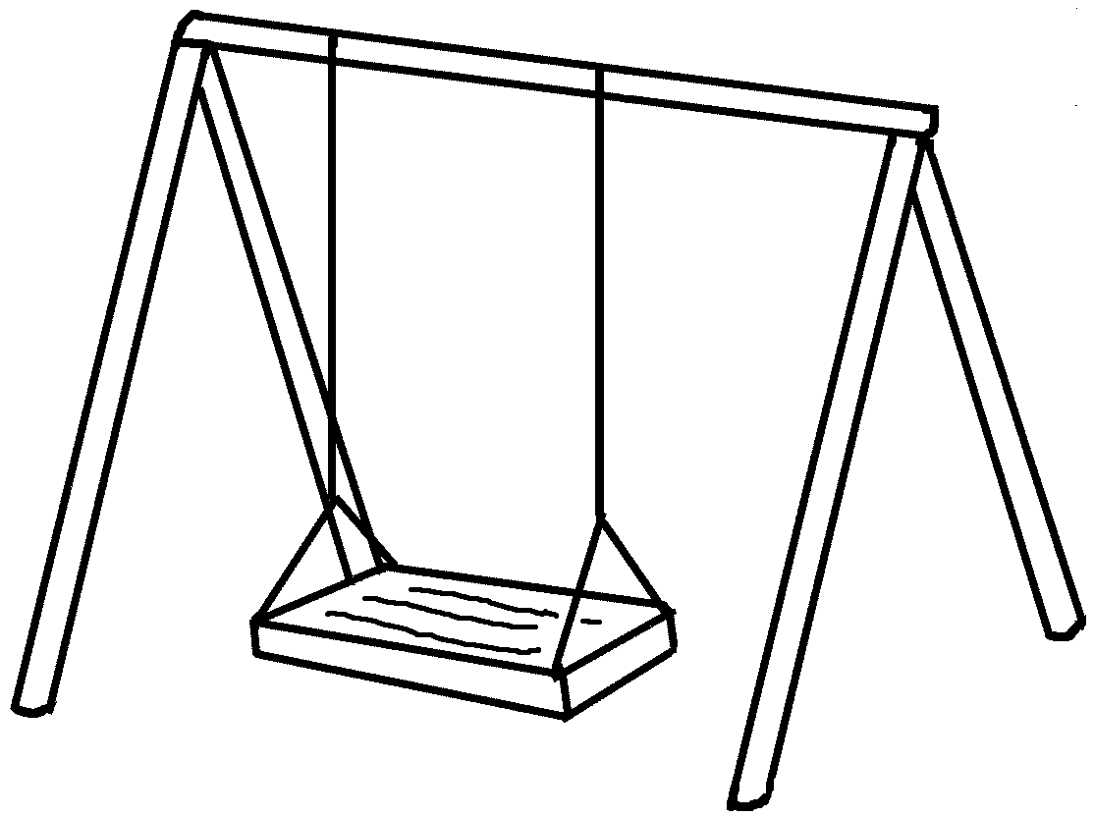 |  | 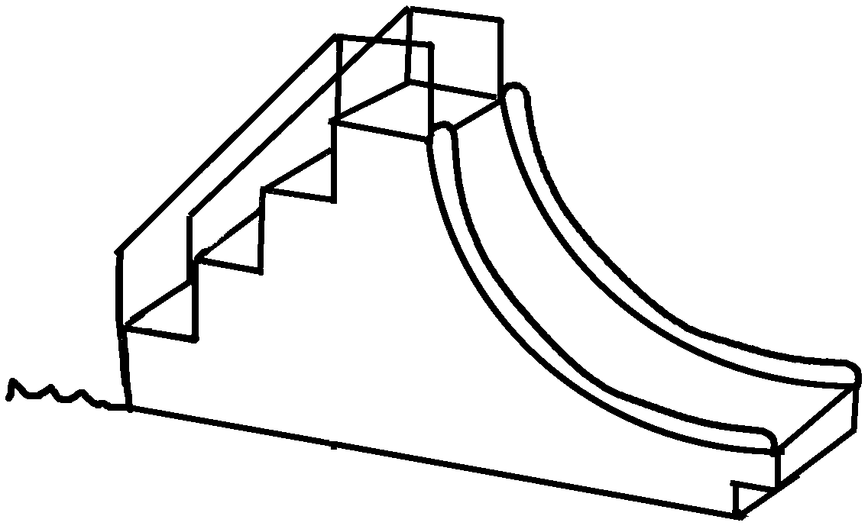
 | a |  | a
 | 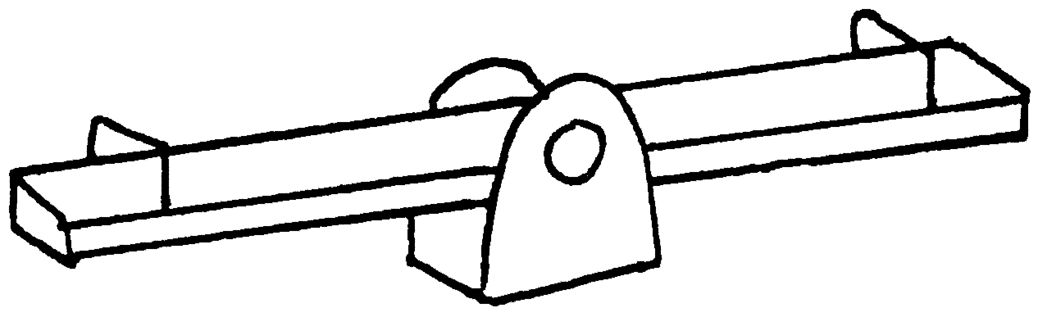 |  | 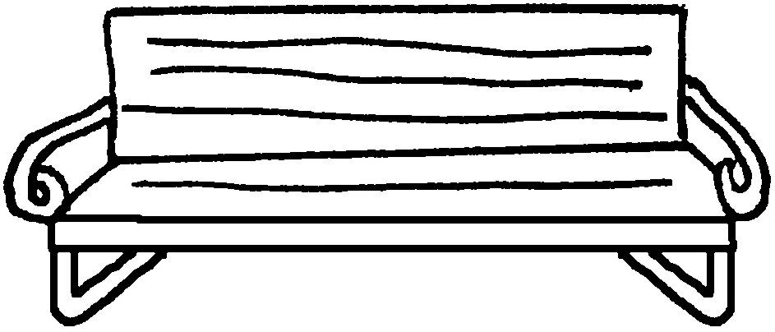
 | a |  | a

flower | grass | pond | tree | sky

 | 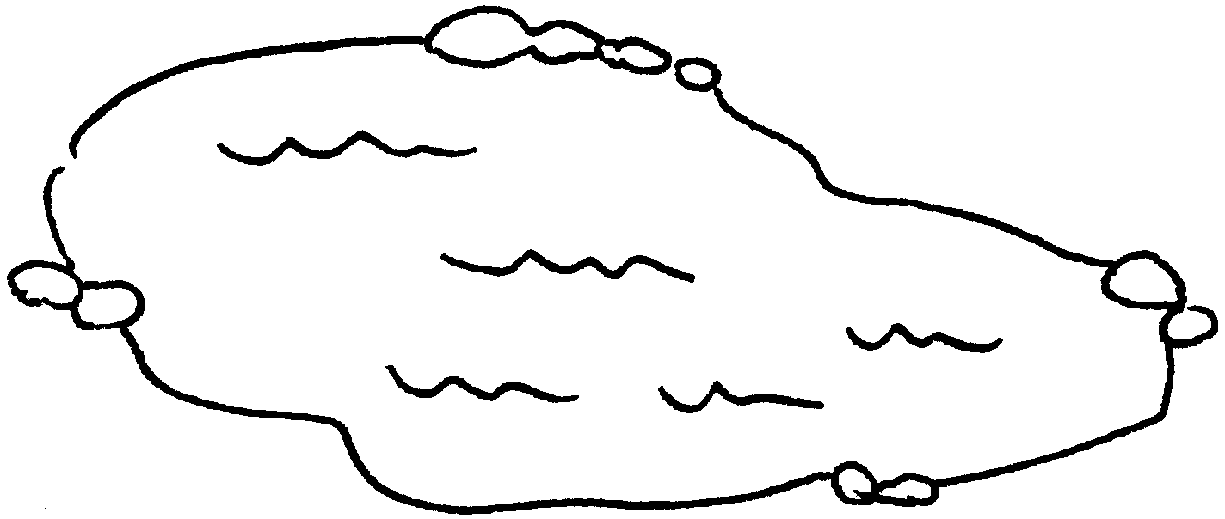 |  |  |  | 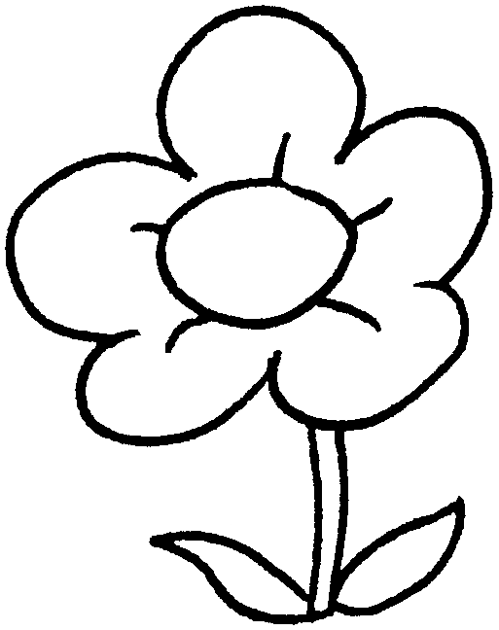
 | a |  |  |  | a
 | 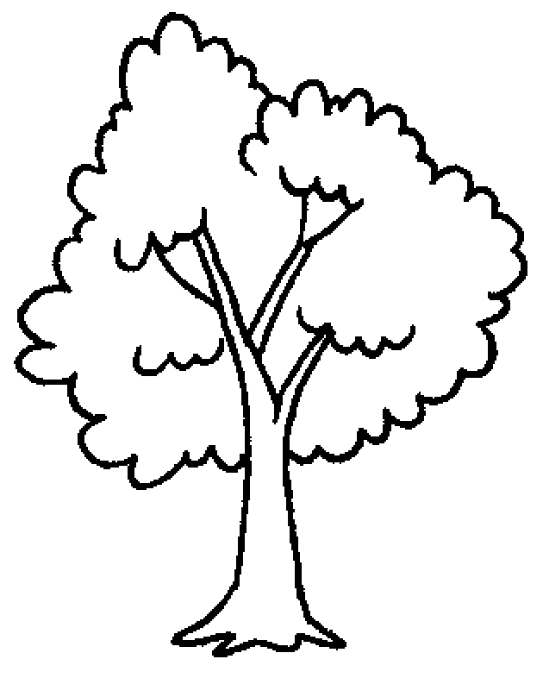 |  | 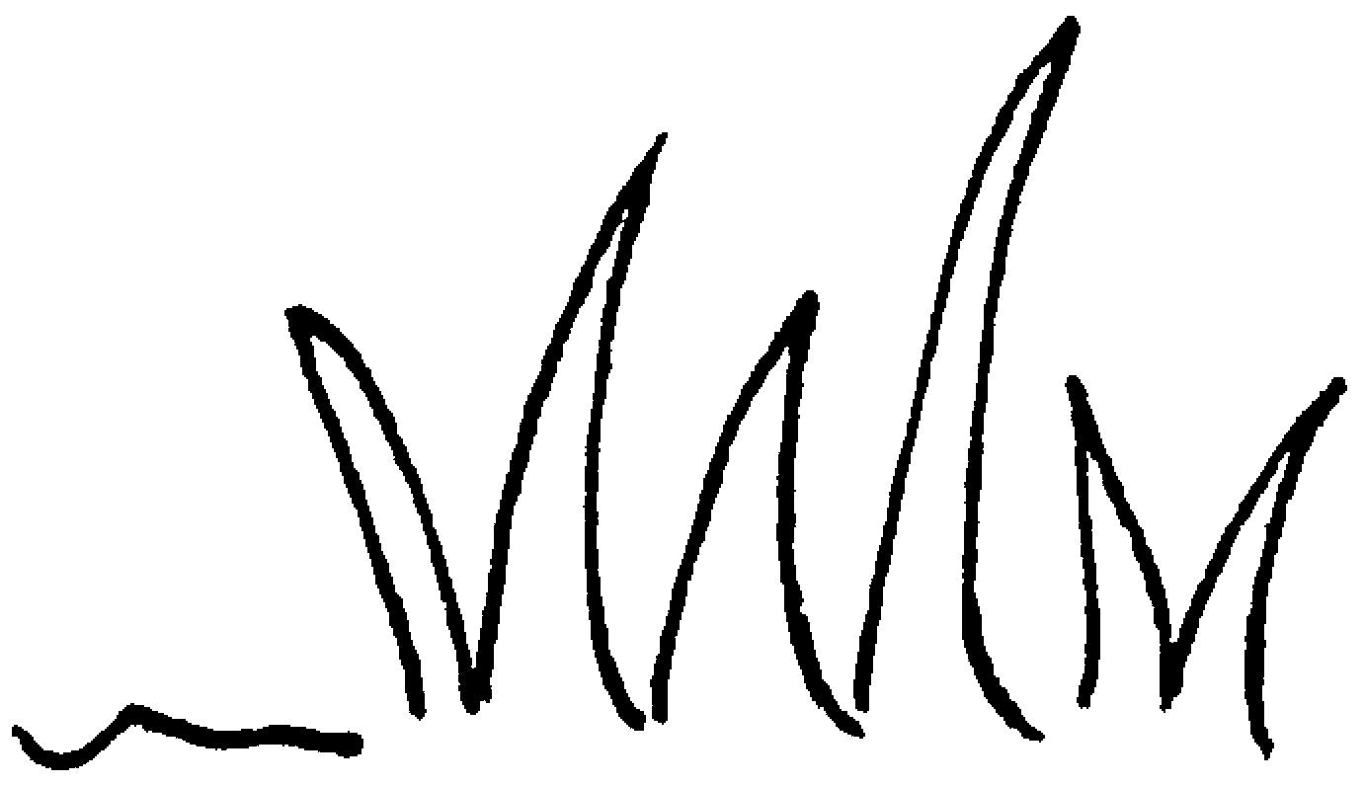 |  |  |  | 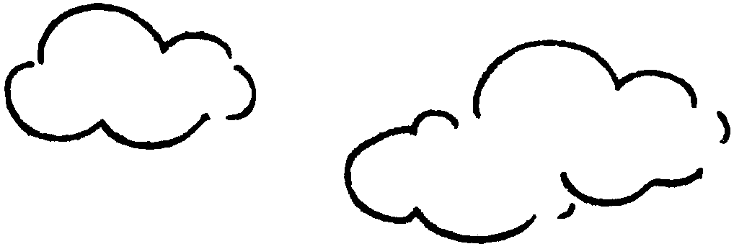
 | a |  | the |  |  |  | the


Book 1B Chapter 3 Graded Worksheets
Worksheet 1⬇
1 bee 2 bird 3 ant
4 swing 5 slide
6 see-saw 7 bench
8 pond 9 flower
10 tree 11 grass 12 sky

