Fill in the missing letters.

1 | 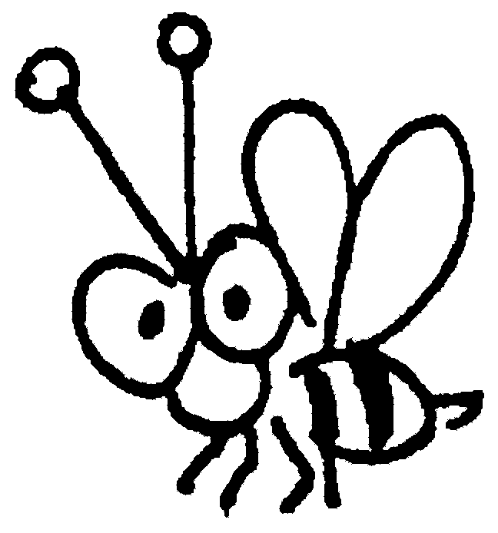 | 2 | 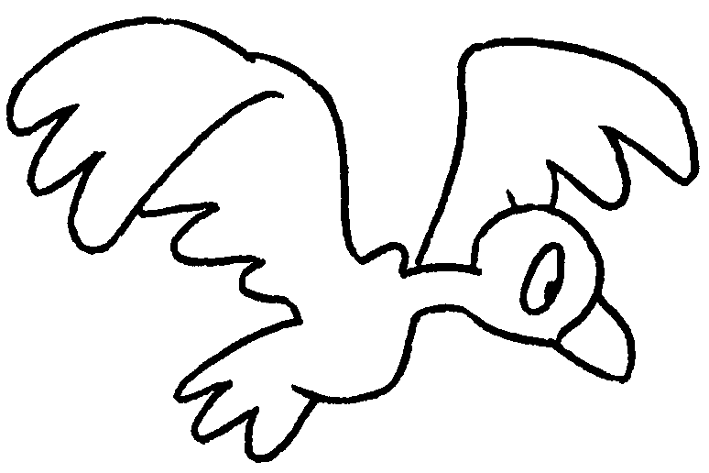 | 3 | 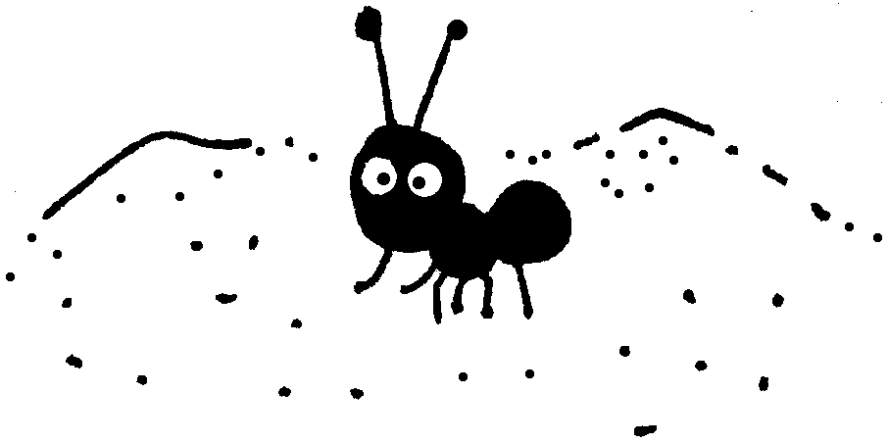
 | a b __ __ |  | a b __ __ __ |  | an a __ __

4 | 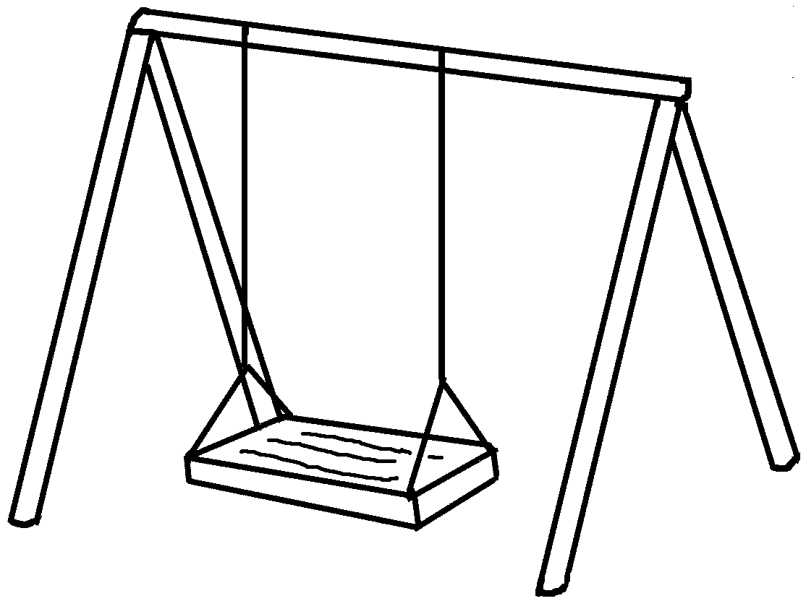 | 5 | 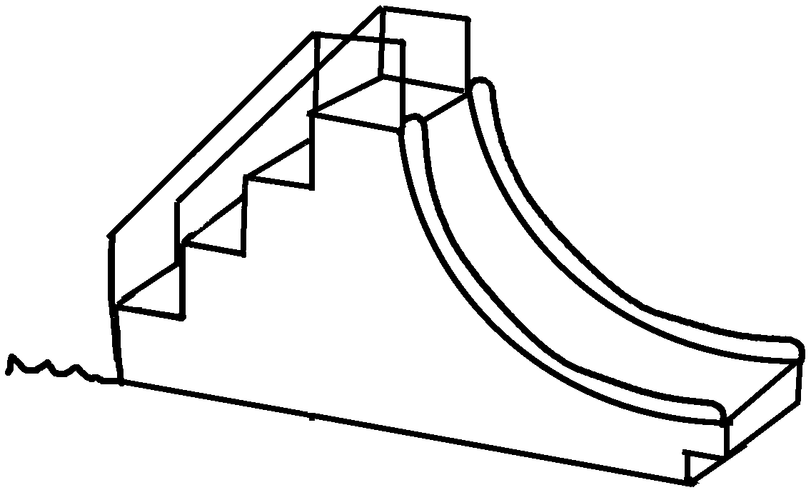
 | a s __ __ __ __ |  | a s __ __ __ __

6 | 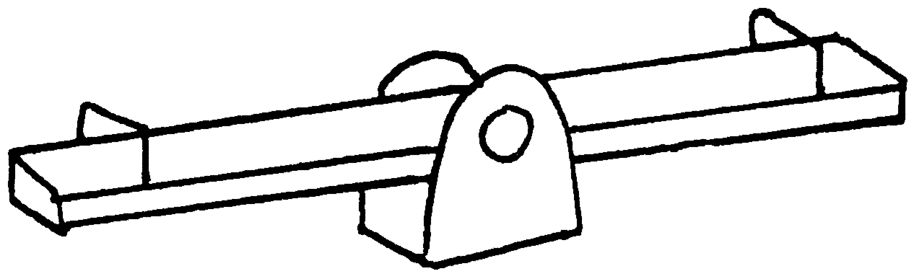 | 7 | 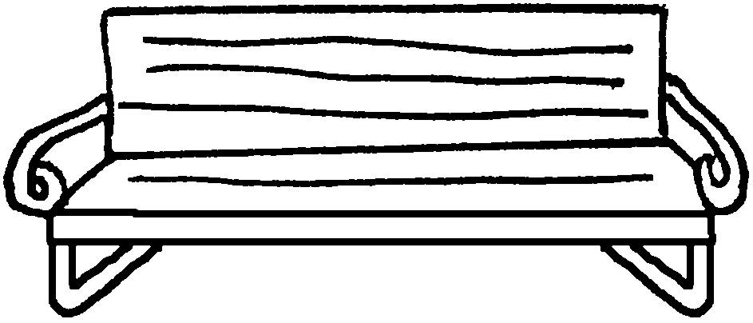
 | a s __ __ - s __ __ |  | a b __ __ __ __

8 | 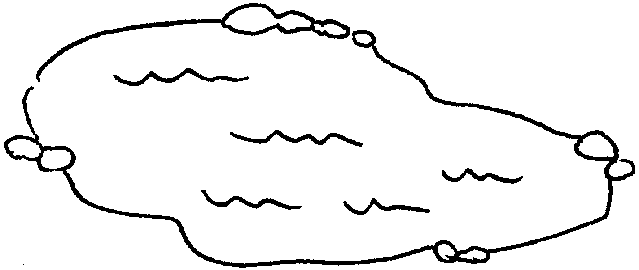 | 9 | 
 | a p __ __ __ |  | a f __ __ __ __ __

10 | 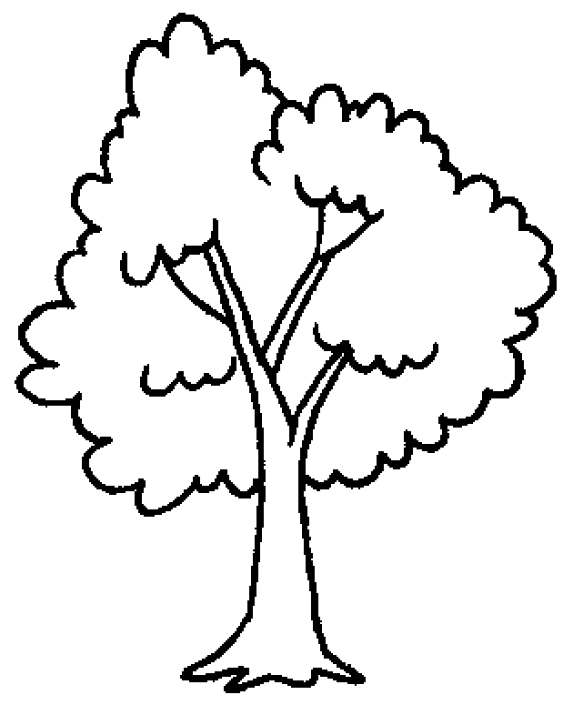 | 11 |  | 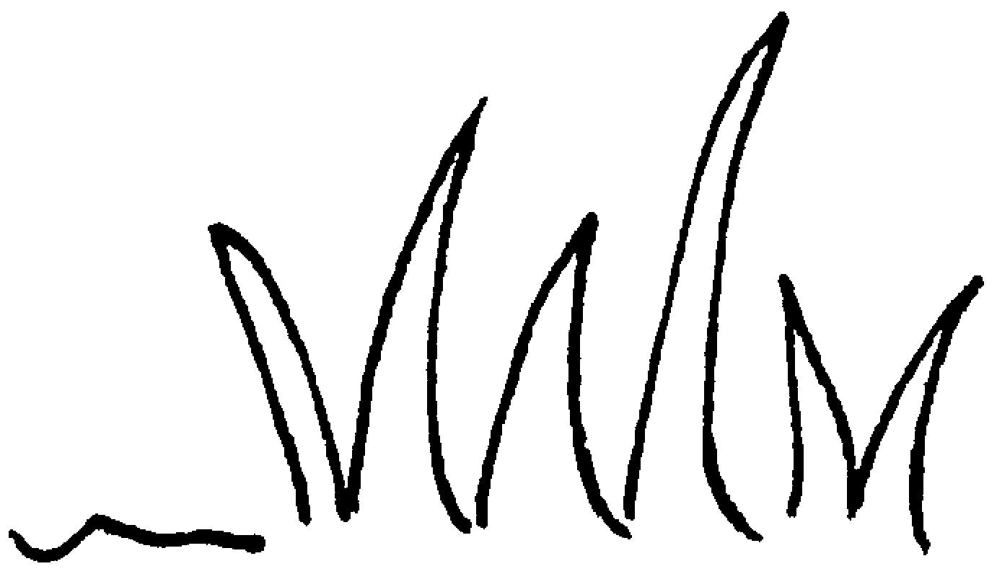 | 12 |  | 
 | a t __ __ __ |  | the g __ __ __ __ |  |  |  | the s __ __


Book 1B Chapter 3 Graded Worksheets
Worksheet 1⬇⬇
1 b e e 2 b i r d 3 a n t
4 s w i n g 5 s l i d e
6 s e e - s a w 7 b e n c h
8 p o n d 9 f l o w e r
10 t r e e 11 g r a s s 12 s k y

