What are they? Write.

1 | 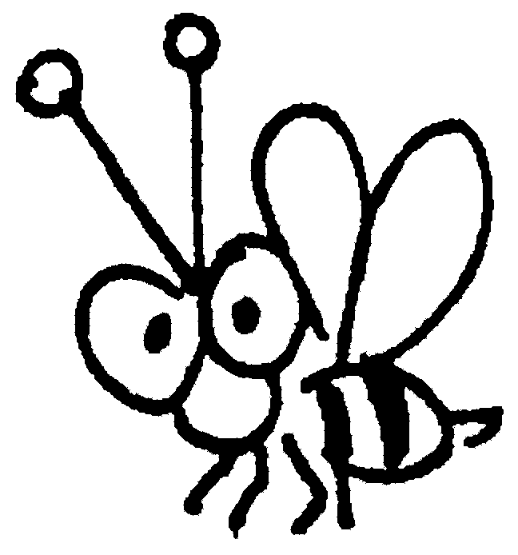 | 2 | 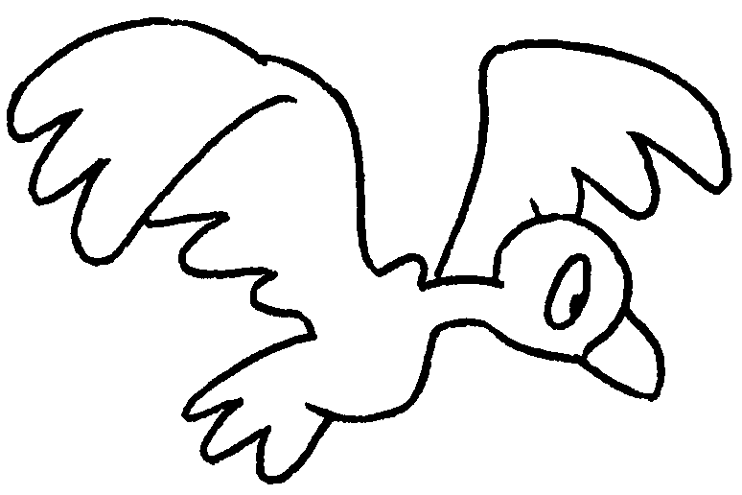 | 3 | 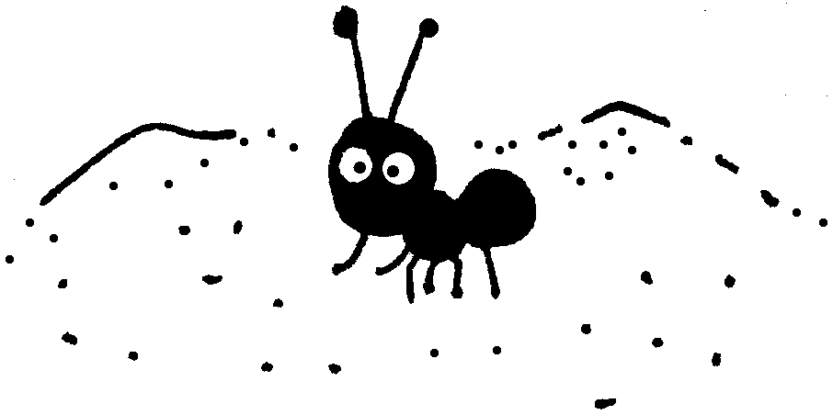
 | a b |  | a b |  | an a

4 | 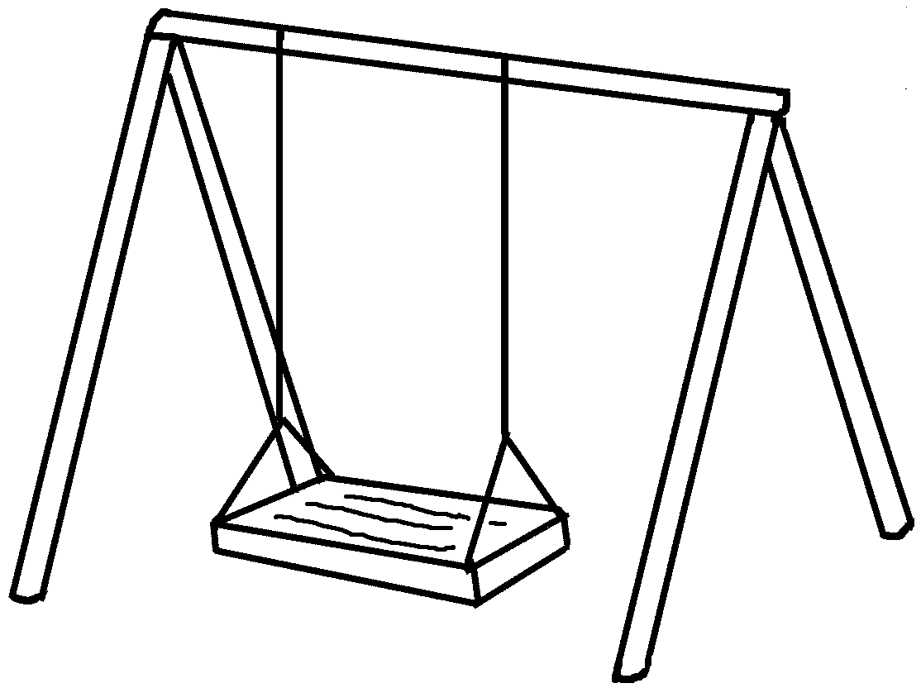 | 5 | 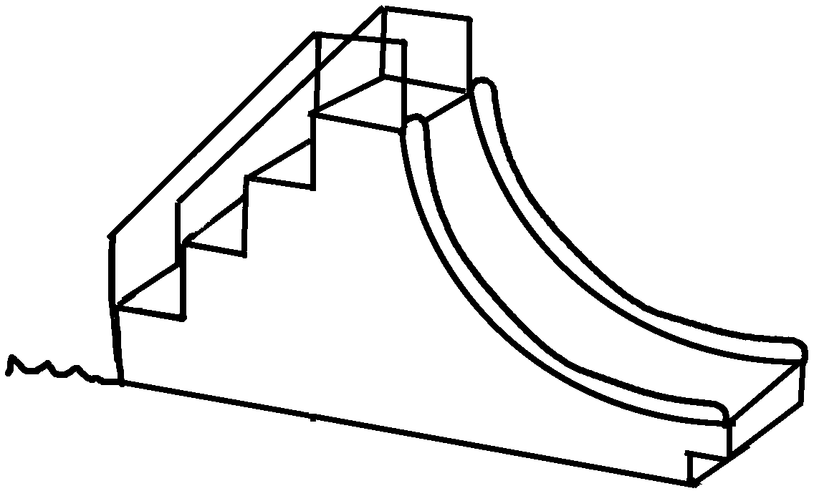
 | ____ |  | ____

6 | 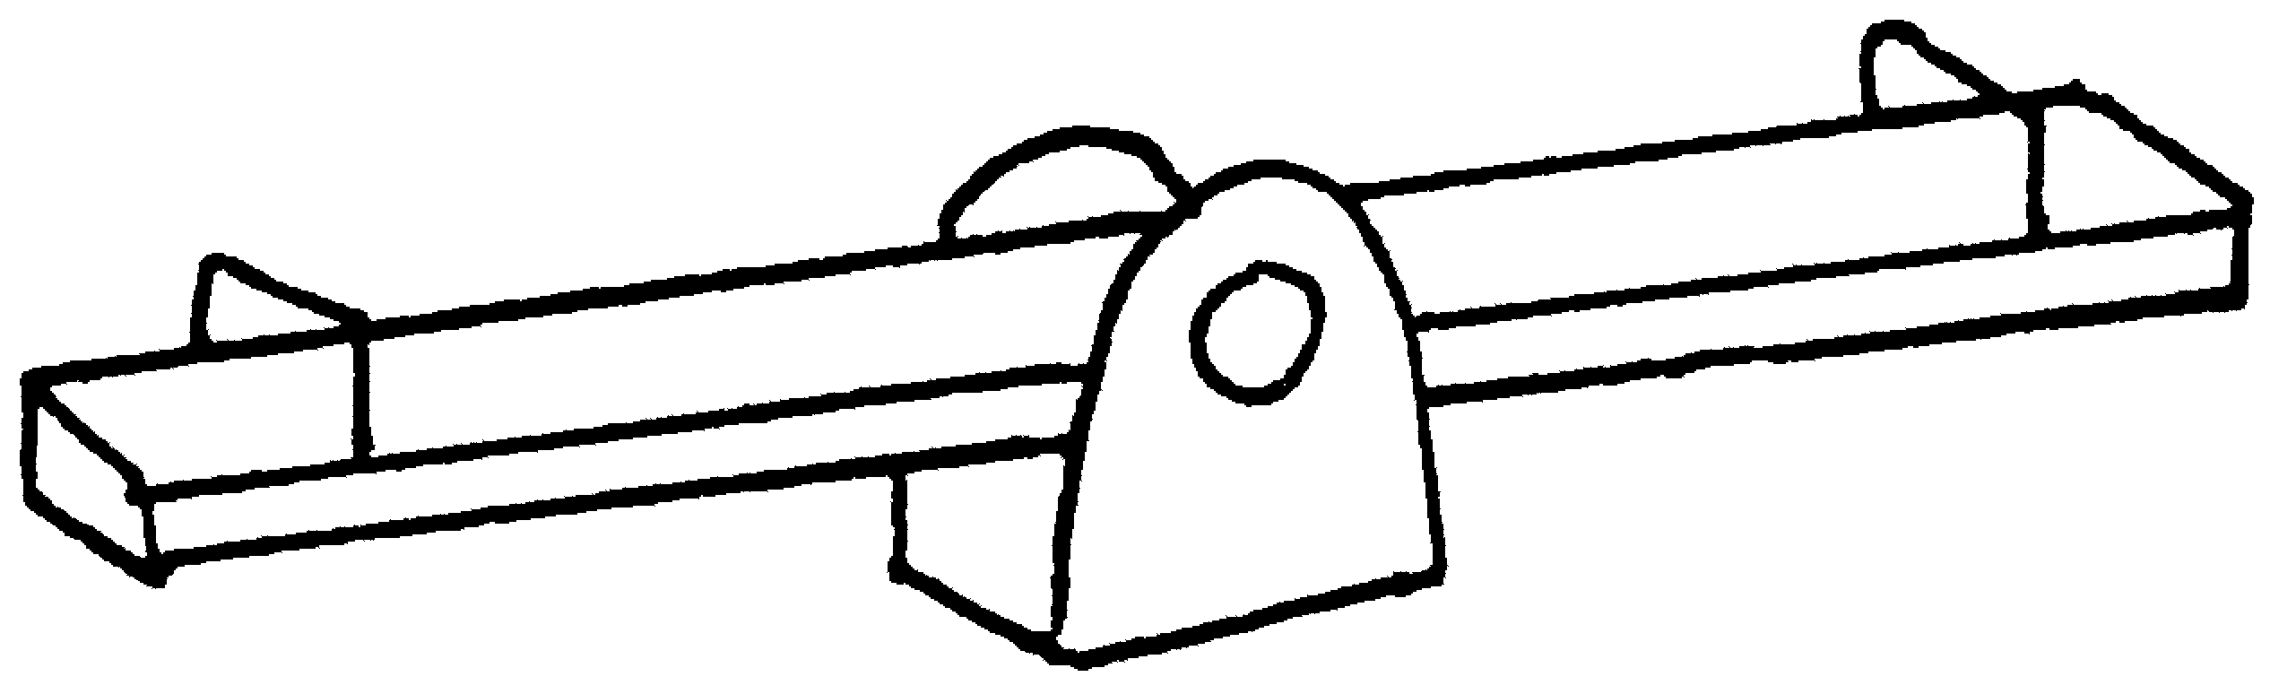 | 7 | 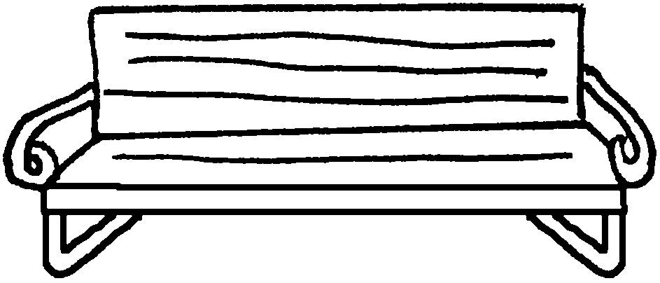
 | ____ |  | ____

8 | 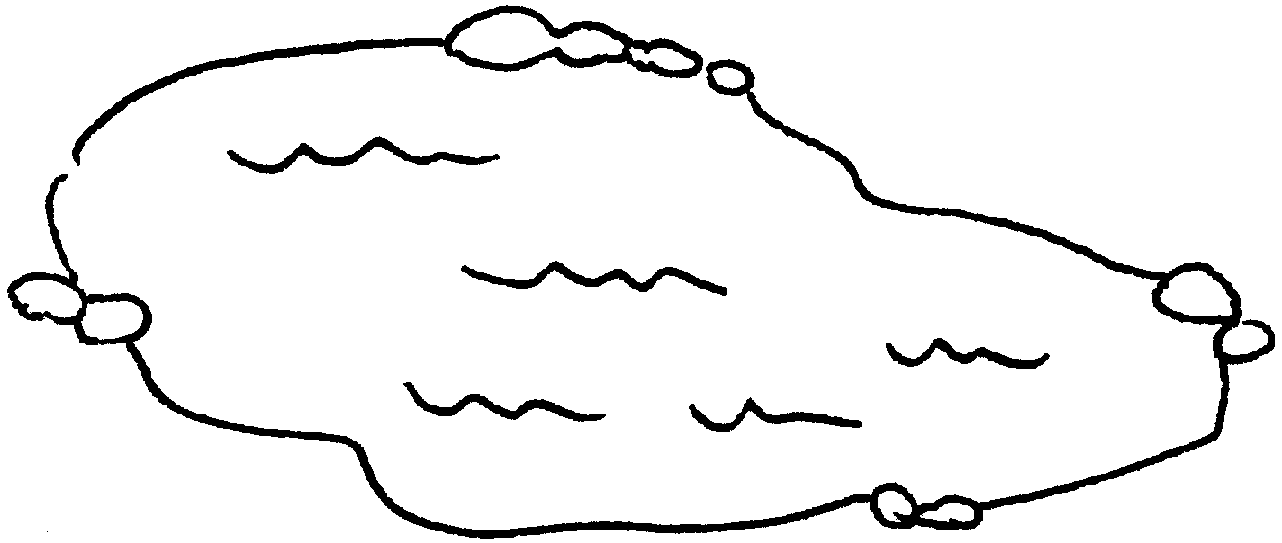 | 9 | 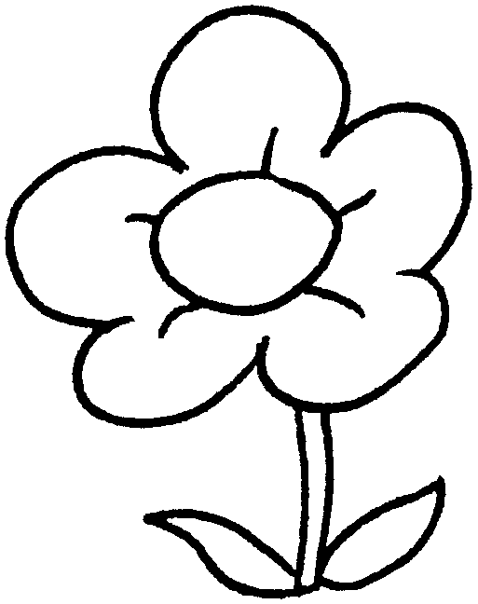
 | ____ |  | ____

10 | 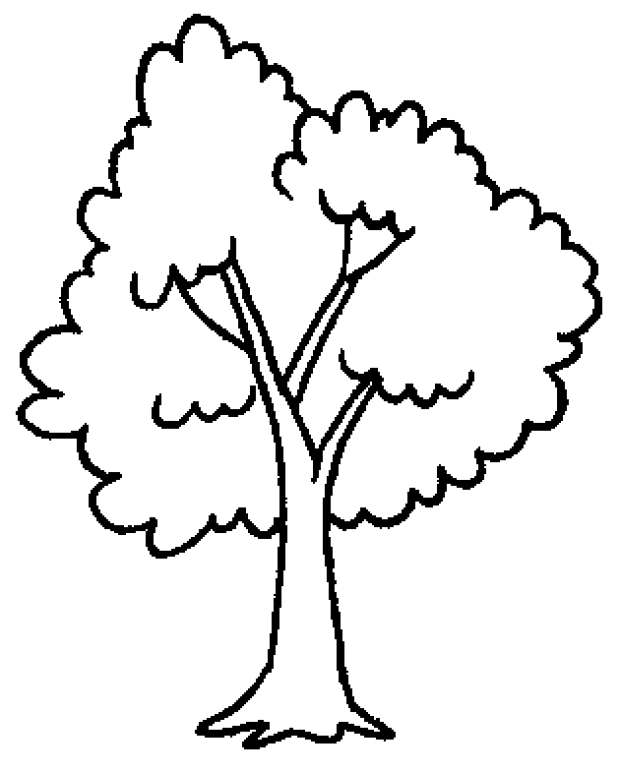 | 11 | 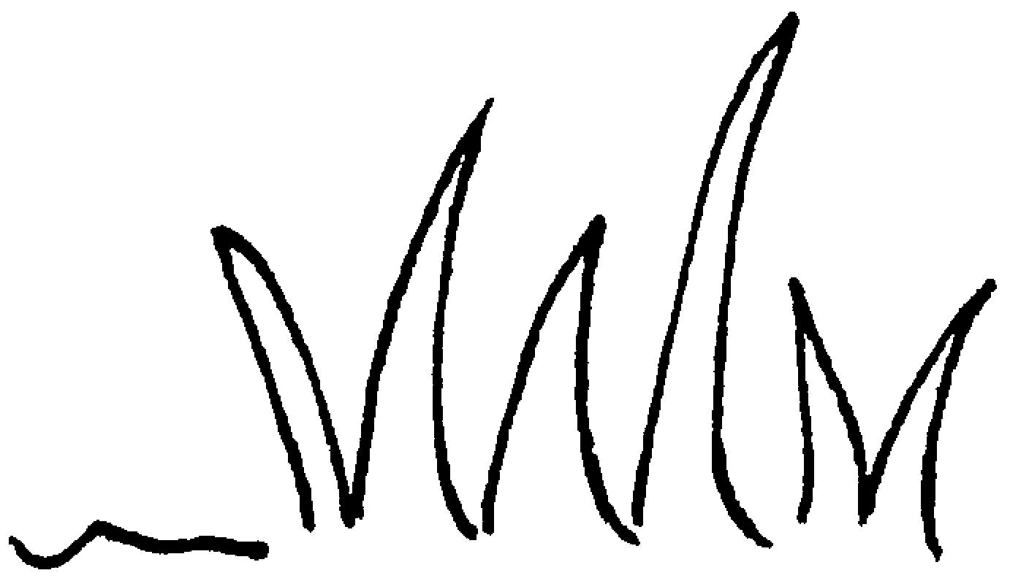 | 12 | 
 | ____ |  | the |  | _____


Book 1B Chapter 3 Graded Worksheets
Worksheet 1⬇⬇⬇
1 bee 2 bird 3 ant
4 a swing 5 a slide
6 a see-saw 7 a bench
8 a pond 9 a flower
10 a tree 11 grass 12 the sky

