Choose and write.
Good morning, Kate.
Good morning, Tom.
Good afternoon, Tom.
Goodbye, Tom.
Good morning, Jack.
Good afternoon, Jack.
Goodbye, Jack.
Goodbye, Andy.
a | an | the

A  B | 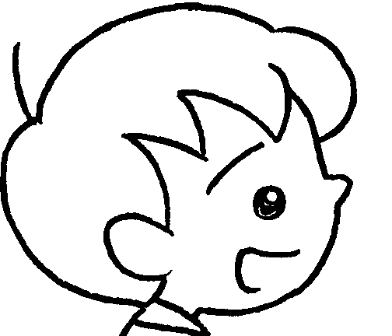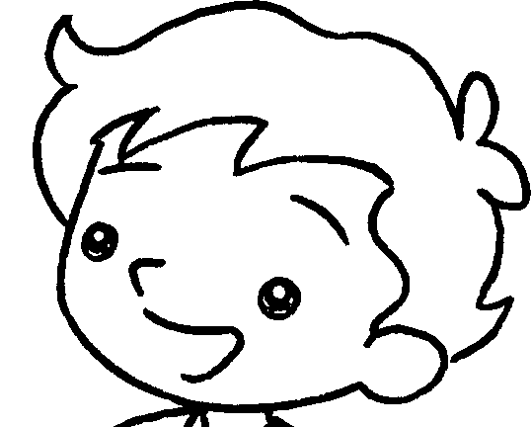
1 | 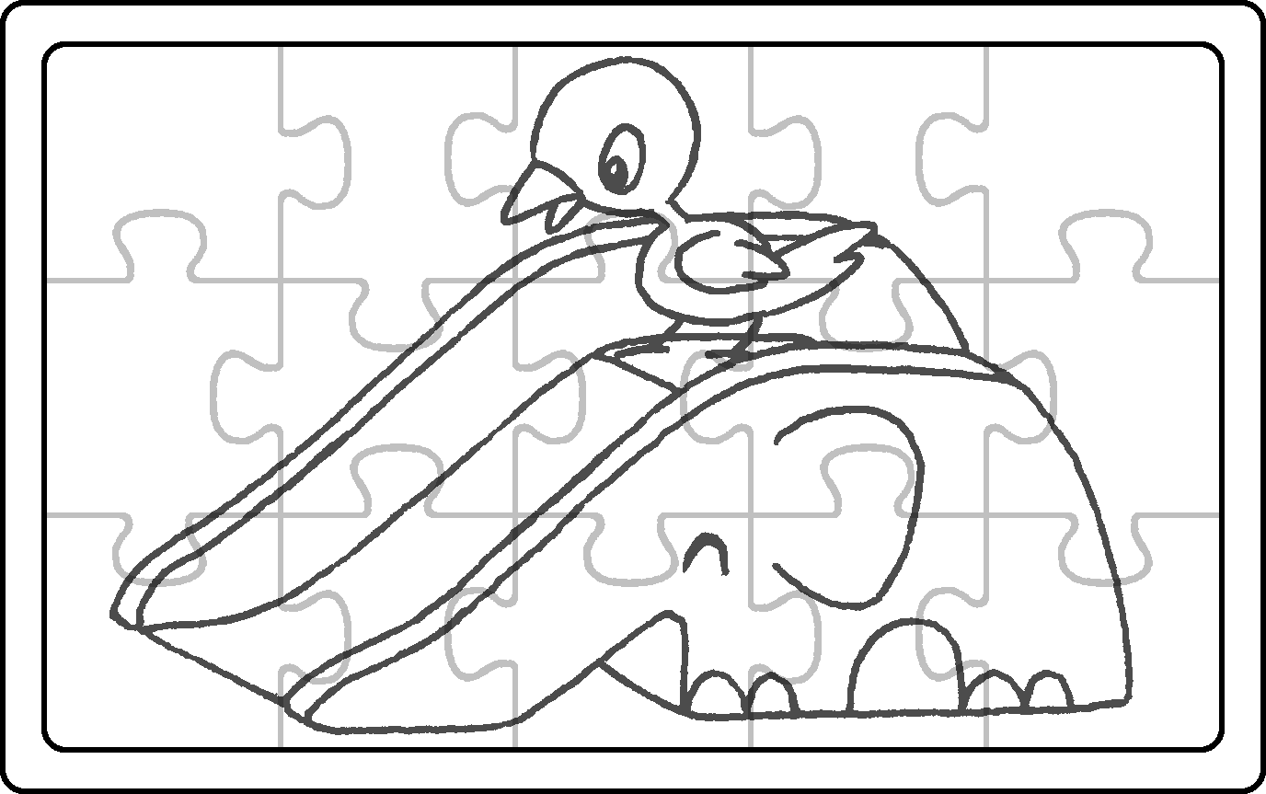 | A : What can you see?  B : I can see bird.  A : Where is bird?  B : It is on slide.
2 | 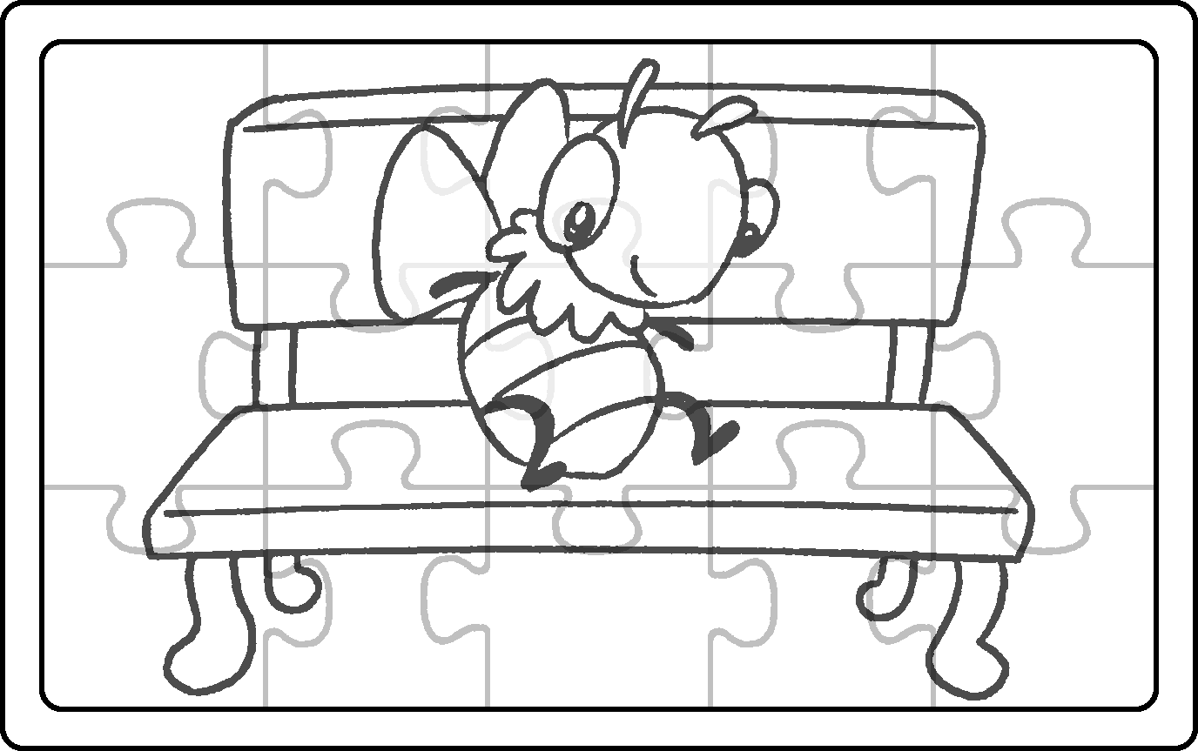 | A : What can you see?  B : I can see bee.  A : Where is bee?  B : It is on bench.
3 | 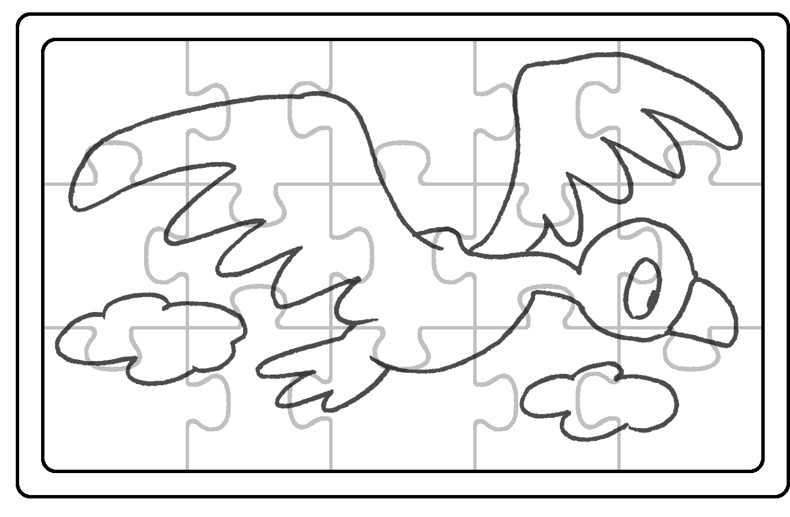 | A : What can you see?  B : I can see bird.  A : Where is ?  B : It is in .
4 | 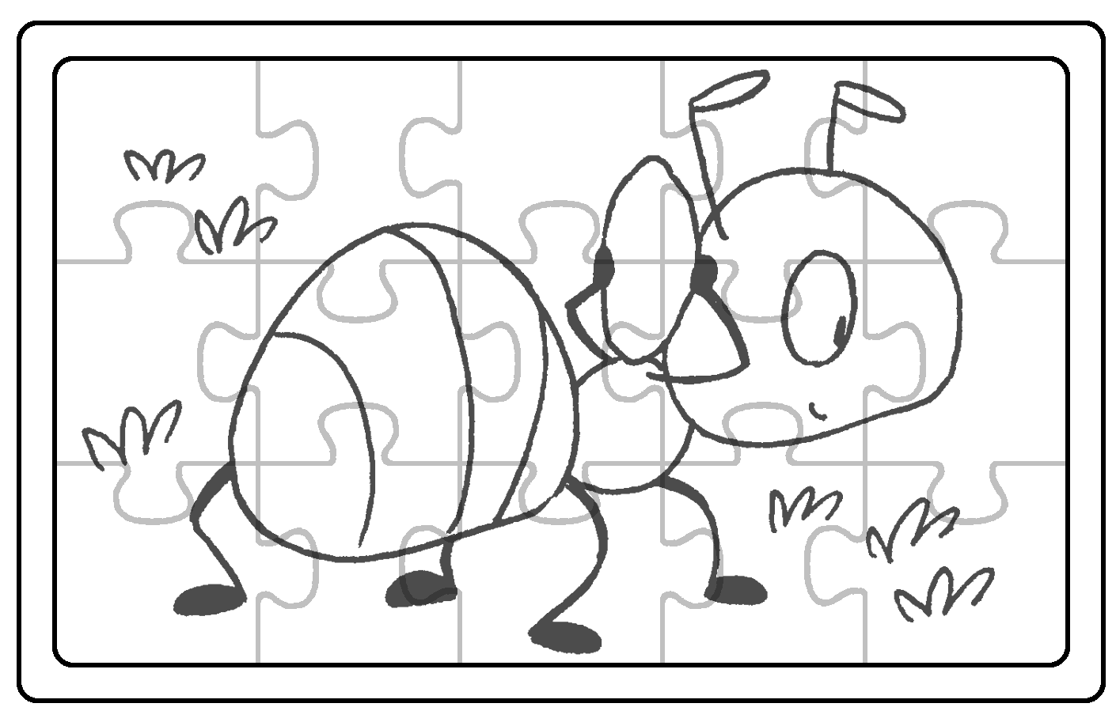 | A : What can you see?  a  the  a  B : I can see ant.  A : Where is ?  B : It is on .



Book 1B Chapter 3 Graded Worksheets
Worksheet 2⬇⬇
- a
the
a
- a
the bird
the sky
- an
the ant
the grass

