Choose and write.
Where | in on under

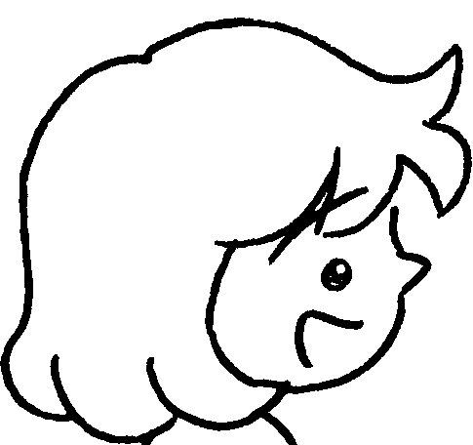
A
B
1 | 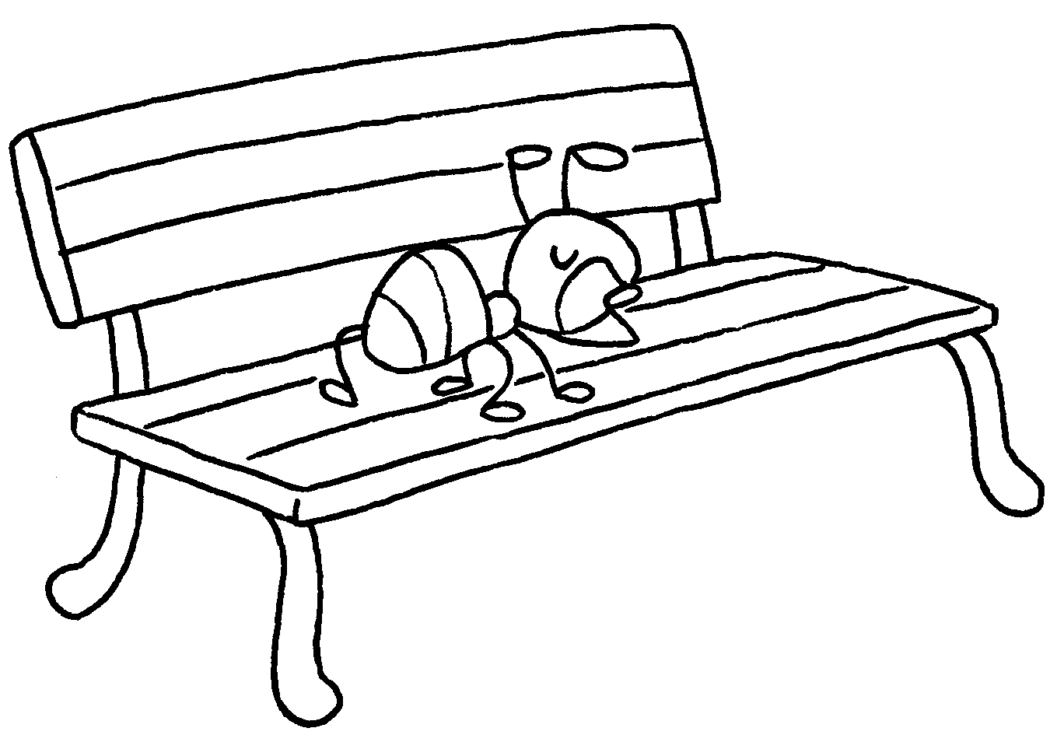 | A : Where is the ant?  B : It is a bench.
2 | 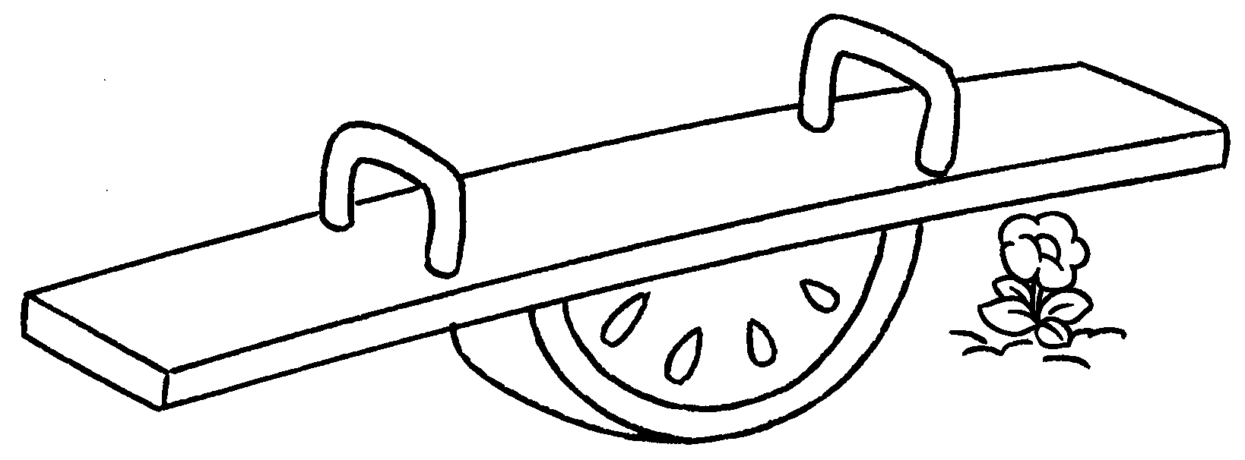 | A : Where is the flower?  B : It is a see-saw .
3 | 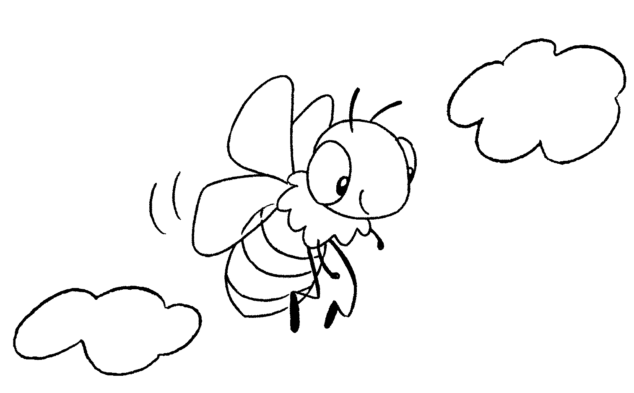 | A : is the bee?  B : It is the sky.
4 | 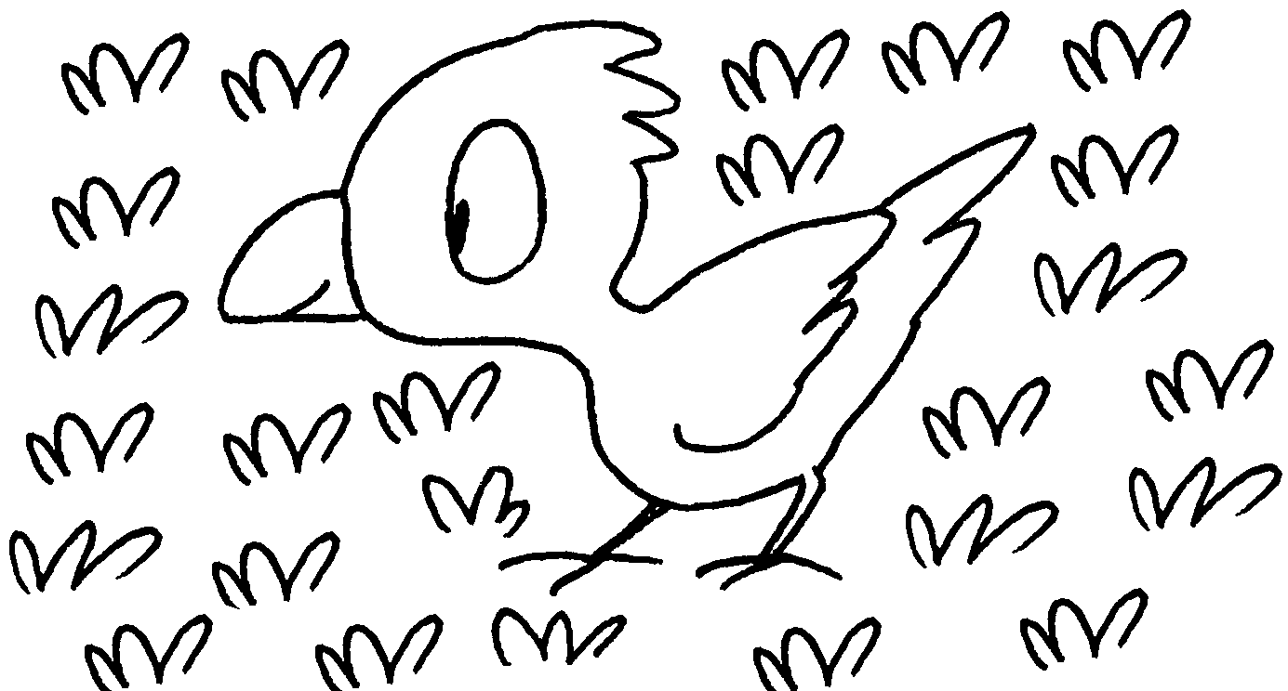 | A : is the bird?  B : It is the grass.
5 | 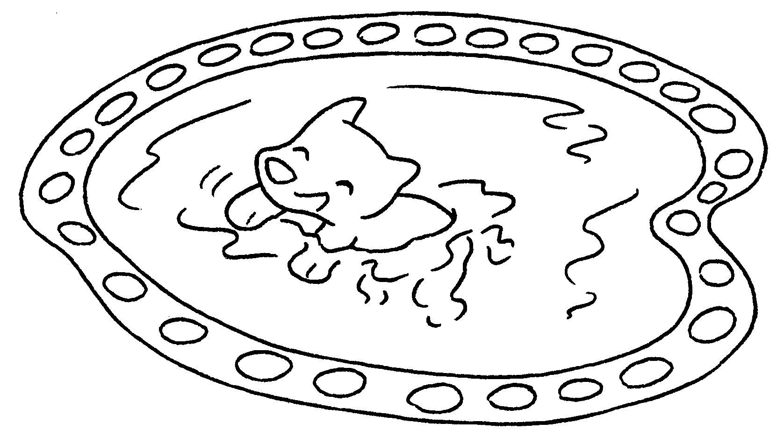 | A : is the dog?  B : It is a pond.


Book 1B Chapter 3 Graded Worksheets
Worksheet 3⬇
1 on
2 under
3 Where
in
- Where
on
- Where
in

