Where are they? Write.

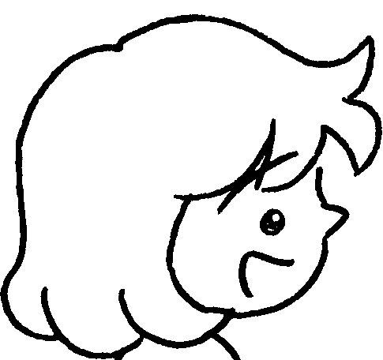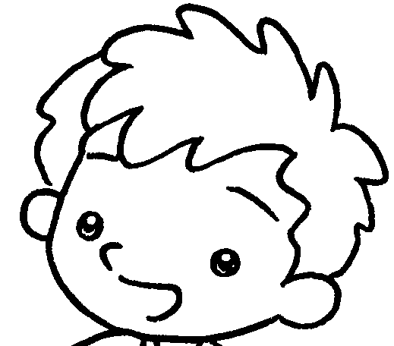
A
B
1 | 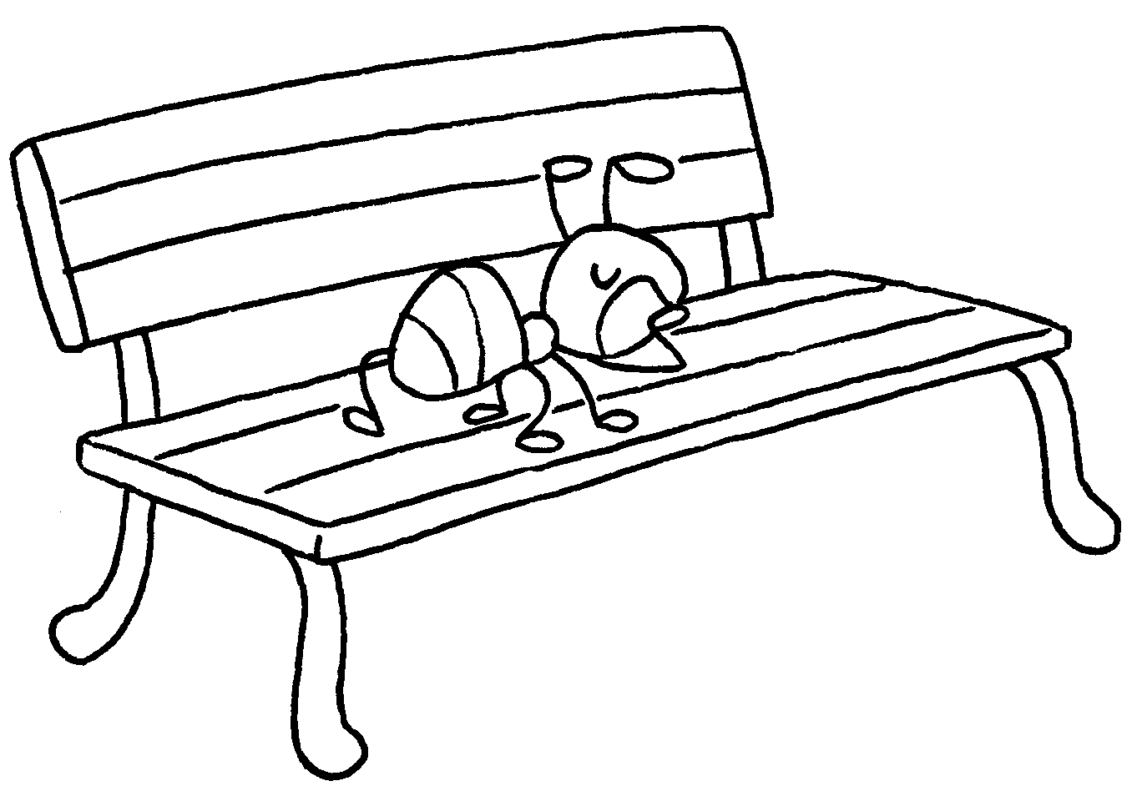 | A : Where is the ant?  B : It is a bench.
2 | 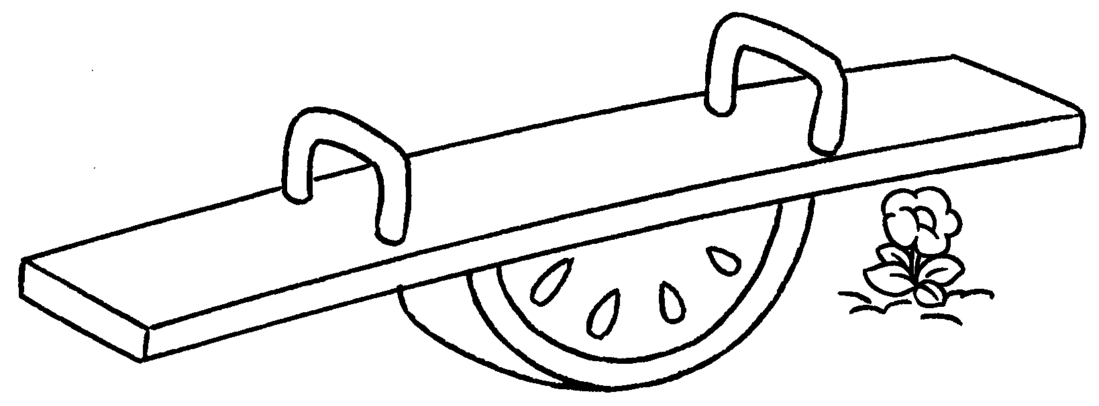 | A : is the flower?  B : It is a see-saw.
3 | 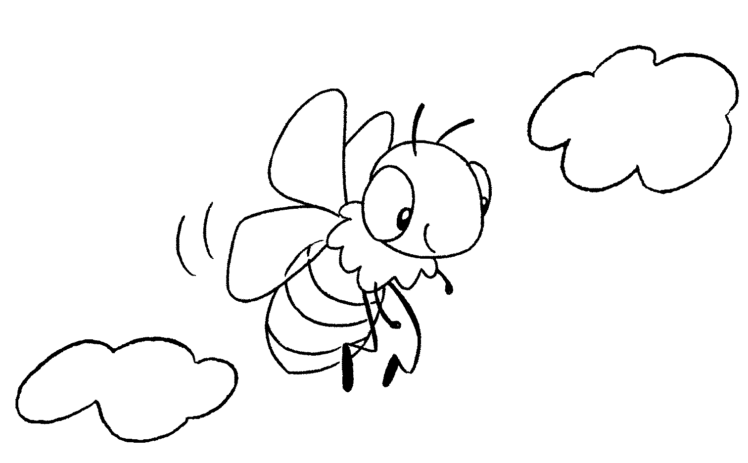 | A : the bee?  B : It is  .
4 | 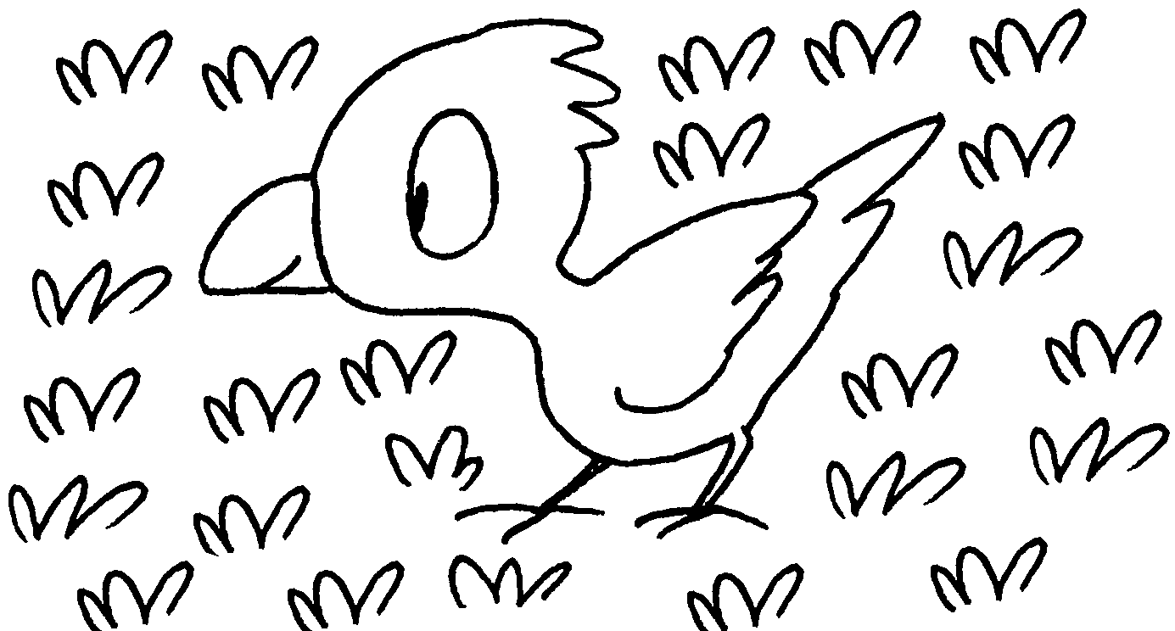 | A : the bird?  B : It is .
5 | 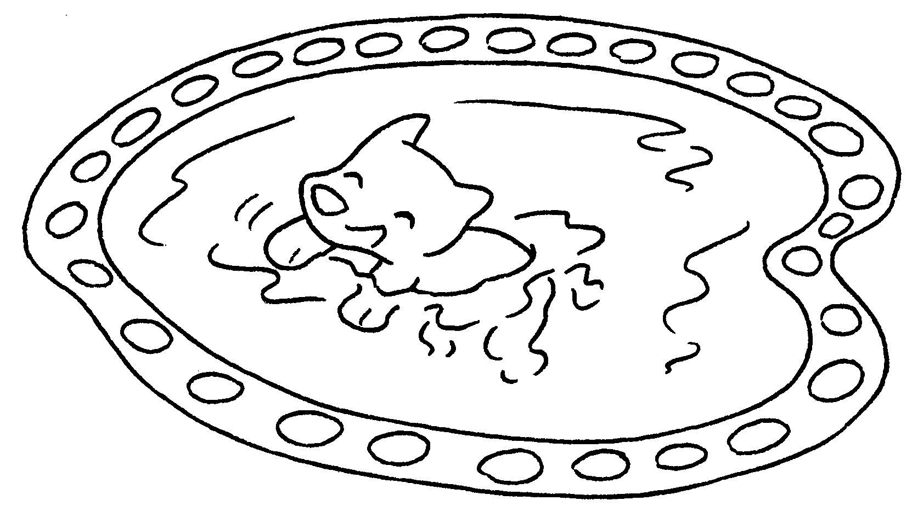 | A :  B :


Book 1B Chapter 3 Graded Worksheets
Worksheet 3⬇⬇⬇
- on
- Where
under
- Where is
in the sky
- Where is
on the grass
- Where is the dog?
It is in a pond.

