Choose and write.
elephant | giraffe | hippo | lion
monkey | panda | tiger | zebra

1 | 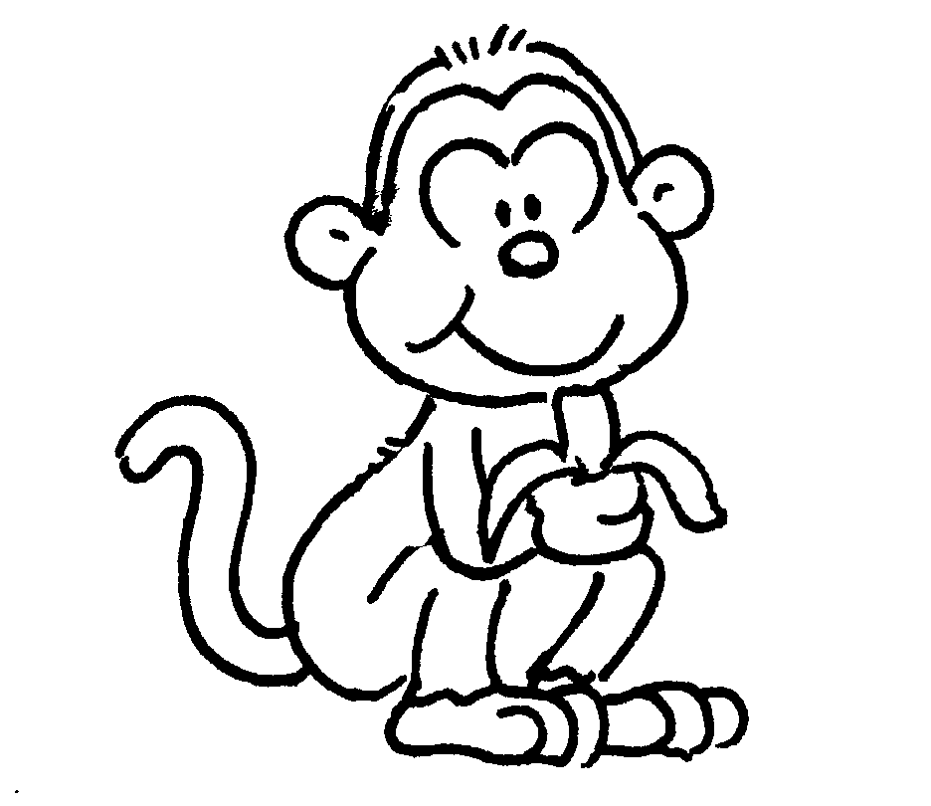 | 2 | 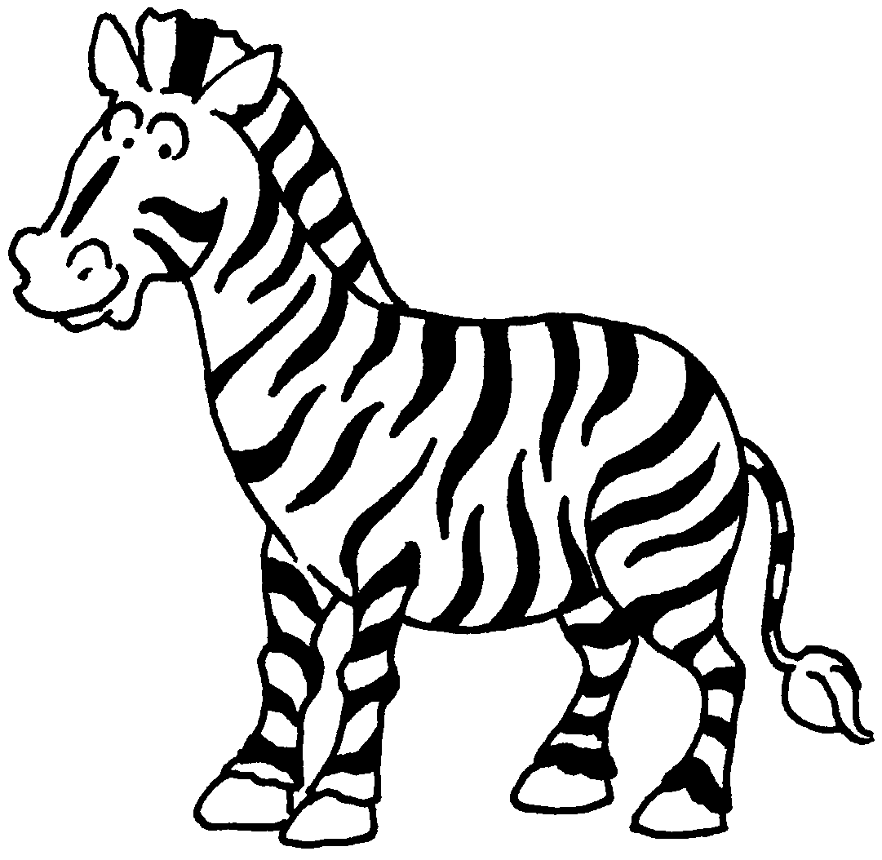
 | a |  | a
3 | 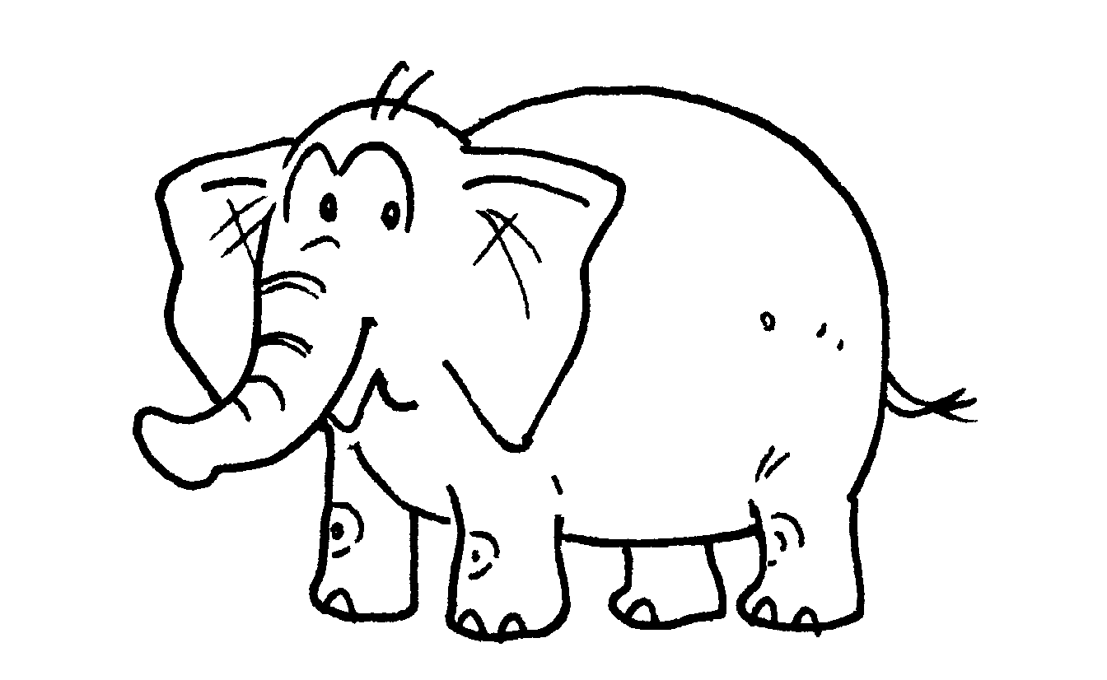 | 4 | 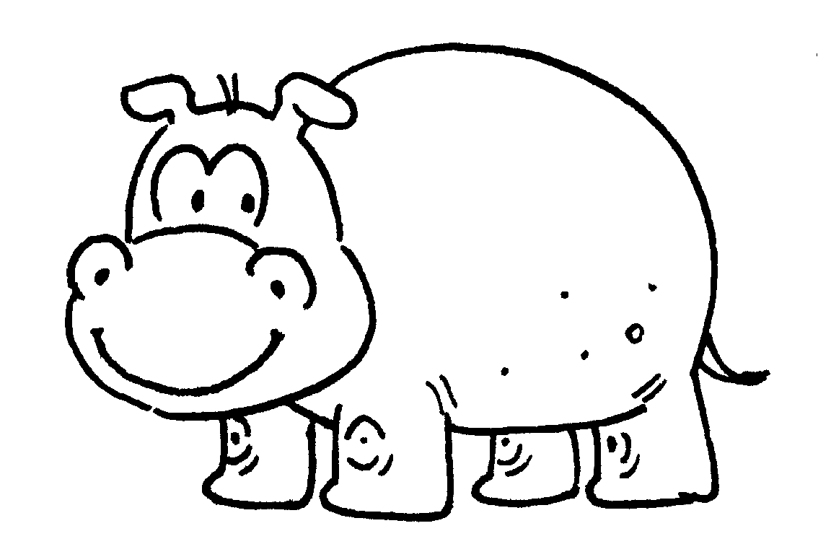
 | an |  | a
5 | 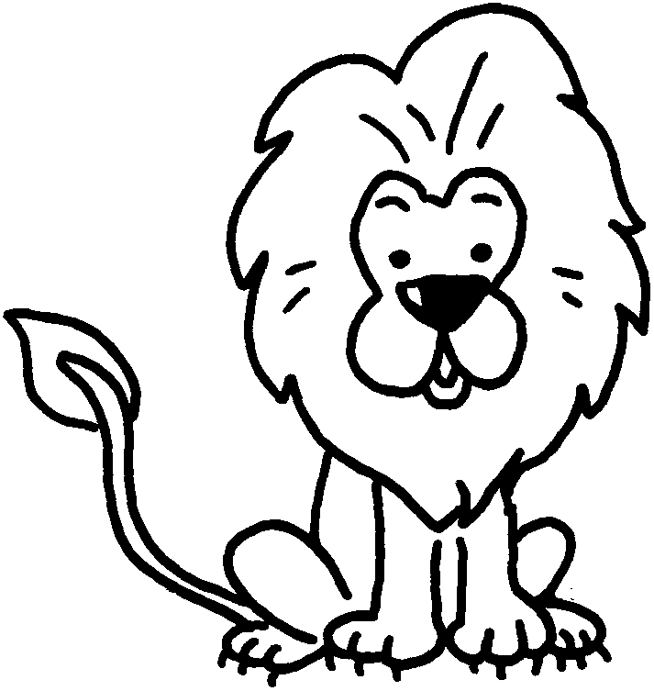 | 6 | 
 | a |  | a
7 | 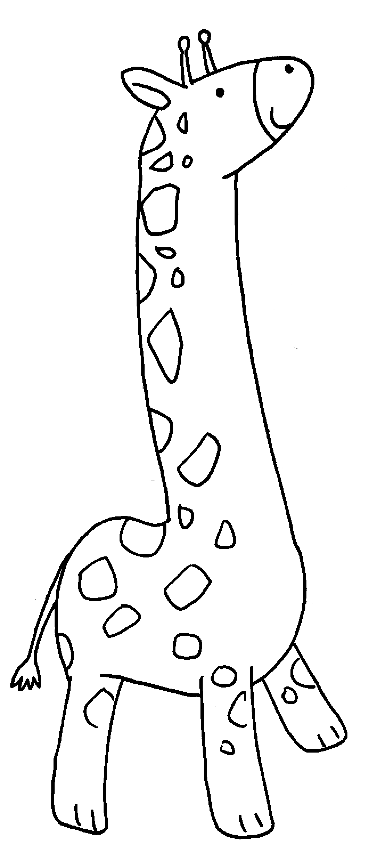 | 8 | 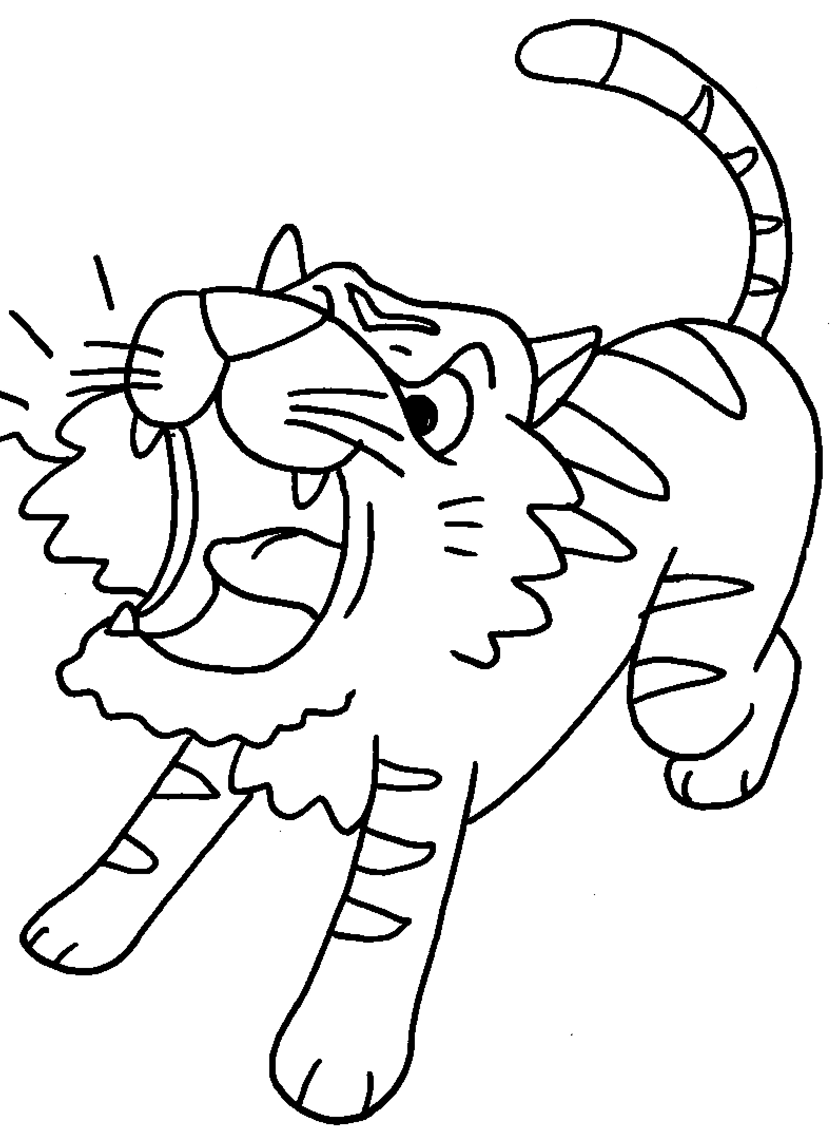
 | a |  | a


Book 1B Chapter 4 Graded Worksheets
Worksheet 1⬇
- monkey 2 zebra
3 elephant 4 hippo
5 lion 6 panda
7 giraffe 8 tiger

