Fill in the missing letters.

1 | 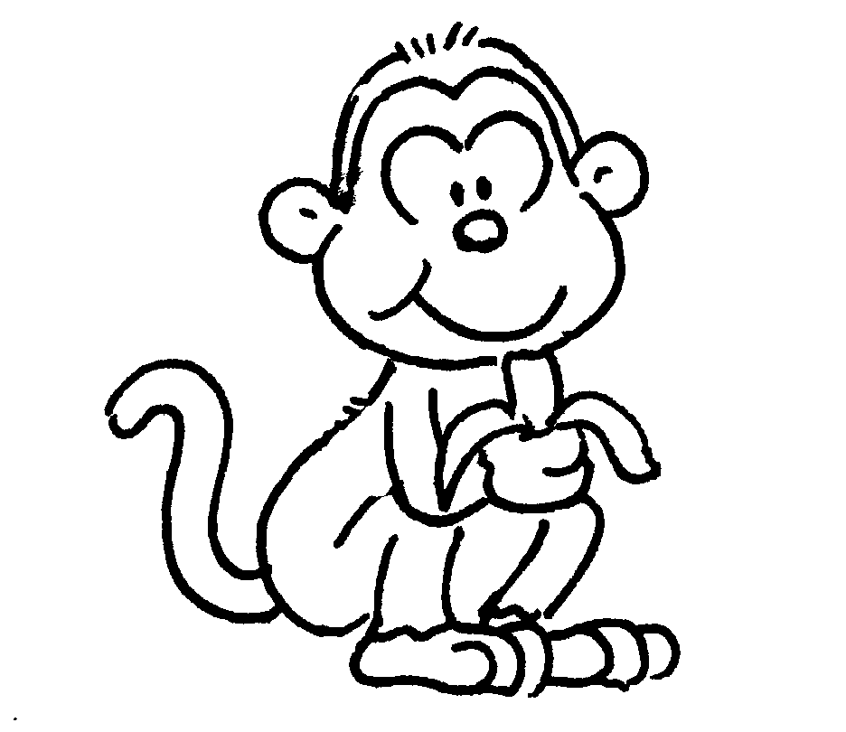 | 2 | 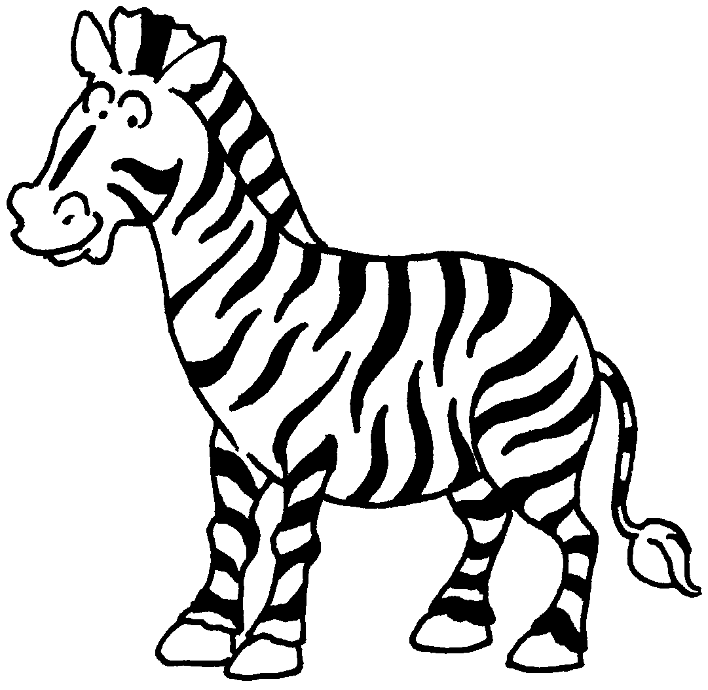
 | a m __ __ __ __ __ |  | a z __ __ __ __
3 | 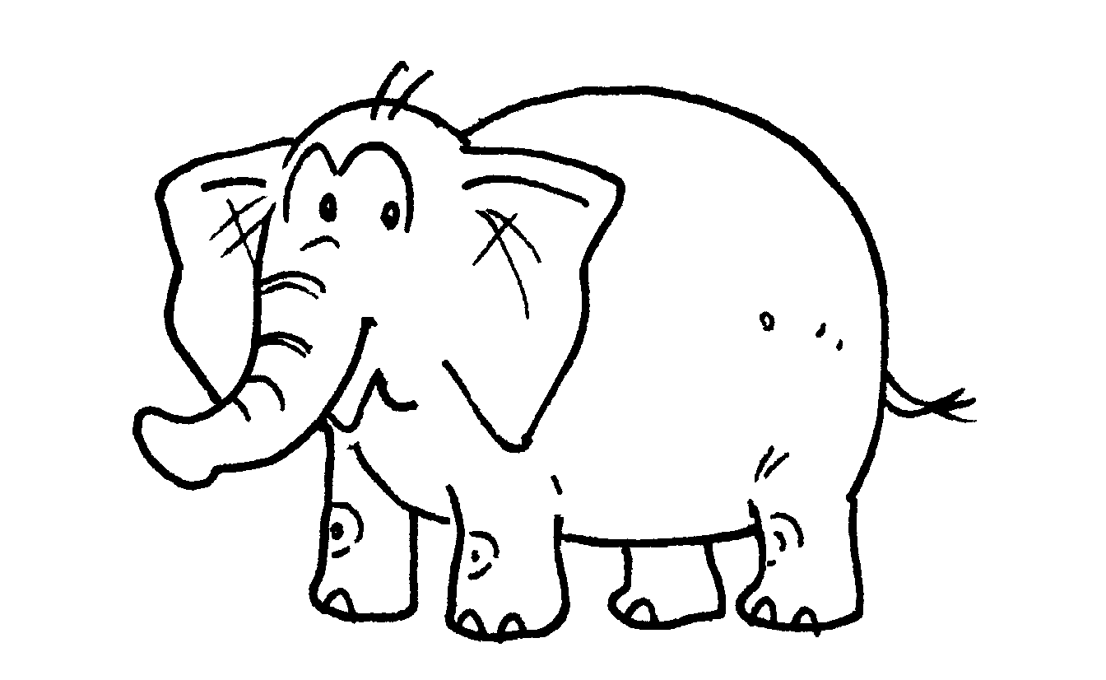 | 4 | 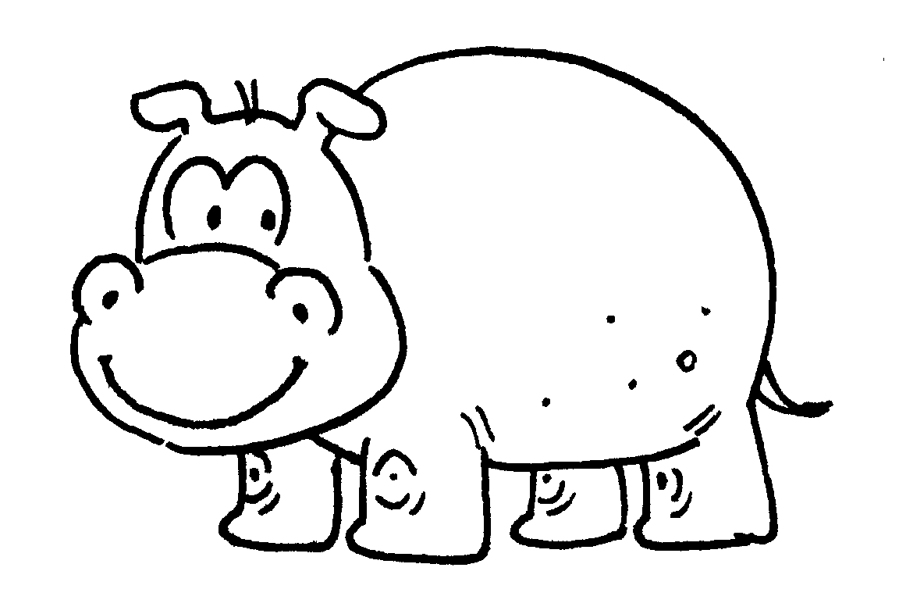
 | an e __ __ __ __ __ __ __ |  | a h __ __ __ __
5 |  | 6 | 
 | a l __ __ __ |  | a p __ __ __ __
7 | 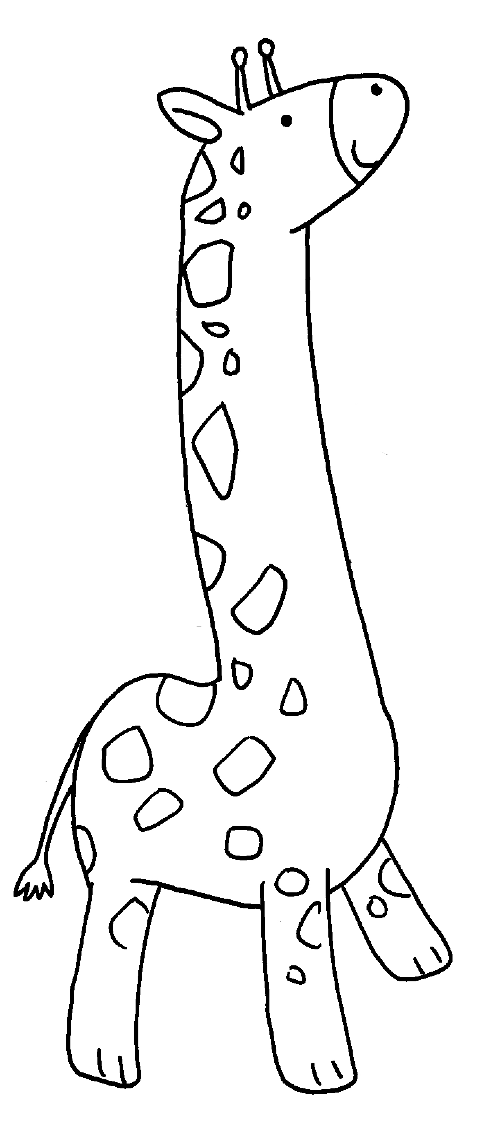 | 8 | 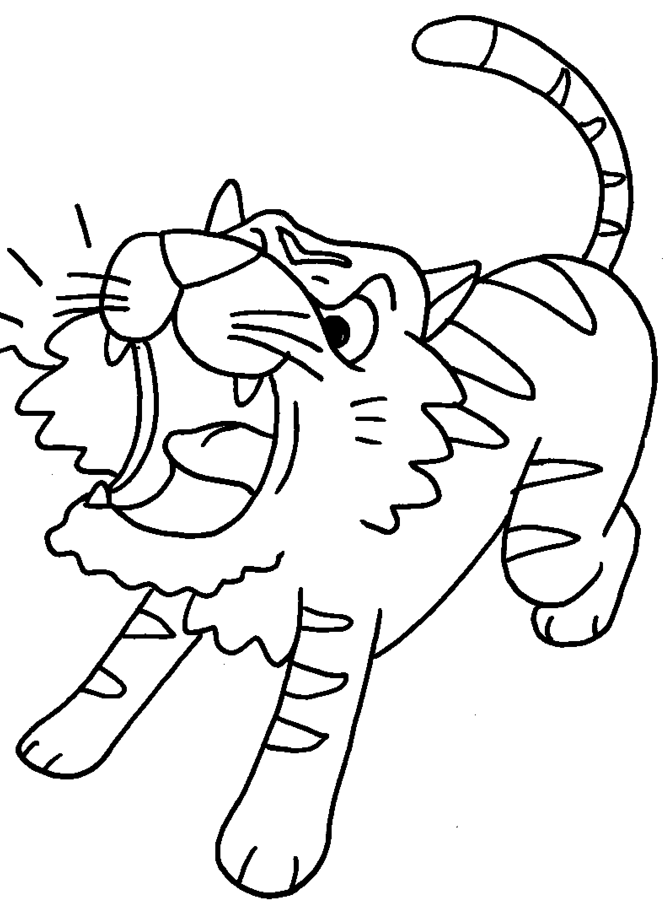
 | a g __ __ __ __ __ __ |  | a t __ __ __ __


Book 1B Chapter 4 Graded Worksheets
Worksheet 1⬇⬇
1 m o n k e y 2 z e b r a
3 e l e p h a n t 4 h i p p o
5 l i o n 6 p a n d a
7 g i r a f f e 8 t i g e r

