What are they? Write.

1 | 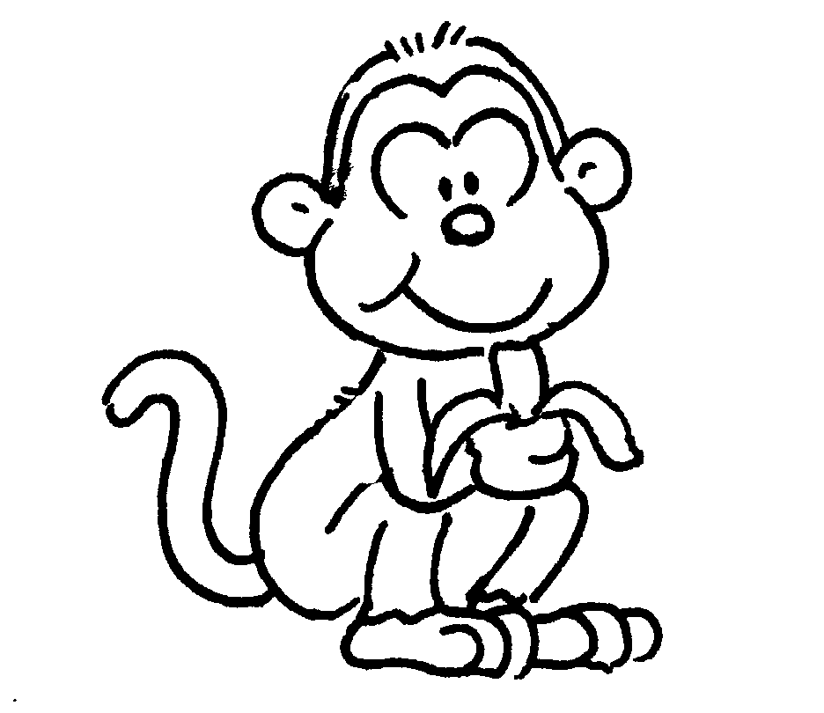 | 2 | 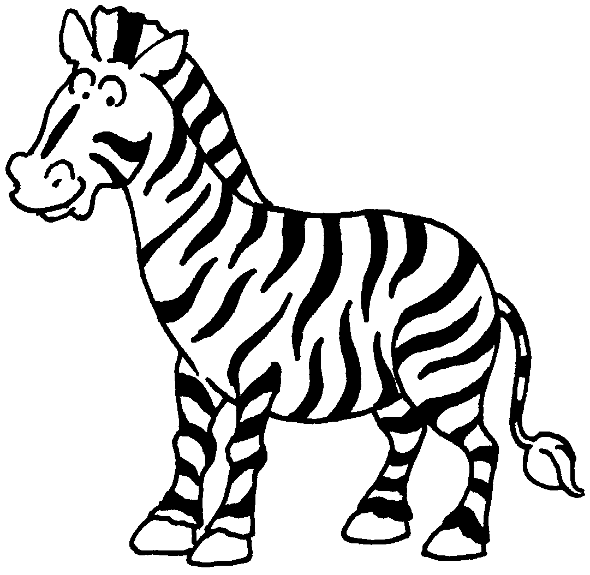
 | a m |  | a z
3 | 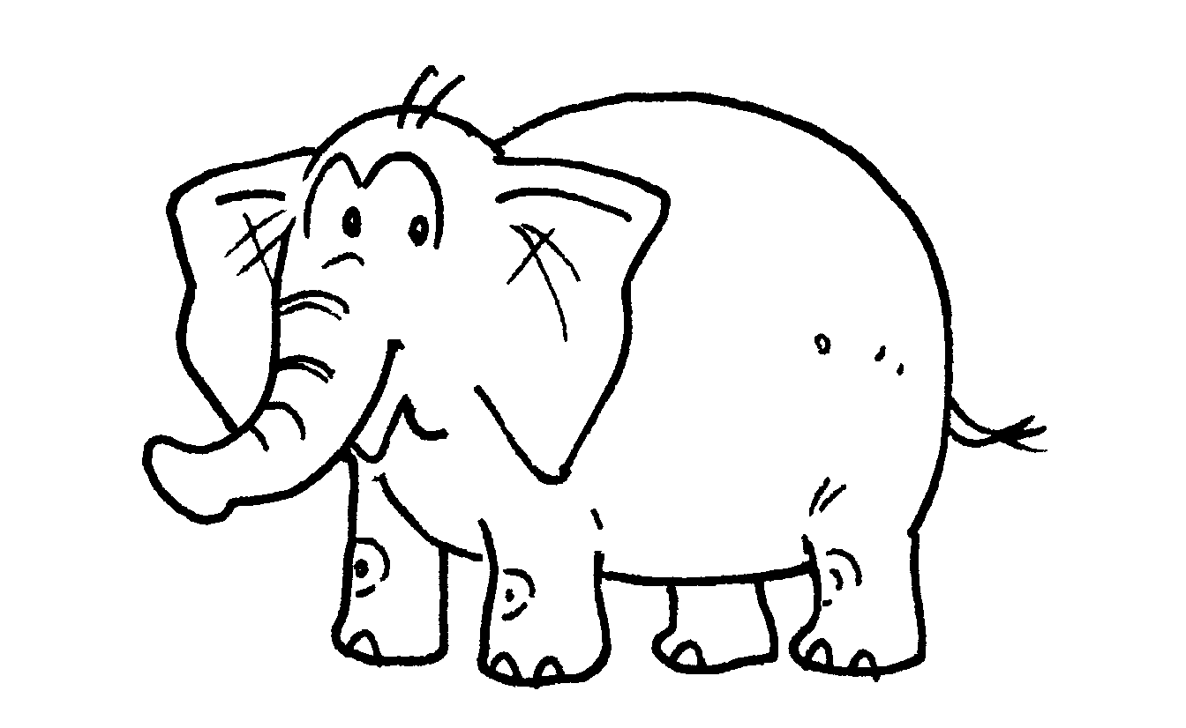 | 4 | 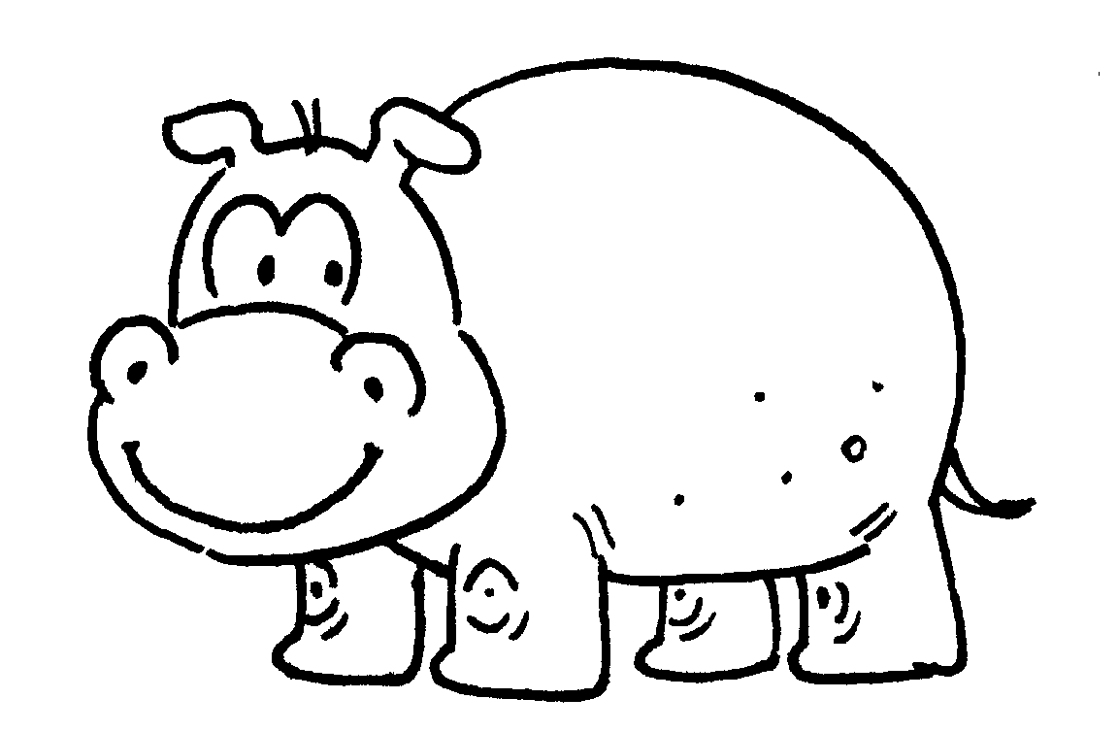
5 | 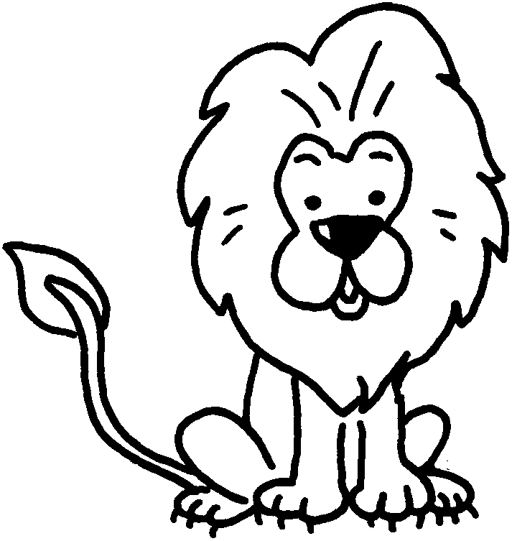 | 6 | 
7 | 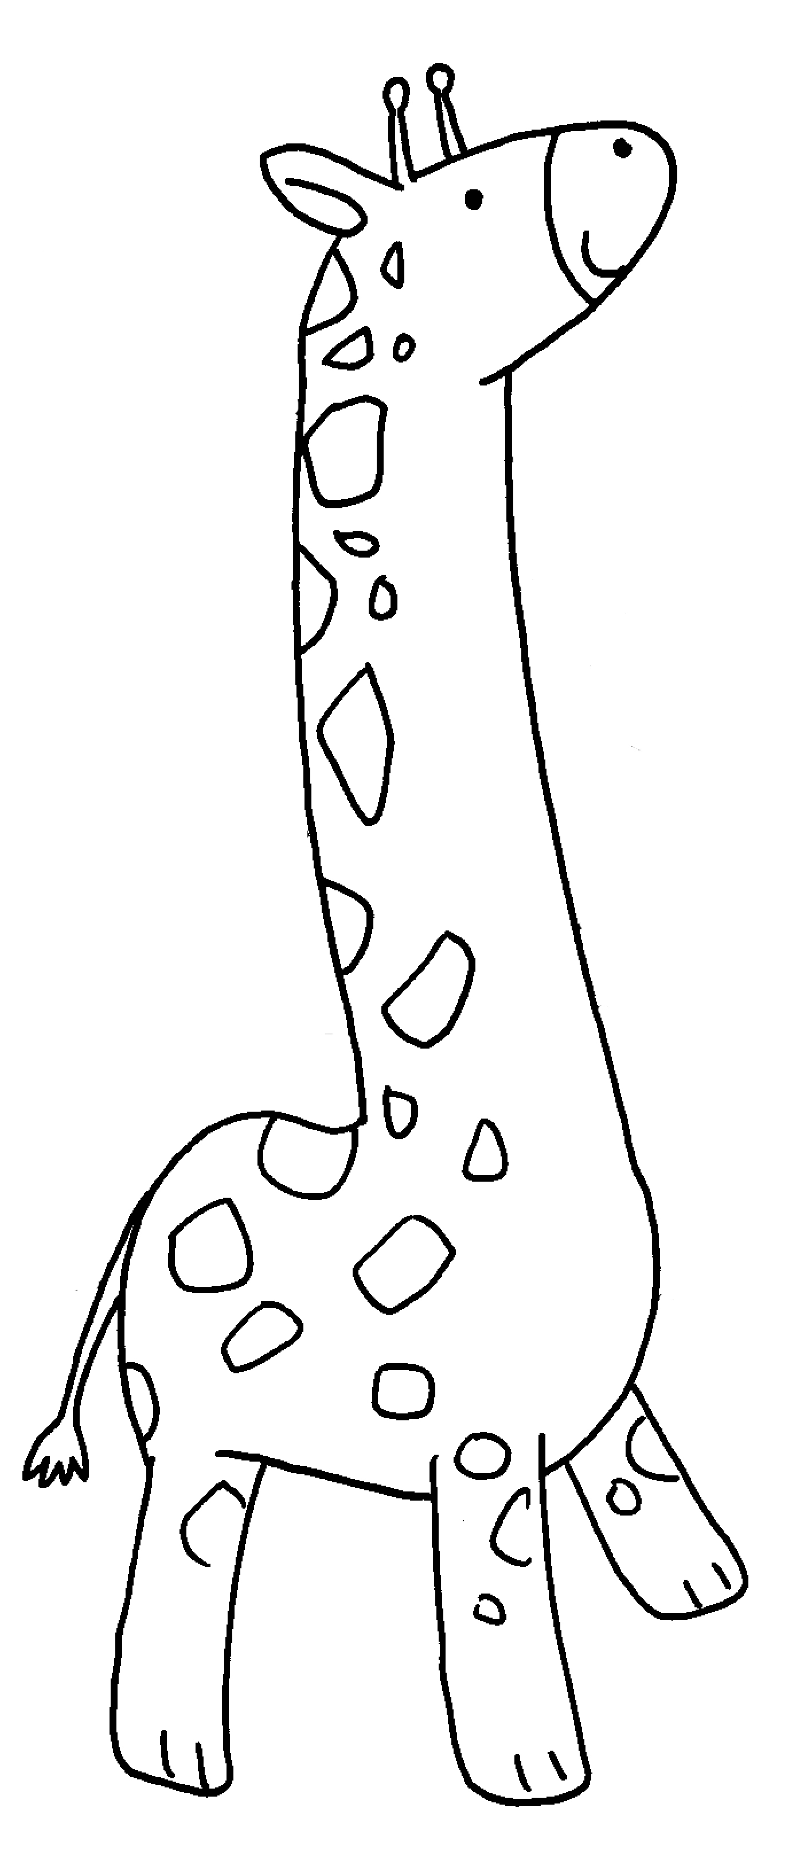 | 8 | 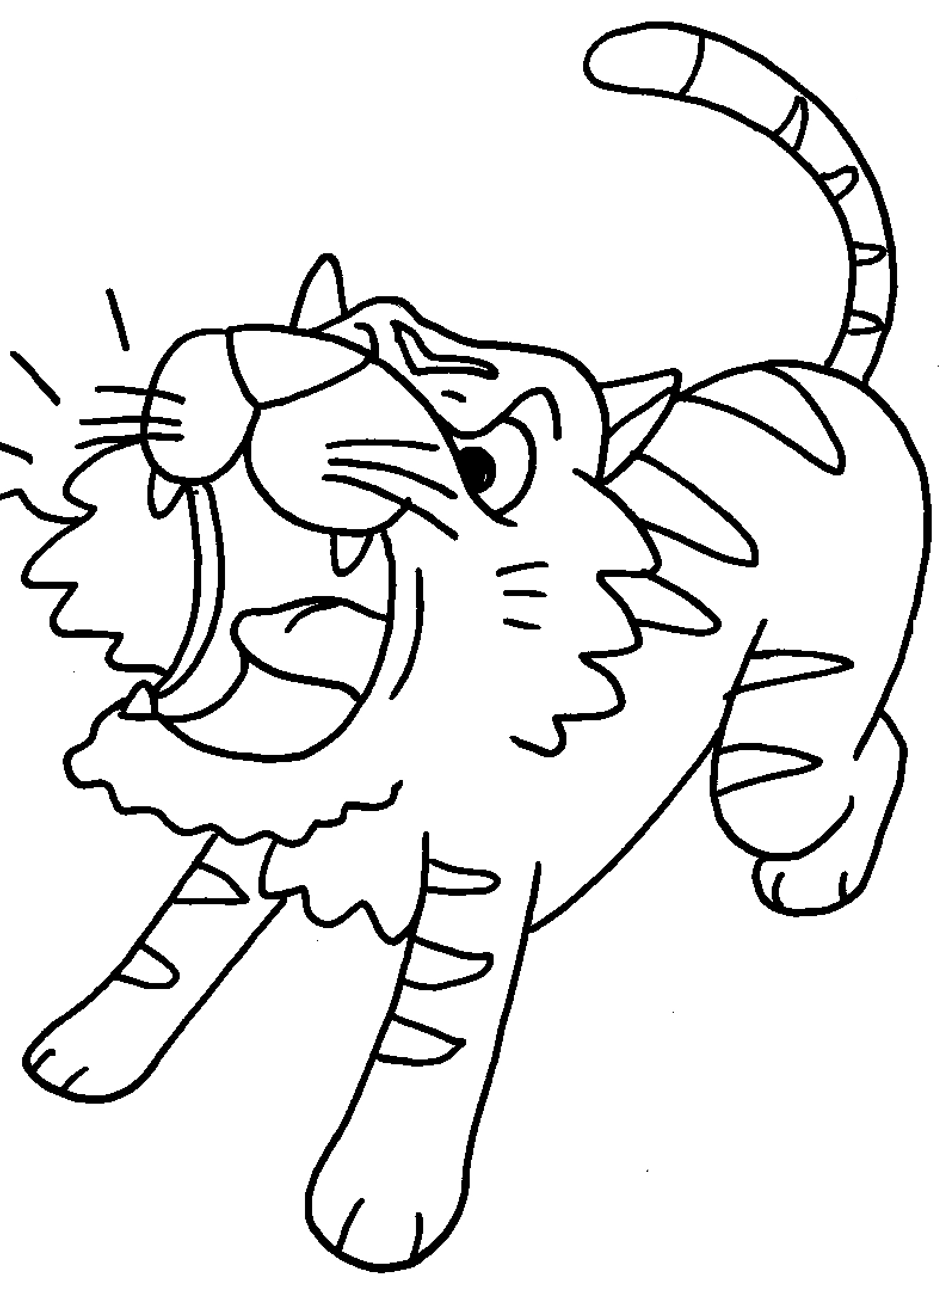


Book 1B Chapter 4 Graded Worksheets
Worksheet 1⬇⬇⬇
1 monkey 2 zebra
3 an elephant 4 a hippo
5 a lion 6 a panda
7 a giraffe 8 a tiger

