Choose and write.
How many | There is
How many | There are

1 | 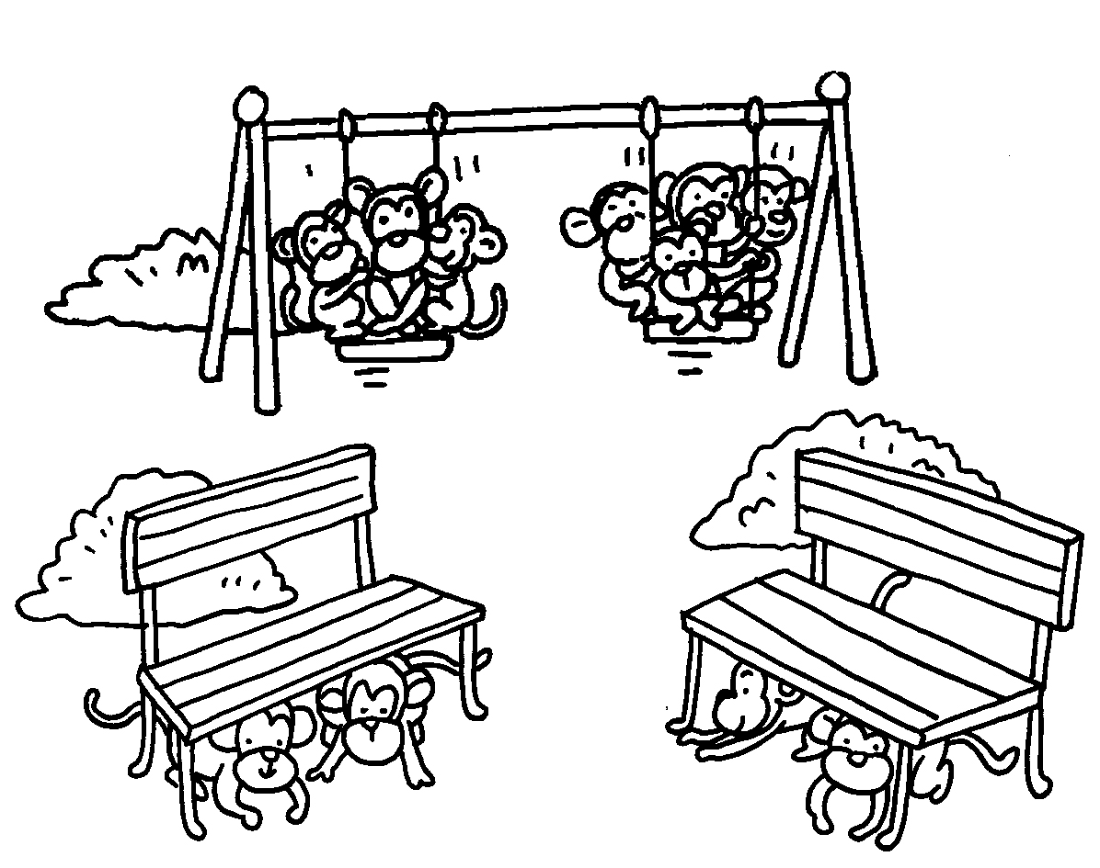 | 2 | 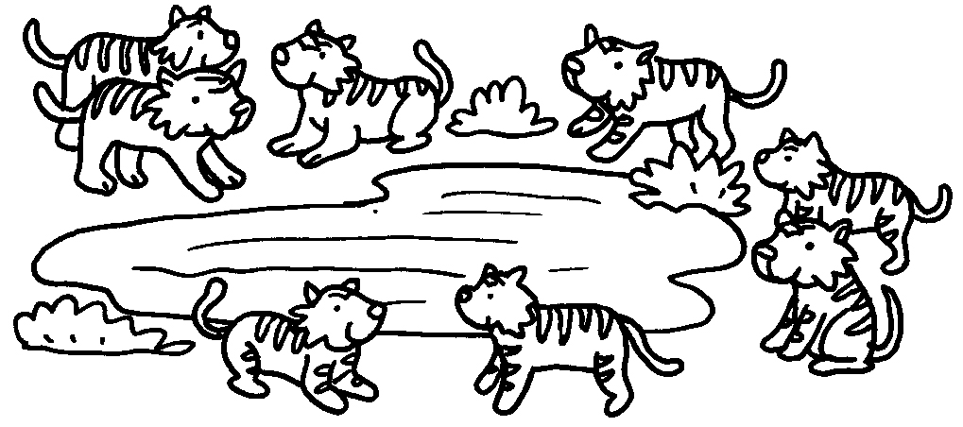
 | A : How many monkeys  are there?  B :  eleven monkeys. |  | A :  tigers are there?  B : There are eight tigers.
3 | 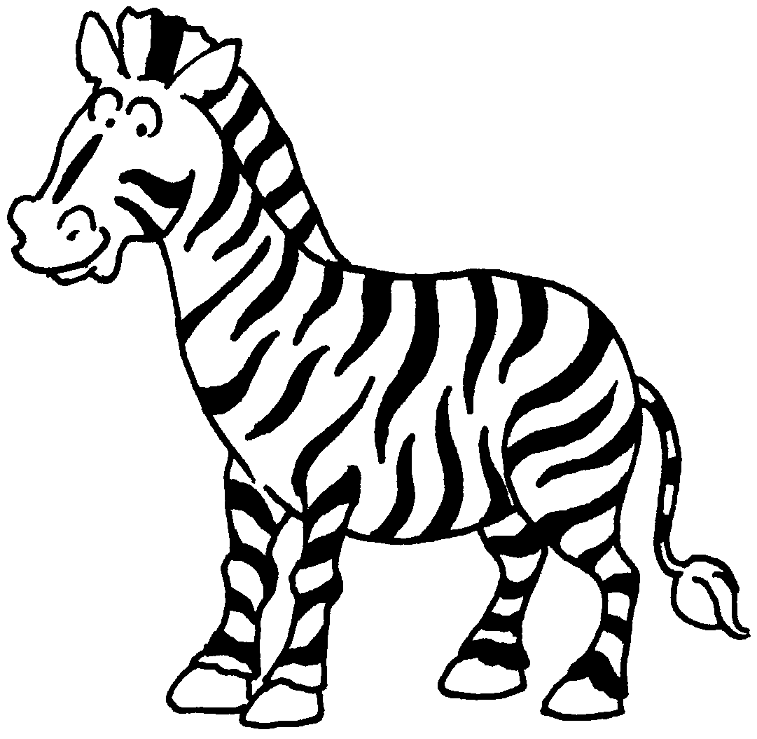 | 4 | 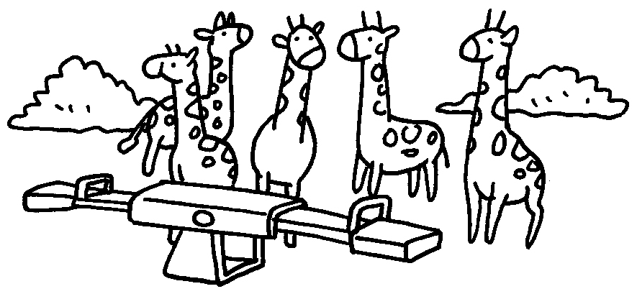
 | A :  zebras are there?  B : one  zebra. |  | A :  giraffes are there?  B : five  giraffes.



Book 1B Chapter 4 Graded Worksheets
Worksheet 3⬇
- There are
- How many
- How many
There is
- How many
There are

