Finish the questions and answers.

How many There is / are

1 | 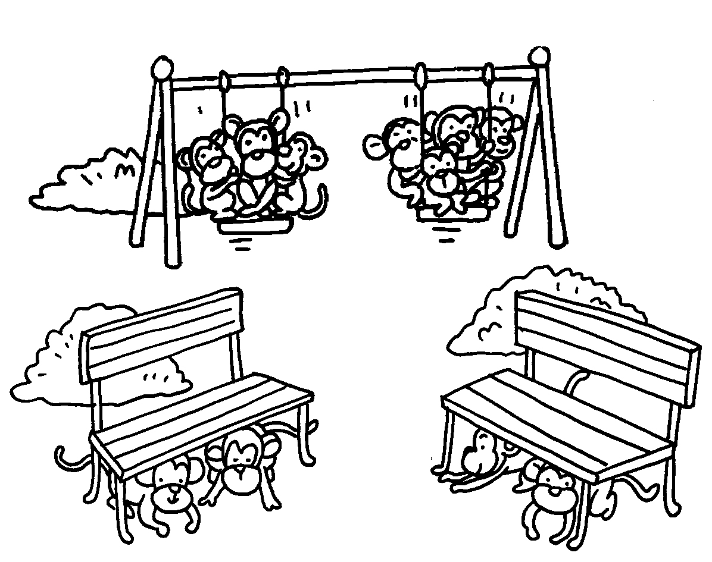 | 2 | 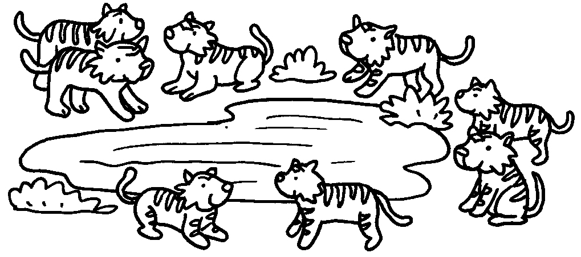
 | A : How many monkeys  are there?  B :  eleven monkeys. |  | A :  tigers are there?  B : eight tigers.
3 | 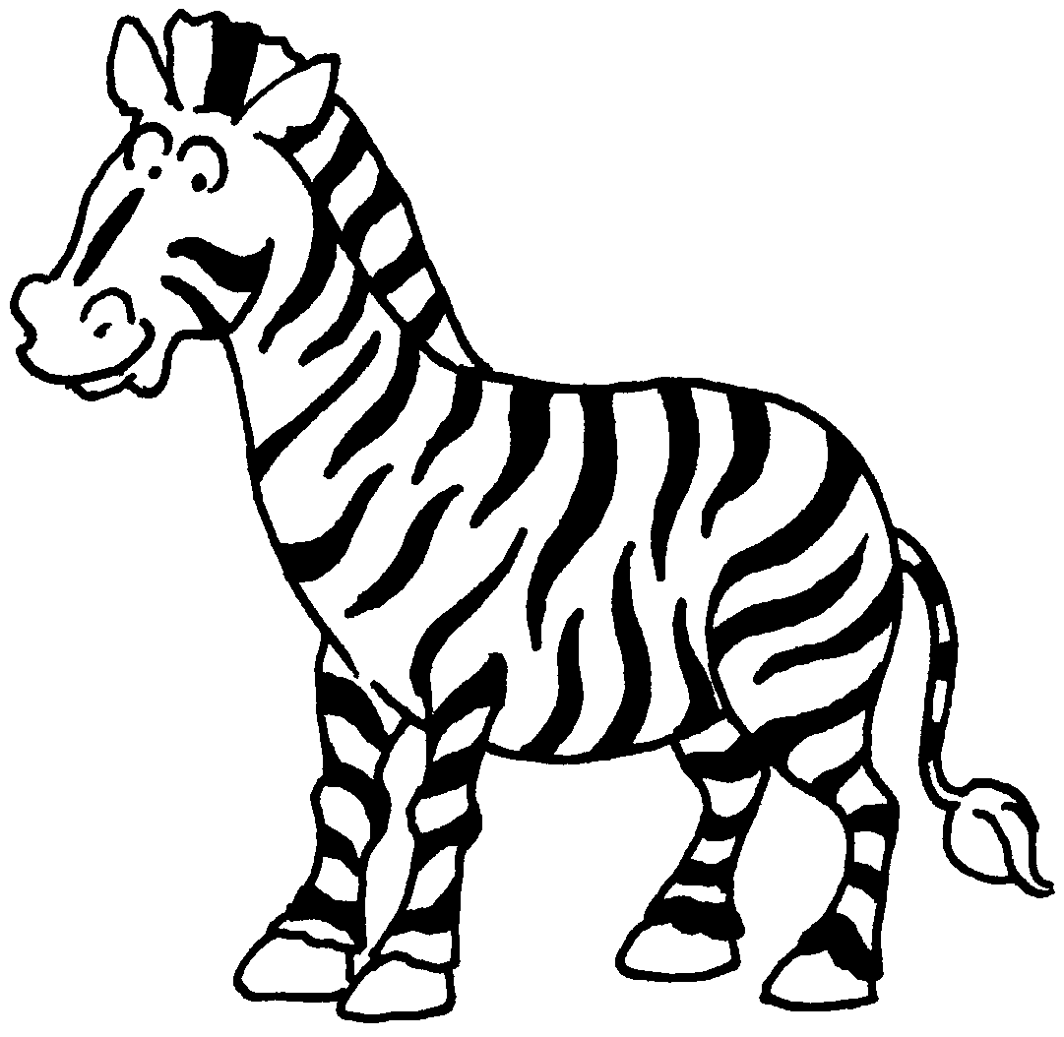 | 4 | 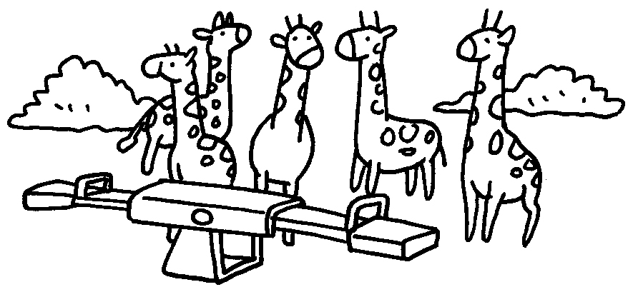
 | A :  zebras are there?  B :  zebra. |  | A :  giraffes are there?  B :  giraffes.



Book 1B Chapter 4 Graded Worksheets
Worksheet 3⬇⬇
- There are
- How many
There are
- How many
There is one / a
- How many
There are five

