Finish the questions and answers.

1 | 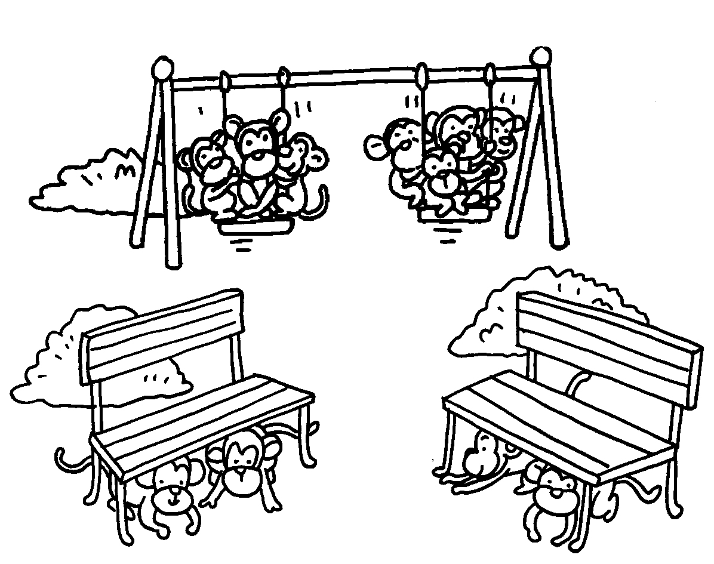 | 2 | 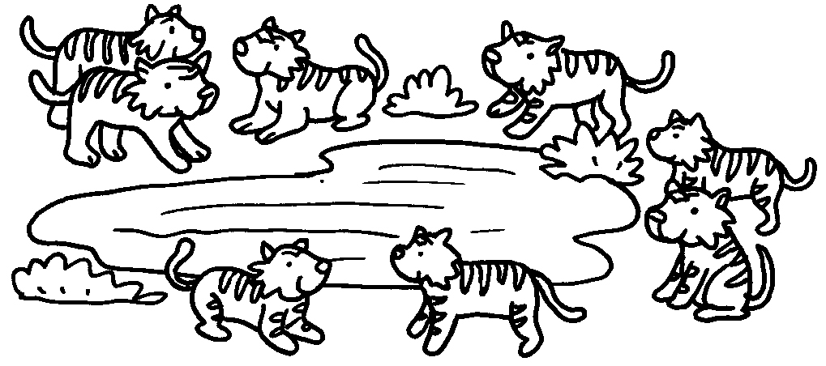
 | A : How many monkeys  are there?  B : There  eleven monkeys. |  | A :  tigers are there?  B :  eight tigers.
3 | 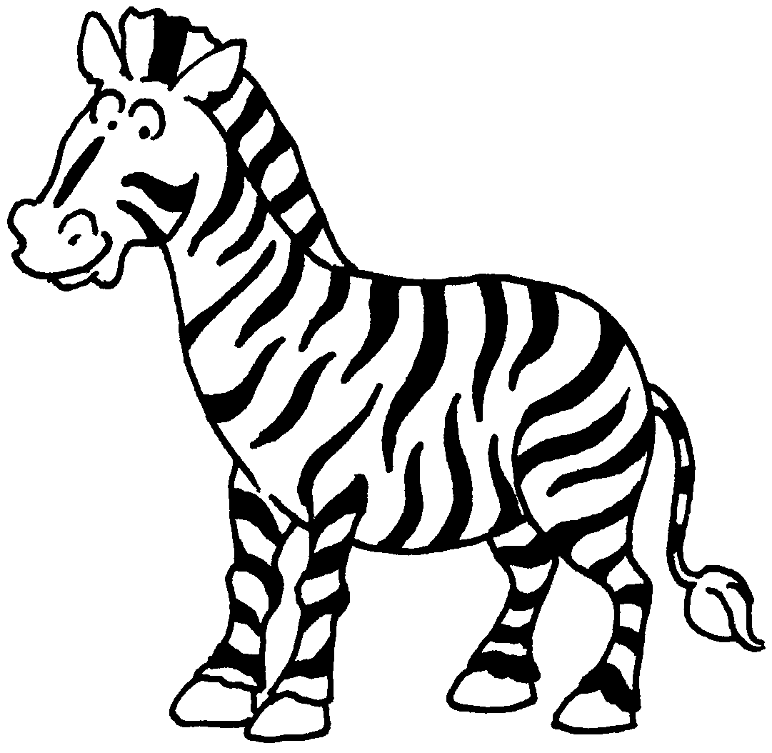 | 4 | 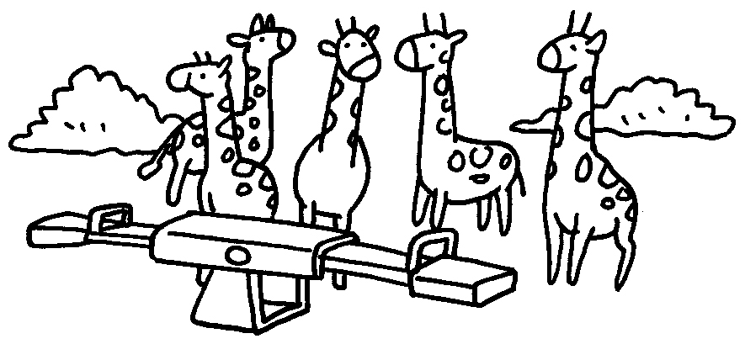
 | A :  zebras ?  B :  zebra. |  | A :  are there?  B :



Book 1B Chapter 4 Graded Worksheets
Worksheet 3⬇⬇⬇
- are
- How many
There are
- How many are there
There is one / a
- How many giraffes
There are five giraffes.

