Choose and write.
draw | play | read | sing

1 | 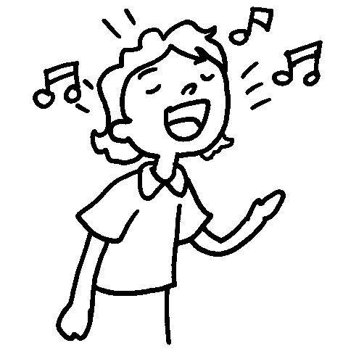 | 2 | 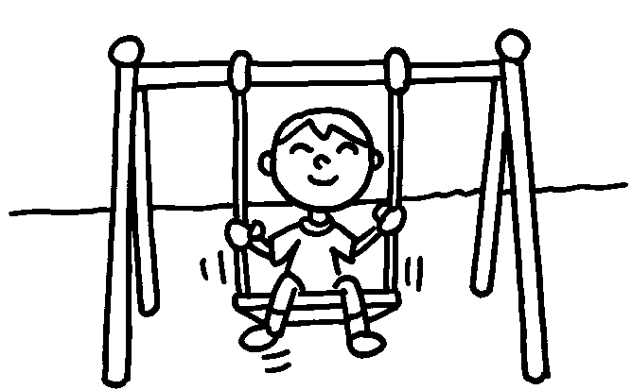
3 | 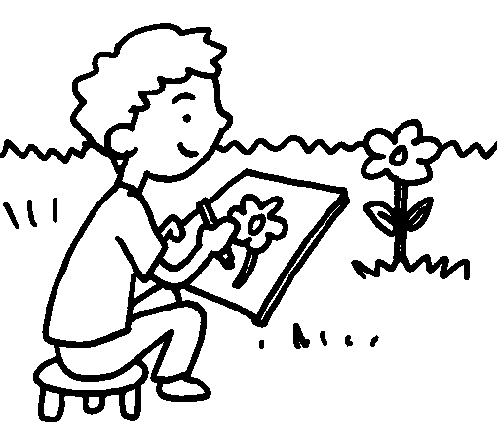 | 4 | 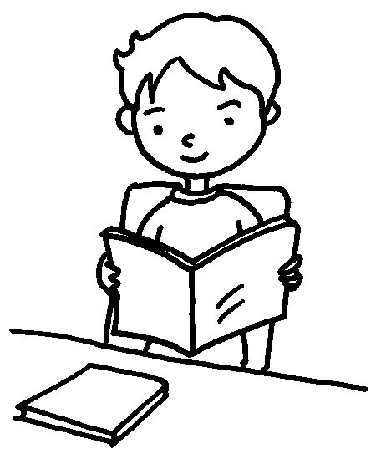

drink | eat | laugh | sleep | talk

5 |  | 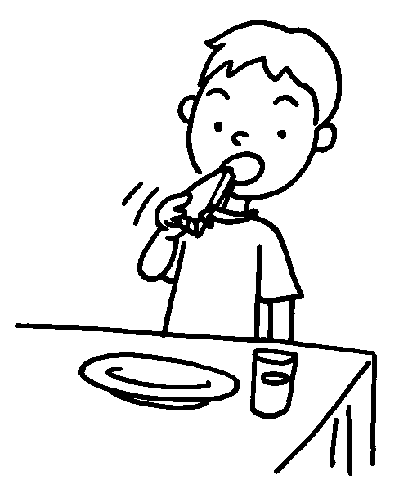 |  | 6 | 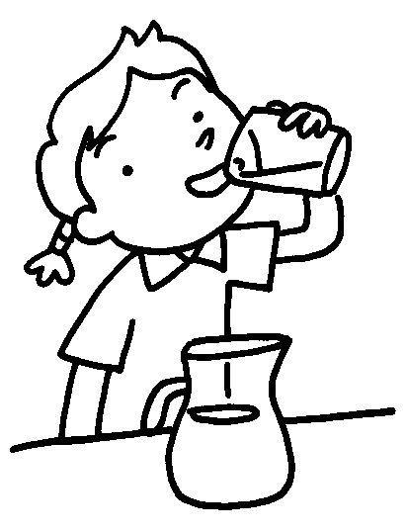
7 | 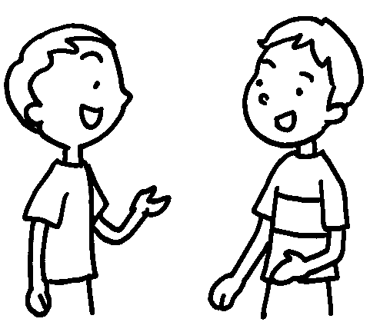  …  … |  | 8 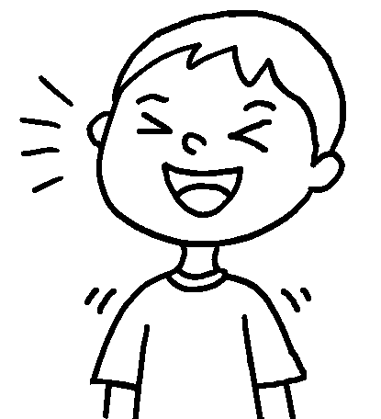 |  |  | 9 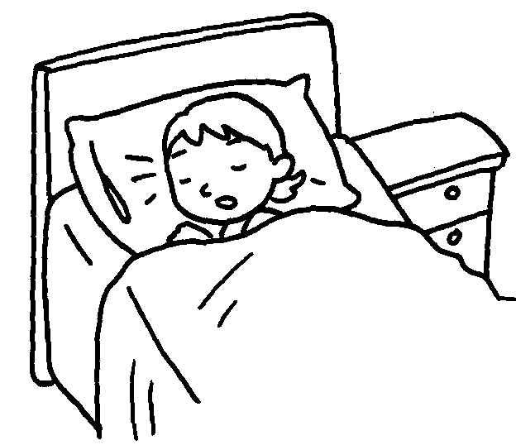



Book 1B Chapter 5 Graded Worksheets
Worksheet 1⬇
- sing 2 play
3 draw 4 read
5 eat 6 drink
7 talk 8 laugh 9 sleep

