Put the letters in the correct order to form words.

1 | 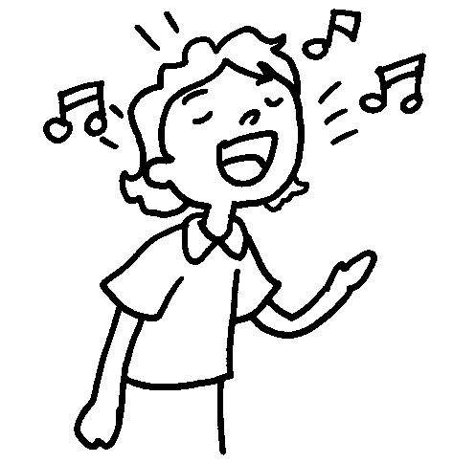 | 2 | 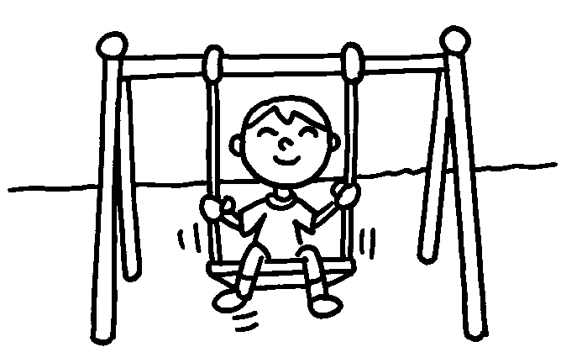
 | n i g s sing |  | l a y p __________
3 | 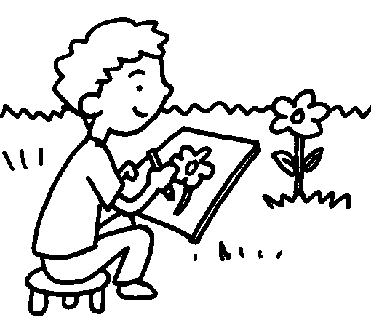 | 4 | 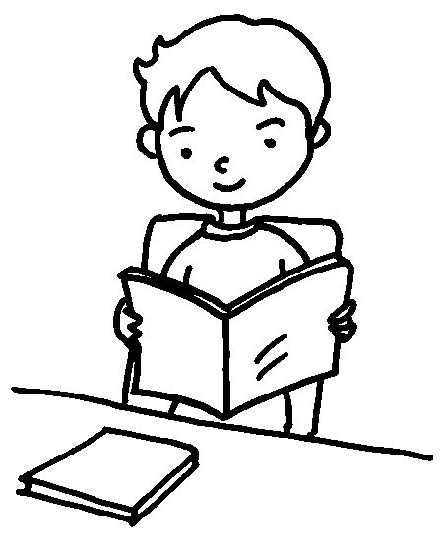
 | d w a r __________ |  | d e r a __________

5 |  | 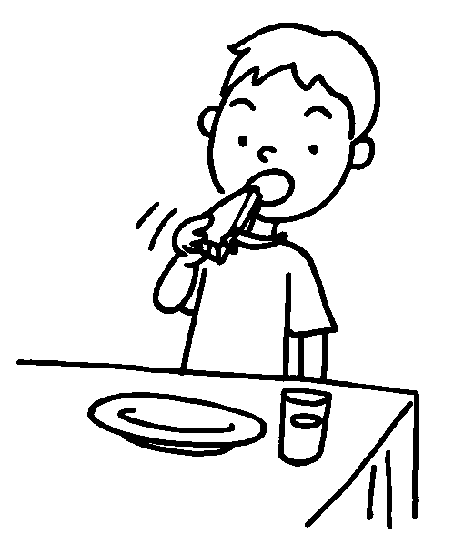 |  |  | 6 | 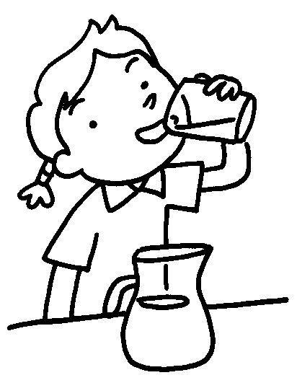
 |  | t a e __________ |  |  |  | r n d i k __________
7 | 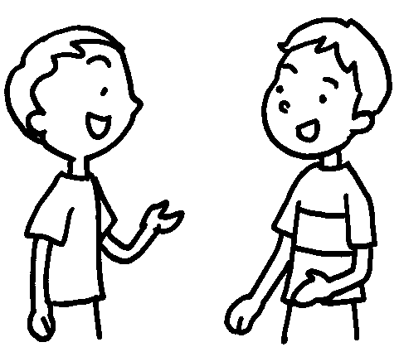  …  … |  |  | 8 |  |  | 
 | k l a t __________ |  |  |  |  |  | l u a h g __________
9 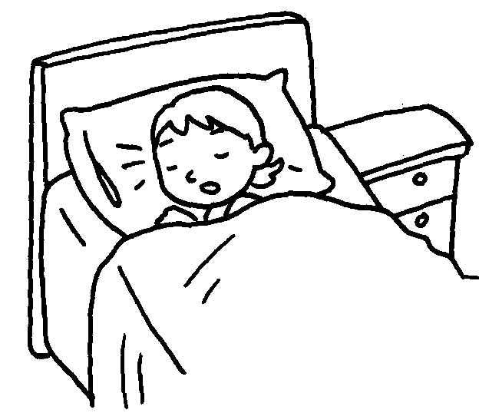
l e p s e __________



Book 1B Chapter 5 Graded Worksheets
Worksheet 1⬇⬇
2 play
3 draw 4 read
5 eat 6 drink
7 talk 8 laugh 9 sleep

