Circle the correct answers.
1 | 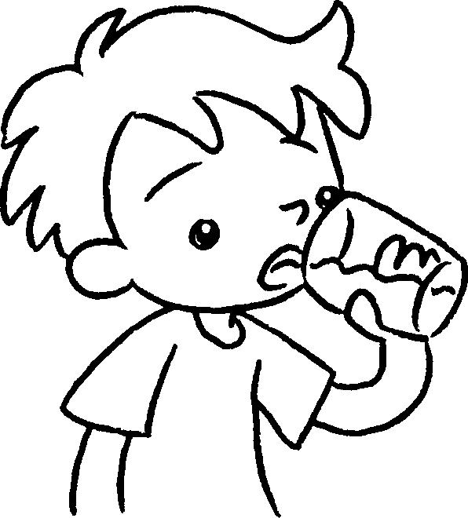  …  … | 2 | 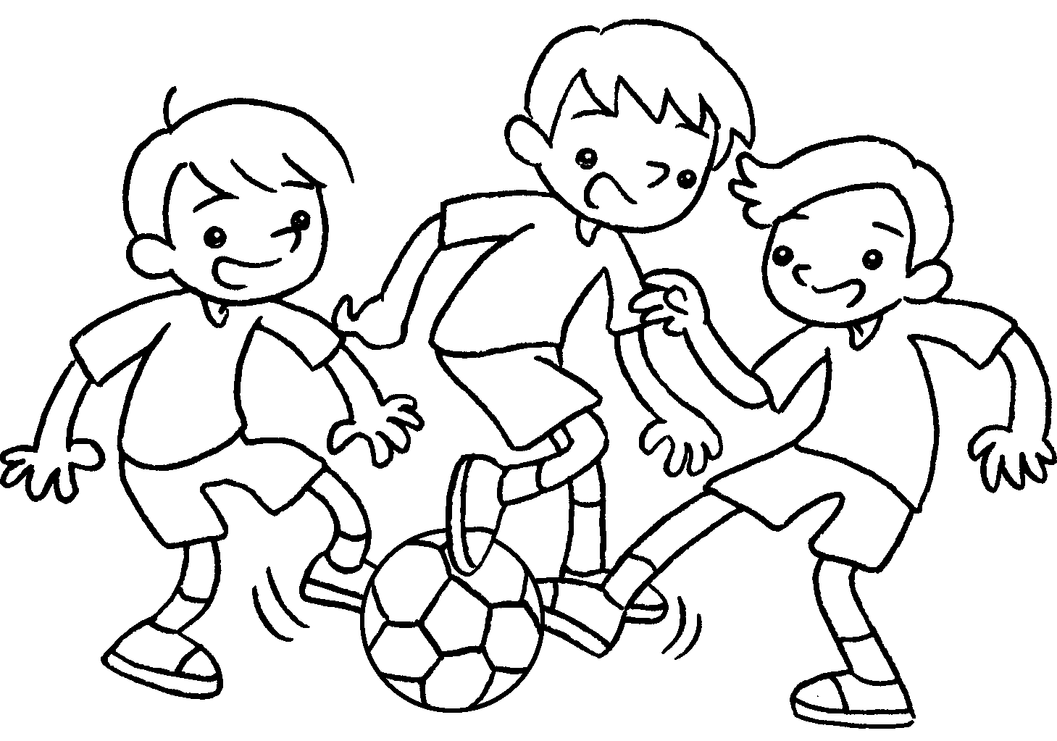
 | I am ( drink / drinking ). |  | We are ( playing / play ).
3 | 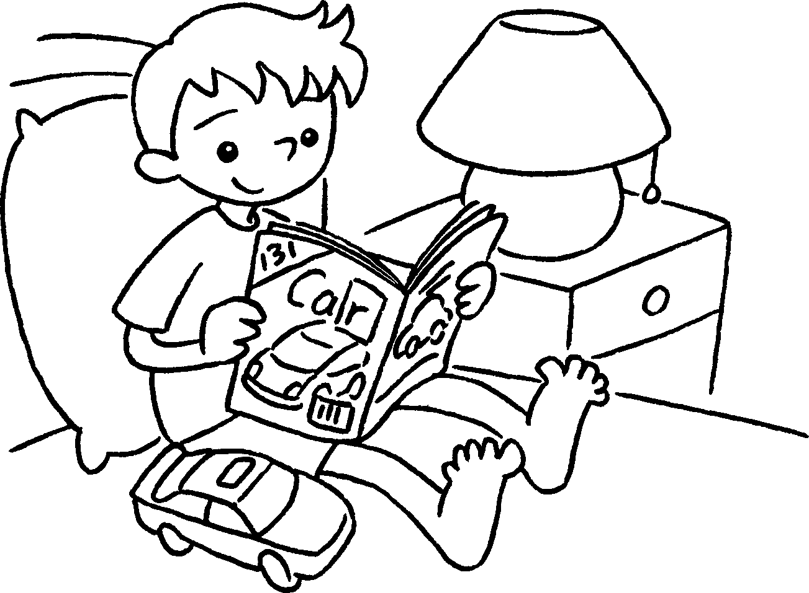  … | 4 | 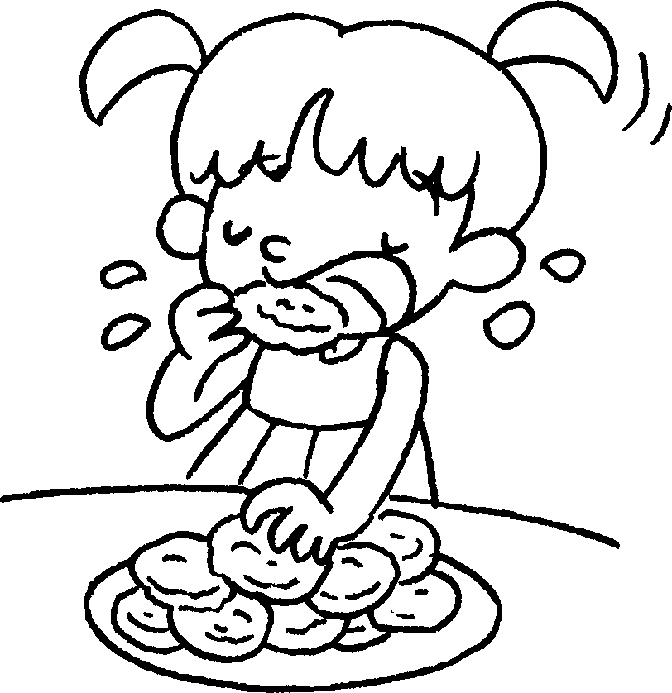  …
 | I am ( reading / read ). |  | I am ( eating / eat ).
5 | 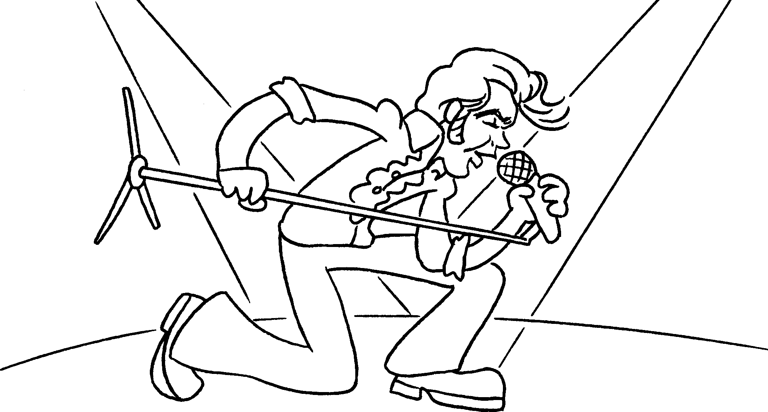  … | 6 | 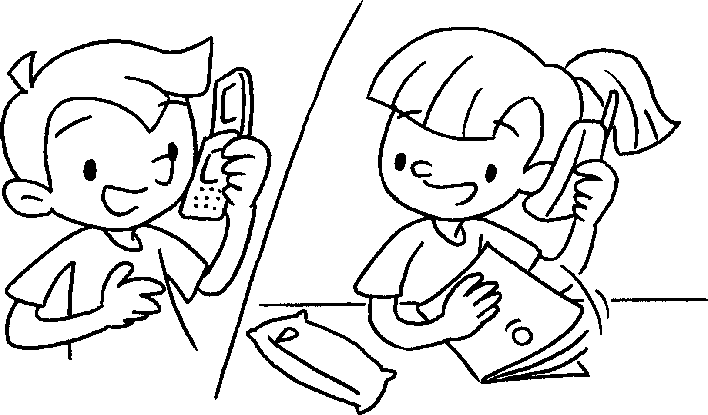  …
 | I am ( sing / singing ). |  | We are ( talking / talk ).


Book 1B Chapter 5 Graded Worksheets
Worksheet 2⬇
- ( drink / drinking )
- ( playing / play )
3 ( reading / read )
4 ( eating / eat )
5 ( sing / singing )
6 ( talking / talk )

